**User guide**

Before use Lighthouse plugin, users are required to read the **installation guide**, which contain the following information:

1. How to setup the database server
2. How to setup the Eclipse workspace
3. Requirements (e.g. SVN)
4. Illustrated step-by-step how to install the plugin
5. Guide of how to start using it
6. Troubleshooting

After following all the steps of the installation guide the users are ready to use the Lighthouse features that are:

1. **Emerging Design:** UML-like representation of the design as it exists in the code. The Emerging Design is built as the developers implement each part of the code and is automatically updated when the code evolves.

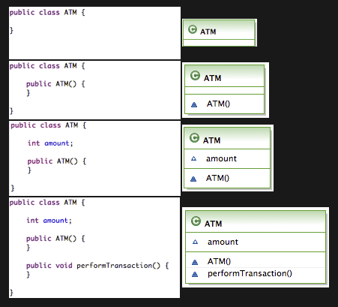

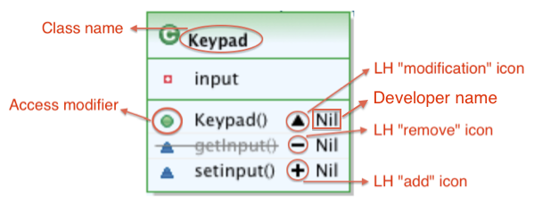

1. **Awareness info:** The Emerging Design represents implementation changes from all team members in real-time, developers can follow the design evolution by simply observing the chain of changes for the diagram elements

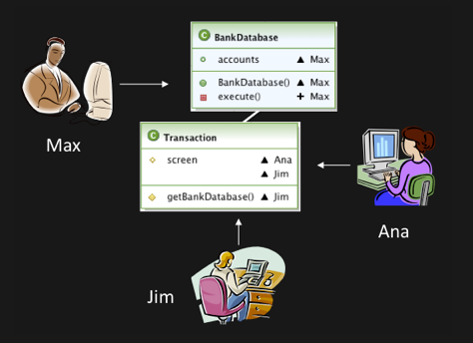

1. **Diagram Visualization Modes:**The user can choose the level of detail that he wants to see.
   1. Shows class names only in the class diagram.
   2. Shows class names and events associated with such classes.
   3. Shows class names and the methods being modified along with authors working on said methods in the class diagram.
   4. Shows class names and all class methods in the class diagram. As well as showing the authors working on methods.

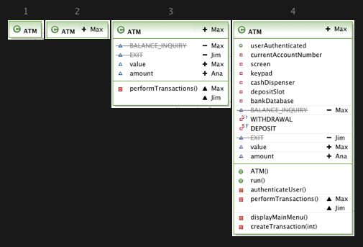

1. **Filters:** The use of Lighthouse in a large software product naturally introduces scalability issues with respect to the visualization. As one can see in the following picture

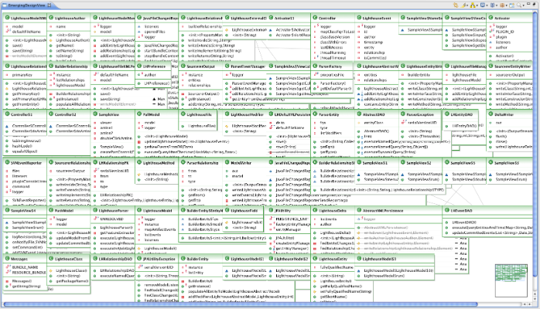

In order to address this problem, we developed a variety of filters:

* 1. **By users (Ana)**

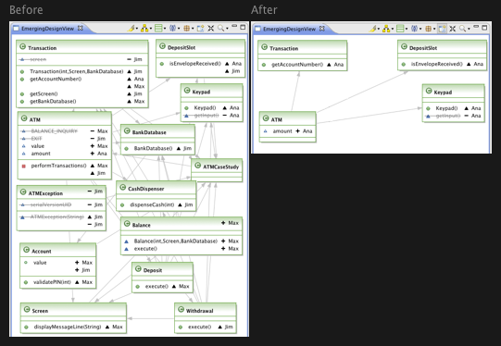

* 1. **Filter By Modifications**

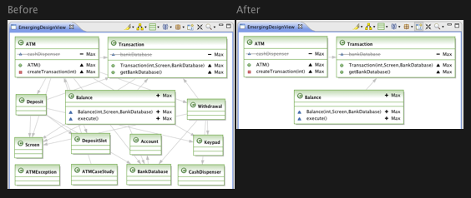

* 1. **By Package**

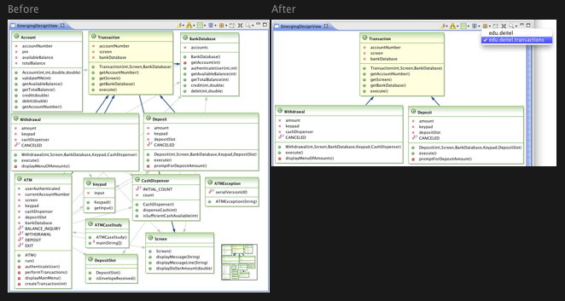

**Icons’ description**

Macintosh HD:Users:nilmax:Desktop:Screen shot 2011-07-13 at 4.56.01 PM.png

|  |  |
| --- | --- |
| Icon | Description |
| Macintosh HD:Users:nilmax:Desktop:Screen shot 2011-07-13 at 4.56.18 PM.png | Highlights in yellow the selected class and/or relationships. |
| Macintosh HD:Users:nilmax:Desktop:Screen shot 2011-07-13 at 4.56.26 PM.png | Cycles through the topographical layouts available, also provides a drop down menu to select individual layouts. |
| Macintosh HD:Users:nilmax:Desktop:Screen shot 2011-07-13 at 4.56.32 PM.png | Cycles through various levels class diagram detail, also provides a drop down menu to select a level of detail. |
| Macintosh HD:Users:nilmax:Desktop:Screen shot 2011-07-13 at 4.56.39 PM.png | Filters classes that particular authors are working on. |
| Macintosh HD:Users:nilmax:Desktop:Screen shot 2011-07-13 at 4.56.50 PM.png | Filters classes by package. |
| Macintosh HD:Users:nilmax:Desktop:Screen shot 2011-07-13 at 4.56.58 PM.png | Filters classes that have been modified. |
| Macintosh HD:Users:nilmax:Desktop:Screen shot 2011-07-13 at 4.57.16 PM.png | Filters only the class currently selected in the editor and its dependencies. |
| Macintosh HD:Users:nilmax:Desktop:Screen shot 2011-07-13 at 4.57.31 PM.png | Provides a zoom drop down menu. |