Lighthouse Demo Scenario

Task 1: Nilmax

* New transaction: The ATM needs to provide the current account balance.

Task 2: Tiago

* New Police: The transactions can only occur between 8:00 am and 8:00 pm.

**Before presentation**

1. Turn on database
2. Get IP
3. Run build.xml to clean database
4. Checkout Projects
   1. <https://calico.ics.uci.edu/svn/lighthouse/trunk/LighthouseSamples/Atm>
   2. https://calico.ics.uci.edu/svn/calico3client/trunk
5. Import both projects to the database
6. Filter project by package
   1. *“edu.deitel”*
7. Turn on
   1. Link with editor
   2. Highlight Class
   3. Highlight Relationship
8. Set Mode # 3
9. Layout diagram
   1. Give emphasis to
      1. Transaction
      2. Deposit
      3. Withdraw
      4. BankDatabase
      5. ATMException
      6. Screen

**During presentation**

MAX

1. Create class Balance.java
   1. Extend from Transaction
   2. Contructor from superclass

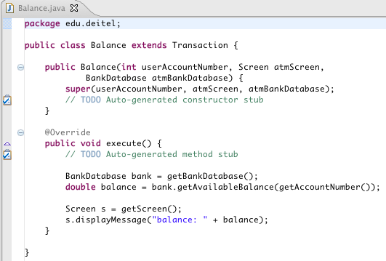

1. Emphasis the creation of the class
2. Show the annotation of creation (+Max)
3. Show the relationship with
   1. Transaction
   2. BankDataBase
   3. Screen
4. Show the annotation of modification ( * Max)

TIAGO

1. Code inside Trasanction.getBankDatabase()

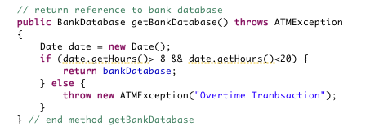

1. Add throws declaration in Deposit.execute()
2. Add throws declaration in Trasaction.execute()
3. Add throws declaration in Withdrawal.execute()
4. WAIT, this is the proper time to talk with each other (
   1. Max apply filter by modifications
   2. Max apply filter by user
   3. Max apply layout diagram
5. Commit all 3 files (say that the visualization will be cleaned)
6. Tiago now has the latest version of the 3 files

MAX

1. It will be notified with a commit icon
2. Then he can Update all 3 files (say that the visualization will be cleaned)
3. Now Max and Tiago are working on the same version
4. Add throws declaration in Balance.execute()
5. Commit Balance.java

**Information Overload**

MAX

1. Show the calico project (75 thousands lines of code)
   1. Filters by package
      1. calico.controllers