Lighthouse Eclipse Plug-in

How to install

1. Go to Menu -> Help -> Install New Software

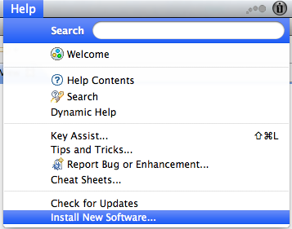

1. Click in the Add… Button:

Type *Lighthouse* in the *Name* field

Type <https://nautilus.ics.uci.edu/~lighthouse/updates> in the *Location* field

Press OK button

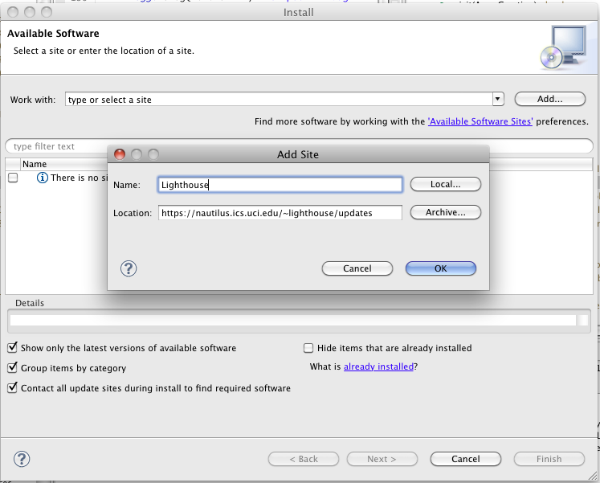

1. Check the collaboration and Subversion and then press *Next >*

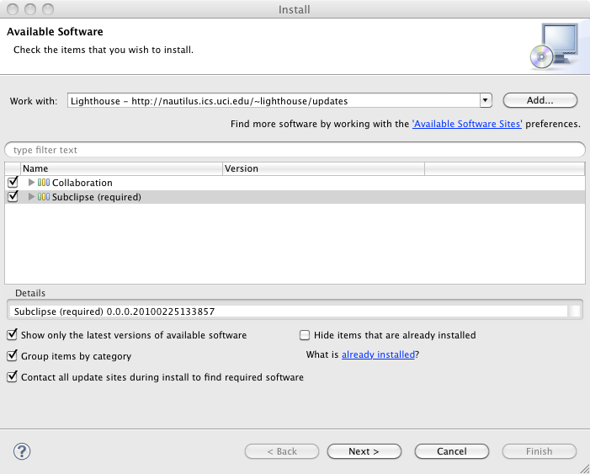

1. The follow window should be displayed. Accept the license agreements and click in finish.

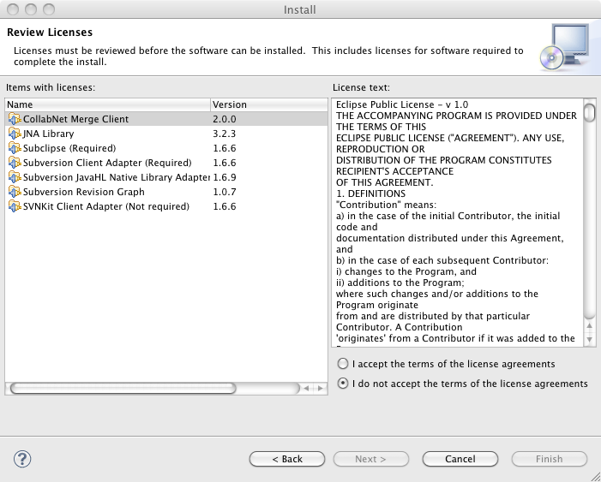

1. Go to Menu -> Eclipse/File -> Preferences…

All fields are already filled. You just have to change the database for your group name (lighthouse_team1, lighthouse_team2, lighthouse_team3)

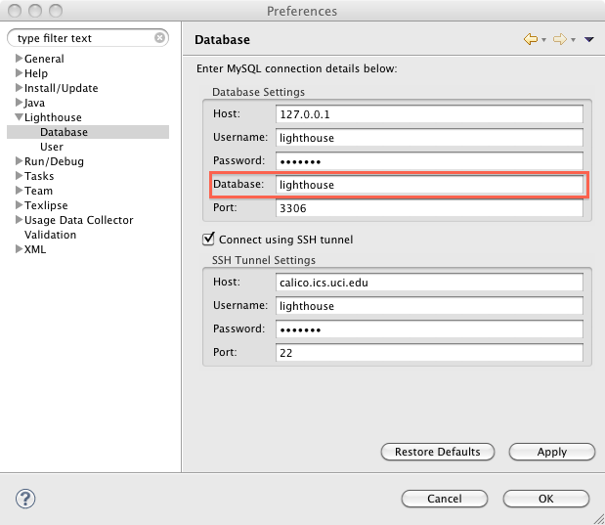

1. Click in *User* under Lighthouse Option

Set your *First name* as your *Username*

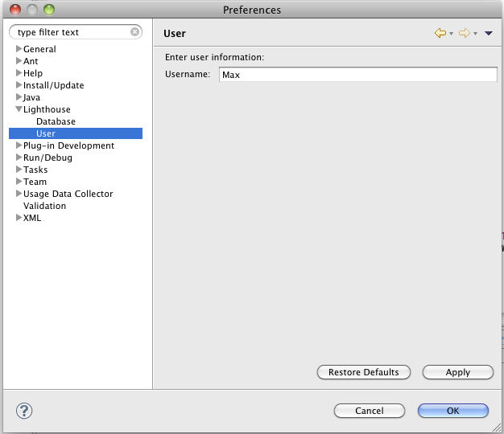

1. How to show the visualization

Go to Windows -> Show View -> Other…

Choose *EmergingDesignView* under Lighthouse folder

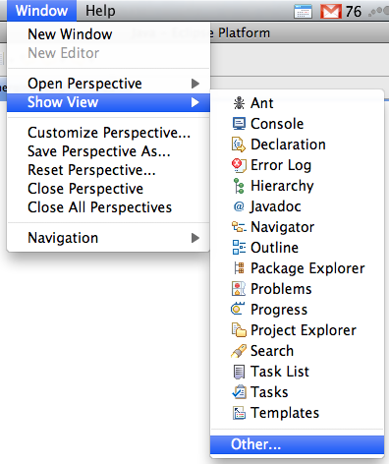 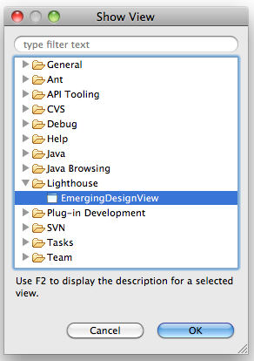

1. After you edit some classes. It should appear an Eclipse view, just like that:

