Lighthouse Eclipse Plug-in

User Manual

* Layout Algorithms

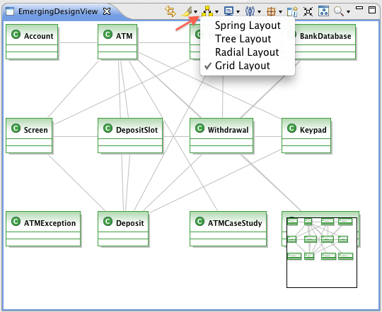

* Highlight

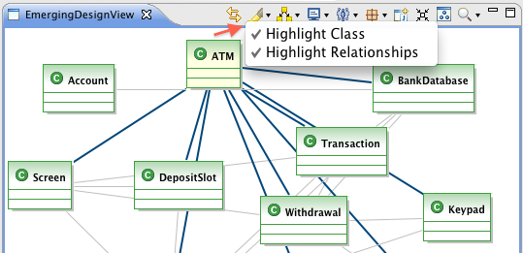

* Classes visualization modes:

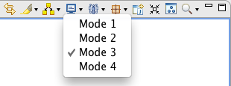

* Filter by Users

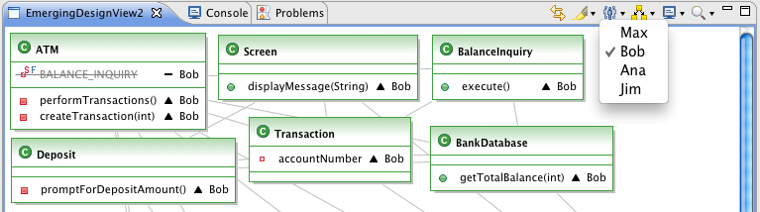

* Filter by modifications

It just shows classes that have some event related.



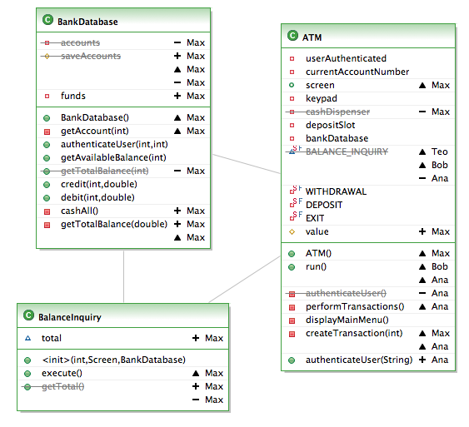

* Filter by packages

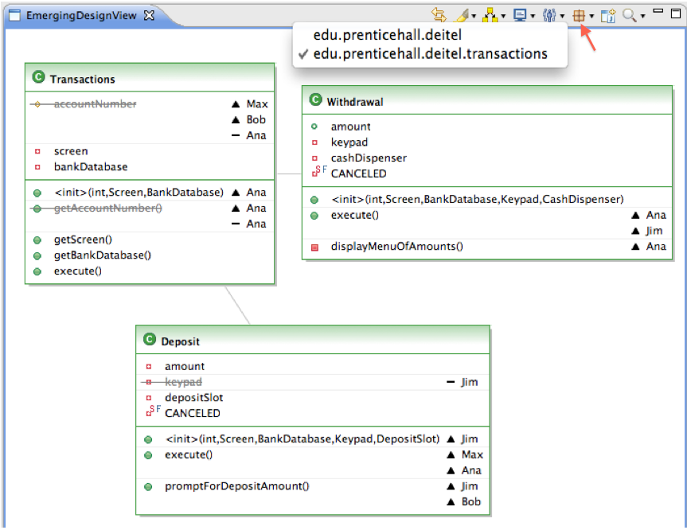

* Show the activate class (opened in the editor) and its dependencies

