Lighthouse Installation Guide

Server Setup

Lighthouse is a workspace awareness tool, and as such it needs to handle all the events that come from each host. In order to perform this event notification we make use of **ONE** database server. Here are the necessary steps to setup the database.

1. Install MySQL 5.1
   1. <http://dev.mysql.com/doc/refman/5.1/en/installing.html>
2. Run Lighthouse database script:
   1. <http://www.ucicalico.com/~lighthouse/downloads/db_structure.sql>
   2. run mysql –u root < db_structure.sql

*This script will create:*

* Username: lighthouse – Password: lighthouse
* Schema: lighthouse
* Tables and Triggers

Required applications

1. Eclipse Helios
   1. <http://www.eclipse.org/downloads/>

Recommendations  
(those are not requirements just recommendations)

1. Put the SVN Repository and MySQL Database on the same machine
   1. This will avoid some eventual clock desynchronization
2. Creating a new Java Project

* Go to File-> New -> Project… -> Choose: “Java Project”
  + Do NOT use blank space when typing a *project name*
  + Eclipse will AUTOMATICALLY create a *Java Source Folder* **SRC**.
  + Do create all your packages INSIDE this folder
  + Do create all your classes INSIDE the packages you just created
  + Do NOT create a class inside a default package

Limitations

1. You need to use SVN as a CM system

How to install the Lighthouse Eclipse Plugin

1. Go to Menu -> Help -> Install New Software

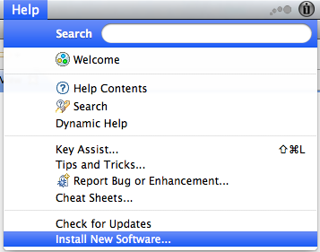

1. Click in the Add… Button:

Type *Lighthouse* in the *Name* field

Type <http://lighthouse.ucicalico.com/~lighthouse/updates> in the *Location* field. Press the OK button

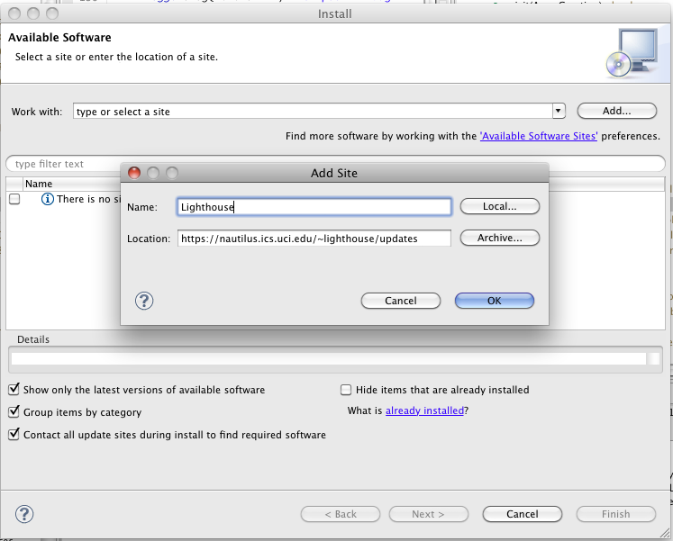

1. Check the collaboration and Subversion and then press *Next >*

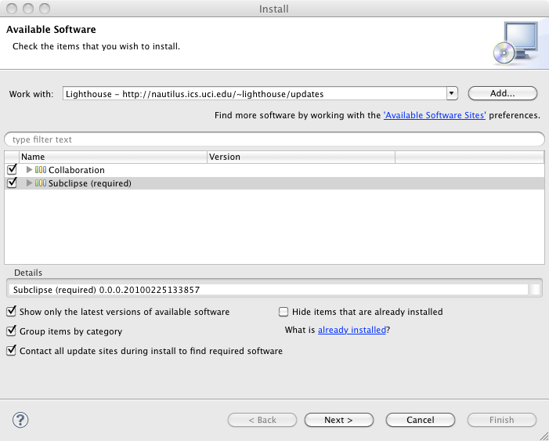

1. The follow window should be displayed. Accept the license agreements and click in finish.

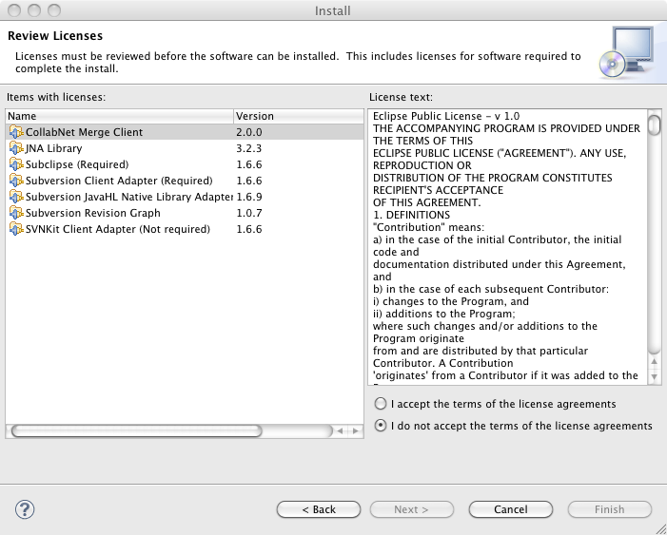

1. Go to Menu -> Eclipse/File -> Preferences…

Specify the *Host Address* where the lighthouse database was installed.

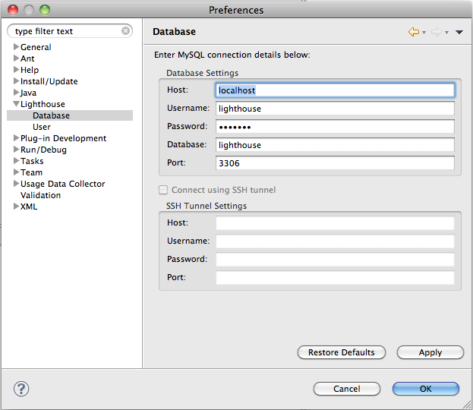

1. Click in *User* under Lighthouse Option

Set your *First name* as your *Nickname*

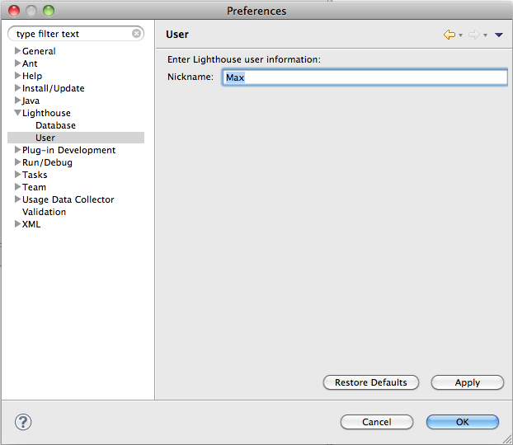

1. How to show the visualization

Go to Windows -> Show View -> Other…

Choose *EmergingDesignView* under Lighthouse folder

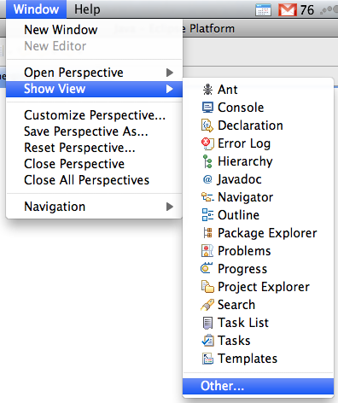 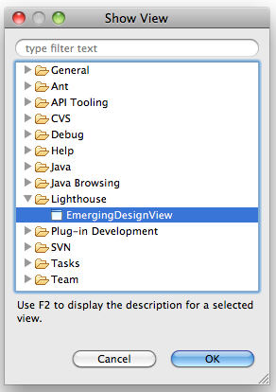

Starting Using It

1. Only **ONE** of the team members needs to share the Eclipse Projects that are currently being developed.
   1. Do share all the related Eclipse projects at the same time (Projects that has dependencies with each other)
   2. You can only import Eclipse projects that have at least one Java File.

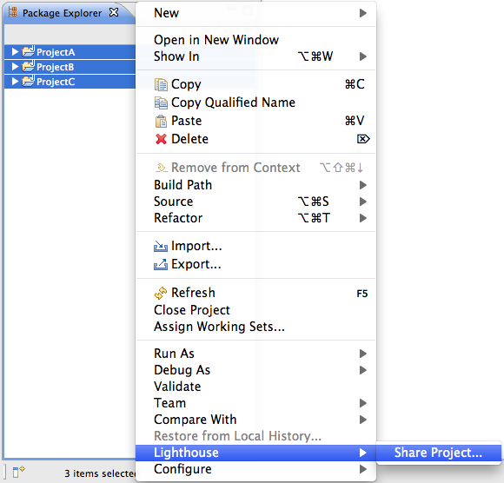

1. This window will show up.

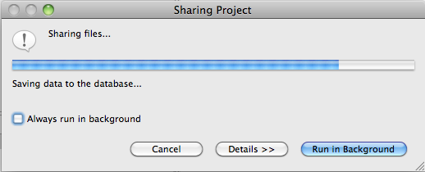

1. In the end you should be able to see the Emerging Design view

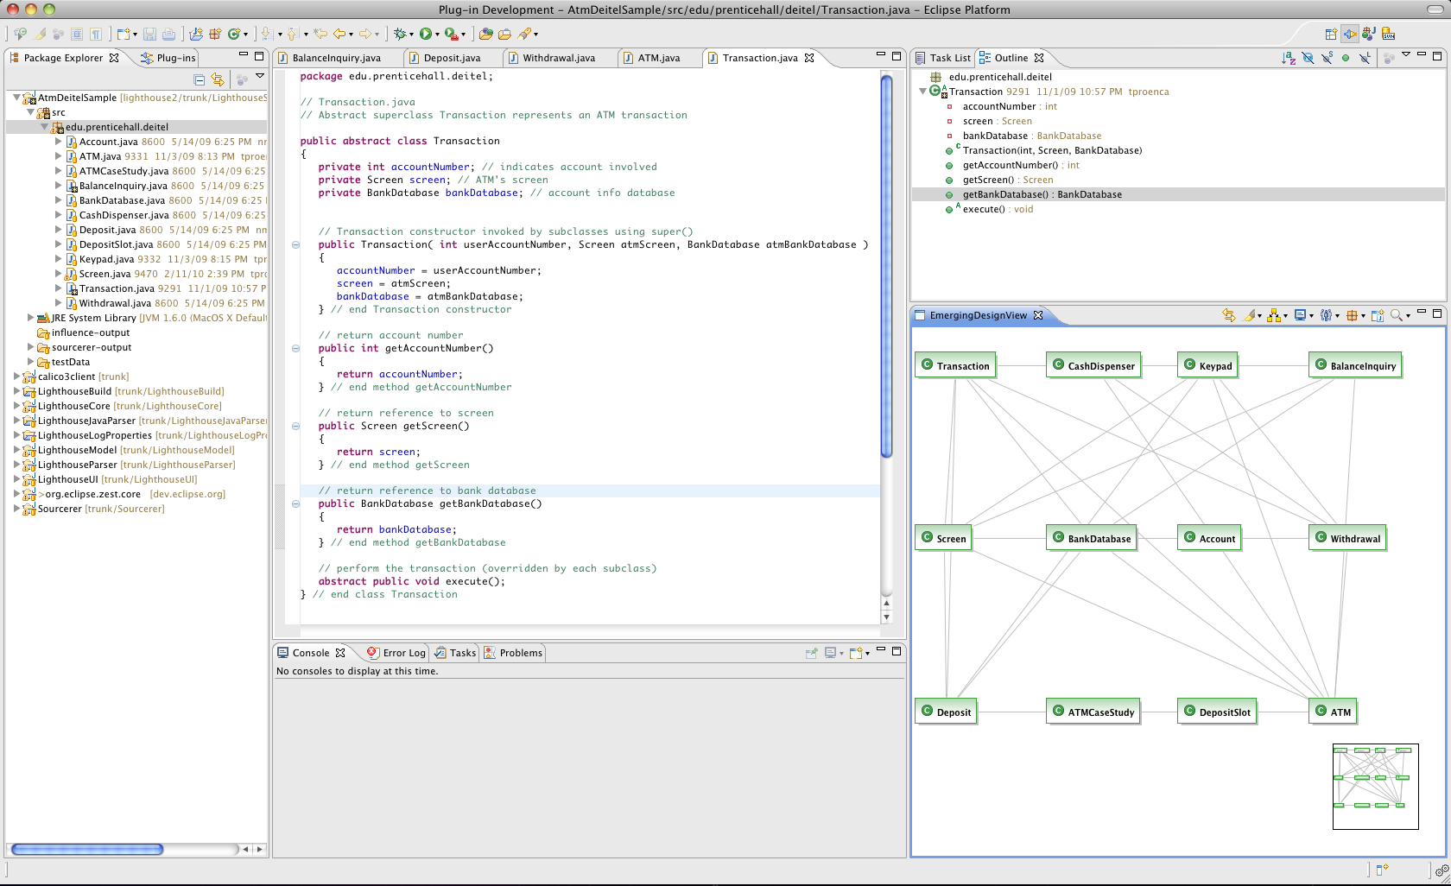

1. Once the project is shared, the others team members only are required to:
   1. Point to the same database server
   2. Perform a checkout of the related Eclipse Projects
2. **TROUBLESHOOTING**

If at any moment the emerging design is not populated accordingly, you can always go ahead and press the *SYNCRONIZE button* in Eclipse preferences:

