# Documentation

How to use the Showcase feature on Smile Notes?

This is how the Showcase feature on the web site will look like

To add an image you will need to select the plus icon and choose ‘Add File’ on the drop down menu

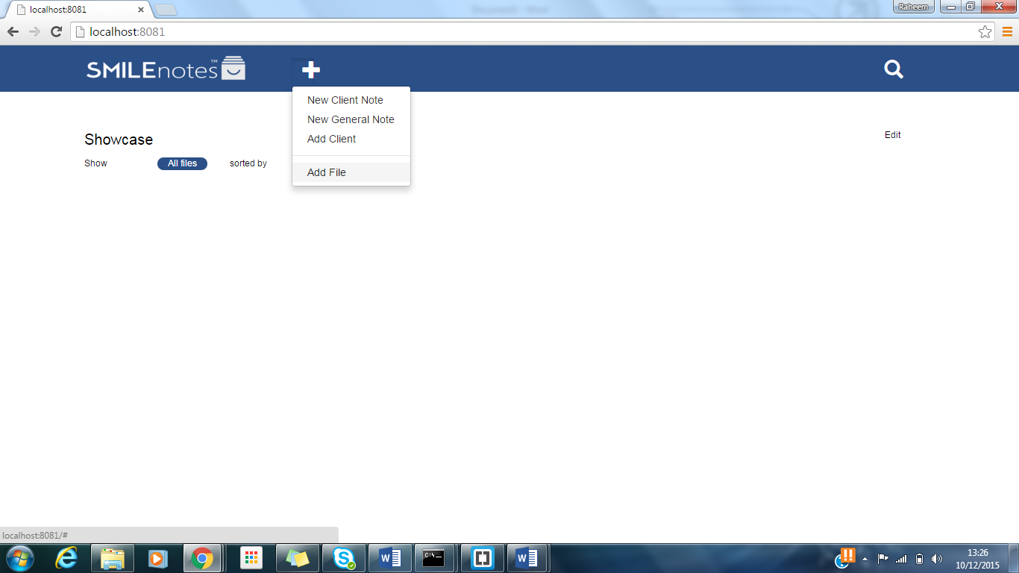

Then you will need to choose the file, after choosing the file you will need to input a description and then lastly add at least one label to the image. To add another label to the image you press ‘Add Label’ once you’ve inputted.

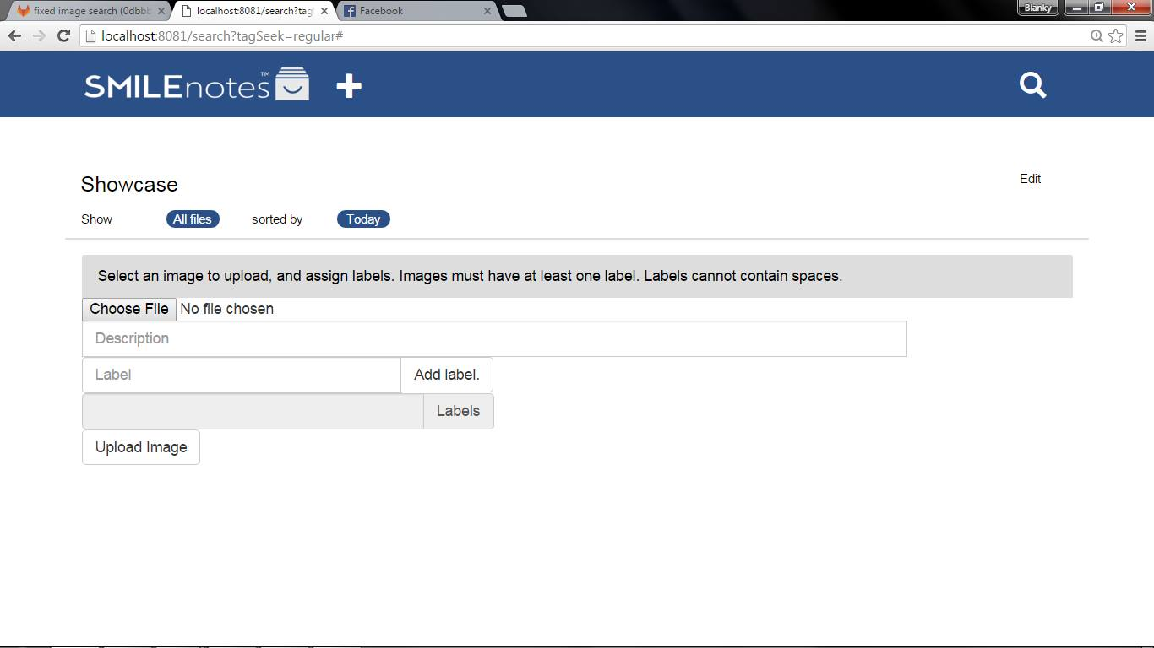

After that has been done then you select upload image, and then this should happen

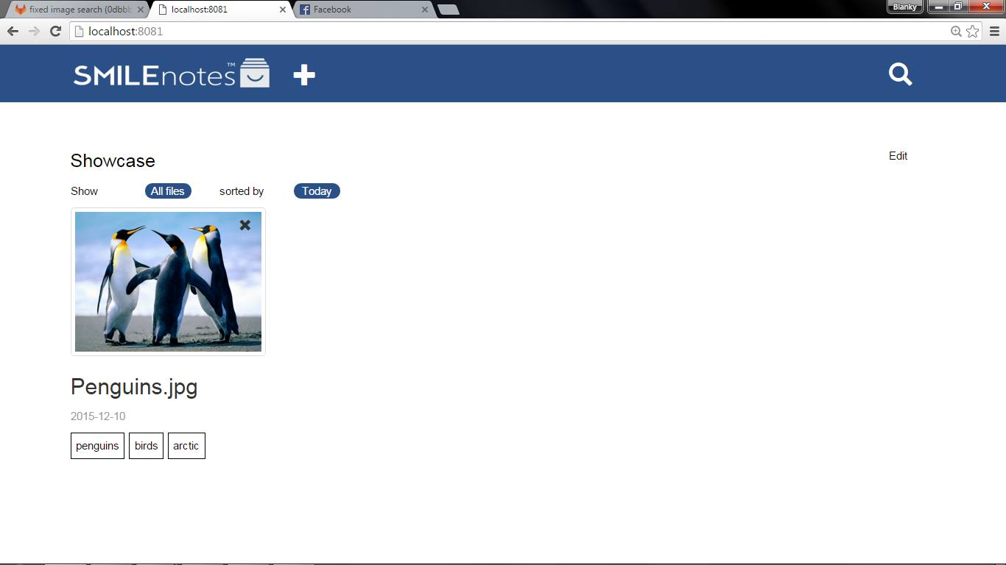

You can search through all current labels by selecting ‘All files’. Choosing a label from the drop down will then display all images that share that label. Choosing ‘All files’ in the drop down menu will display all images in the database. 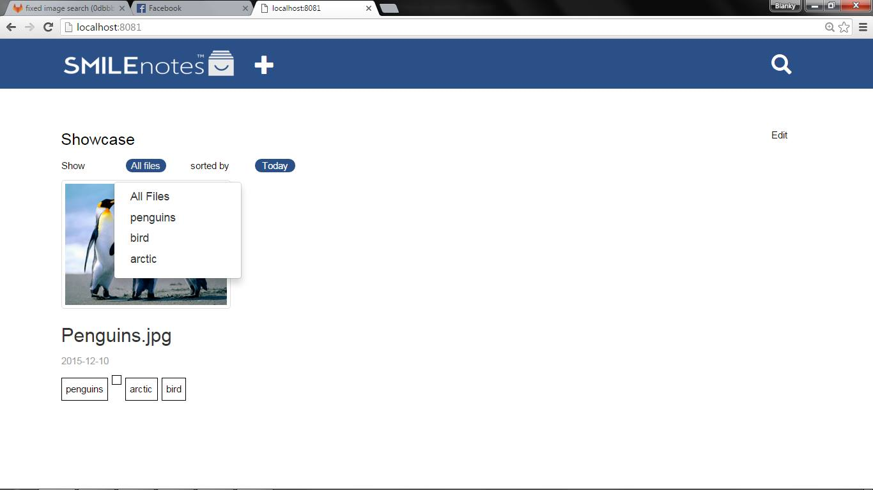

You can also view images in a slideshow view by clicking on an image, there is then left and right indicators to allow you to cycle though the images. To exit the slideshow view just click anywhere outside of the image.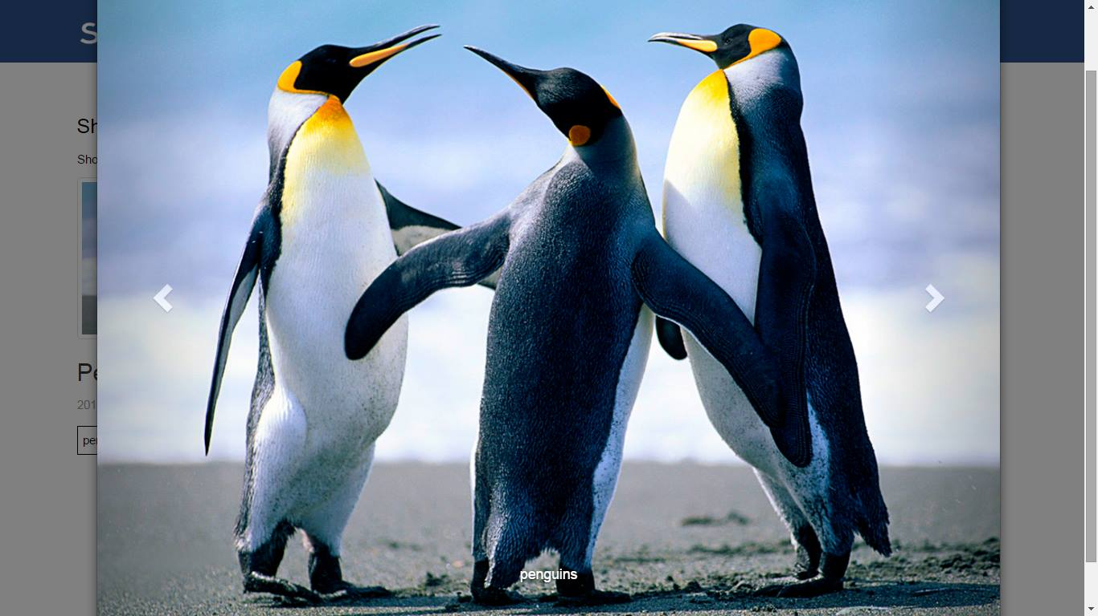

You can delete an image by selecting the ‘X’ in the right hand corner of an image, a pop up will be displayed to ensure that you have selected delete correctly. 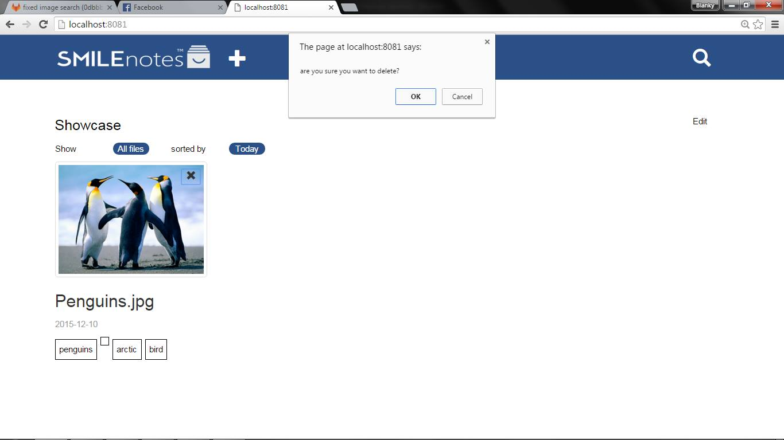

Technical

Backend;

Node.js

EJS

Express

Multer

Sqlite3

Frontend;

Jquery

Bootstrap

To run the server copy dentist folder use the windows command prompt to navigate to the directy. Then run npm install, this will download the required npm modules. Then in the same directory run node app.js this will create the server. In your browser of choice navigate to <http://localhost:8081/>. You will be required to install node.js which can be downloaded at https://nodejs.org/en/download/.

The server is created with node.js running via express server runs a sqlite3 database to store images, the image upload is handled with multer. The server creates a databases called persistent.db this has three tables, images which contains image information such as name, path, and a unique ID. The tags table contains the tags and a unique ID. The link table links the images to the tag, so that an image can contain multiple tags.