Lee Moriarity

Professor Kelly

CIS 245 ONL01

13 December 2022

Final Project

For my Database I decided to make a practical database for my girlfriends online crystal business. The database tables include CUSTOMERS, PRODUCTS, ORDERS, ORDER_DETAILS, and PAYMENTS. I tried to make it functional by focusing on the main aspects of the business which is customers, products, and orders. I ended up having a lot of fun working on this assignment and I hope to implement what I have learned to help develop a simpler website ordering system.

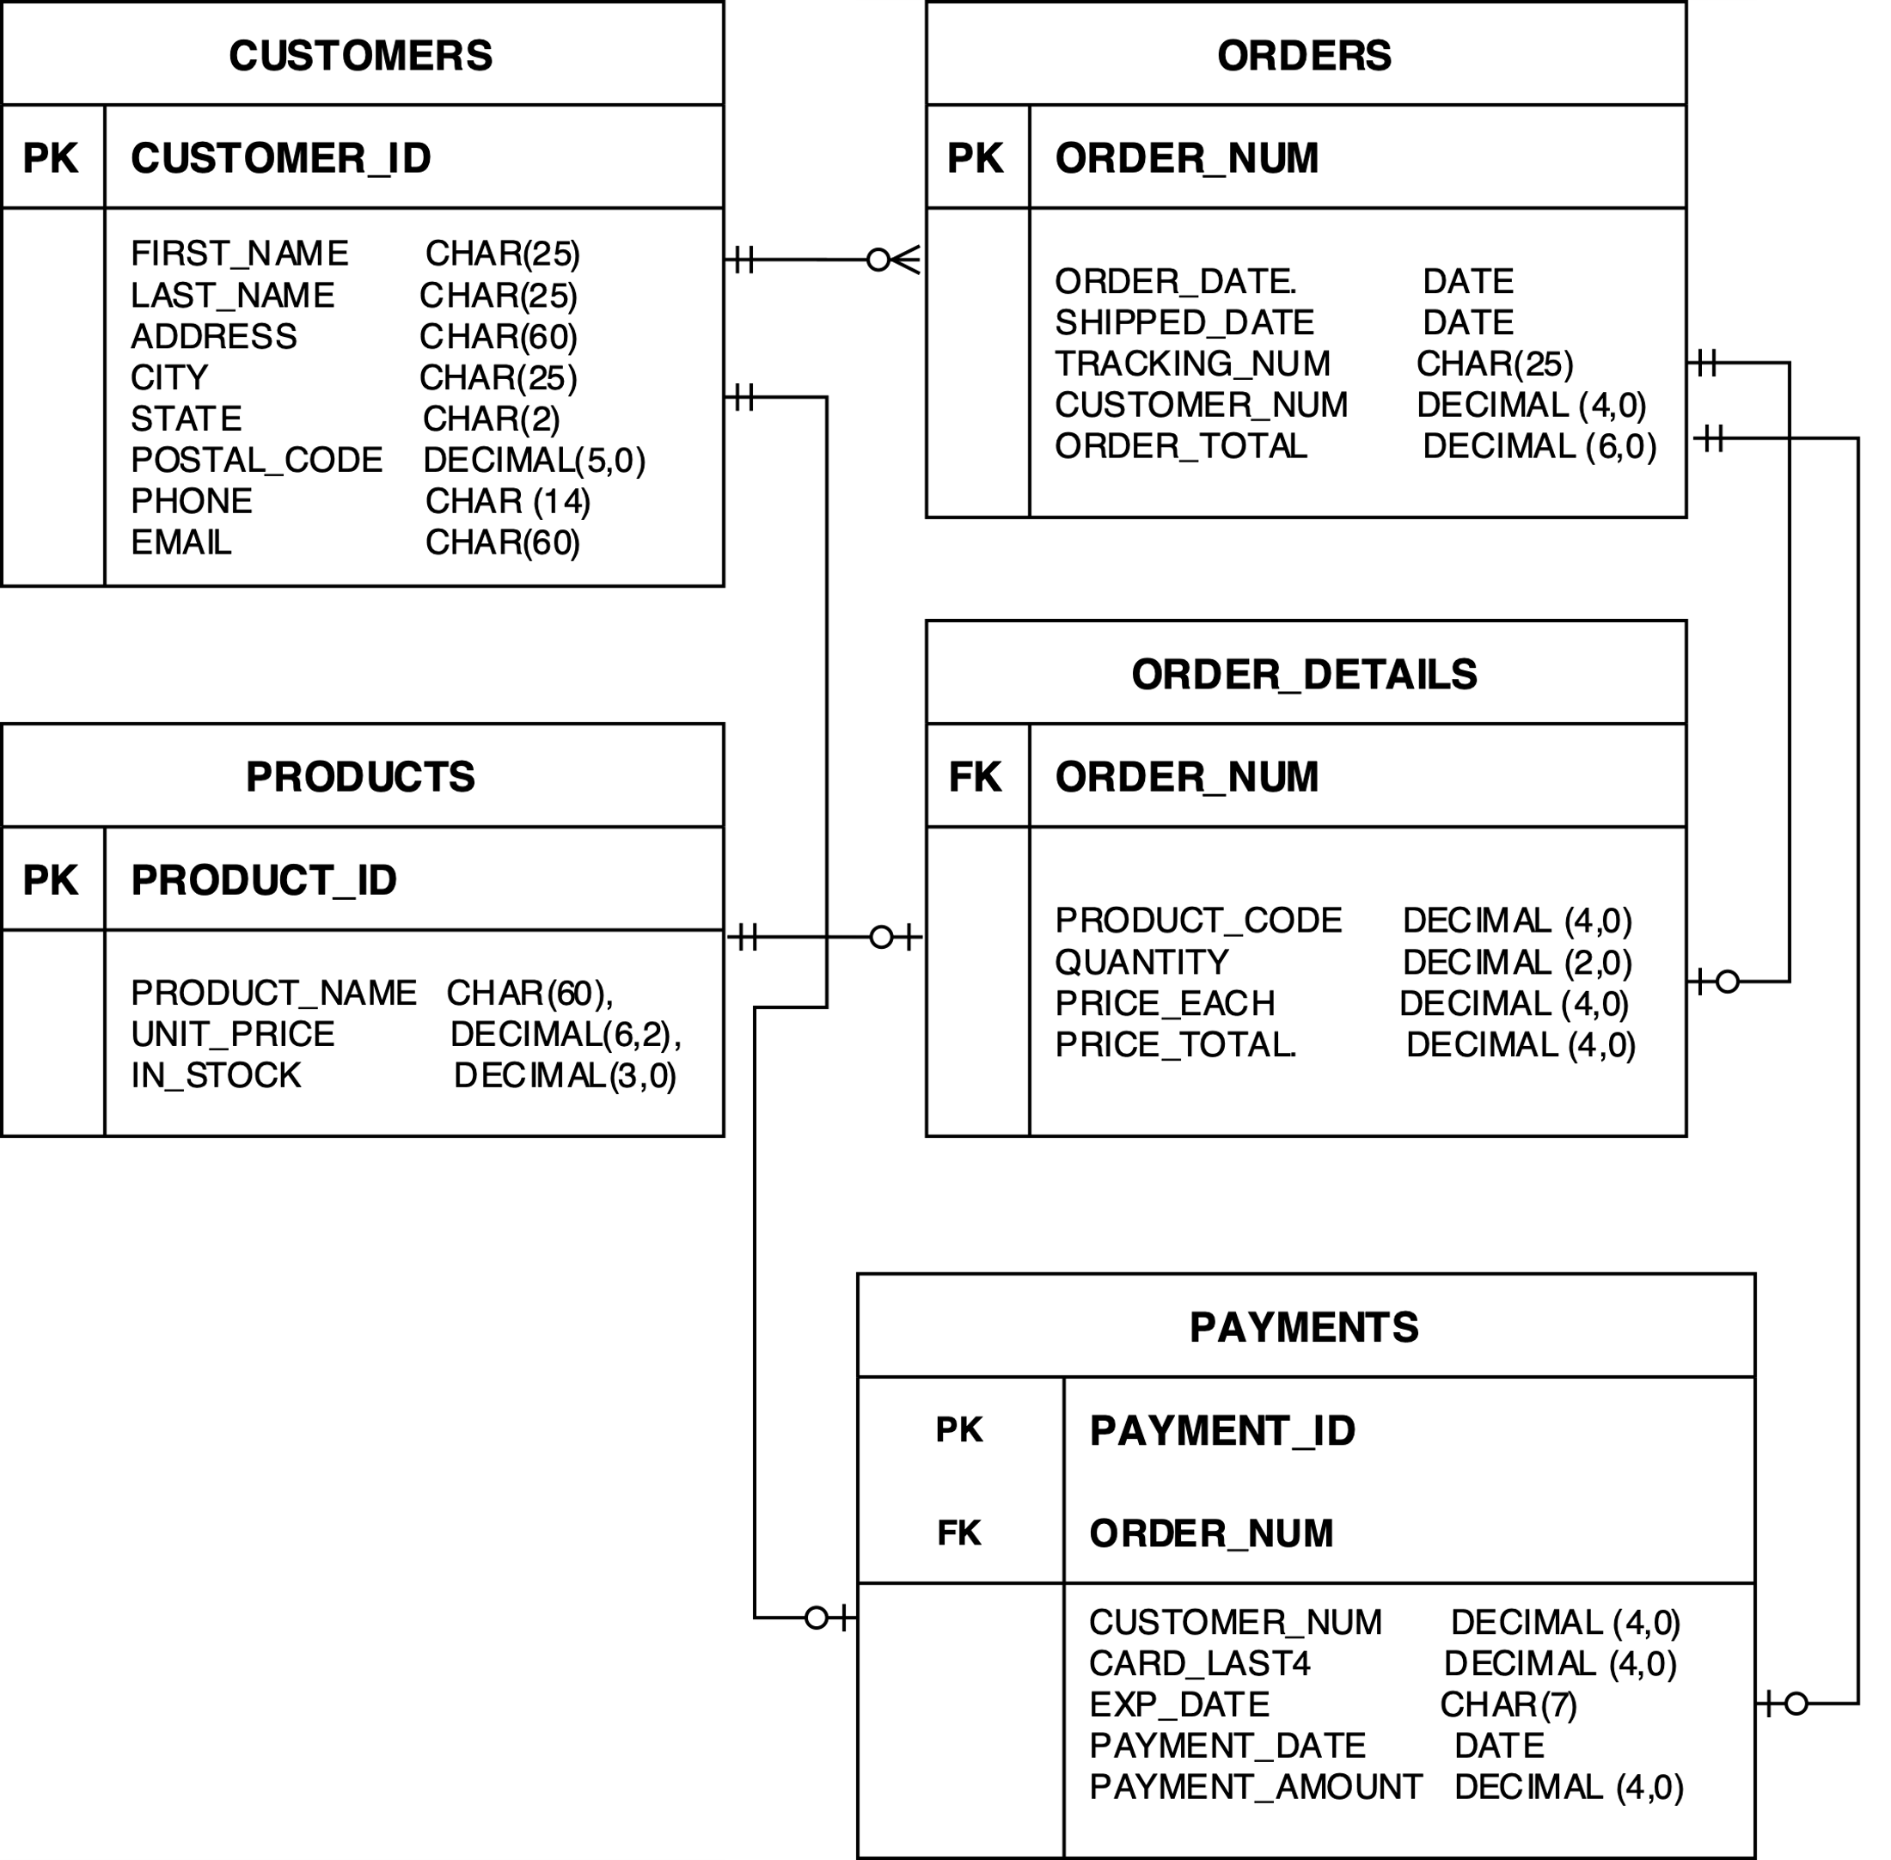

T-SQL Statements

/* ADD A NEW CUSTOMER - usp_INSERT_ CUSTOMER*/

CREATE PROCEDURE usp_INSERT_CUSTOMER

@customerid decimal (4),

@firstname char (25),

@lastname char (25),

@address char (60),

@city char (25),

@state char (2),

@postalcode decimal (5),

@phone char (14),

@email char (60)

AS

BEGIN

INSERT INTO CUSTOMERS(CUSTOMER_ID, FIRST_NAME, LAST_NAME, ADDRESS, CITY, STATE, POSTAL_CODE, PHONE, EMAIL)

VALUES (@customerid, @firstname, @lastname, @address, @city, @state, @postalcode, @phone, @email)

END

/* sample use: exec usp_INSERT_CUSTOMER … */

/* ADD A NEW PRODUCT - usp_INSERT_PRODUCT*/

CREATE PROCEDURE usp_INSERT_PRODUCT

@productid decimal (4),

@productname char (60),

@unitprice decimal (6),

@instock decimal (3)

AS

BEGIN

INSERT INTO PRODUCTS(PROD_ID, PROD_NAME, UNIT_PRICE, IN_STOCK)

VALUES (@productid, @productname, @unitprice, @instock)

END

/* sample use: exec usp_INSERT_PRODUCT … */

/* ADD A NEW PRODUCT - usp_INSERT_PAYMENT*/

CREATE PROCEDURE usp_INSERT_PAYMENT

@paymentid decimal (4),

@customernum decimal (4),

@cardlast4 decimal (4),

@expdate char (7),

@paymentdate date

AS

BEGIN

INSERT INTO PAYMENTS(PAYMENT_ID, CUSTOMER_NUM, CARD_LAST4, EXP_DATE, PAYMENT_DATE)

VALUES (@paymentid, @customernum, @cardlast4, @expdate, @paymentdate)

END

/* sample use: exec usp_INSERT_PAYMENT … */

/* DELETE A PRODUCT BY PRODUCT_ID - usp_DELETE_PRODUCT */

CREATE PROCEDURE usp_DELETE_PRODUCT

@productid decimal (4)

AS DELETE

FROM PRODUCTS

WHERE SERVER_ID = @productid

/* sample use: exec usp_DELETE_PRODUCT 1 */

/* DELETE A PRODUCT BY PRODUCT_ID - usp_DELETE_PRODUCT */

CREATE PROCEDURE usp_DELETE_ORDER

@ordernum decimal (4)

AS DELETE

FROM ORDERS, ORDER_DETAILS, PAYMENTS

WHERE ORDER_NUM = @ordernum

/* sample use: exec usp_DELETE_ORDER 1004 */

/* DELETE A CUSTOMER BY CUSTOMER_ID - usp_DELETE_CUSTOMER */

CREATE PROCEDURE usp_DELETE_CUSTOMER

@customerid decimal (4)

AS DELETE

FROM CUSTOMERS

WHERE ORDER_NUM = @customerid

/* sample use: exec usp_DELETE_CUSTOMER 1002 */

/* DELETE A CUSTOMER BY EMAIL - usp_DELETE_CUSTOMER_EMAIL */

CREATE PROCEDURE usp_DELETE_CUSTOMER_EMAIL

@email char (60)

AS DELETE

FROM CUSTOMERS

WHERE EMAIL = @email

/* sample use: exec usp_DELETE_CUSTOMER_EMAIL ‘donniegee@icloud.com’ */

/* UPDATE CUSTOMER EMAIL - usp_UPDATE_CUSTOMER_EMAIL */

CREATE PROCEDURE usp_UPDATE_CUSTOMER_EMAIL

@customerid decimal (4),

@email char (60)

AS

UPDATE CUSTOMERS

SET

EMAIL = @email,

WHERE

CUSTOMER_ID = @customerid

/* sample use: exec usp_UPDATE_CUSTOMER_EMAIL ’new@email.com’… */

/* UPDATE CUSTOMER PHONE - usp_UPDATE_CUSTOMER_PHONE */

CREATE PROCEDURE usp_UPDATE_CUSTOMER_PHONE

@customerid decimal (4),

@phone char (14)

AS

UPDATE CUSTOMERS

SET

PHONE = @phone,

WHERE

CUSTOMER_ID = @customerid

/* sample use: exec usp_UPDATE_CUSTOMER_PHONE ‘555-123-4567’… */

/* UPDATE PRODUCT PRICE - usp_UPDATE_PRODUCT_PRICE */

CREATE PROCEDURE usp_UPDATE_PRODUCT_PRICE

@productid decimal (4),

@price decimal (6)

AS

UPDATE PRODUCTS

SET

UNIT_PRICE = @price,

WHERE

PRODUCT_ID = @productid

/* sample use: exec usp_ UPDATE_PRODUCT_PRICE… */

/* UPDATE PRODUCT QUANTITY - usp_UPDATE_PRODUCT_QUANTITY */

CREATE PROCEDURE usp_UPDATE_PRODUCT_PRICE

@productid decimal (4),

@instock decimal (3)

AS

UPDATE PRODUCTS

SET

IN_STOCK = @instock,

WHERE

PRODUCT_ID = @productid

/* sample use: exec usp_ UPDATE_PRODUCT_QUANTITY… */