**Demo for MainReFramework.xaml:**

**Objective:**

To automate the matching of job skill-sets required by a job position with a list of CVs in either docx and pdf formats and output the best matched CV's file names to a spreadsheet and with hyper-link added so that user can view the best matched CV's content by clicking on their filename.

**Method:**

1. Adopt UiPath REFramework approach using CV files as Transaction Items.

Business Exception will occurred if faling to open CV files to read texts…

2. User to input the skill-set keywords(min 1, max 7) of his choice in Config.xlsx.

3. List of CVs are to be kept in folder “CVs_docx” and/or “CVs_pdf” under Data.

(30 docx CVs and 30 pdf CVs are used for this Demo)

4. Out put files matchOut.xlsx and log file OutputLog.xlsx will be auto created.

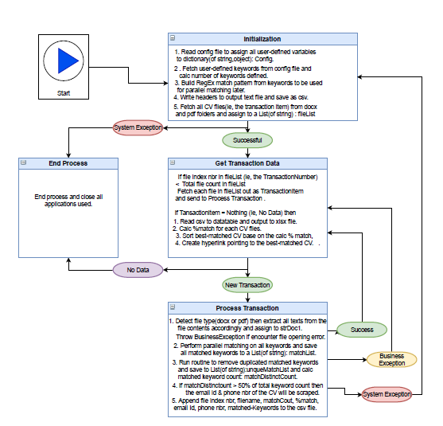

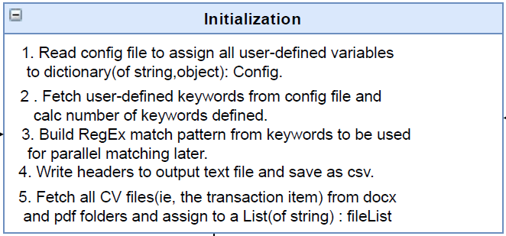

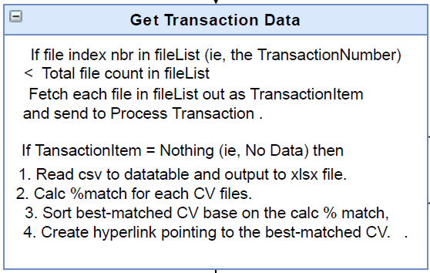

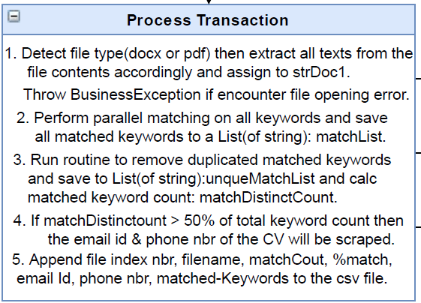

**Demo for Add_hyper_link.xaml:**

**Objective:**

After received best-matched CV names in matchOut.xlsx, user may add more hyper-link over more best-matched CVs besides the top few from the default setting for immediate viewing.

**Approach:**

1. Run the above sub sequence and enter the starting row nbr and the ending row nbr for the range of CV names to be converted to hyper-link.

**Demo for Email_Automation_for_Shortlisted_Candidates.xaml:**

**Objective:**

After having reviewed the contents of best matched CVs by clicking the hyperLinks, user may run this sequence to send interview invitation emails to the shortlisted candidates of his choices.

**Approach:**

1. User only need to add the Candidate’s names, interview date and time onto the same row under column name “Candidate Name”, “Interview Date”, “Interview Time” in the same output spreadsheet.

2. The sequence will fetch these info to update an email template and send it out via the shortlisted candidate email Id one at a time automatically.

3. This demo use Outlook Mail for sending email.

Thank You.