**Demo for MainReFramework.xaml:**

**Objective:**

To automate the matching of job skill-sets required by a job position with a list of CVs in either docx and pdf formats and output the best matched CV's file names to a spreadsheet and with hyper-link added so that user can view the best matched CV's content by clicking on their filename.

**Method:**

1. Adopt UiPath REFramework approach using CV files as Transaction Items.

Business Exception will occurred if faling to open CV files to read texts…

2. User to input the skill-set keywords(min 1, max 7) of his choice in Config.xlsx.

3. List of CVs are to be kept in folder “CVs_docx” and/or “CVs_pdf” under Data.

(30 docx CVs and 30 pdf CVs are used for this Demo)

4. Out put files matchOut.xlsx and log file OutputLog.xlsx will be auto created.

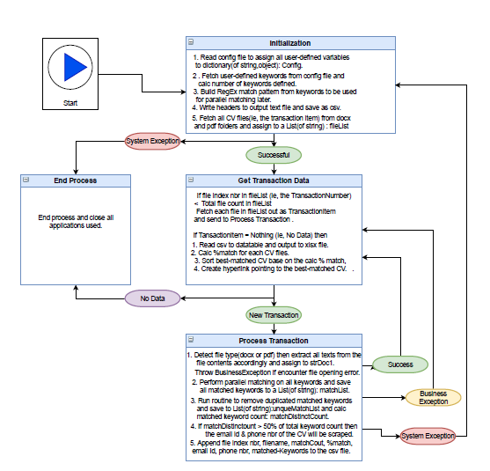

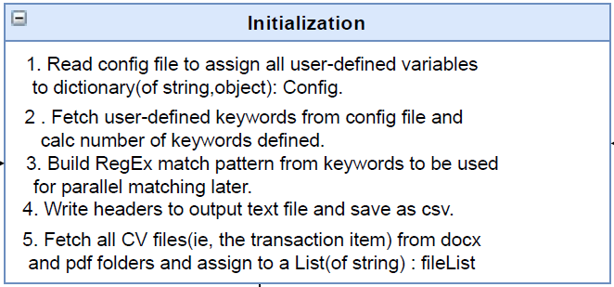

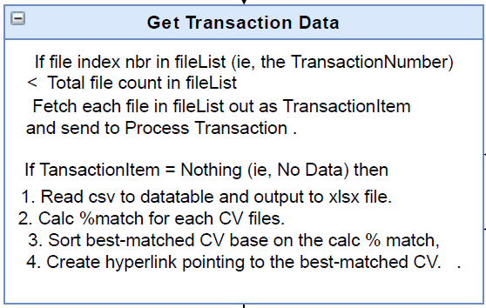

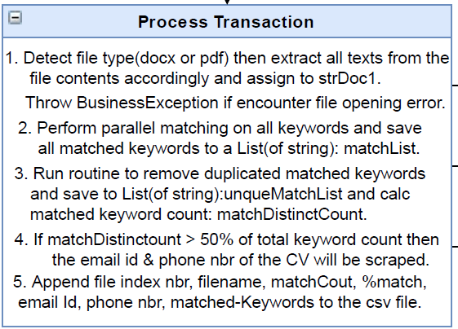

**Demo for Add_hyper_link.xaml:**

**Objective:**

After received best-matched CV names in matchOut.xlsx, user may add more hyper-link over more best-matched CVs in addition for the existing ones for immediate viewing.

**Approach:**

1. Run the above sub sequence and enter the starting row index nbr and the ending row index nbr. The CV names within the range will be converted to hyper-link.

**Demo for Email_Automation_for_Shortlisted_Candidates.xaml:**

**Objective:**

After having reviewed the contents of best matched CVs (by clicking on the hyperLinks), user may run this sub sequence to automate the sending of interview invitation emails to a list of shortlisted candidates of his choices

**Approach:**

1. User only need to fill in the Candidate’s names, interview date and time in the same row under column name “Candidate Name”, “Interview Date”, “Interview Time” on the same output spreadsheet.

2. The sequence will fetch these info to update an email template and send it out via the candidate’s email Id one at a time automatically.

3. This demo use Outlook Mail as example for sending email.

Demo on ReadPDFtoChangeFileName.xaml:

Objective:

Renaming all the pdf resumes from number-based filenames to email-id based filenames minus the suffix “@domain.com”.

Before executing the UiPath program:

Folder pdf_orig contains 3110 CV files with number-based filename to be converted.

After the execution:

Folder pdf_renamed will be auto created to save all successfully renamed pdf files.

Folder pdf_badfile will be auto created to save problematic pdf files.

Folder pdf_orig will be emptied.

Problemic pdf files refer to: (x denotes the original number-based filename)

1. File opening error => renamed to BadPdf_x.pdf

2. No email id or invalid email id => renamed to NoEmail_x.pdf

Converting 3000 files would take about 5mins to complete.

Thank You.