Que 1. Command for searching pattern line by line in any document with an example.
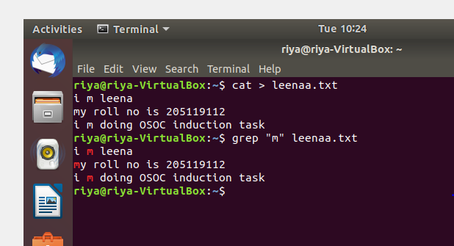

Que 3. Create a folder OSOC and inside that another folder Inductions and now create a file task.txt inside Inductions with some content now copy this file into another folder Workshop in OSOC.
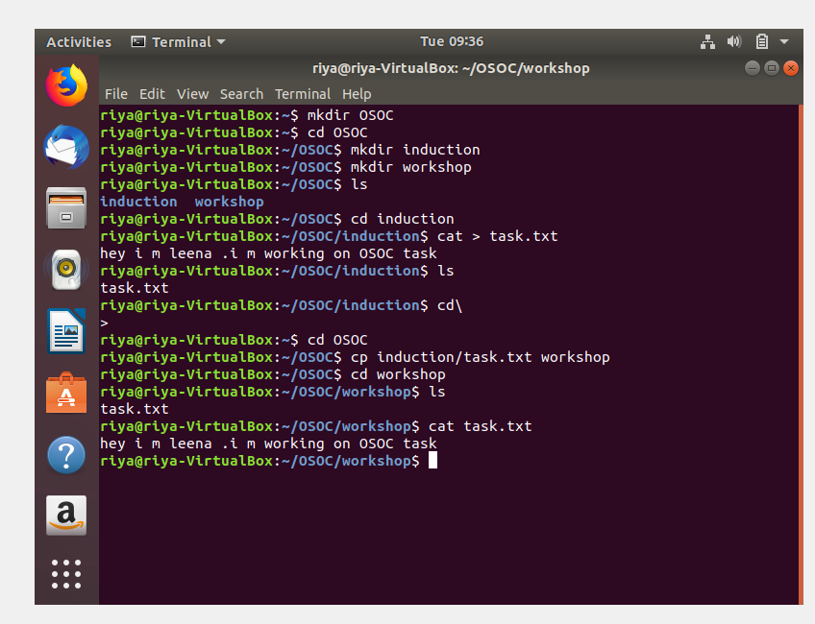

4. I want to check whether my system is connected to any network or not, please suggest appropriate command for this.
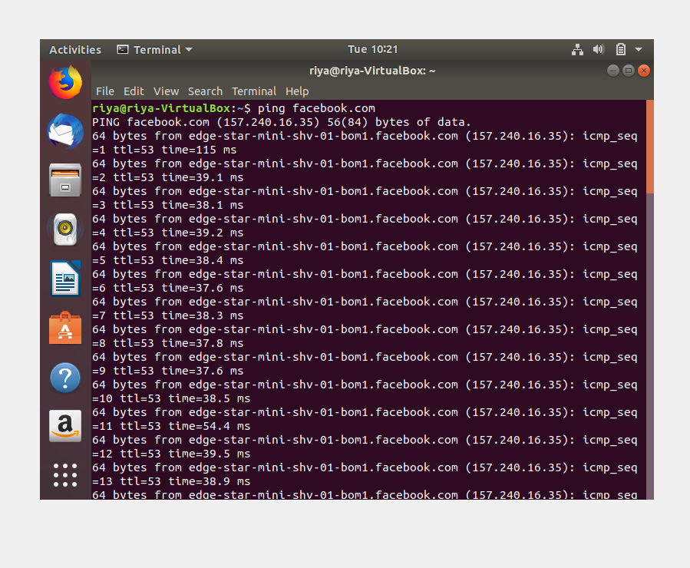

5. I want to change password of another user how will I do that?
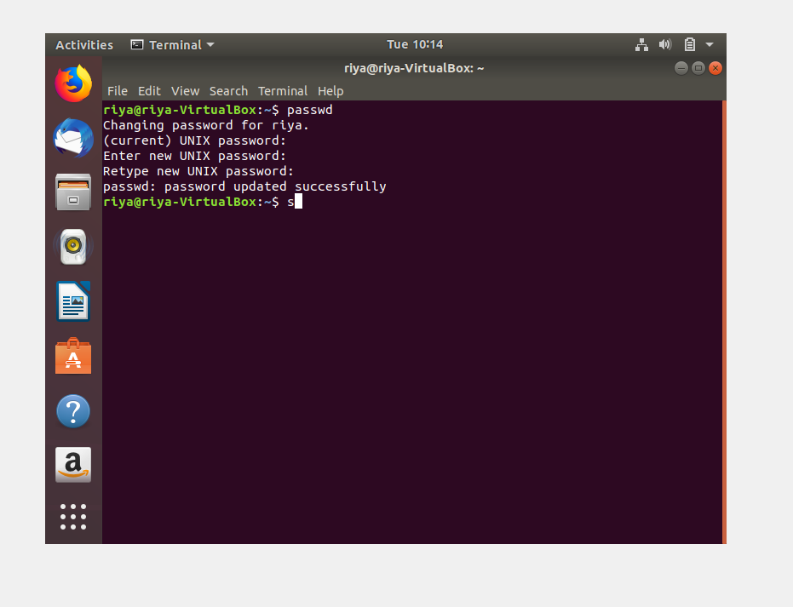

6. Using shell scripting write program for sort an Array. Input should be taken from user.
