Topics to be included in Report

1. INTRODUCTION

1.1. Purpose

1.2. Scope

1.3. Objectives
1.4. Methodologies

2. ANALYSIS

2.1. INTRODUCTION

2.1.1. Project Overview

2.2. DATA FLOW DIAGRAM(S)

2.3. SPECIFIC REQUIREMENTS

2.4. EXTERNAL INTERFACE REQUIREMENTS
o User Interfaces
Create a user manual with all user commands, screen formats etc. For
example, if display terminal is used, specify required screen format, menus, and
report layouts, function keys etc.

o Hardware Interfaces
SRS should specify the logical characteristics of each interface between software
product and the hardware component. The current use and load characteristics of the hardware should be given.

2.5 DATABASE REQUIREMENT(S)

3. DESIGN

3.1. INTRODUCTION

The purpose of the design phase is to plan a solution of the problem specified by the requirement documents. This phase is the first step in moving from the problem domain to the solution domain. The output of this phase is the design document, which will act as a blue print for the solution and is used later during implementation, testing and maintenance.
The design activity is divided into three separate phases: Conceptual Data Modeling, Logical
Data Base Design, and Physical Data Base Design.
  - Conceptual Data Modeling analyzes the overall data requirement of the proposed information system.
  - Logical Data Base Design transform the conceptual data model into a standard relation called relation based on relational database theory and a process called Normalization.
  - In Physical Data Base Design and Definition, one decides on the organization of the database in computer storage (usually disk) and defines the physical structure of data base management system.
3.2. ENTITY-RELATIONSHIP MODEL

3.3. PHYSICAL DATABASE DESIGN

4. SOFTWARE DEVELOPMENT METHODOLOGY

5. SYSTEM TESTING
1. INTRODUCTION
1.1 System Overview
1.2 Test Approach
2. TEST PLAN
2.1 Features to be tested
2.2 Features not to be tested
3. TEST CASES

6. OUTPUT FORMS & REPORTS

7. CONCLUSION

8. FUTURE ENHANCEMENT(S)

BIBLIOGRAPHY
APPENDICES

1. INTRODUCTION

An employment website is a web site that deals specifically with employment or careers. Many employment websites are designed to allow employers to post job requirements for a position to be filled and are commonly known as job boards. Other employment sites offer employer reviews, career and job-search advice, and describe different job descriptions or employers. Through a job website a prospective employee can locate and fill out a job application or submit resumes over the Internet for the advertised position.
Most items could be of interest to people in various roles and conditions including those considering career options, job seekers, employers and employees.

Although many sites that provide access to job advertisements include pages with advice about writing résumés and CVs, performing well in interviews,

other topics of interest to job seekers there are sites that specialise in providing information of this kind, rather than job opportunities. One such is Working in Canada. It does provide links to the Canadian Job Bank.

Job Portal is the software aimed at providing a wide range of access to the administrator in managing and monitoring the requirment registered by the Job seeker regarding the problems they face in accessing the connections extended by the Job Portal.

The Center can even maintain the record of the Job Seeker in the organization in allocating the unique id no. to the Job Seeker. This intranet-based application provides the Job Seeker of the system a centralized view of the things maintained in the software depending on the privileges assigned by the administrator accordingly. In this, there are admin who solve problems which have posted by the Job Seeker .

Scope
- User friendly interface.
- A central database holds the key to system.
- All forms are html templates driven
- Integration among all functional areas.
- The availability of the information is easy.
- Routine tasks are easily performed.
- It automates the redundant tasks.
- It is cost effective.

OBJECTIVE OF THE PROJECT

The aim of this project i.e. Job Portal is all about a Organisation system and this system take the resume from job seeker and company retrieve that job seeker’s resume and response it to job seeker as soon as possible.The extra feature involved in our check features. It is secured in a way that only registred job seeker can access this system.

Main Objectives are :-
- The Job Portal is meant to keep the security of the company and between the job seeker.
- A job seeker can easily view the status of His resume.
- A job seeker can post the resume.
- Company can view the job seeker’s resume .
- Company can add new Jobs details .
- The main concern of this project is to improve the efficiency and effectiveness of the whole system.

We combine the best people, processes and technology to achieve excellent results — consistently. We offer patient the advantages of:
Speed: We understand the importance of timing, of getting there before the competition. A rich portfolio of reusable, modular frameworks helps jump-start projects. Tried and tested methodology ensures that we follow a predictable, low-risk path to achieve results. Our track record is testimony to complex projects delivered within and even before schedule.

Expertise: Our teams combine cutting edge technology skills with rich domain expertise. What's equally important — we share a strong Student orientation that means we actually start by listening to the Student. We're focused on coming up with solutions that serve Student requirements today and anticipate future needs.
A Full Service Portfolio: We offer Customer the advantage of being able to Architect, Integrate and Manage technology services. This means that they can rely on one, fully accountable source instead of trying to integrated University Portal System multi-specialty packages solutions.

Project Modules
Different Modules In Computerized System

Module 1: Password Module
In this module, Member enters a password and the software checks its validity. If the password is valid then he is allowed to enter, otherwise “Invalid User/Password” message is displayed. Different data access rights are assigned to different users. A new member can also be registered in this module.

Module 2: New Job Seeker Registration Module
In this module new user can submit his personal details regarding the user’s email id, password, contact no, date of birth etc.

Module 3 Vacancy Module
In this module admin can upload the job information with full description .
Module 4: Job Seeker list Module
In this module, Admin can view the Job Seeker list. It is the details of registered user like name ,email id, contact no and country etc.

Module 5: Job Apply Module
In this module, Job Seeker can view the job list according to his categrory and after that he can apply for it and this information is viewed by admin.

2. SYSTEM ANALYSIS

INTRODUCTION

System Analysis is first stage according to System Development Life Cycle model. This System Analysis is a process that starts with the analyst.
Analysis is a detailed study of the various operations performed by a system and their relationships within and outside the system. One aspect of analysis is defining the boundaries of the system and determining whether or not a candidate should consider other related systems. During analysis, data is collected from the available files, decision points, and transactions handled by the present system.

Logical system models and tools are used in analysis. Training, experience, and common sense are required for collection of the information needed to do the analysis.

REQURIEMENTS ANALYSIS

The requirement phase basically consists of three activities:

1. Requirement Analysis
2. Requirement Specification
3. Requirement Validation

Requirement Analysis:

Requirement Analysis is a software engineering task that bridges the gap between system level software allocation and software design. It provides the system engineer to specify software function and performance indicate software’s interface with the other system elements and establish constraints that software must meet.

The basic aim of this stage is to obtain a clear picture of the needs and requirements of the end-user and also the organization. Analysis involves interaction between the clients and the analysis. Usually analysts research a problem from any questions asked and reading existing documents. The analysts have to uncover the real needs of the user even if they don’t know them clearly. During analysis it is essential that a complete and consistent set of specifications emerge for the system. Here it is essential to resolve the contradictions that could emerge from information got from various parties.

This is essential to ensure that the final specifications are consistent.
It may be divided into 5 areas of effort.
1. Problem recognition
2. Evaluation and synthesis
3. Modeling
4. Specification

Review

Each Requirement analysis method has a unique point of view. However all analysis methods are related by a set of operational principles. They are:
1. The information domain of the problem must be represented and understood.

2. The functions that the software is to perform must be defined.

3. The behavior of the software as a consequence of external events must be defined.

4. The models that depict information function and behavior must be partitioned in a hierarchical or layered fashion.

5. The analysis Job Portal process must move from essential information to implementation detail.

REQUIREMENT SPECIFICATION

Specification Principles:

Software Requirements Specification plays an important role in creating quality software solutions. Specification is basically a representation process. Requirements are represented in a manner that ultimately leads to successful software implementation.
Requirements may be specified in a variety of ways. However there are some guidelines worth following: -
- Representation format and content should be relevant to the problem
- Information contained within the specification should be nested
- Diagrams and other notational forms should be restricted in number and consistent in use.
- Representations should be revisable.

Software Requirements Specifications:

The software requirements specification Job Portal produced at the culmination of the analysis task. The function and performance allocated to the software as a part of system engineering are refined by establishing a complete information description, a detailed functional and behavioral description, and indication of performance requirements and design constraints, appropriate validation criteria and other data pertinent to requirements.
An outline of the Software Requirements Specification:
A simplified outline can be given for the framework of the specifications. This is according to the IEEE Standards.
FEASIBILITY STUDY

All projects are feasible, given unlimited resources and infinite time. But the development of software Job Portal plagued by the scarcity of resources and difficult delivery rates. It is both necessary and prudent to evaluate the feasibility of a project at the earliest possible time.
Three key considerations are involved in the feasibility analysis.

Economic Feasibility:

The Job Portal procedure is to determine the benefits and savings that are expected from a candidate system and compare them with costs. If benefits outweigh costs, then the decision is made to design and implement the system. Otherwise, further justification or alterations in proposed system will have to be made if it is to have a chance of being approved. This is an ongoing effort that improves in accuracy at each phase of the system life cycle.

Technical Feasibility:

Technical feasibility centers on the existing computer system (hardware, software, etc.,) and to what extent it can support the proposed addition. If the budget is a serious constraint, then the project is judged not feasible.

Operational Feasibility:

People are inherently resistant to change, and computers have been known to facilitate change. It is understandable that the introduction of a candidate system requires special effort to educate, sell, and train the staff on new ways of conducting business.

FEASIBILITY STUDY IN THE CYBER SPACE ROJECT

Technical Feasibility
Job Portal is the product that is designed mainly on PHP. The main reason behind choosing the PHP environment is that, as the users. In order to post the queries to related Organization always require Input screen which usually provides services all around the time. Such environment that always gives instant reply to the users should support input screen. These requirements are satisfied by PHP, as it is multi platform environment supports web Browser where as other languages lack these features.

In order user to continuously communicate he/she needs a reliable protocol i.e., is TCP/IP protocol. The Job Portal protocol frequently transfers messages between client and user. Communication Standards such as HTTP is used .An HTTP is a client/server interaction consists of a single request/reply interchange, it user-friendly environment.

Economic Feasibility
As Job Portal which provides continuous communication to users at the front end, provides solutions to different queries to various different problems as get from the use of different product. And the solutions for their queries are sent to them by messaging to their sites within the expiry time or the time mentioned i.e., within 12hrs or 24hrs.

Operational Feasibility
Operations done in the Job Portal are very fast and are able to succeed in sending the responses very fastly. Updating is done very quickly that the modified data is stored in the database in no time. Its supports up to five hundred simultaneously users against the central database at any given time.
- Home:-
In this sub-module project demonstration and overview of our projects
- About the Project
In this sub-module we are try to demonstrate our project.
- Contact us
In this sub-module we give the list of who is make project under the guidance.

DATAFLOW DIAGRAMS
LEVEL 0
Initially in the first level of the Data flow the level 0 explains the basic outline of the system. The end-user sends the packets to the system to determine the source and destination address. The diagram marked as the 0 represents the complete Packet watching system which simply represents the basic operation that is being performed by it in the initial level.
LEVEL 1
The level 1 of the Data flow diagram given explains in detail about the Packet watching system which was marked as 0 in the previous level. In this level the end-user who passes the request for the system enters into the first process, the capturing process and then to the processing module. After processing the packets it was send for storing.

LEVEL 2
The level 2 provides the clear explanation about the whole system. In this level first we have to select the packet and perform test over that selected packets. Then identify the end address of the packet and send that packet for processing. After processing the packet it was send to the identity content. Then send the processed packet for storing and display the source and destination addresses.

DATA FLOW DIAGRAMS

Context Level DFD

USER

Job Portal
REPORT
Administrator
Enters or update users data
Administrate the entire process
Generates the entire processes reports
First level (Job Seeker Module)

Pwd, Customername Updated Successfully
Logout

Job Seeker
1.0
Login process
2.0
View Personal Details
3.0
Apply Job
4.0
Search Job

If post the problem

First level (Employee Module)

Pwd, Customername Updated Successfully
Logout

Employee
1.0
Login process
2.0
View Application Form
3.0
Post Vacancy
4.0
User LIst

If post the problem

E-R Diagram
Discription

Phone
Address
rid
Name
Post
Job Seeker
Resume

Name
Cname
Date

Worksunder
Has
Response
Apply

vid

Experiance
Post
date
Employee
Vacancy
username
EmployeeDetails

SPECIFIC REQUIREMENTS

Hard ware Specification:

Processor : Intel P-III based system

Processor Speed : 250 MHz to 833MHz

RAM : 64MB to 256MB

Hard Disk : 2GB to 30GB

Software Specification:

Language : PHP

Database : My Sql 5.0

Operating System : Any Operating System.

DATABASE REQUIREMENT(S)

- User login
Fields | Data Type | Size | Constraints
login_id | Varchar2 | 10 | Primary key
Password | Varchar2 | 10 | Not null

- Job
Fields | Data Type | Size | Constraints
ID | Varchar2 | 10 | Foreign key
Job Name | Varchar2 | 10 | Not null
Discription | Varchar2 | 200 | Not null
Date | Varchar2 | 200 | Not null
Experience | Varchar2 | 200 | Not null
Qualification | Varchar2 | 200 | Not null

- Admin login
Fields | Data Type | Size | Constraints
login_id | Varchar2 | 10 | Not null
Password | Varchar2 | 10 | Not null

- Apply Job
Fields | Data Type | Size | Constraints
Id | Number | 10 | Primary key
Job Name | Varchar2 | 20 | Not null
Discription | Varchar2 | 10 | Not null
Exepriance | Varchar2 | 30 | Not null
Qualification | Varchar2 | 20 | Not null
Name | Varchar2 | 100 | Not null
Date | Varchar2 | 100 | Not null
Job Categrory | Varchar2 | 100 | Not null
- User Account Details
Fields | Data Type | Size | Constraints
User_id | Varchar2 | 10 | Foreign key
User_name | Varchar2 | 20 | Primary key
Password | Varchar2 | 20 | Not null
Name | Varchar2 | 30 | Not null
Gender | Varchar2 | 10 | Not null
Dob | Date
Mob no | Varchar2 | 10
Address | Varchar2 | 20

DESIGN

SOFTWARE DEVELOPMENT METHODOLOGY

LIFE CYCLE MODELS

The stage of planning and development process involves defining, developing, testing, delivering, operating, and maintaining a software product. Different lifecycle models emphasize different aspects and no single lifecycle model is suitable for all software products. A lifecycle model that is understood and accepted improves project communication and enhances project manageability, resource allocation, cost control, and product quality.

The Phased Life Cycle Model

The phased lifecycle model represents software lifecycle as a series of successive activities. The Employee Management Systemhas requires well-defined input information, processes and results in well-defined products. The phased lifecycle model consists of following phases.
Analysis, Design, Implementation, System Testing and Maintenance

This model is sometimes called the Waterfall Model, the products cascade from one level to another in smooth progression.
Analysis | Design | Implementation | System Testing | Maintenance
Planning,  User needs  Definition | Design  Details | Code, debug and Test | Integration & Acceptance | Enhance, Fix Adapt

The Analysis Stage consists of Planning and Requirements definition.
A feasibility study, developing a recommended solution strategy, determining the acceptance criteria and planning development process. The products of planning are a System definition and a project plan.

The Software Design follows analysis. Design is concerned with its software components, specifying relationships among components specifying some structure, maintaining a record of design decisions and providing blueprint implementation phase. Design consists of detailed design and Architectural design.

The implementation phase of software development involves translation of design specification into source code, and debugging, documenting and unit testing the source code. To enhance the quality of the software the methods are structured control constructs, built in and user defined data types, secure type checking, flexible scope rules exception handling mechanism, concurrency constructs and separates compilation modules.

System Testing involves two kinds of testing integration testing and acceptance testing. Developing a strategy for integrating the components of a software system into a functioning requires careful planning so that modules are available for integration when needed. Acceptance testing involves planning and execution of various tests in order to demonstrate that the implemented system satisfies the requirement document.

The Maintenance phase comes after the acceptance of the product by the customer and release of the system for production work. Maintenance activities include enhancements of capabilities, adaptation of software to new processing environments, and correction of software bugs. The Employee Management Systemproject follows the Phased Life Cycle Model or the Water Fall model to a large extent.

The analysis stage consisted of listening to the needs and requirements of the examination department obtaining the required format of the system as desired by them, taking the required data to be stored for future use etc., In the design stage the structure of the system was designed and all the required

Screens were formatted. This was then shown to the officer’s approval and the system was built. Implementation phase was done at PRITHVI INFORMATICS as they provided a computer with all the required software and with required configuration. The coding and debugging was done. Even after this stage certain changes were made as requested by the guide.
The testing was done to check for any errors or bugs or unwanted behavior in the system. Individual modules as well as the whole system were tested separately.
SOFTWARE TESTING

Software Testing is a critical element of software quality assurance and represents the ultimate review of specification, design and coding, Testing presents an interesting anomaly for the software engineer.

Testing Objectives include:

- Testing is a process of executing a program with the intent of finding an error
- A good test case is one that has a probability of finding an as yet undiscovered error
- A successful test is one that uncovers an undiscovered error

Testing Principles:

- All tests should be traceable to end user requirements
- Tests should be planned long before testing begins
- Testing should begin on a small scale and progress towards testing in large
- Exhaustive testing is not possible
- To be most effective testing should be conducted by a independent third party

TESTING STRATEGIES

A Strategy for software testing integrates software test cases into a series of well planned steps that result in the successful construction of software. Software testing is a broader topic for what is referred to as Verification and Validation. Verification refers to the set of activities that ensure that the software correctly implements a specific function. Validation refers he set of activities that ensure that the software that has been built is traceable to customer’s requirements

Unit Testing:

Unit testing focuses verification effort on the smallest unit of software design that is the module. Using procedural design description as a guide, important control paths are tested to uncover errors within the boundaries of the module. The unit test is normally white box testing oriented and the step can be conducted in parallel for multiple modules.

Integration Testing:

Integration testing is a systematic technique for constructing the program structure, while conducting test to uncover errors associated with the interface. The objective is to take unit tested methods and build a program structure that has been dictated by design.

Top-down Integration:

Top down integrations is an incremental approach for construction of program structure. Modules are integrated by moving downward through the control hierarchy, beginning with the main control program. Modules subordinate to the main program are incorporated in the structure either in the breath-first or depth-first manner.

Bottom-up Integration:

This method as the name suggests, begins construction and testing with atomic modules i.e., modules at the lowest level. Because the modules are integrated in the bottom up manner the processing required for the modules subordinate to a given level is always available and the need for stubs is eliminated.

Validation Testing:
At the end of integration testing software is completely assembled as a package. Validation testing is the next stage, which can be defined as successful when the software functions in the manner reasonably expected by the customer. Reasonable expectations are those defined in the software requirements specifications. Information contained in those sections form a basis for validation testing approach.
System Testing:
System testing is actually a series of different tests whose primary purpose is to fully exercise the computer-based system. Although each test has a different purpose, all work to verify that all system elements have been properly integrated to perform allocated functions.

Security Testing:
Attempts to verify the protection mechanisms built into the system.

Performance Testing:
This method is designed to test runtime performance of software within the context of an integrated system.

6. OUTPUT FORMS & REPORTS

Home Page



Job List
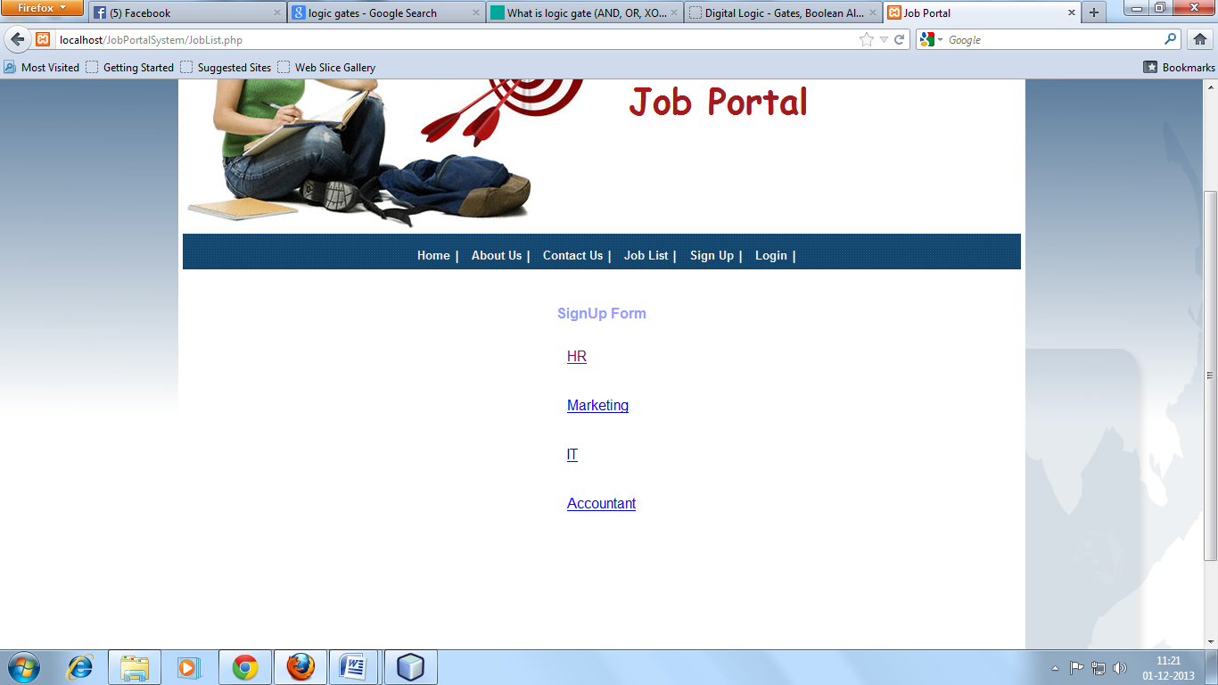

APPLY HERE
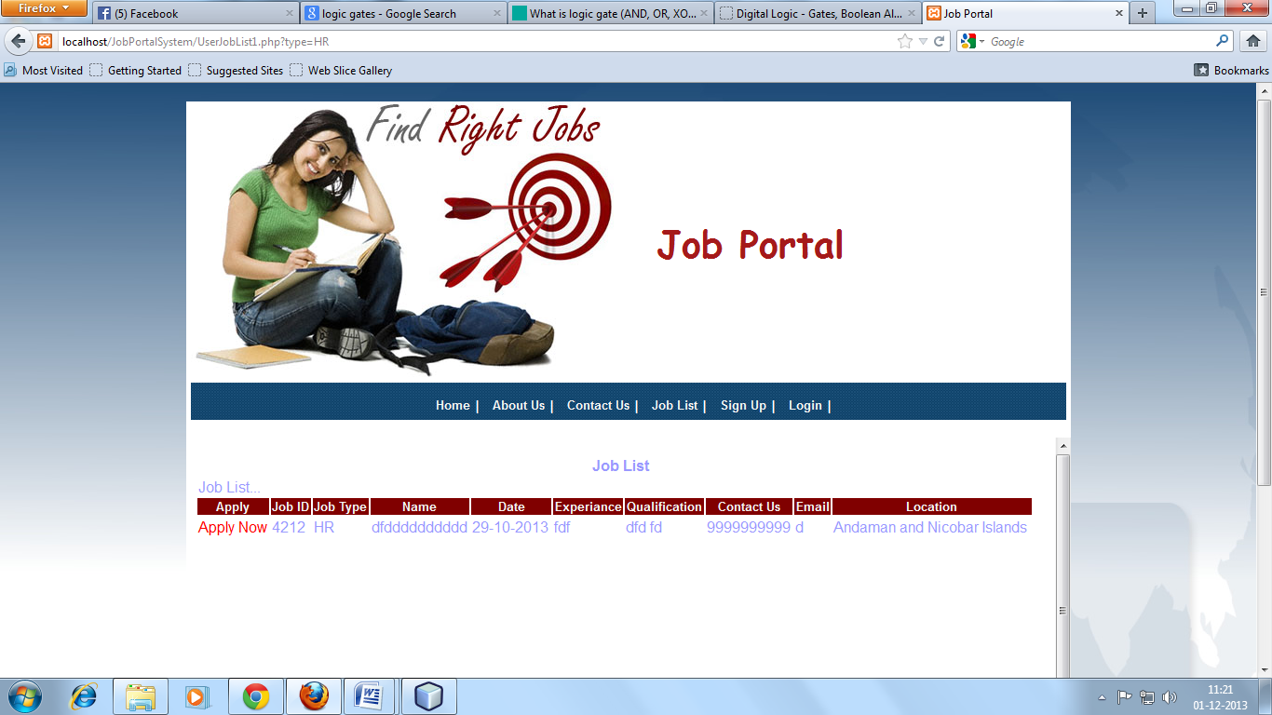

REGISTRATION
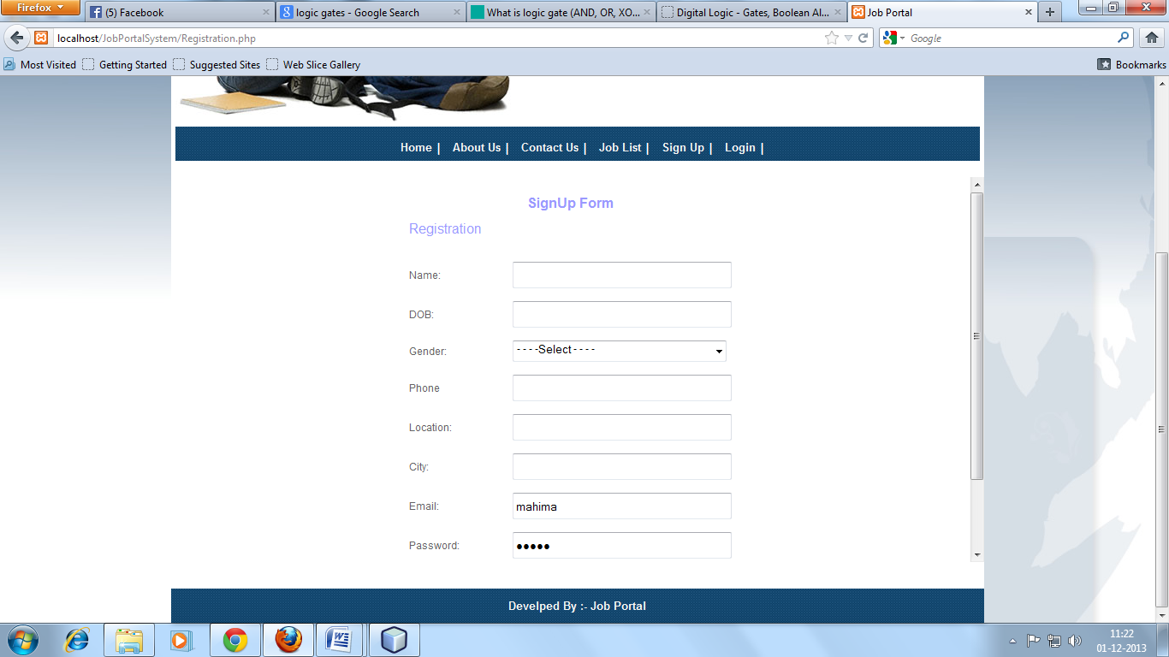

LOGIN PAGE
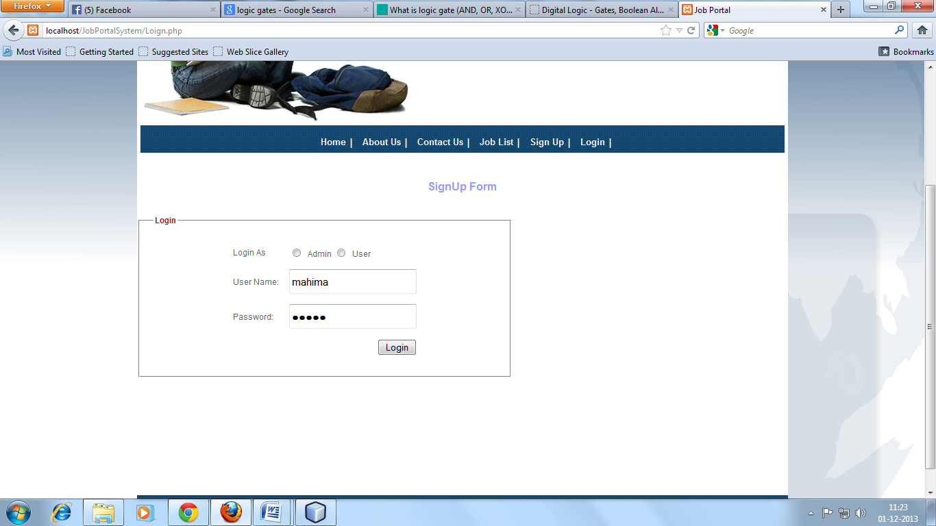

JOB SEEKER HOME PAGE
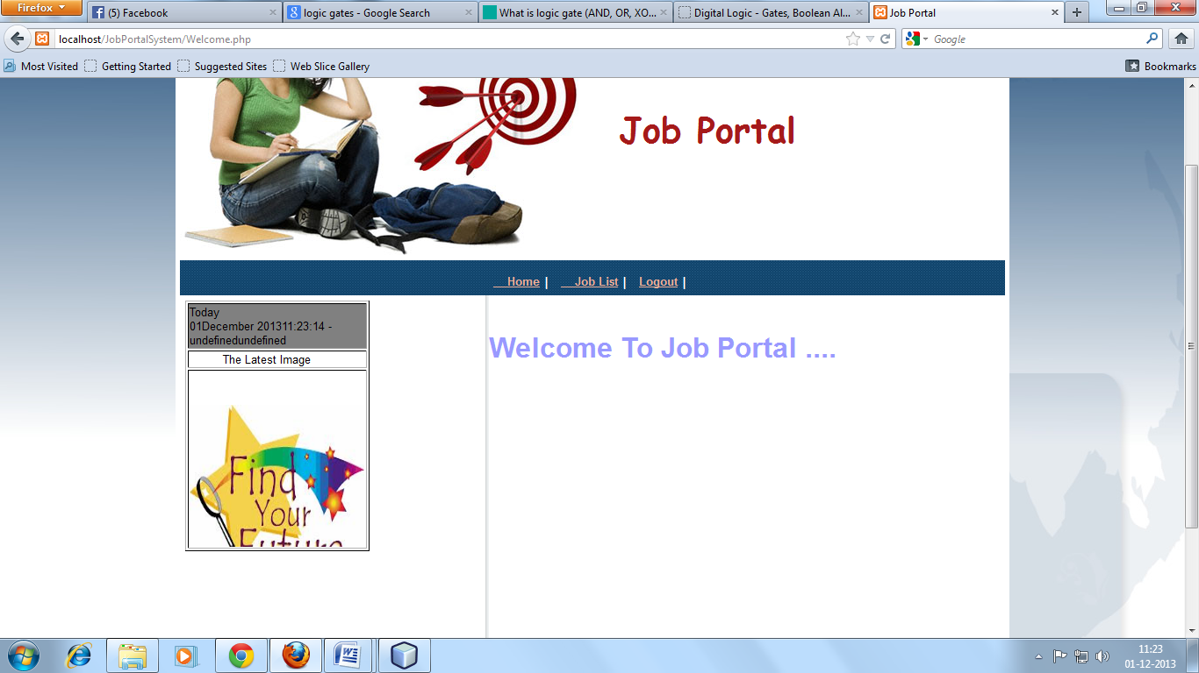

APPLY PAGE
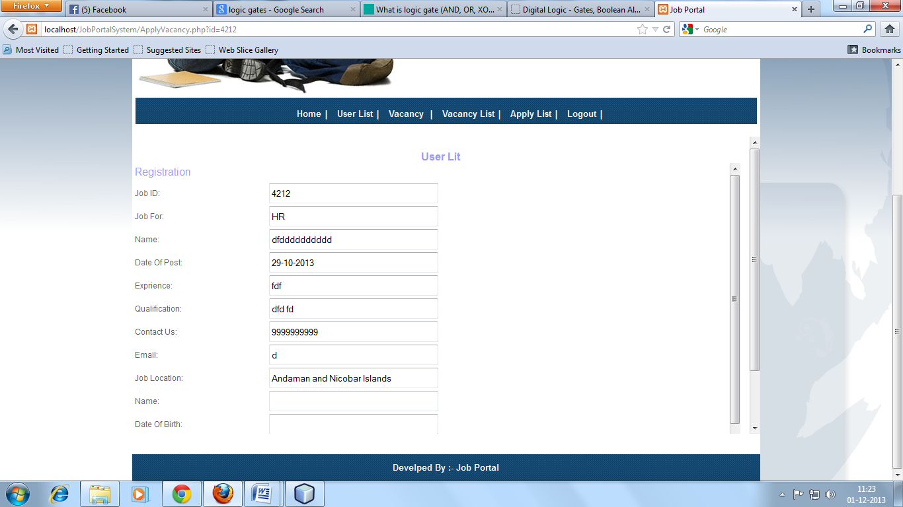

ADMIN HOME PAGE
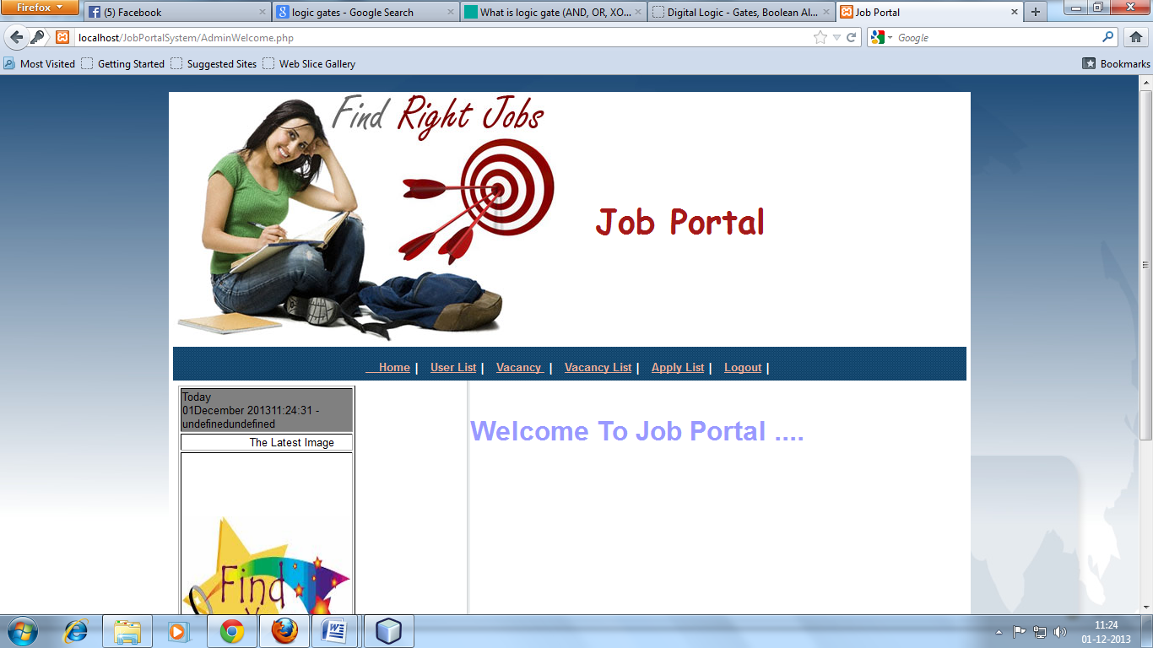

JOB SEEKER LIST
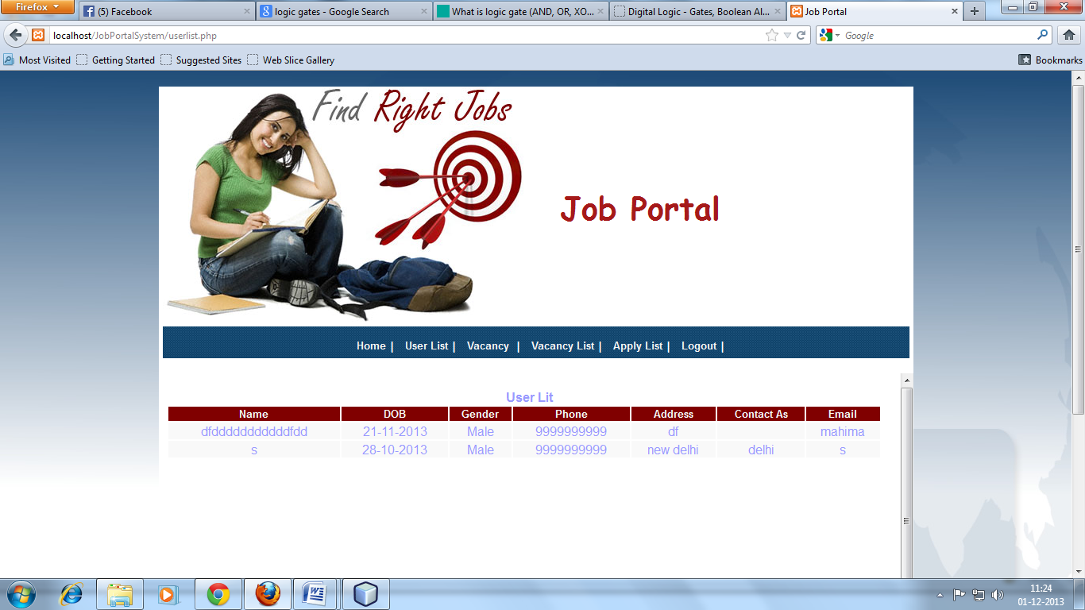

VACANCY PAGE
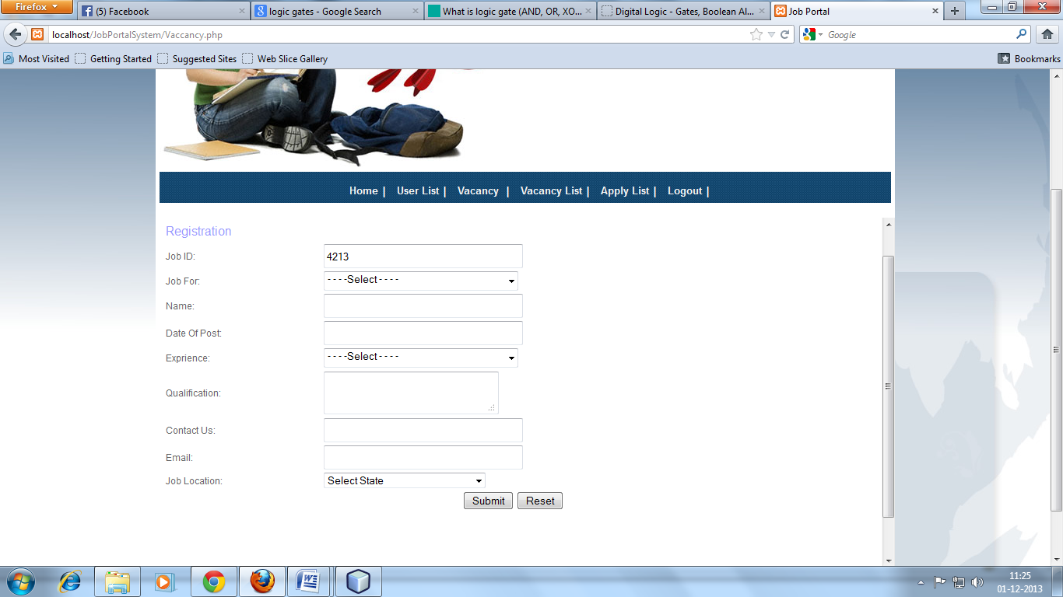

- CONCLUSION

The result of the Job Portal is that it supports many type of different-different resume of individual job seeker or the end- job seeker with unique interface, through which the job seeker’s resume problems are solved within given time and it shows efficiency in the internal messaging system and results in accurate task scheduling system and this can be run with the minimal administration. We can also have one more module of implementing this project on web.

FUTURE ENHANCEMENT(S)

The Job Portal system for the manage process can be further developed into a separate, automated system with the following enhancements:
- Help file can be included. The system, as of now, does not support any help facility for the users of the system. A help menu can be provided with a special function key and help command in the main page itself. Help can be either introduced as a separate window, a reference to a printed manual or as one or two line suggestion produced in a fixed screen location.
- The system can use typed commands, as they were once the most common mode of communication with the system. The typed command can be provided through control sequence or function keys or typed word.
A training module can be included in the system. This module can be used to train the users of the system about the systems usage.

BIBLIOGRAPHY
BOOKS AND MANUALS :-

1.PHP-2 Complete-Reference

Author : Patric Norton & Herberlt Schild
Publisher : Tata McGraw Hill

2.System Analysis & Designing

Author : James A. senn
Publisher : Tata McGraw Hill

3.Software Engineering Concepts

Author : Fairley
Publisher : Tata McGraw Hill Publication,3rd
Edition.

4.Software Engineering Principles

Author : Pressman

5.Java Server Pages

Author : James Good Will
Publisher : Techmedia

