ROLL NO:-105

NAME:-AMOL DILIP PATOLE

ASSIGNMENT NO:-1.2

ASSIGNMENT NAME:-To Develope Programs To Understand The For LOOP OF Python.(Range,List,Tuple,Dictionary,String)

**1)FOR LOOP USING RANGE:-**

for x in range (4):

print(x)

**OUTPUT:-**

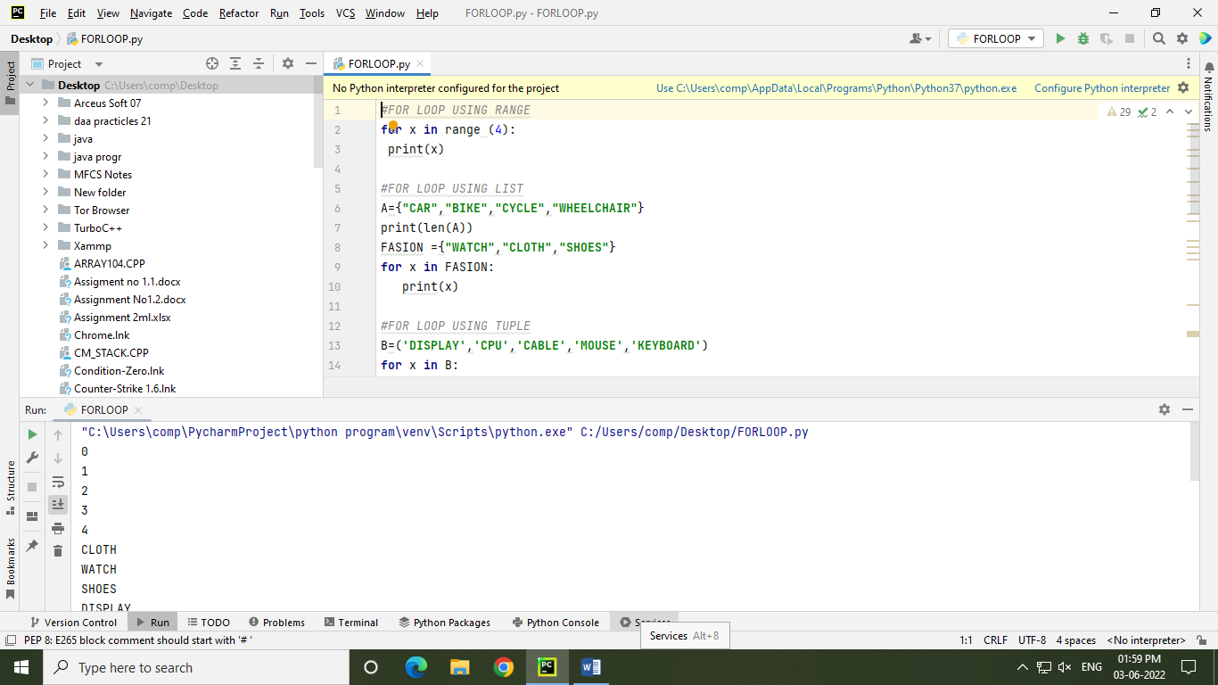

**2)FOR LOOP USING LIST:-**

A={"CAR","BIKE","CYCLE","WHEELCHAIR"}

print(len(A))

FASION ={"WATCH","CLOTH","SHOES"}

for x in FASION:

print(x)

**OUTPUT:-**

TFG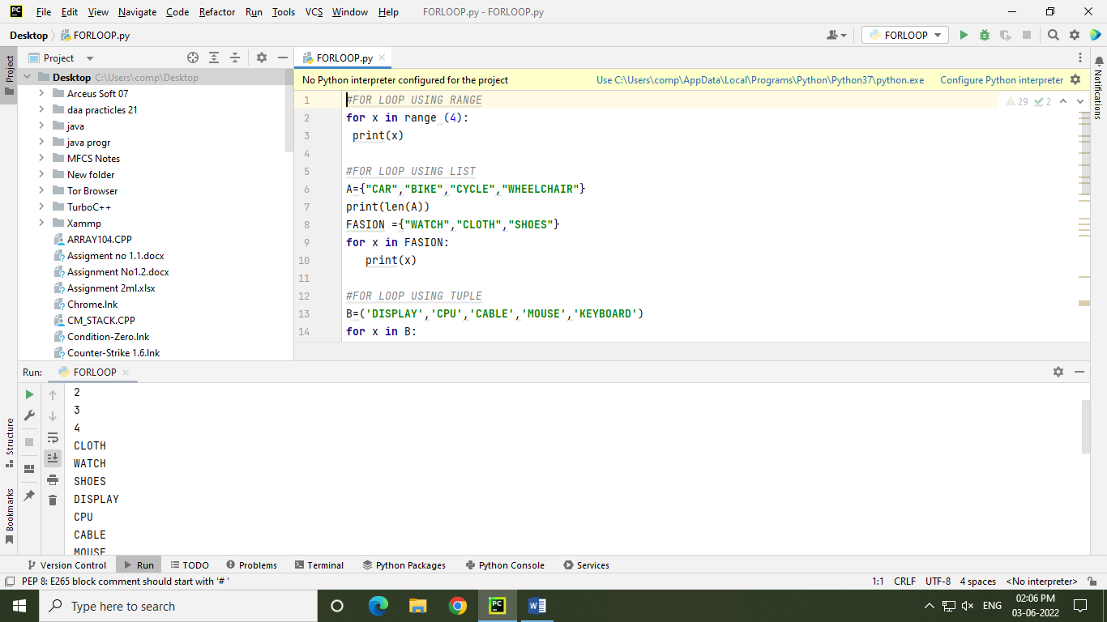

**3)FOR LOOP USING TUPLE:-**

B=('DISPLAY','CPU','CABLE','MOUSE','KEYBOARD')

for x in B:

print(x)

B1=('MATH','SCIENCE','ENGLISH')

print(len(B1))

**OUTPUT:-**

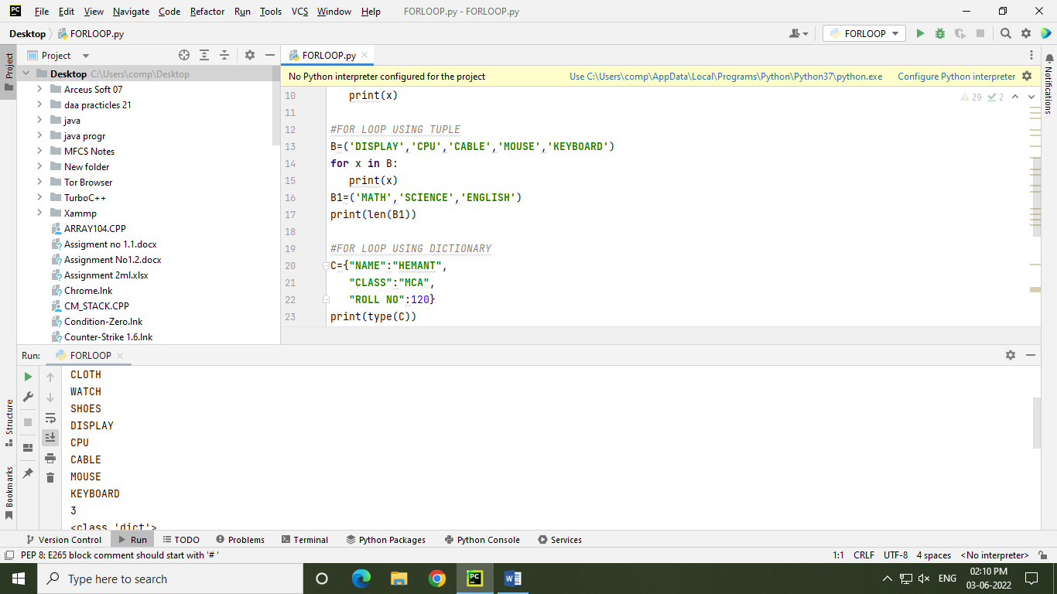

**4)FOR LOOP USING DICTIONARY:-**

C={"NAME":"AMOL","CLASS":"MCA","ROLL NO":105}

print(type(C))

for x in C:

print(C)

for x in C:

print(C[x])

**OUTPUT:-**



**5)FOR LOOP USING STRING:-**

for x in "PYTHON":

print(x)

**OUTPUT:-**

