mobiVUE PMMS (Pharmaceutical Manufacturing Management System)




Ajanta Pharma Limited
Software Requirement Specification (SRS)

Project ID:
The document details the summary of solution architecture and approach for the development of mobiVUE PMMS (Pharmaceutical Manufacturing Management System) for Ajanta Pharma Limited. The document is based on the inputs, system study, discussions and meeting held between BCI & Ajanta Pharma Teams.
Prepared By: Leena
Submission Date:
Version: 1.0
BAR CODE INDIA, 691 Udyog Vihar Phase V, Gurugram, Haryana-122016, PH: 0124 4337555

REVISION NO. | DATE | PREPARED BY | REVIEWED BY | COMMENT
1.0 |  | Leena |  | SRS Document for Ajanta Pharma Limited .
  - REVISION HISTORY

Abbreviations:
Name | Abbreviation
Microtek International Pvt. Ltd. | Microtek
Bar Code India | BCI
Fixed Mount Scanner | FMS
Handheld Terminal | HHT
Systems, Applications & Products in Data Processing | SAP

  - Table of Contents
1 Specification Organization 1
2 Introduction 2
2.1 Intended Audience and Reading Suggestions 2
2.2 Project Scope 3
3 Software/Hardware Requirements 4
3.1 Cloud Server Configuration 4
3.2 Computers 4
3.3 Hardware Requirements 4
4 Solution Architecture 5
5 User Interface Specification Conventions 6
6 System Log 7
6.1 Error Logs 7
6.2 Audit Logs 7
7 Architectural Design 8
7.1 Web Application 8
7.2 Device Application 8
7.3 Communication Server 8
7.4 Scheduler Application 8
8 Application Modules 9
8.1 Application Login- Web & Device Application 9
8.2 User Management 10
8.2.1 User Master 10
8.2.2 User Rights/ Permission 11
8.3 Masters 12
8.3.1 Material Master 12
8.3.2 Customer Master 13
8.3.3 Vendor Master 13
8.3.4 Storage Location Master 14
8.3.5 BOM Master 14
8.3.6 Tool Master 15
8.3.7 Line Master 15
8.3.8 Routing Master 16
8.3.9 Bin Master 17
8.3.10 Machine Master 17
8.3.11 Pallet Master 18
8.4 Vendor Portal 19
8.4.1 Label Printing 19
8.4.2 Secondary Packing 21
8.4.3 Dispatch 22
8.5 Identification Operations 24
8.5.1 Location Marking 24
8.5.2 Bin Identification 26
8.5.3 Machine Identification 27
8.5.4 Pallet Identification 28
8.6 RM Operations 29
8.6.1 Receiving 29
8.6.2 GRN Cancellation And Remapping 31
8.6.3 Quality Check- Sampling 33
8.6.4 Quality Check Status 35
8.6.5 Putaway 37
8.6.6 Picklist Generation 39
8.6.7 Picking 41
8.6.8 Issuance 43
8.6.10 Shop Floor Return 45
8.6.11 Material Movement 47
8.7 FG Warehouse Operation 49
8.7.1 Receiving 49
8.7.2 Putaway 50
8.7.3 Picklist Generation 52
8.7.4 FG Picking 54
8.7.5 FG Dispatch 56
8.8 Reports 58
9 SRS Scope Change Process 59
9.1 Before Sign Off 59
9.2 After Sign Off 59
9.3 SRS Acceptance 59

Specification Organization
The objective of this document is to supply underlying concepts, procedures, and formats used in the design, development and installation of this software application. This specification consists of three sections organized as follows:
Section 1: Introduction

This section provides hardware requirements and documentation conventions.

Section 2: User Interface

This section depicts screen design and logic flow, and is categorized into two groups:
- Application Function Module
- Common Routine

Section 3: System Architecture
This section provides information of system architecture.

Introduction

Intended Audience and Reading Suggestions
The scope of this document is to provide the understanding of this solution to user & development teams associated with the application development & implementation.
This document major emphasizes on providing clear understanding of mobiVUE PMMS
This solution comprises of:
- Web Application
- Mobile Device Application
- Web Services
- SAP Interfaces

Project Scope mobiVUE PMMS
The project scope is to develop and implement the Automation System at Warehouse, Manufacturing and Finish Goods for Ajanta Pharma Limited, the solution will facilitate user to manage the storage of inventory at warehouse and also helps in efficient allocation of Material for Sampling and Dispensing. Barcode Labels will be generated for the received Material Packaging i.e. Containers or Bags against the Gate Entry Number; the application also provides identification for Equipment, Dispensing Booths, Weighing Machine, In-process machines, Pallets, Trolleys and process/dispensing rooms.
The application will be integrated with the Weighing Machine which will help to capture weight automatically, this help as it provides control on inventory as no wrong Material or quantity can be issued.
The system will be integrated with the SAP and will control the flow of information from application to database and vice- versa. Each and every transaction will be recorded along with the time stamp which will help user to access any process related information as and when required.
This would require development of Wi-Fi enabled application for real time transaction i.e. the data will be captured in real-time, once the data has been collected, the database can then provide useful reports about status of material.
The entire solution consists of followings:
- Web Application
- Mobile Device Application
- Web Services
- SAP Interface with PI Server

Software/Hardware Requirements
Below are the hardware and the software requirements of the application:
*TO BE CHANGED AS PER APPLICATION REQUIREMENT

Plant Server (Both DB and Application)
The solution would require the high performance server with minimum following:
Server will be placed as 1 for prod & 1 for DEV/QA
Descriptions | Qty
HPE DL20 Gen10 4SFF SERVER :  1 x INTEL XEON E-2136 6C 3.3GHz Processor  rail kit, 1xLP riser, HP drive cage | 1
HPE 16GB 2Rx8 PC4-2666V-E STND Kit | 2
HPE 1TB SATA 7.2K SFF SC DS HDD | 2
HPE 500W FS Plat Hot Plug LH Power Supply Kit | 2
3years 4hour response 24x7 warranty | 1

Desktop Computers
Desktop would require following specifications:-
- I3/i5 Processor with Windows 7 operating System
- 16 GB RAM
- 100GB HDD
- Dot net Framework 4.0

Hardware Requirements
Hardware required for the application:
- Android Mobile Device
- Zebra Barcode Label Printer

Solution Architecture

User Interface Specification Conventions
This section specifies the user interface portion of the application.

Section Organization
The User Interface Specification presents screen displays or “Dialogs”.
Documentation Conventions
This section incorporates illustrations of the application user interface. Each screen display “Dialog” consists of the screen display image, a process name, a paragraph documenting the processing required for the dialog, a paragraph listing the navigation options, and a table listing for each variable field on the dialog, its database source or destination, format, and any instructions required to process the field.
The following section contains a sample dialog with each area identified.

System Log
System shall maintain internal logs for application.

Error Logs
These logs will contain any errors encountered during runtime for faster resolution of any problem post deployment.

Audit Logs
These logs will monitor the activities of user who accessed the application, made changes to File/ Document and the time stamp of these activities.

Architectural Design
*TO BE CHANGED AS PER SYSTEM REQUIREMENT
Overall System consists of:
- Web Application
- Device Application
- Web Services

Web Services
This application will handle the device request in real time. Most of business logic on scanning will run on this module. Web Service will be hosted in IIS Services, Web Services will run on central server.

Device Application
This application will include warehouse process modules. Application will directly communicate with user input and process the request to communication server.

Web Application
A Web Application will be developed using which users will create the master data, download details from SAP, prints item barcode label etc. It also helps to generate and display related transaction reports to End Users in real time.

User Management
The module will let application administrator to manage the Users, and the rights assigned to the same; the rights will define authorized application access of users.
The User Management & Master data will be created using Web Application.

User Master
This module will let user to create application users who will access the application. . To keep the system secured and track activities done by different users, user need to be registered to the system. PMMS provides following functionalities to manage users. User master will be integrated with Active directory of customer.
The master will store the users’ details in system.
Note: Super user / Super Admin is a special user which is seeded during PMMS hosting and not created using the PMMS UI.
Data Fields | - First Name  - Last Name  - Phone Number  - Select Designation  - Select Mode  - Select Sub Plant  - Select Reporting Manager  - Employee Code  - Email  - Password  - Confirm Password  - Is Active  - Role
Process Steps | - Enter required details such as First Name, Last Name, and Phone Number.  - Select Designation, Mode, Sub Plant, and Reporting Manager from dropdown.  - Enter Employee Code, Email, Password, Confirm Password.  - Select Status as Is Active if it is active.  - Select Role that need to assign to the user from the checklist.  - Click on Add button to save details in database.  - Newly added user will appear in data grid
Functions | - Add, edit/update, delete as per requirement  - Employee Code and Password is used to access the application.
Role | Admin will create/ add user details via window application

Role Management/ Permission
This module will let admin to assign access of particular Role in the application. Once assigned, authorized users can access the application. Once permissions are assigned, user will be able to view only Modules-Sub Modules of Role which he has been given access rights to by Admin.
Data Fields | - Role Name  - Display Name  - Description  - Is Active  - Permissions
Process Steps | - Admin will enter the Role Name, Display Name, and Description.  - Select Status as Is Active if role is active.  - Select the Permission by clicking on Module-Sub modules names in data grid.  - Admin will check the checkbox against Module-Sub module to which selected User should be assigned access permissions.  - Save and Update the details in database
Functions | Add, edit/update Roles as per requirement
Role | Admin will assign Roles to the selected User.

Password Management
This module will let Admin reset the password of application users if the user forgets the password. Once the password get reset by admin, then admin will share the password with the user and authorized users can access the application.
Data Fields | - First Name  - Last Name  - Employee Code  - Password  - Confirm Password
Process Steps | - Admin will enter the First Name, Last Name, and Employee Code of the user whose password needs to Reset.  - Enter the password and confirm the Password.  - Admin can see the Status of User is changed pending to Submitted.  - User will use the password reset by Admin and user has to set his new password and login again. (New password will valid for 90 days.)  - Admin can see the Status of User is changed Submitted to Completed.  - Save and Update the details in database.
Functions | Reset password of users as per requirement.

Masters

Plant Master
The master module will be used to create/update the Plant Master details in database. Different Plants in the organization will be mentioned here.
Data Fields | - Plant ID  - Plant Description  - Select Plant Type  - Is Active  - Tax Reg. No  - License  - GS1 Prefix  - Address1  - Address2  - Postal Code  - City  - State  - Country  - Email  - Phone Number  - Website
Process Steps | - Enter Plant ID.  - Enter Plant Description.  - Select Plant Type from dropdown i.e. Master Plant/ Sub Plant. (If Sub Plant is not present then enter Plant ID).  - Select Status as Is Active if it is active.  - Enter all details such as Tax Reg. No, License, GS1 Prefix, Address1, Address2, Postal Code, City, State, Country, Email, Phone Number, Website.  - Save the details in database.
Functions | Add, edit/update and delete Plant details as per requirement.

Department Master
This master will contain Department details which will define department in plants. With the help of this master.
Data Fields | - Department Code  - Select Sub Plant  - Department Name  - Department Description  - Is Active
Process Steps | - System will generate a unique code for Department Code.  - Select Sub Plant from dropdown.  - Enter Department Name and Description.  - Select Status as Is Active if it is active.  - Save the details in database.
Functions | Add, edit/update and delete Department details as per requirement.

Area Master
This master will contain Area details which will define Area in Departments. With the help of this master will maintain area details.
Data Fields | - Area Code  - Area Name  - Area Description  - Select Sub Plant  - Select Department  - Zone  - Is Active
Process Steps | - System will generate a unique code for Area code.  - Enter Area Name and Area Description.  - Select Sub Plant and Department from dropdown.  - Enter Zone.  - Select Status as Is Active if it is active.  - Save the details in database.
Functions | Add, edit/update and delete Area details as per requirement.

Cubicle Master
Cubicles are generally closed areas under zone and are meant for specific activities. Many times, they may be restricted except few authorized users.
Data Fields | - Cubicle Code  - Select Sub Plant  - Select Department  - Cubicle Description  - Select Area  - Is Active
Process Steps | - Enter Cubicle Code.  - Select Sub Plant and Department from the dropdown  - Enter Cubicle Description.  - Select Area from the dropdown.  - Select Status as Is Active if it is active.  - Save the details in database.
Functions | Add, edit/update, and delete Cubicle details as per requirement.

Location Master
The master module will be used to create/update the Location Master details in database. A barcode will be generated for Locations and will affix on the locations, this will provide a unique identification to each Location. User can take print out of Location barcode as well through this module.
Data Fields | - Location Code  - Storage Location type  - Select Sub Plant  - Location Description  - Select Department  - Select Area  - Zone  - Location Temperature Lower Limit  - Location Temperature Upper Limit  - Temperature Unit  - SLOC Type  - Select Level (example: Level 0 , Level 1, etc.)
Process Steps | - Enter Location Code.  - Enter Location Description.  - Select Storage Location type, Sub Plant, Department, Area, Temperature Unit, and Level from dropdown.  - Enter Zone, Location Temperature Lower Limit, Location Temperature Lower Limit, SLOC Type.  - Select Status as Is Active if it is active.  - Save the details in database.
Functions | Add, edit/update and delete Location details as per requirement.

Equipment Master
Apart from raw and production material, warehouse also has other material and equipment that are required to perform various activities. For example, for weighing activity the weight machine or weighing scale is used. Similarly, computers, scanners, machineries etc. are equipment that are used in warehouse activities as catalyst or helper but they themselves are not consumed for production.
Data Fields | - Equipment Code  - Equipment Name  - Equipment Alias  - Select Sub Plant  - Select Department  - Equipment Description  - Select Equipment type  - Select Communication Type  - Vendor Name  - Vendor Document Number  - Date of Procurement  - Maintenance Schedule Days  - Date of Installation  - Support Expire On  - Clean Hold Time  - Is Maintenance Required  - Is Portable  - Is Active
Process Steps | - Enter Equipment Code, Equipment Name, Equipment Alias, and Equipment Description.  - Select Sub Plant, Department, Equipment Type, and Communication Type from the dropdown.  - Enter Vendor Name, Vendor Document Number.  - Select Date of Procurement, Date of Installation, Support Expire On.  - Enter Maintenance Schedule Days, Clean Hold Time.  - Select the checkbox of Is Maintenance Required, Is Portable, and Is Active status as yes if needed.  - Save the details in database
Functions | Add, edit/update, and delete Equipment details as per requirement.

Handling Unit Master
A Handling Unit is a physical unit consisting of packaging materials (load carriers/packing material) and the goods contained on/in it. A handling unit is always a combination of products and packaging materials.
Data Fields | - Handling Unit Code  - Select Sub Plant  - Select Handling Unit Type  - Handling Unit Name  - Handling Unit Description  - Is Active
Process Steps | - Enter Handling Unit Code.  - Select Sub Plant and Handling Unit Type from dropdown.  - Enter Handling Unit Name and Description.  - Select Status as Is Active if it is active.  - Save the details in database.
Functions | Add, edit/update, and delete Handling Unit details as per requirement.

Gates Master
All inward stock movement starts, and all outward movement ends through Gate. Gate pass is generated at the gate which helps controlling vehicle movement inside a plant.
Data Fields | - Name  - Gate Code  - Select Sub Plant  - Gate Description  - Alias Name (if any)  - Is Active
Process Steps | - Enter Gate Name.  - Enter Gate Code.  - Select Sub Plant from dropdown.  - Enter Gate Description.  - Enter Alias Name (if any).  - Select Status as Is Active if it is active.  - Save the details in database.
Functions | Add, edit/update and delete Gate details as per requirement.

Checklist Type Master
Check List Type master will be used to display the type of checklist while displaying the check point in Check list master and while displaying the check points in the transactions.
Data Fields | - Select Sub Plant  - Select Sub Module  - Checklist Type Name
Process Steps | - Select Sub Plant and Sub Module from Dropdown.  - Enter Checklist Type Name  - Save the details in database.
Functions | Add, edit/update and delete Checklist Type details as per requirement.

Checklists Master
Inspection Checklist is used in various activities like vehicle inspection, material inspection, cubicle cleaning, line clearance for cubicle etc. Checklist will be created as per the module and will be displayed in that specific module only.
Data Fields | - Checklist Code  - Version  - Checklist Name  - Select Sub Plant  - Select Sub Module  - Checklist Description  - Format Number (SOP No.)  - Select Checklist Type  - Select Mode (Production/Store)  - Is Active
Process Steps | - System will generate a unique code for Checklist Code and Version.  - Enter Checklist Name and Checklist Description.  - Select Sub Plant and Sub Module from dropdown.  - Enter Format Number (SOP No.).  - Select Checklist Type and Mode from the dropdown.  - Select Status as Is Active if it is active.  - Save the details in database.
Functions | Add, edit/update, and delete Inspection Checklist details as per requirement.

Checkpoints Master
User can add multiple checkpoints against one Checklist.
Data Fields | - Checkpoint Name  - Select Checkpoint Type (Text/ Options/Condition)  - Select Checkpoint Mode (Production/Quality/Store)  - Value Tag  - Acceptance Value
Process Steps | - Enter Checklist Name.  - Select Checkpoint Type from the dropdown.  - Select Checkpoint Mode from the dropdown.  - Enter Value Tag and Acceptance Value.  - Save the details in database.
Functions | Add, edit/update, and delete Checkpoints details as per requirement.

Weighing Machine Master
This master will contain Weighing Machine details. With the help of this master, user will print barcode label for Weighing Machine to provide unique identification to each Weighing Machine at Store and will be able to update or delete the required Weighing Machine details.
Data Fields | - Weighing Machine Code  - Sub Plant ID  - IP Address  - Port Number  - Unit of Measurement (UOM)  - Capacity  - Make  - Modal  - Minimum Operating Capacity  - Maximum Operating Capacity  - Least count  - Least Count in digit after decimal.  - Stamping Done On  - Stamping Due On  - Verification  - Standard Weight 1st  - Standard Weight 2nd  - Standard Weight 3rd  - Monthly Calibration  - Standard Weight 1st  - Standard Weight 2nd  - Standard Weight 3rd  - Eccentricity Acceptance value  - Linearity Acceptance value  - Repeatability Acceptance value  - Uncertainty Acceptance value  - %RSD value  - Standard deviation value  - Mean value  - Formula
Process Steps | - User will enter Weighing Machine Code.  - Enter other details.  - Save the details in database.
Functions | Add, edit/update, and delete Weighing Machine details as per requirement.
- Removed below fields
  - Verification
  - Monthly Calibration

- Added whole section of Calibration Instruction as below.
  - User can add Multiple Calibration Instruction against Frequency
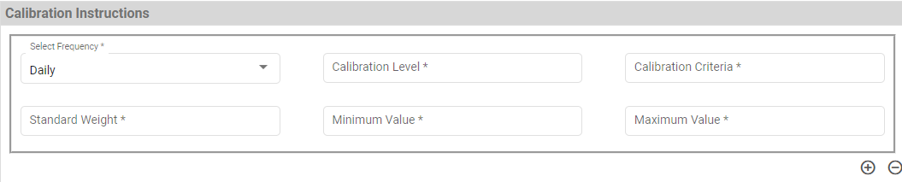
- Configurable option for all the test at Weighing Machine + Frequency level. So that only configured tests are required while doing Weighing Machine Calibration

Standard Weight Boxes Master
Data Fields | - Standard Weight Box ID  - Select Sub Plant  - Select Department  - Select Area  - Standard Weight Box Description  - Is Status
Process Steps | - Enter Standard Weight Box ID.  - Select Sub Plant, Department, and Area from the dropdown.  - Enter Standard Weight Box Description.  - Select Status as Is Active if it is active.  - Save the details in database.

Standard Weight Master
This master will contain Standard Weight details which are used while weighing calibration. With the help of this master, in this master Standard weight ID will be maintain as unique id.
Data Fields | - Standard Weight ID  - Select Sub Plant  - Select Department  - Standard Weight Description  - Select Area  - Capacity  - Select Unit of Measurement  - Select Standard Weight Box  - Stamping Done On  - Stamping Due On  - Is Status
Process Steps | - Enter Standard Weight ID.  - Select Sub Plant, Department from the dropdown.  - Enter Standard Weight Description, Capacity.  - Select Area, Unit of Measurement, and Standard Weight Box from the dropdown.  - Select Stamping Done On and Stamping Due On dates.  - Select Status as Is Active if it is active.  - Save the details in database.
Functions | Add, edit/update, and delete Standard Weight details as per requirement.

Unit of Measurements Master
Unit of Measure (UoM) is a quantity used as a standard of measurement for the inventory. PMMS defines all standard units used in inventory and the conversion rates from one to another.
Data Fields | - UoM Name  - Select UoM Type  - UoM Description  - UOM  - Is Active
Process Steps | - Enter UoM Name.  - Select UoM Type from dropdown.  - Enter UoM Description and UoM.  - Select Status as Is Active if it is active.  - Save the details in database.
Functions | Add, edit/update, and delete UoM details as per requirement.

Devices Master
This master will store Devices details, through system can have details of all the devise information as Mobile device, Printer and tablets and maintain the connection parameters. Through which the devices will be accessible in network.
Data Fields | - Device ID  - Select Sub Plant  - Select Device Type (Mobile/Printer/Tablet)  - Select Mode (Production/Quality/Store)  - IP Address  - Port  - Make  - Model  - Serial Number  - Select Department  - Select Area  - Select Cubicle  - Is Active
Process Steps | - Enter Device ID, it can be alpha numeric.  - Select Sub Plant from dropdown.  - Select Device Type (Mobile/Printer/Tablet) from dropdown.  - Select Mode (Production/Quality/Store) from dropdown.  - Enter other details such as IP Address, Port, Make, Model, and Serial Number.  - Select Department, Area, and Cubicle from dropdown.  - Select Status as Is Active if it is active.  - Save the details in database.
Functions | Add, edit/update, and delete Devices details as per requirement.

Activity Master

Data Fields | - Activity Name  - Activity Code  - Activity Description  - Select Module Name  - Select Sub Module Name  - Is Active
Process Steps | - Enter Activity Name, Activity Code, and Activity Description.  - Select Module Name, Sub Module Name.  - Select Status as Is Active if it is active.  - Save the details in database.
Functions | View details of the Activity master.

Inward

Gate Entry
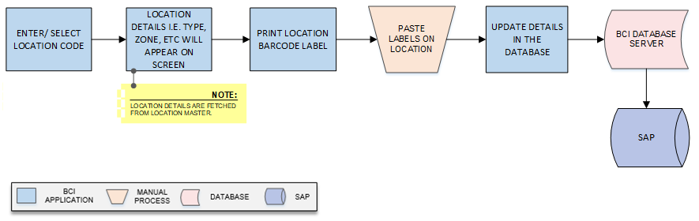
Activities
Module Description | Gate Pass activities controls and manage the external vehicle movement inside the plant for unloading the material.

Pre-Conditions | - Purchase Order details needs to be imported from SAP.

Process Steps | - Security Person will login into PMMS Application.  - Enter the Purchase Order No. mentioned on Invoice in Gate Entry module.  *Purchase Order details will be fetched from SAP.  - Details such as Purchase Order Date, Vendor Name, and Vendor Code will appear on the screen.  - A grid format of Material details such as Material Code, Material Description, Quantity, Manufacturer Code, Manufacturer Name, and UOM will appear on the screen.  - User will enter Invoice Quantity.  - Balance quantity against invoice quantity will appear on the screen.  - Enter the remaining details such as Invoice No, Invoice Date, Transporter Name, LR No, LR Date, Driver Name, Vehicle No, Vendor Batch No, Delivery Note, Bill of Landing.  - Purchase Order No Delivery Schedule will be appear on the screen from the Invoice date.  - Click on Add button to save the details.  - A grid format of Purchase Order details such as PO Number, Vendor Name, Invoice No., Invoice Date, LR No., LR Date, Vendor Batch No., and Remove will appear on the screen.  - Gate Pass No. will be generated.  - Gate Pass will get printed.  - Barcode will be printed on Gate pass.  - If there is any mismatch while physical verification and vehicle needs to be hold then security person will enter remark and Gate pass will not be printed.  Note: i. Single Gate Pass will be generated for multiple Purchase Order.  ii. Item having purchase order in SAP only can be used here and gate pass for that can be printed.

Post-Conditions | - Gate Pass barcode should be available at the unloading bay.

Validations | - An alert should be displayed in case duplicate/ invalid Purchase Order No is entered.  - An alert should be displayed in case duplicate/ invalid Invoice No is entered.  - An alert should be displayed in case Purchase Order details are not fetched from SAP.

Sample Screen Design | 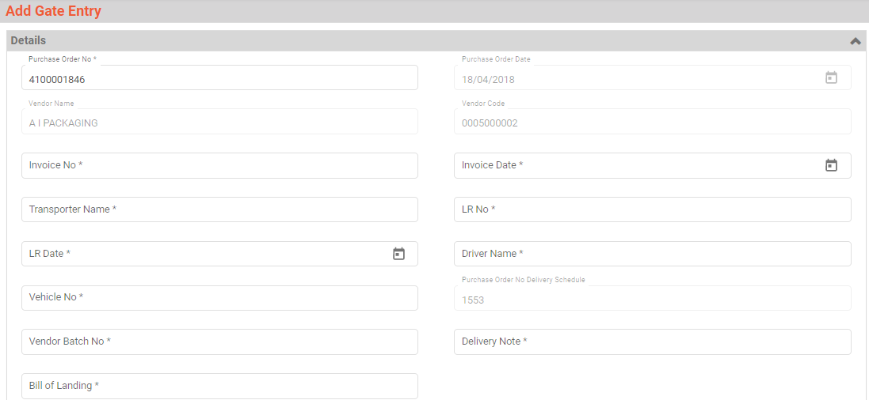  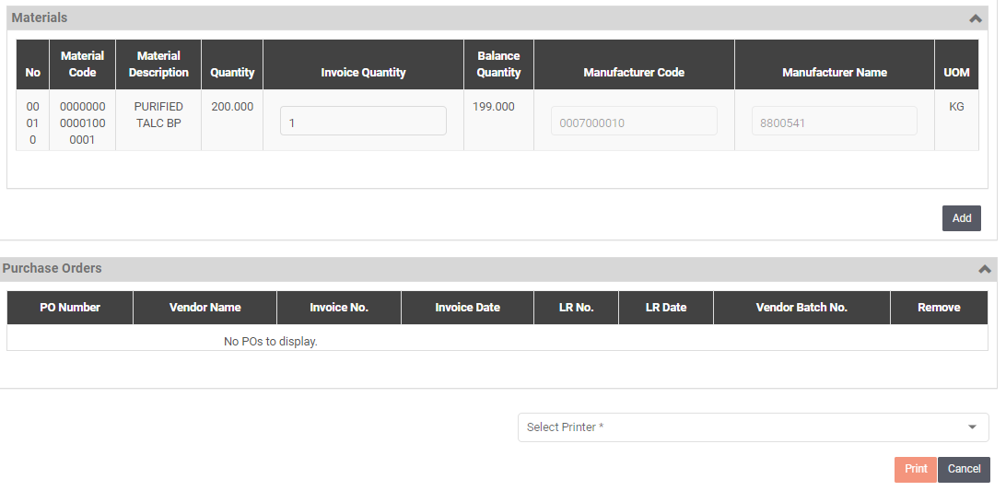  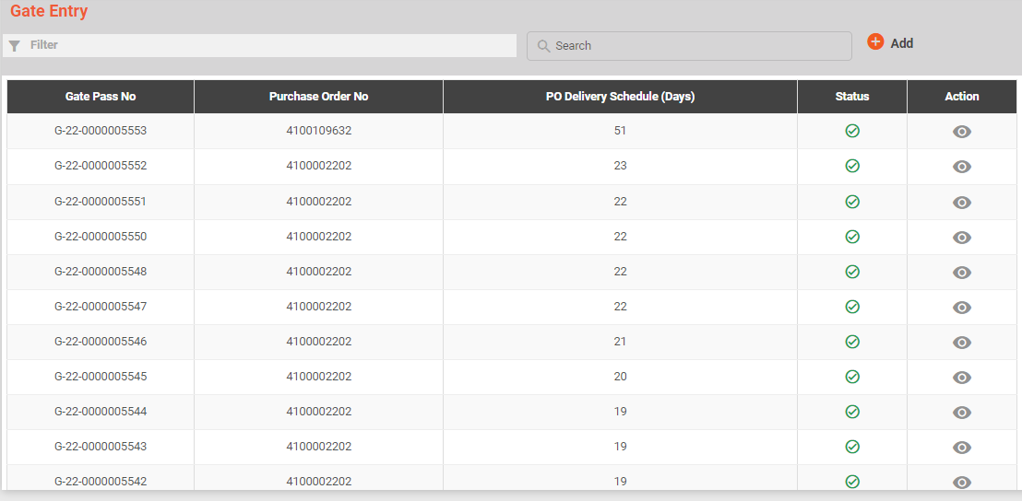

Vehicle Inspection
Activities
Module Description | Before unloading material from the vehicle, vehicle will be inspected against the defined checklist.  *This activity will be done using Device Application.

Pre-Conditions | - Printed Gate Pass should be printed given at the Gate entry.  - Checklist should available in Checklist master.

Process Steps | - Driver will provide printed Gate Pass at the Gate entry.  - User will login in PMMS application.  - Scan the Gate Pass No.  - Select Purchase Order.  - Enter Delivery Note, Bill of Landing, Vendor Batch No.  - Details such as Vendor Name, Invoice No, Invoice Date, LR No, LR Date, Driver Name, Vehicle No, Purchase Order No Delivery Schedule, and Vendor Code will appear on the screen.  - Checklist for inspection of vehicle will get displayed on the screen.  - User will verify the checklist physical.  - Update the in PMMS application by clicking on Add button.  - If there is any discrepancy then user will enter discrepancy remark.  - If the verification is passed then Vehicle Inspection will be completed else it will be returned.

Post-Conditions | - Vehicle inspection will be completed.

Validations | - An alert should be displayed in case invalid Gate Pass is scanned.  - An alert should be displayed in case duplicate/ invalid Purchase Order is selected.  - An alert should be displayed in case of invalid activity.

Sample Screen Design | 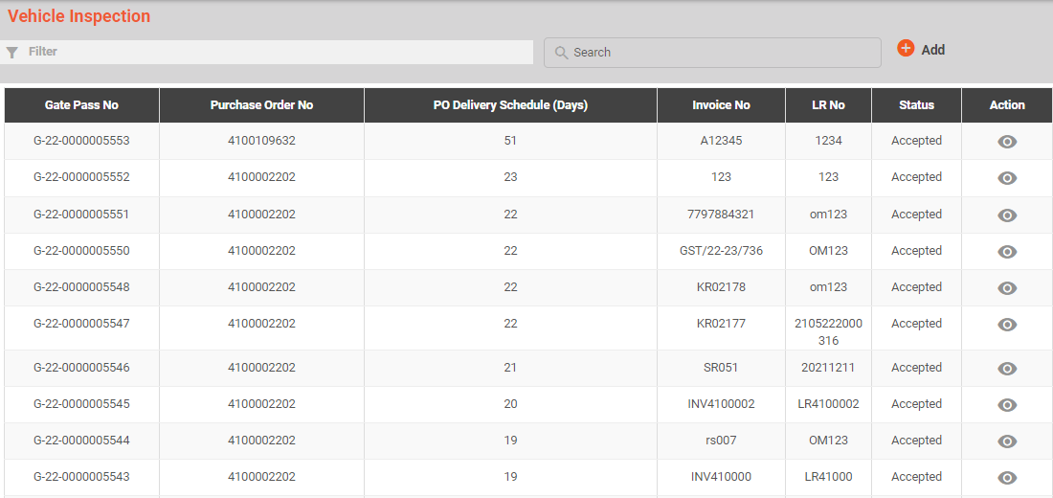  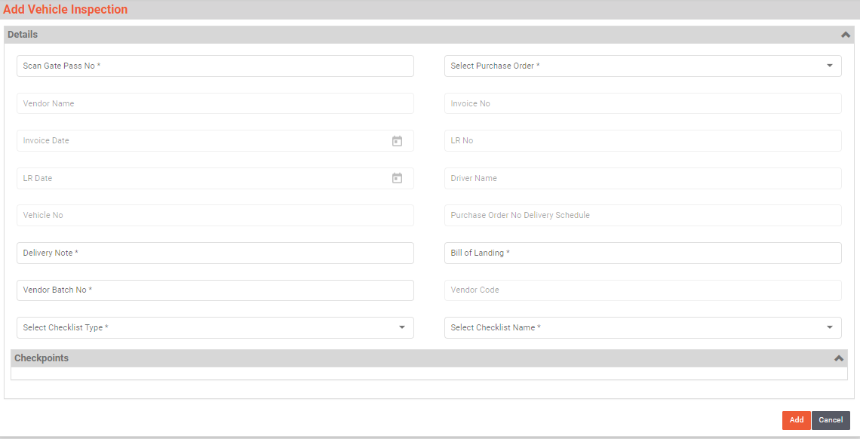  Vehicle Inspection after adding the data:

Material Inspection
Activities
Module Description | In this module material is inspected after the material has arrived, mostly from outside plant (from Vendor, other plants etc.)

Pre-Conditions | - Gate Pass should be available for scanning.  - Vehicle Inspection should be completed.

Process Steps | - Driver will provide printed Gate Pass at the Gate entry.  - User will login in PMMS application.  - Scan the Gate Pass No.  - Select Purchase Order.  - Delivery Note, Bill of Landing, Vendor Batch No.  - Details such as Details such as Purchase Order No Delivery Schedule, Invoice No, Invoice Date, LR No, LR Date, Driver Name, Vehicle No, Vendor Name, and Vendor Code will appear on the screen.  - User will enter Consignment details such as Manufacturing Date and Manufacturing Retest Date, Unit of Measurement.  *Expiry Date will be fetched from SAP.  - Manufacturer Batch No, Quantity as per Invoice, Remaining days left for Retest, Status, and Expiry date will appear on the screen.  Note: Expiry date will be considered as after 365 days of manufacturing date.  - Checklist for inspection of vehicle will get displayed on the screen.  - User will verify the checklist physical.  - If there is any discrepancy then user will enter discrepancy remark.  - Update the in PMMS application by clicking on Save button.  - If the verification is passed then Material Inspection will be completed else it will be returned.  - Damage Material:  - If any material is found damage then remark will be mentioned against the same.  - User will enter the Vendor Batch No., Quantity, Container No, Unit of Measurement, and Remark.

Post-Conditions | - Material inspection will be completed.

Validations | - An alert should be displayed in case invalid Gate Pass is scanned.  - An alert should be displayed in case duplicate/ invalid Purchase Order is selected.  - An alert should be displayed in case of invalid activity.

Sample Screen Design | 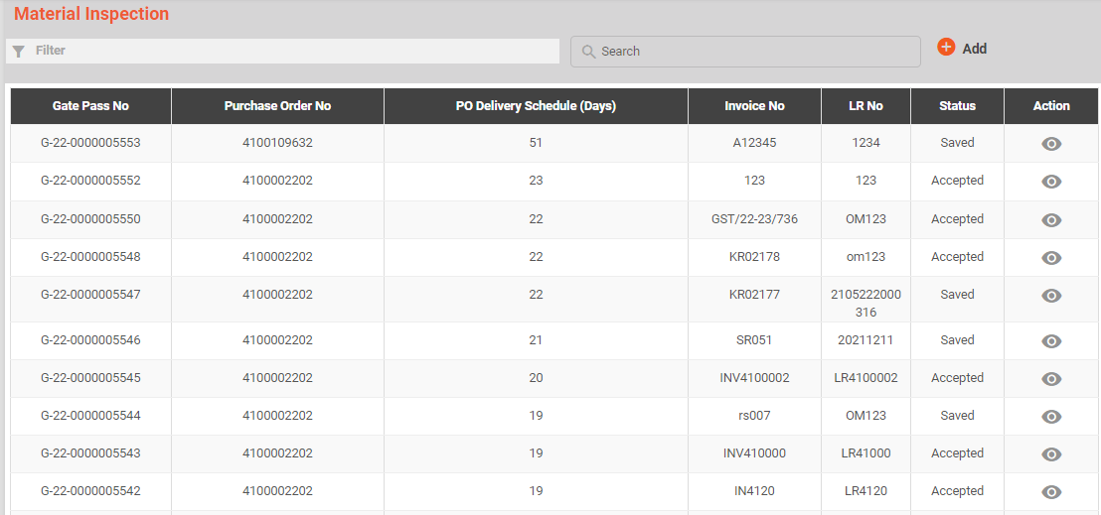  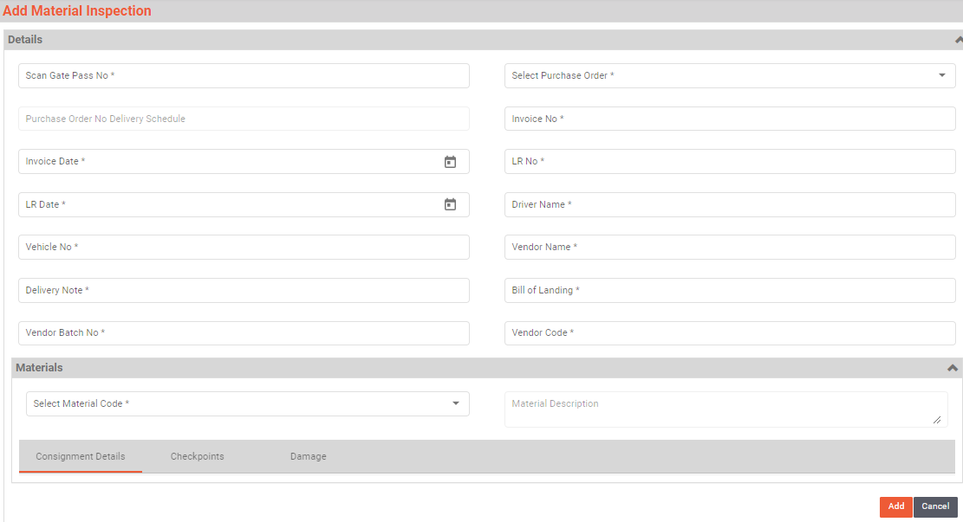  Material Inspection after adding data:

Weight Capture
Activities
Module Description | In this module the Weight details of Inspected materials are maintained.

Pre-Conditions | - Material Inspection should be completed.

Process Steps

Post-Conditions | - Gate Pass barcode should be available at the unloading bay.

Validations | - Purchase Order No. entered is valid, entered by security Personnel  - Duplicate Gate Pass can’t be generated however can be reprinted on authorization.

Sample Screen Design | 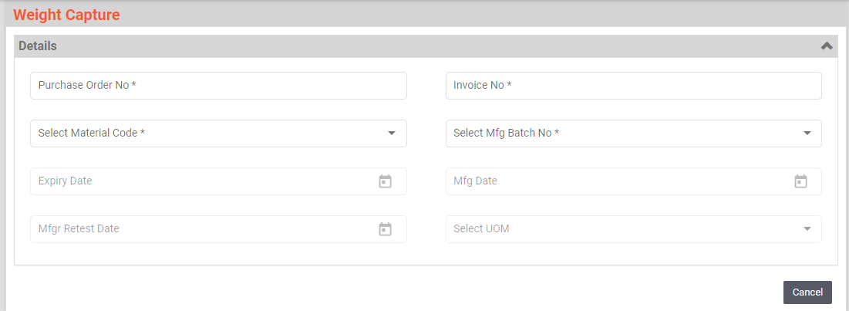

SRS Scope Change Process

Before Sign Off
Any changes in SRS need to be informed in writing by Ajanta Pharma. It will be incorporated / confirmed only after doing detailed feasibility study by BCI.
- If any change is out of scope then this would be done as a CR post feasibility and priority will be decided based on mutual agreement.
- Once the change is developed , any further change in the same would be considered as a CR

After Sign Off
Any changes in proposed solution after approval of this document by Ajanta Pharma are subjected to confirmation from BCI, taking feasibility constraints into account. These changes will be incorporated (if any) into the solution only after delivering proposed solution & may be charged as extra.
- Any change in the proposed solution due to customer system design or process will be considered as CR
- Any process which is not mentioned in this document will not be considered as “mutual understanding or default presence or standard practice”.
The changes in proposed solution before & after acceptance will be mutually agreed and duly signed and accepted by Ajanta Pharma & BCI.

SRS Acceptance
For Ajanta Pharma | For Bar Code India (BCI)
Name: | Name:
Designation: | Designation:
Department: | Department:
Agreed and Accepted by Ajanta Pharma and Bar Code India.

