A = LOAD '/home/acadgild/leena/ass/ass9/petrol-dataset.txt' USING PigStorage(',') AS (DistrictID:chararray, Dist_Name:chararray, Buy_rateD:chararray, Sell_rateD:chararray, Vol_IN:int, Vol_OUT:int, Year:int); B = FOREACH A GENERATE DistrictID, Dist_Name, (long)SUBSTRING(Buy_rateD, 1, (int)(SIZE(Buy_rateD))) AS Buy_rate, (long)SUBSTRING(Sell_rateD, 1, (int)(SIZE(Sell_rateD))) AS Sell_rate, Vol_IN, Vol_OUT, Year;

B = FOREACH A GENERATE DistrictID, Dist_Name, (float)SUBSTRING(Buy_rateD, 1, (int)(SIZE(Buy_rateD))) AS Buy_rate, (float)SUBSTRING(Sell_rateD, 1, (int)(SIZE(Sell_rateD))) AS Sell_rate, Vol_IN, Vol_OUT, Year;

B: {DistrictID: chararray,Dist_Name: chararray,Buy_rate: float,Sell_rate: float,Vol_IN: int,Vol_OUT: int,Year: int}

1. What is the total amount of petrol in volume sold by every distributer?

C = GROUP B BY Dist_Name;

D = FOREACH C GENERATE Dist_Name, SUM(B.Vol_OUT);

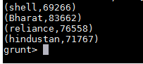

2. Which are the top 10 distributers ID's for selling petrol? Also display the amount of petrol sold in volume.

E = ORDER B BY Vol_OUT DESC, DistrictID ASC

topTen = LIMIT E 10;

resultTopTen = FOREACH topTen GENERATE DistrictID, Vol_OUT;

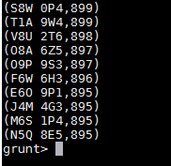

3. List 10 years where consumption of petrol is more with the distributer id who sold it.

F = ORDER B BY Vol_IN DESC, DistrictID ASC;

topTenConsume = LIMIT F 10;

resultTopTenConsume = FOREACH topTenConsume GENERATE DistrictID, Vol_OUT, Year;

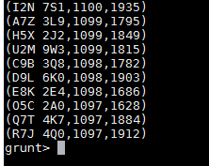

4. Find the distributer name who sold petrol in least amount.

G = ORDER B BY Vol_OUT ASC, DistrictID DESC;

leastSold = LIMIT G 1;

resultLeastSold = FOREACH leastSold GENERATE DistrictID;

