1. Used an existing database created for an earlier assignment.

use custom1;

1. Create the table with the fields – name, skill, rank, place

create table if not exists employee (ename string, skill string, rank int, place string)row format delimited fields terminated by ',' lines terminated by '\n' stored as textfile;

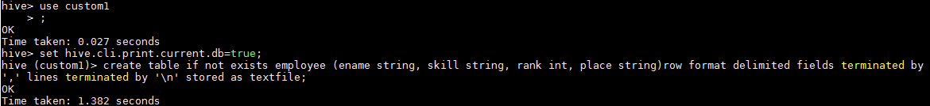

1. Load the table with the file data from the given data file

load data local inpath '/home/acadgild/leena/ass/ass-15/emp_details.txt' into table employee;

1. Select the required fields and count

select COUNT(ename), skill FROM employee GROUP BY skill;



Output

