Steps

1. On the Oracle VM start all Hadoop daemons.
2. <https://apps.twitter.com>
3. Create twitter app
4. Create myaccess token
5. Save the 4 required keys/token
6. Download flume (already downloaded in Oracle VM)
7. Configure flume.conf file – this is attached.
8. org.apache.flume.source.twitter.TwitterSource – download the jars needed

[acadgild@localhost ~]$ ls /home/acadgild/apache-flume-1.6.0-bin/lib/twitter4j-*

/home/acadgild/apache-flume-1.6.0-bin/lib/twitter4j-core-3.0.3.jar

/home/acadgild/apache-flume-1.6.0-bin/lib/twitter4j-media-support-3.0.3.jar

/home/acadgild/apache-flume-1.6.0-bin/lib/twitter4j-stream-3.0.3.jar

[acadgild@localhost ~]$

1. Flume path set as following in /home/acadgild/.bashrc

export FLUME_HOME=$HOME/apache-flume-1.6.0-bin

export PATH=$PATH:$FLUME_HOME/bin

1. [acadgild@localhost ~]$ echo $FLUME_HOME

/home/acadgild/apache-flume-1.6.0-bin

[acadgild@localhost ~]$

1. flume-ng agent -n TwitterAgent -f /home/acadgild/apache-flume-1.6.0-bin/conf/flume.conf

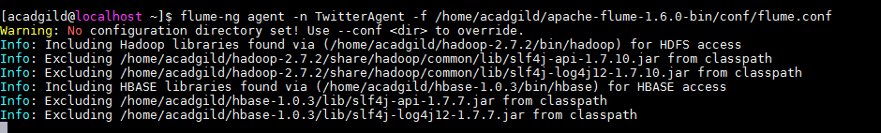

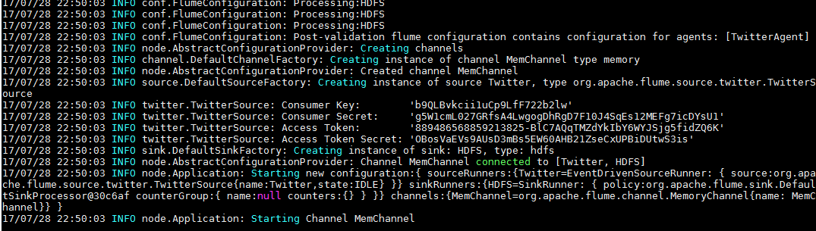

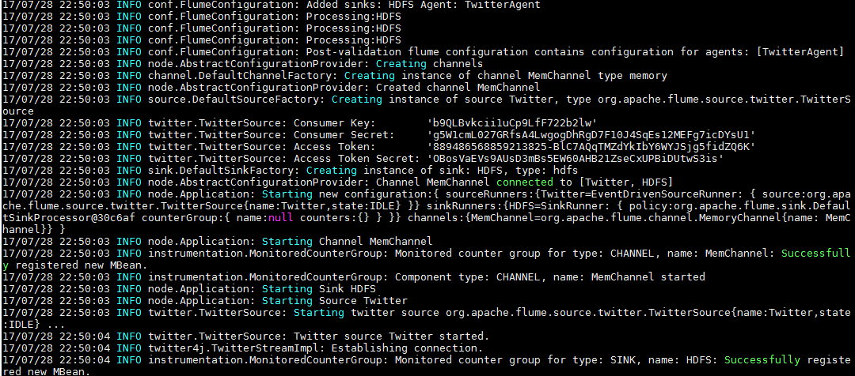

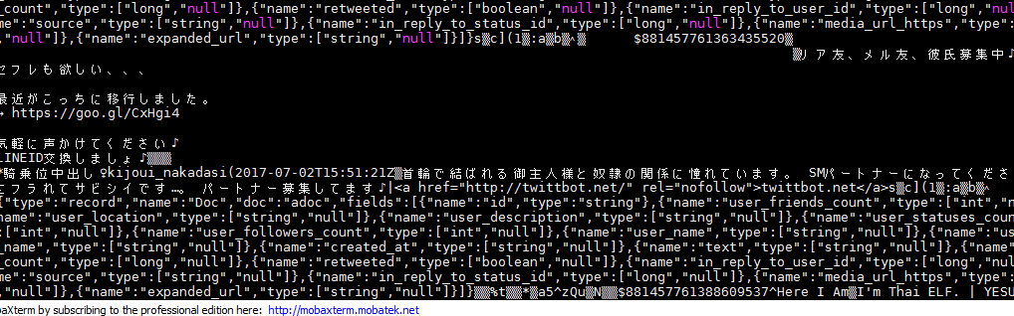

Use ctrl+C to stop

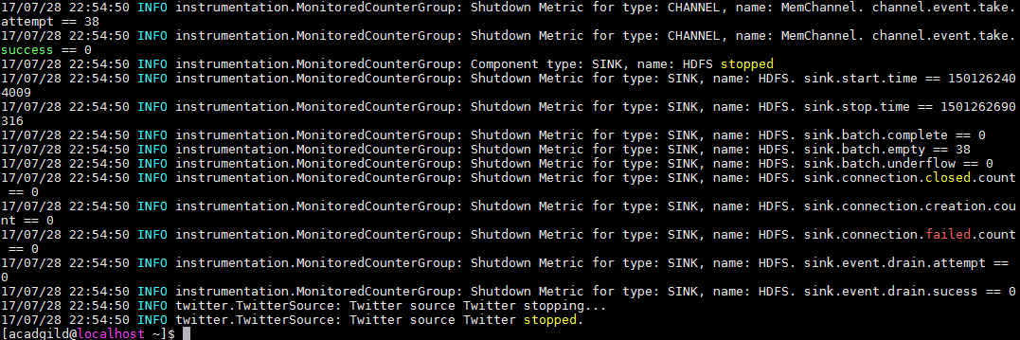

drwxr-xr-x - acadgild supergroup 0 2017-07-18 22:49 tweet/flume

[acadgild@localhost ~]$ ls -l /home/acadgild/tweetdata/

total 4

-rw-rw-r--. 1 acadgild supergroup 5 Jul 28 23:01 flume.1558790339196

[acadgild@localhost ~]$