1. First step is to download the VM from the Acadgild provided location.
2. Next, import the VM onto the Oracle VM VirtualBox.

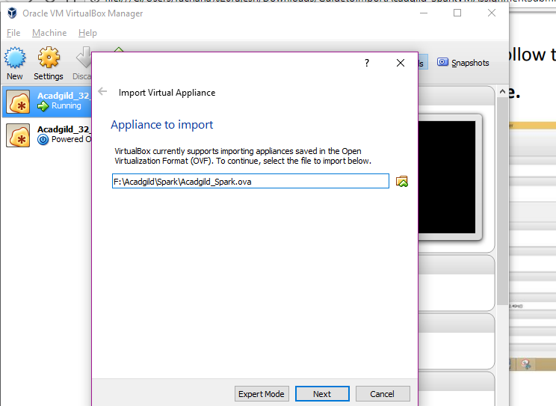

1. Import the VM

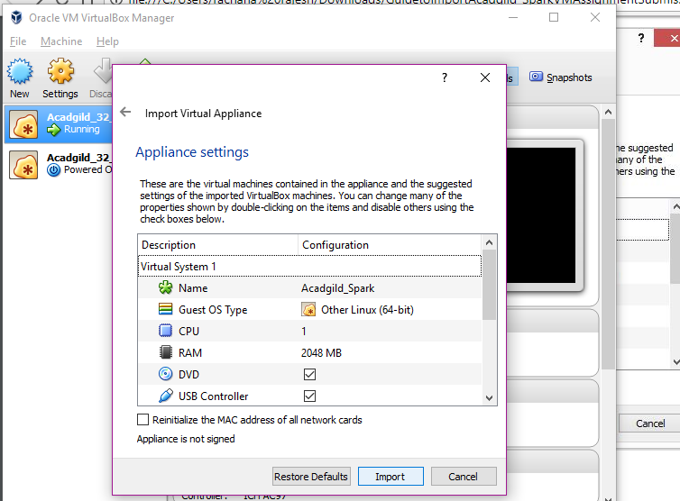

1. Importing the VM in progress

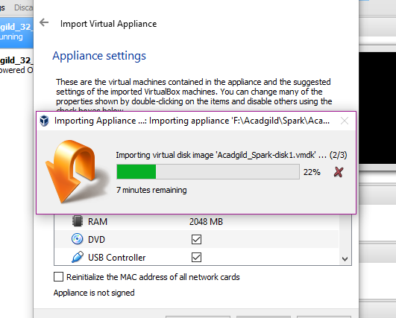

1. The VM import completes

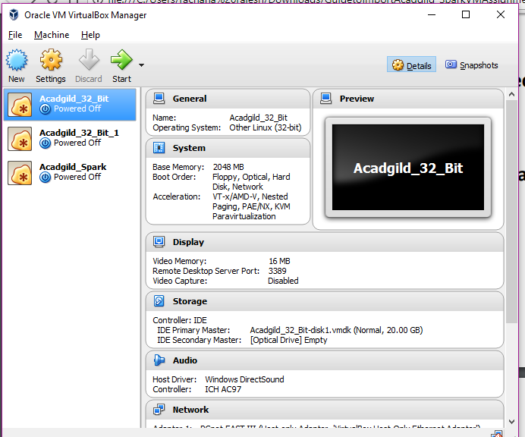

1. Start the VM. Login with the credentials supplied.
2. Start the Hadoop daemons
3. Start historyserver as well

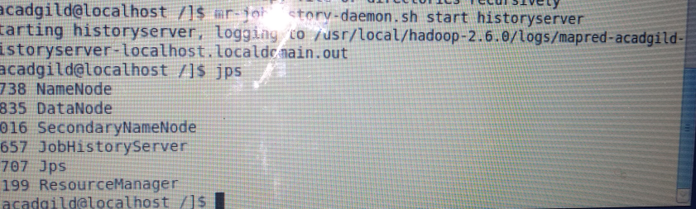

1. To start spark

Change directory to /usr/local/spark/spark-1.6.0-bin-hadoop2.6/sbin

Run start-master.sh

1. To start slave

Run start-slave.sh

