1. Use an existing database custom1
2. Create table olymics
3. Load the data into it

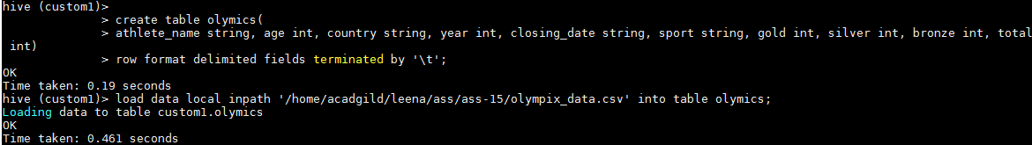

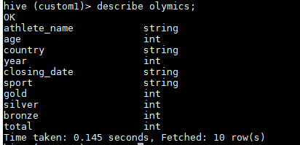

Question 1.

SELECT country, sum(total) FROM olymics WHERE sport='Swimming' GROUP BY country;

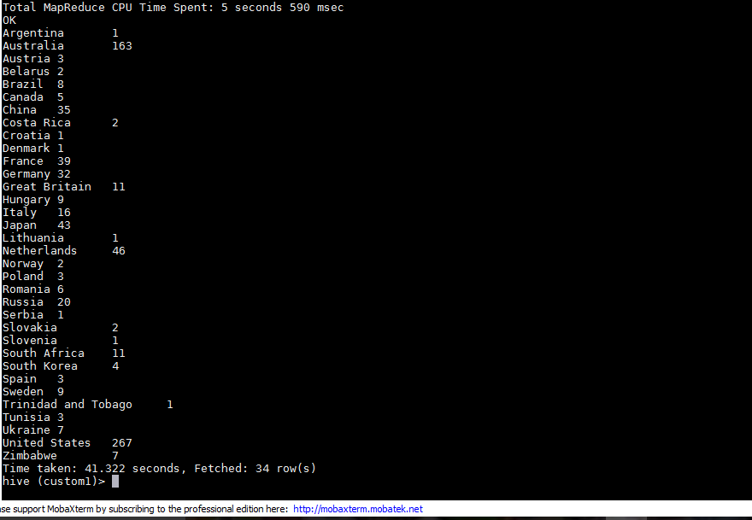

Question 2

SELECT SUM(total), year FROM olymics WHERE country='India' GROUP BY year;

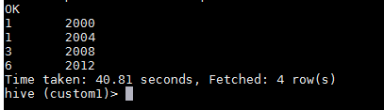

Question 3

SELECT SUM(total), country FROM olymics GROUP BY country;

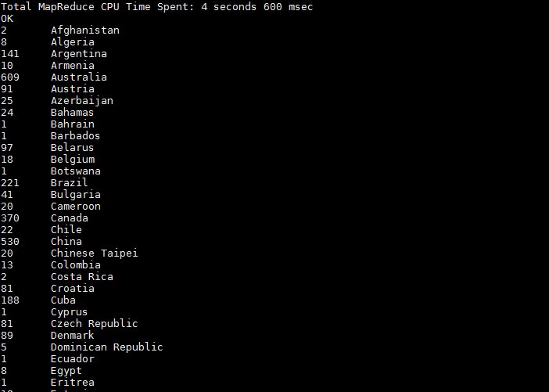

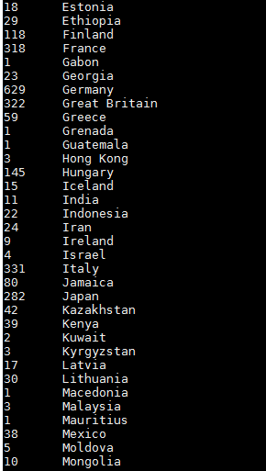

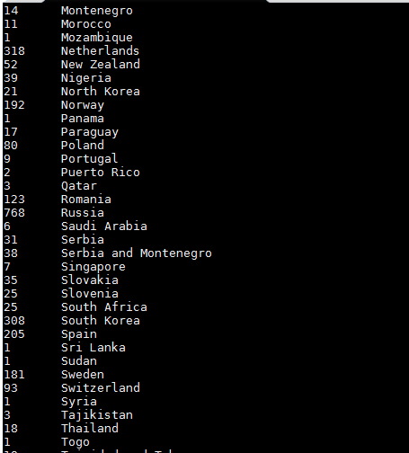

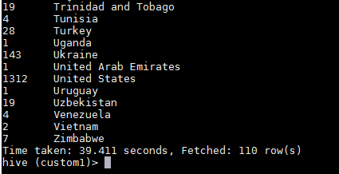

Question 4

SELECT SUM(gold),country FROM olymics WHERE gold>0 GROUP BY country;

