USE custom;

CREATE TABLE emp_sal

(

emp_id int,

emp_name string,

emp_salary int,

emp_unit string

)

ROW FORMAT DELIMITED

fields terminated by '\t';

LOAD DATA LOCAL INPATH '/home/acadgild/hive/Emp_Sal.txt' OVERWRITE INTO TABLE emp_sal;

**Problem 1**

Get a list of employees who receive a salary less than **5**, compared to their immediate employee with higher salary in the same unit

**(Note: Instead of using a difference of 100, salary difference is used as 5, to get the result as there is no record which is having a difference of 100.)**

SELECT emp_id, emp_name, emp_salary, emp_unit, (lead_salary - emp_salary) AS diff_salary FROM

(

SELECT emp_id, emp_name, emp_salary, emp_unit, max(emp_salary) OVER (PARTITION BY emp_unit ORDER BY emp_salary DESC) AS lead_salary

FROM emp_sal

) temp

WHERE lead_salary - emp_salary > 5;

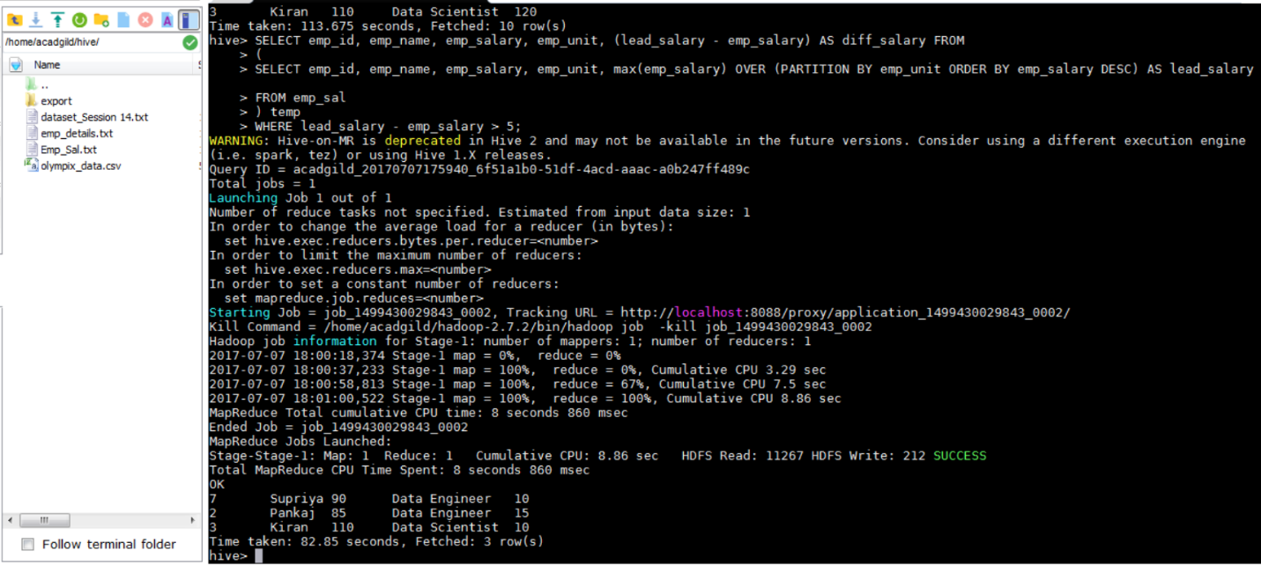

**Problem 2**

List of all employees who draw higher salary than the average salary of that department

SELECT emp_name, emp_salary, emp_unit, avg_salary

FROM

(

SELECT avg(emp_salary) OVER (PARTITION BY emp_unit) AS avg_salary, emp_id, emp_name, emp_salary, emp_unit

FROM emp_sal

) temp

WHERE emp_salary > avg_salary;

