set hive.support.concurrency = true;

set hive.enforce.bucketing = true;

set hive.exec.dynamic.partition.mode = nonstrict;

set hive.txn.manager = org.apache.hadoop.hive.ql.lockmgr.DbTxnManager;

set hive.compactor.initiator.on = true;

set hive.compactor.worker.threads = 2;

CREATE TABLE users(user_id int,user_name string,address string) clustered by (user_id) into 5 buckets stored as orc TBLPROPERTIES('transactional'='true');

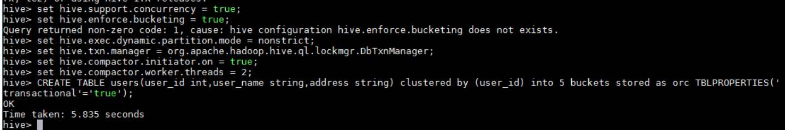

INSERT INTO TABLE users VALUES(111,'Ankur','Delhi'),(112,'Vinay','Mumbai'),(113,'Vivek','Chennai'),(114,'Nitin','Banglore'),(115,'Vaibhav','Gurgaon');

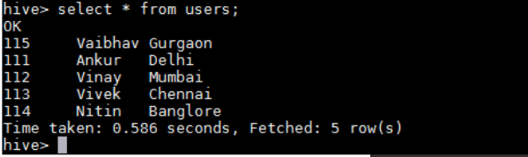

UPDATE users SET address = 'Noida' WHERE user_id = 111;

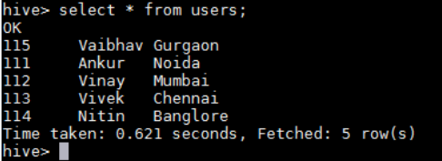

DELETE FROM users WHERE user_id = 115;

