Project 2.1- State-Wise Development Analysis In India

Input data:
https://drive.google.com/file/d/0Bxr27gVaXO5sUjd2RWFQS3hQQUE/view?usp=sharing

Step 1:
Copy dataset from local file system to HDFS using flume.
Filecopy.conf
agent1.sources = mysrc
agent1.sinks = hdfsdest
agent1.channels = mychannel

agent1.sources.mysrc.type = exec
agent1.sources.mysrc.command = hadoop dfs -put /home/acadgild/StatewiseDistrictwisePhysicalProgress.xml /user/acadgild/flumeflume_import

agent1.sinks.hdfsdest.type = hdfs
agent1.sinks.hdfsdest.hdfs.path = hdfs://localhost:9000/user/acadgild/flume

agent1.channels.mychannel.type = memory

agent1.sources.mysrc.channels = mychannel
agent1.sinks.hdfsdest.channel = mychannel

Command:
flume-ng agent -n agent -c conf -f filecopy.conf

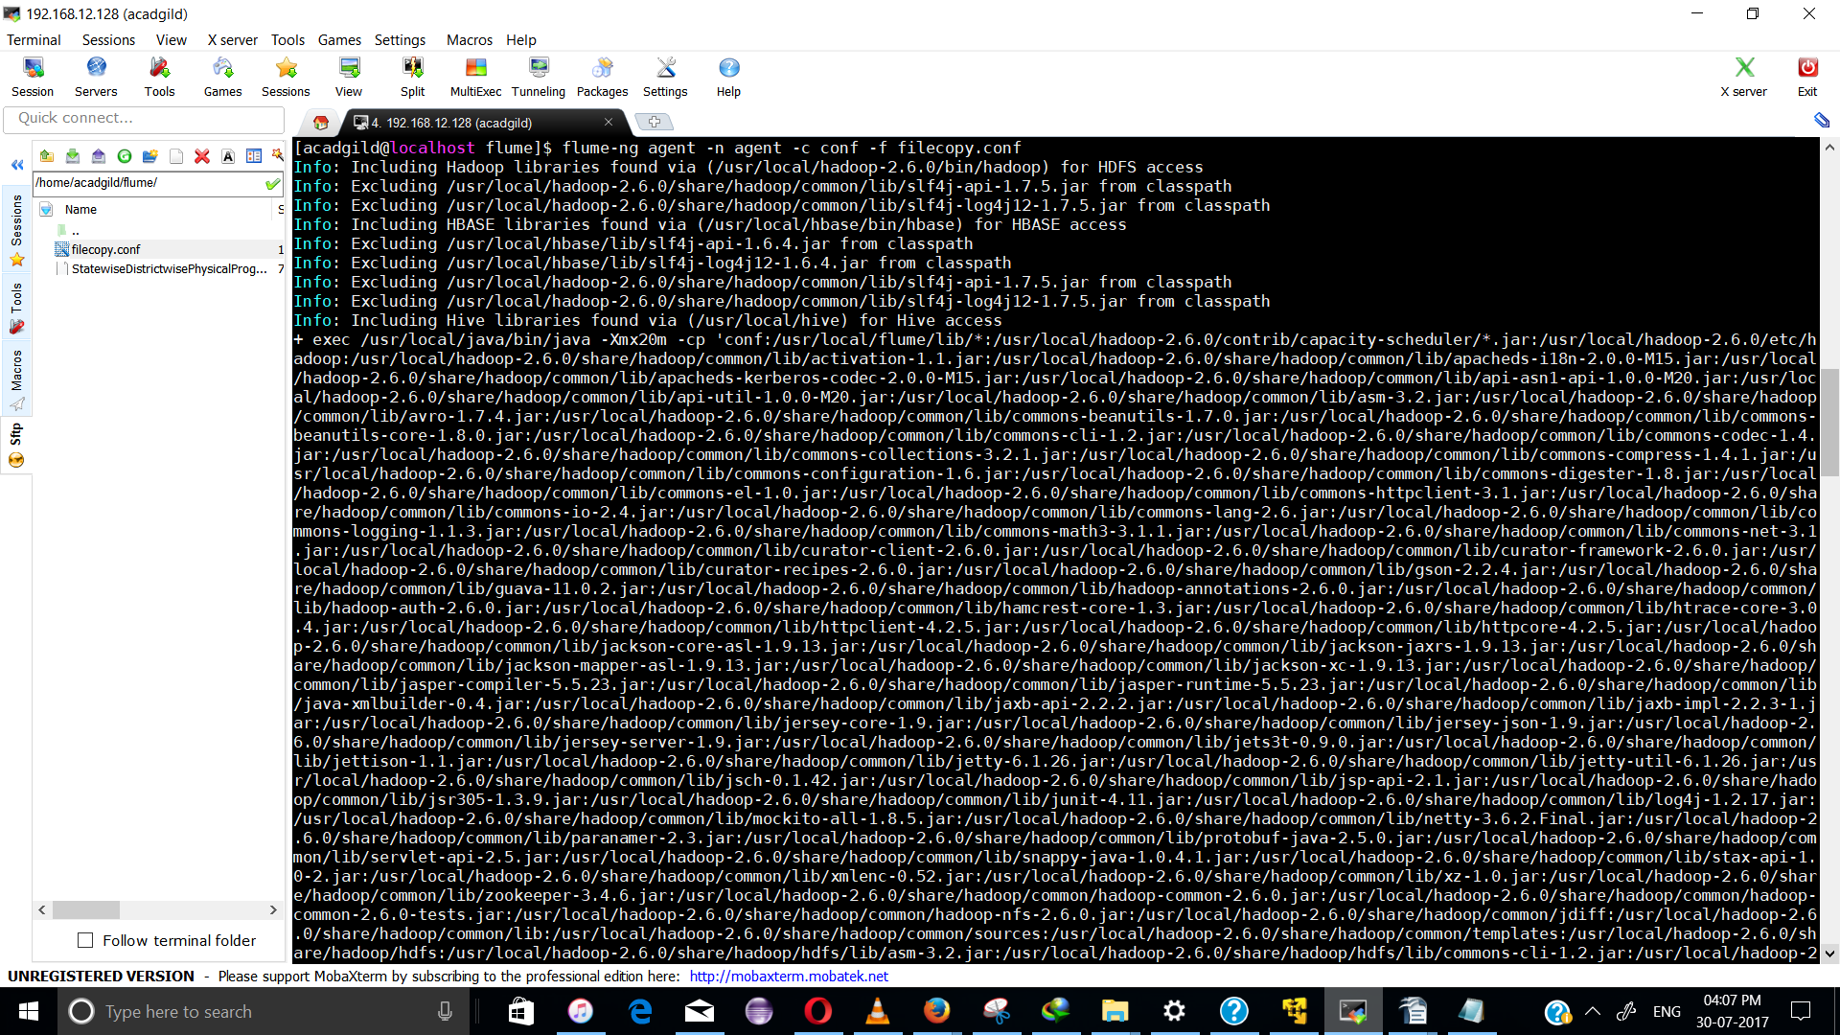
File copied after flume execution:
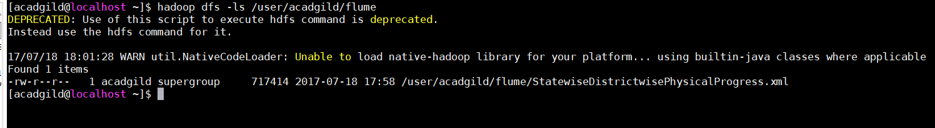

Priority 2:

Problem 1:
1. Find out the districts who achieved 100 percent objective in BPL cards
Export the results to mysql using sqoop

PIG commands:
REGISTER /home/acadgild/flume/piggybank-0.15.0.jar;

DEFINE XPath org.apache.pig.piggybank.evaluation.xml.XPath();

Data = LOAD '/home/acadgild/flume/StatewiseDistrictwisePhysicalProgress.xml' using org.apache.pig.piggybank.storage.XMLLoader('row') as (x:chararray);
StateDet = FOREACH Data GENERATE XPath(x, 'row/State_Name') AS statename, XPath(x, 'row/District_Name') AS disname,XPath(x, 'row/Project_Objectives_IHHL_BPL') AS BPL,XPath(x, 'row/Project_Objectives_IHHL_TOTAL') AS total ;
ObjFiltered = FILTER StateDet BY BPL == total;

STORE ObjFiltered INTO 'hdfs://localhost:9000/flume_import_out' USING PigStorage(',');

The File has been loaded into path:

hdfs://localhost:9000/flume_import_out

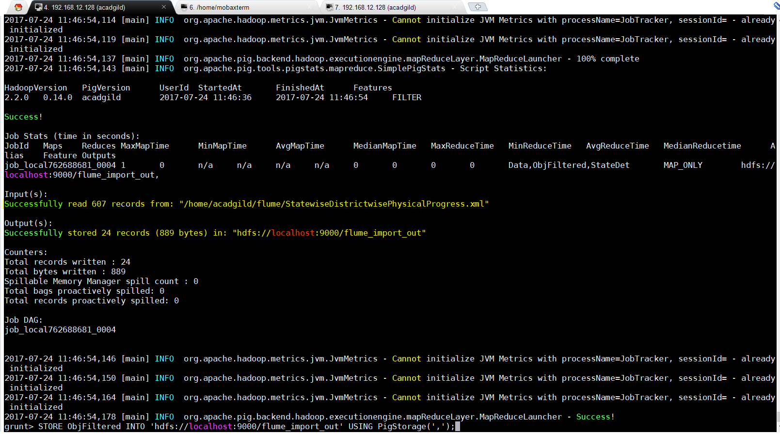
File Location:
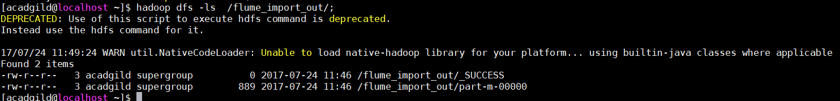
Starting MYSQL:
sudo service mysqld start;

Create a new Database:
mysql>create database DistrictDB;
mysql>use state;

Create a table similar to the structure of the output file contents:
mysql>create table BPLObjectivesMet (State varchar(20), district varchar(50), BPL int, total int);
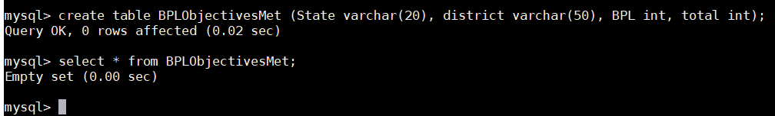

In Terminal1, run the sqoop command to Export the Pig Script analysis from HDFS to MySQL:

sqoop export --connect jdbc:mysql://localhost:3306/districtdb --table BPLObjectivesMet -m 1 --export-dir /flume_import_out/

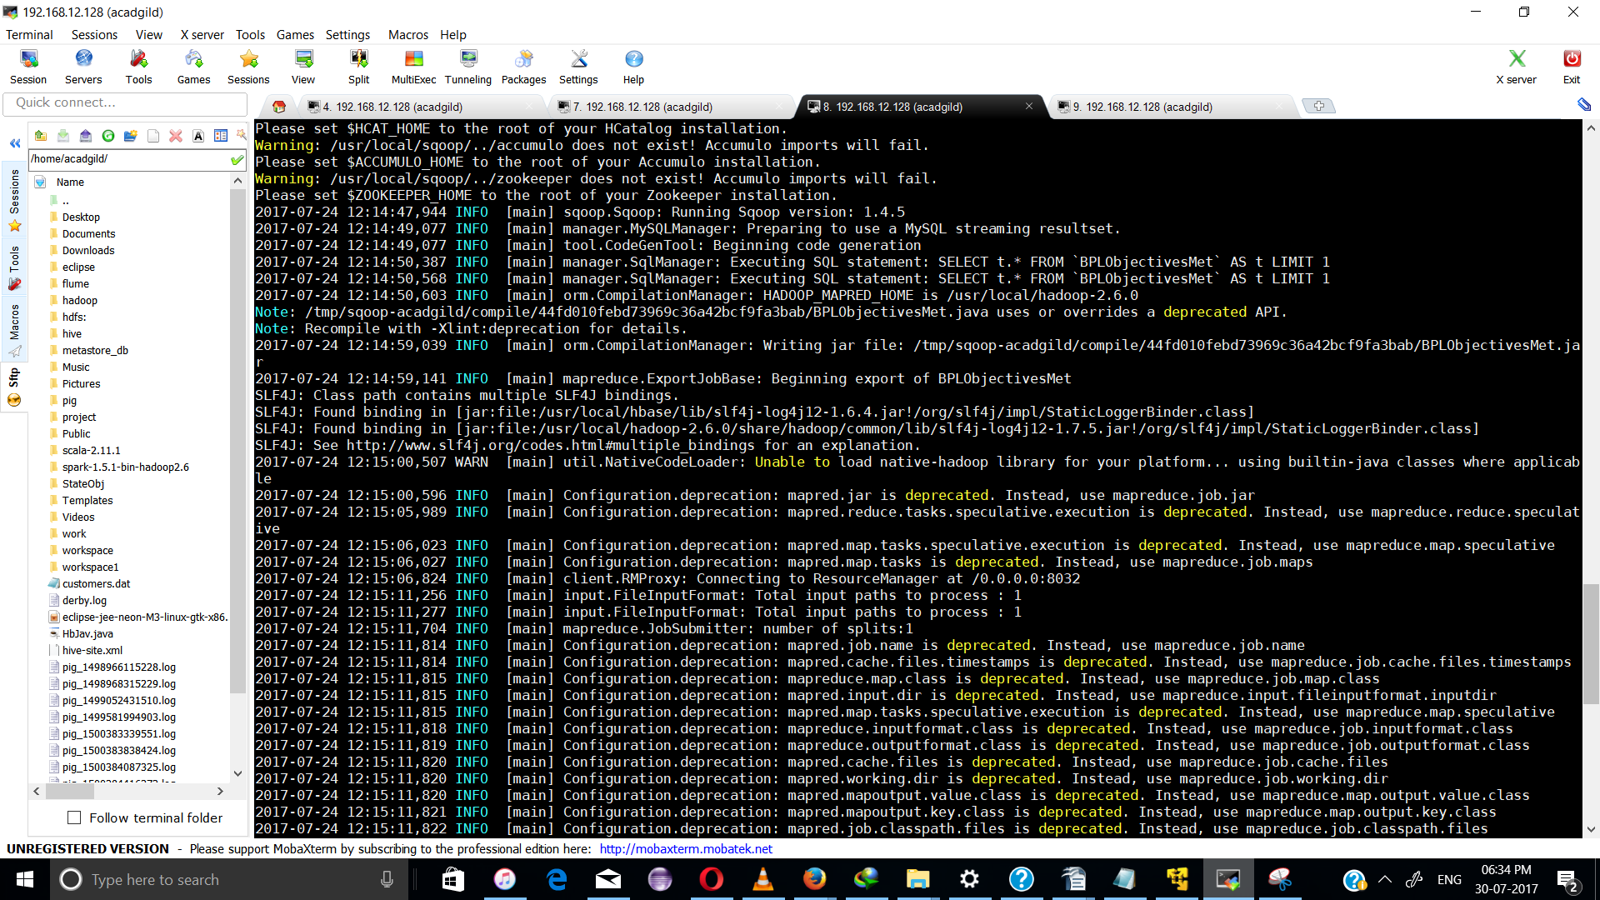

In Terminal2, check for if the Tables have been populated with data:
mysql> select * from BPLObjectivesMet;
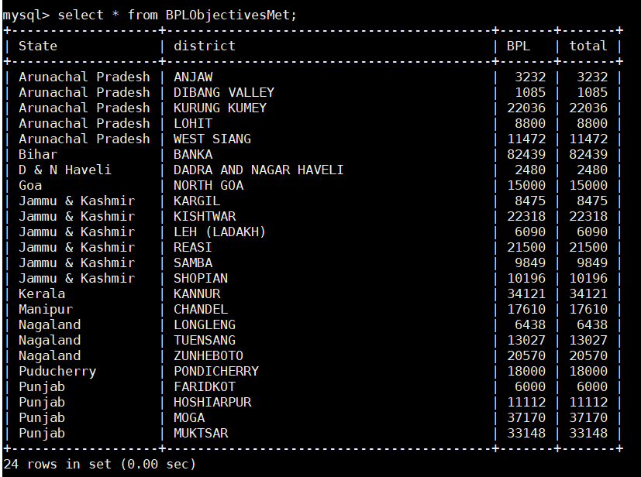

Problem 2:

Create a Pig UDF Filter function to calculate districts that have met 80% or more of the BPL card Objectives.
Convert it into a Jar file to implement as a UDF filter in Pig Script

To create the Jar File, Open eclipse, Create a new java Project: CalcPC.java and add external jar Files from
------------------------------------------------------------------------------------------------------------
1) /usr/local/pig
2) /usr/local/hadoop-2.6.0/share/hadoop/common/lib
3) /usr/local/hadoop-2.6.0/share/hadoop/common
4) /usr/local/pig/lib/hadoop1-runtime

CalcPC.java
------------
import java.io.IOException;
import org.apache.pig.FilterFunc;
import org.apache.pig.data.Tuple;

public class CalcPc extends FilterFunc {
public Boolean exec (Tuple input) throws IOException
{
try
{
int value1 = Integer.parseInt((String) input.get(0));
int value2 = Integer.parseInt((String) input.get(1));

if (value1 == 0 || value2 == 0 )
{
System.out.println("zero values");
System.exit(1);
}
return ((value1/value2)>=0.8);
}
catch (Exception e)
{
System.out.println("something wrong"+e.getMessage());
}
return null;
}

Export the java class to state1.jar

state.pig
----------
REGISTER /home/acadgild/state1.jar;
REGISTER /home/acadgild/flume/piggybank-0.15.0.jar;

DEFINE XPath org.apache.pig.piggybank.evaluation.xml.XPath();

Data = LOAD '/home/acadgild/flume/StatewiseDistrictwisePhysicalProgress.xml' using org.apache.pig.piggybank.storage.XMLLoader('row') as (x:chararray);

StateDet = FOREACH Data GENERATE XPath(x, 'row/State_Name') AS statename, XPath(x, 'row/District_Name') AS disname,XPath(x, 'row/Project_Objectives_IHHL_BPL') AS BPL,XPath(x, 'row/Project_Objectives_IHHL_TOTAL') AS total ;
FilteredData = FILTER StateDet BY project.CalcPc(BPL,total);
STORE FilteredData INTO 'hdfs://localhost:9000/flume_import_out2' USING PigStorage(',');

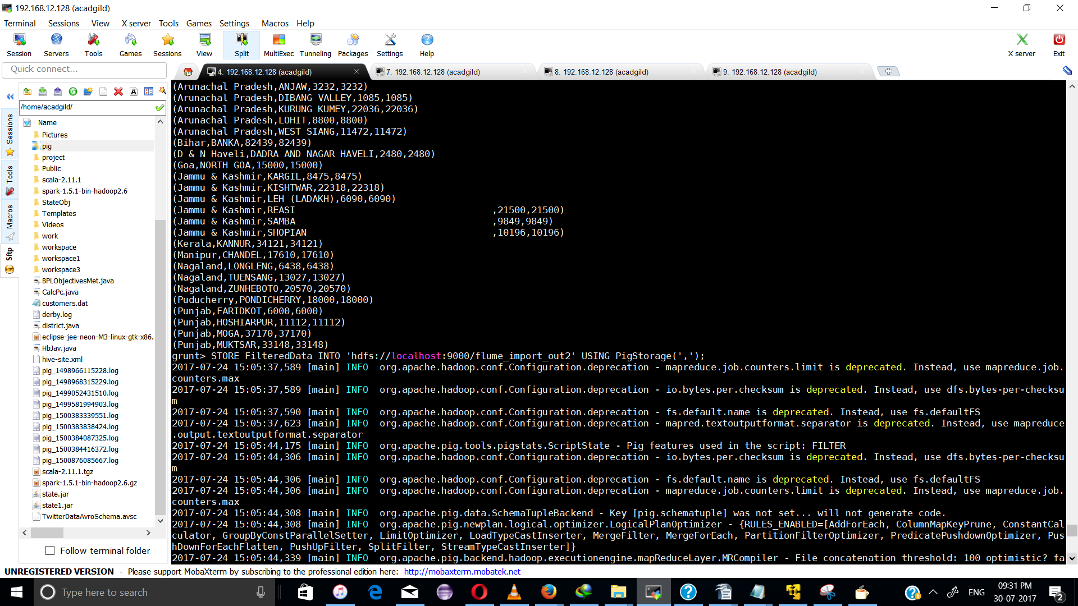
File Present in the HDFS path hdfs://localhost:9000/flume_import_out2
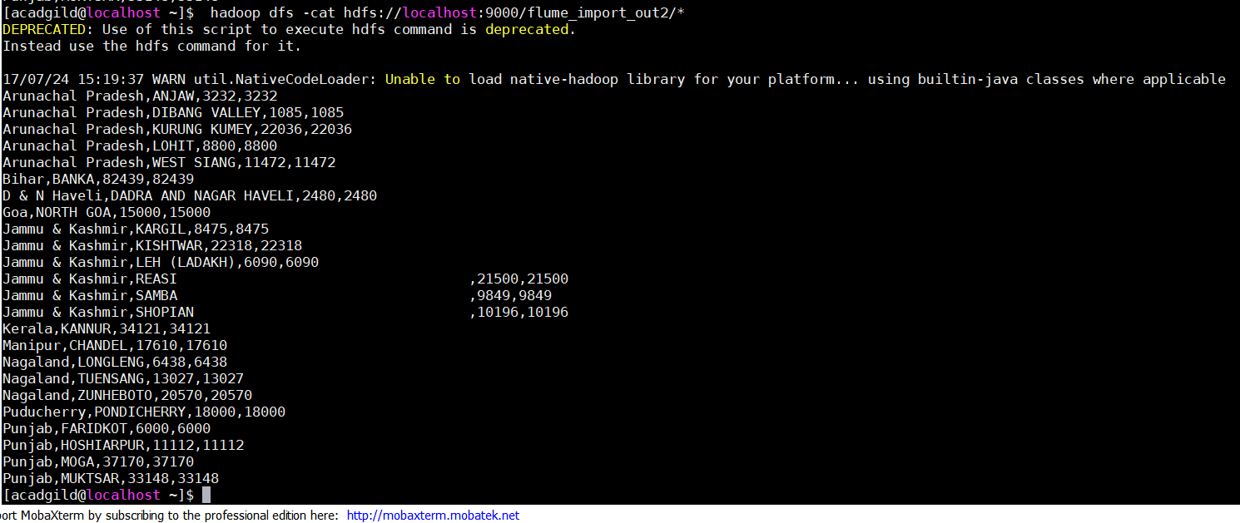

Creating table for Probelm2

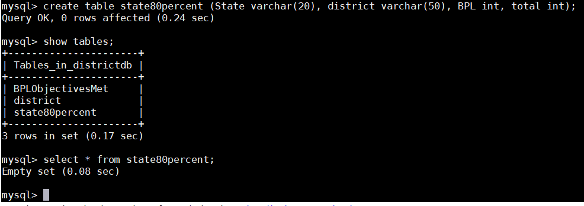

In terminal1, run the sqoop export command to transfer output from hdfs to MySQL
---------------------------------------------------------------------------------

sqoop export --connect jdbc:mysql://localhost:3306/districtdb --table state80percent -m 1 --export-dir /flume_import_out2/

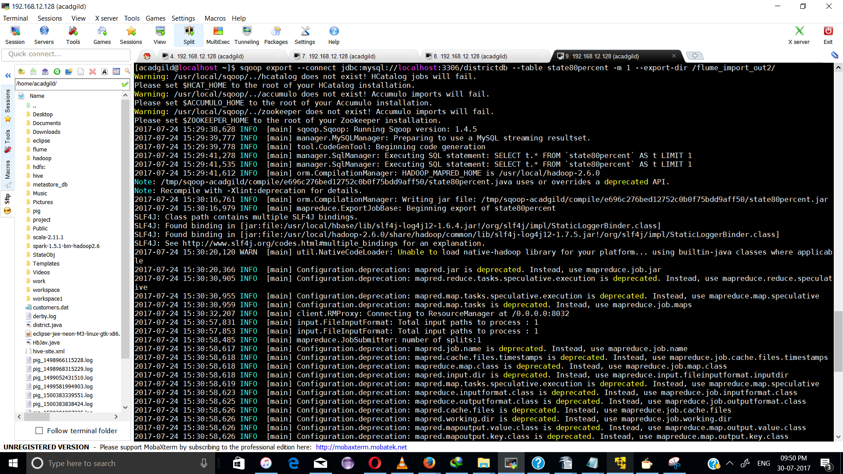

In terminal2, check if the table has been populated with data
mysql> select * from state80percent;

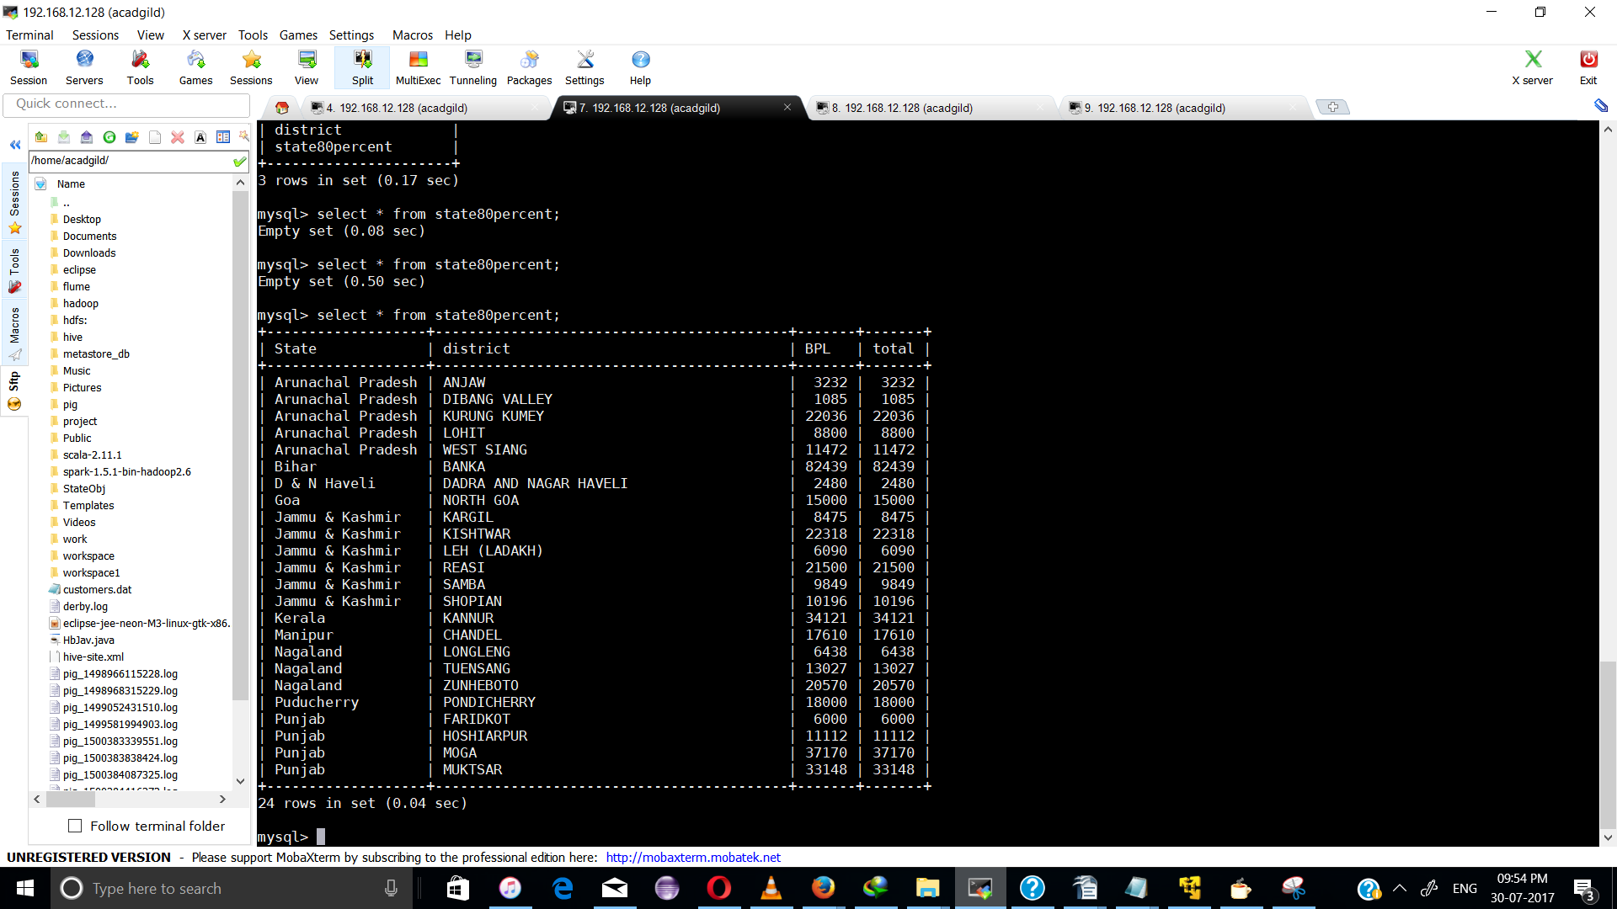

the problem 2 statement has been comleted

