

**Smart Task Assignment System Using AI Algorithms**

* Prepared by:  
  - Deya Alaidi  
  - Wadee Smirat  
  - Leen Mohamed

Supervised by:  
Dr. Basam Hadad

University of Petra – Department of Computer Science

Academic Year: 2025

# Abstract

Task assignment is a common challenge in many organizations where employees must be allocated to tasks based on skills, availability, and workload. This project proposes a smart task assignment dashboard that uses three artificial intelligence algorithms: Greedy, Genetic Algorithm, and Firefly Algorithm to assign tasks effectively. The system is implemented using Python and provides a graphical dashboard in Jupyter Notebook, allowing comparison between the performance of different algorithms.

# Scope

This project focuses on optimizing employee-task assignment using AI-based techniques. Each employee has a skill set and a maximum number of working hours per day. Each task requires a specific skill and has a duration. The system's goal is to assign tasks to suitable employees in a way that respects employee capacity, prioritizes skill match, and distributes workload efficiently.

# Algorithms Overview

1. Greedy Algorithm: A fast and simple approach that assigns each task to the employee with the least hours, if they match the required skill.

2. Genetic Algorithm: A biologically inspired method that uses evolution principles to find optimal assignments. It uses selection, crossover, and mutation.

3. Firefly Algorithm: Inspired by the flashing behavior of fireflies. Brighter fireflies attract others; similarly, better solutions attract other candidates.

# Dataset Format

We use two simple text files:

employees.txt:  
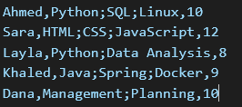

tasks.txt:  
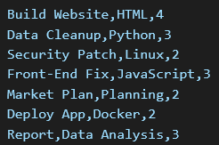

# System Architecture

Input: 2 files (employees & tasks)  
Processing: Each algorithm assigns tasks  
Output: Task assignment table + charts  
Interface: Jupyter Notebook with automatic comparison

# Code Breakdown

Data Loading:  
Screenshot 2025-06-05 225249

**Data Loading:**  
  
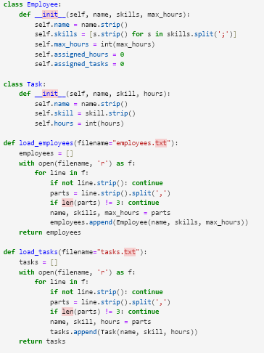

Greedy Assignment:  
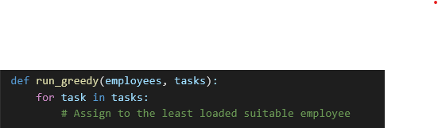

Fastest method, runs in linear time.

Genetic Algorithm:  
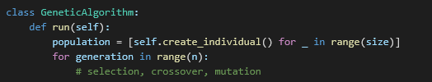

Firefly Algorithm:

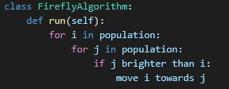

# Visual Output Example

The dashboard shows:  
- A colored table of tasks vs employees  
- A pie chart of skill usage  
- A bar chart of employee workload

# Results & Comparison

0.1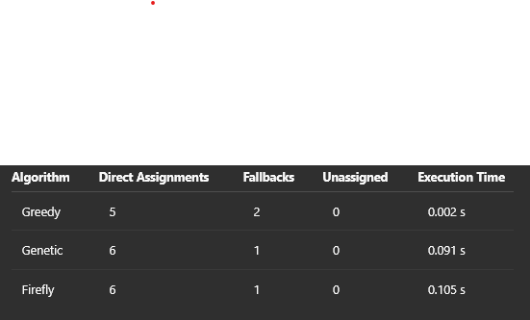

# Conclusion

This project demonstrates how combining artificial intelligence with a visual dashboard can enhance decision-making in task assignment. While the greedy algorithm is fastest, Genetic and Firefly provide better quality assignments. The system is extendable to real-world applications like project management, workforce scheduling, and even resource allocation.