Jordan University of Science and Technology
Faculty of Computer and Information Technology

CS362 – Artificial Intelligence
Phase One Report

Student Name | Leen Mahmoud
Student ID | 165930
Semester | Second Semester 2025/2026
Submission Date | May 2026

1. Selected Datasets
For this project, I decided to work with two different datasets from Kaggle to cover both classification and regression tasks.
- Dataset 1 (Fetal Health): This is for Classification. It has 2,126 records and 22 features. The goal is to predict the fetal_health category (1, 2, or 3).
"Note: The labels were shifted from (1, 2, 3) to (0, 1, 2) during preprocessing to ensure compatibility with the classification algorithms."
- Dataset 2 (Body Fat): This is for Regression. It's a smaller dataset with 252 rows and 15 features, where we try to predict the BodyFat percentage as a continuous number.

2. Why I chose these tasks?
- 2.1 Fetal Health (Classification)
I picked this one for classification because the outcome we’re looking for isn't a range of numbers, but rather three specific categories: Normal, Suspect, and Pathological. The data comes from CTG scans (like heart rate and contractions), and the goal is to sort each case into one of these three buckets. Since we are dealing with distinct labels, it’s a perfect fit for a classification model.
- 2.2 Body Fat Prediction (Regression)
On the other hand, I chose the Body Fat dataset for regression. Here, we aren't trying to put people into "groups," but we want to predict an exact percentage of body fat (like 15.5% or 22.1%). This target is a continuous numerical value based on body measurements like weight, height, and abdomen circumference. Because we’re predicting an actual number, it has to be a regression task.

3. EDA – Exploratory Data Analysis

3.1 Fetal Health
Summary Statistics
I started by running describe() to get an overview. All 2,126 rows are complete, so there are no missing values to worry about. However, I noticed a huge range difference between features; while baseline value is around 130, accelerations is a tiny decimal (0.019 max). This confirmed that Feature Scaling is a must-do step before training.
Class Distribution
I used a countplot to check how many samples we have for each health category. Class 1 (Normal) dominates the dataset at around 77%, making it clearly imbalanced. I’ll need to handle this in Phase Two, perhaps by using better metrics like the F1-score instead of just accuracy.
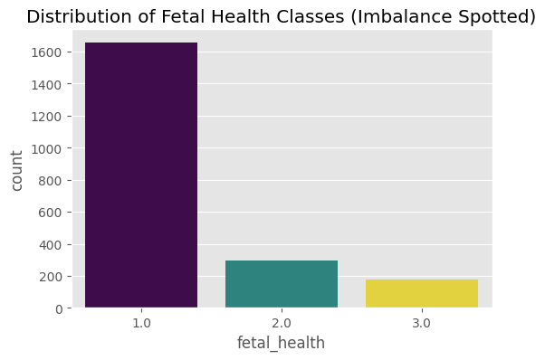
Figure 1: Distribution of fetal_health classes showing clear class imbalance
Feature Distributions
I plotted histograms for the main clinical features to see their "shape." Most of them, like fetal_movement and decelerations, are right-skewed, meaning most cases have low values while only a few abnormal cases show higher numbers. This is typical for medical datasets.

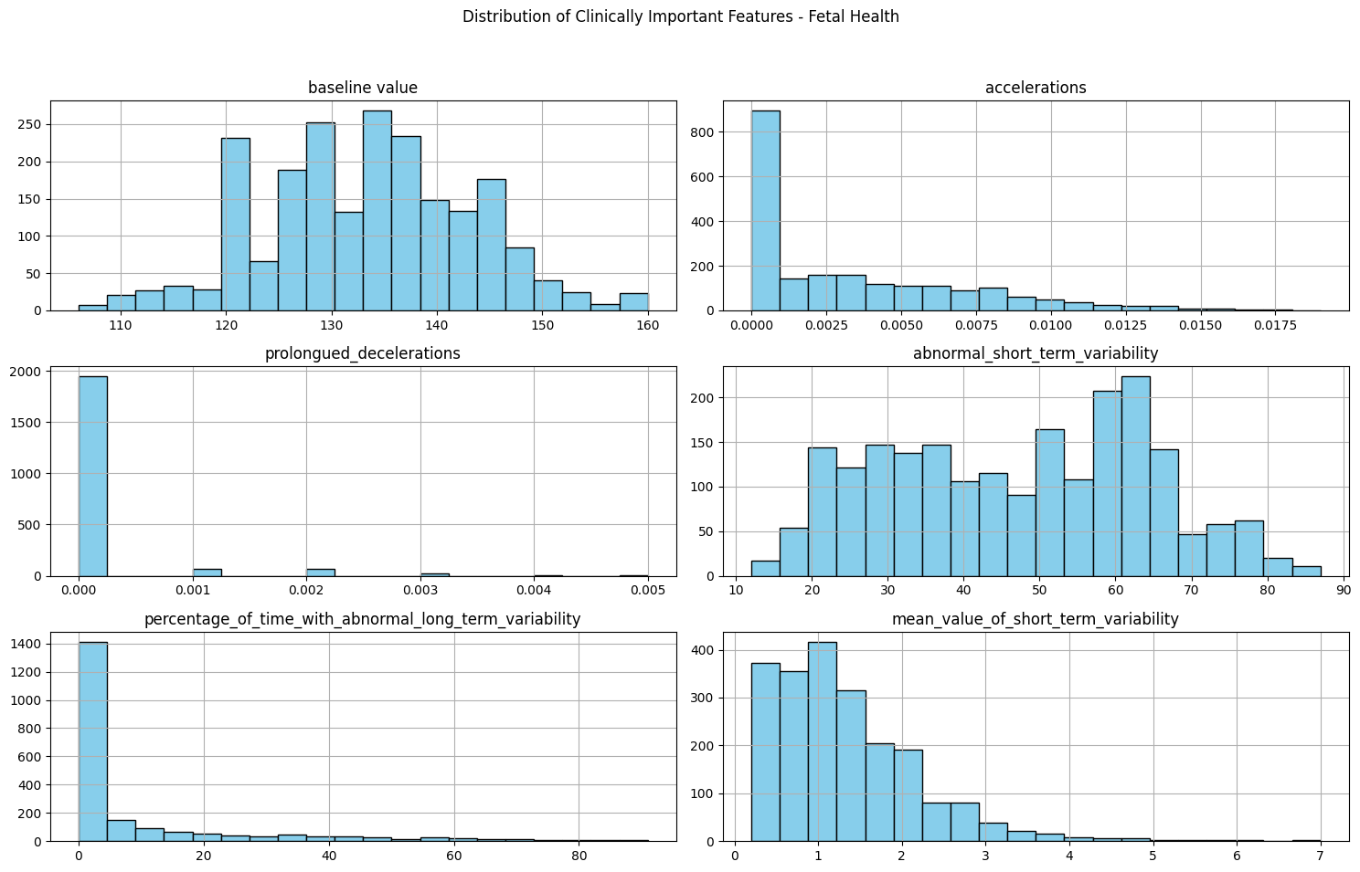
Figure 2:Distribution of clinically important features.
Correlation Heatmap
The heatmap was key to seeing which features actually impact the health class. Features like prolongued_decelerations and abnormal_short_term_variability showed the strongest correlations. I also used this map to identify redundant features (like histogram_mean and median) which I later dropped to avoid multicollinearity.
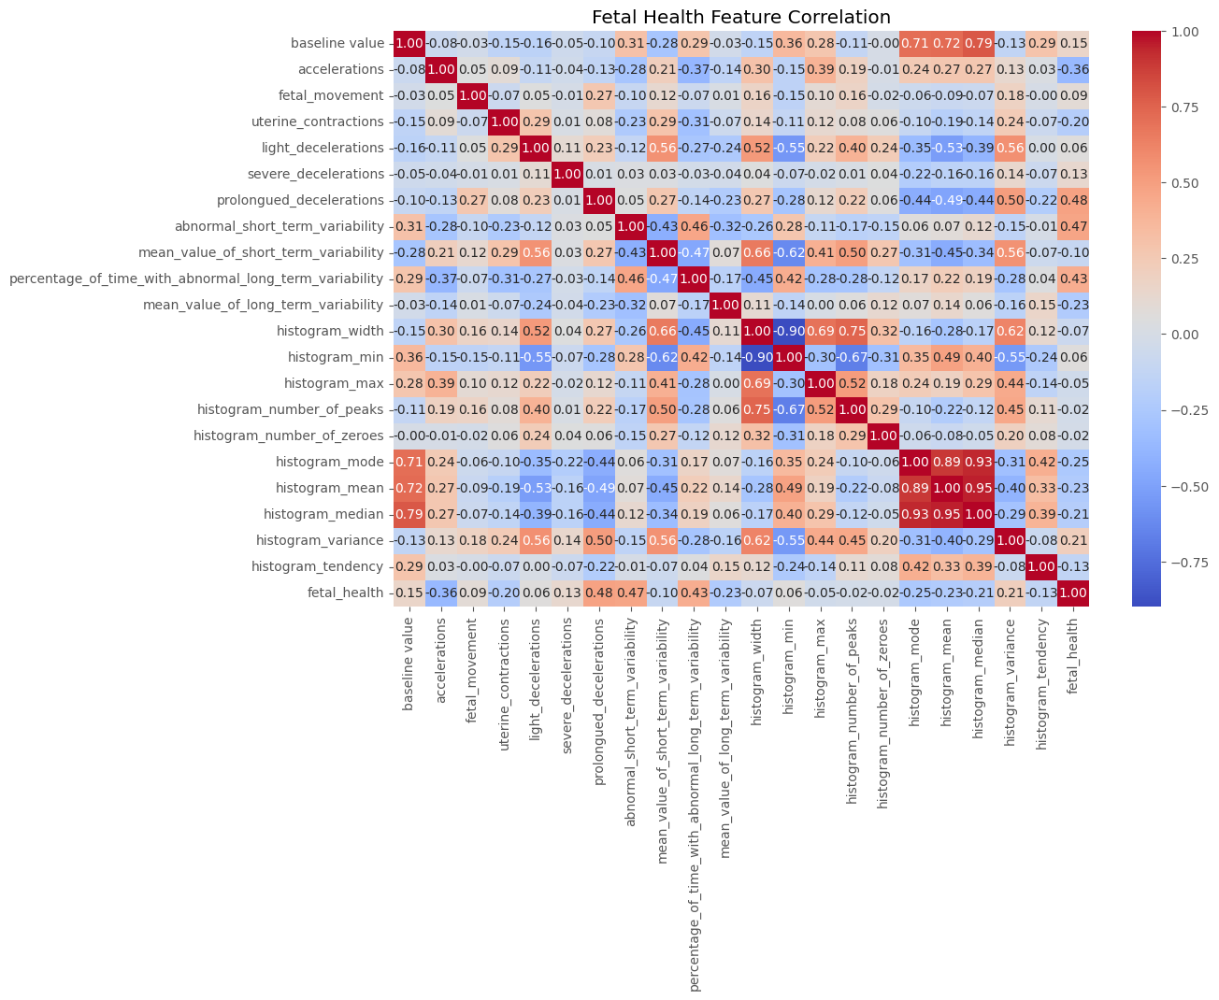
Figure 3: Correlation heatmap for fetal health features.

3.2 Body Fat
Summary Statistics
I started by checking the summary statistics for the Body Fat dataset. The data has 252 rows and 15 features. Just like the first dataset, there were no missing values, which made the initial cleaning easier.
Outlier Detection and Handling
When I looked at the Boxplots and histograms, I noticed some serious outliers:
- Height: There was a logical error where one person's height was listed as 29.5 inches, which is impossible for an adult. I filtered the data to keep only heights above 40 inches.
- Weight: I found some extreme values in weight, so I used the IQR (Interquartile Range) method to remove them and make the data more consistent.

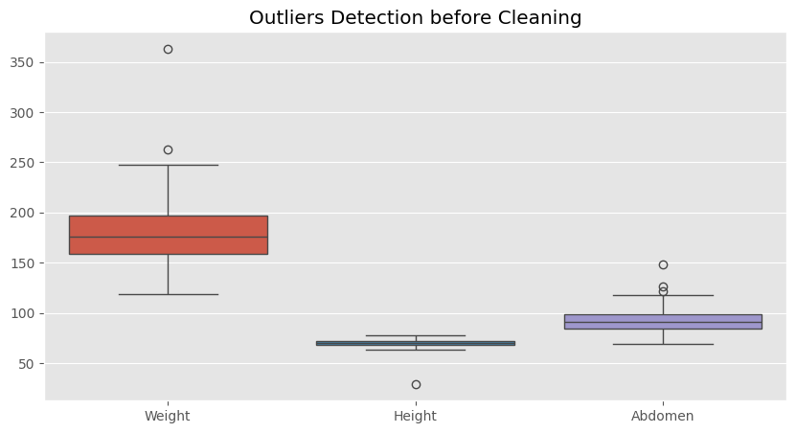 | 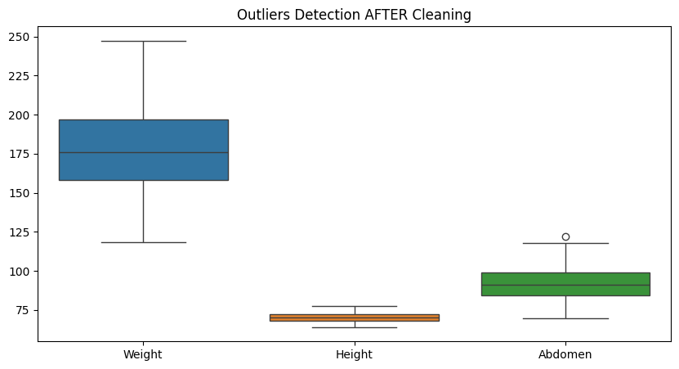

Figure 4: Outlier detection before and after the cleaning process.
Distribution of Features
I plotted histograms for the target variable (BodyFat) and main features like Weight and Abdomen. Most of them follow a normal distribution, but there's a clear difference in scales (Weight is in pounds, while others are in inches), which confirms that Scaling is necessary.

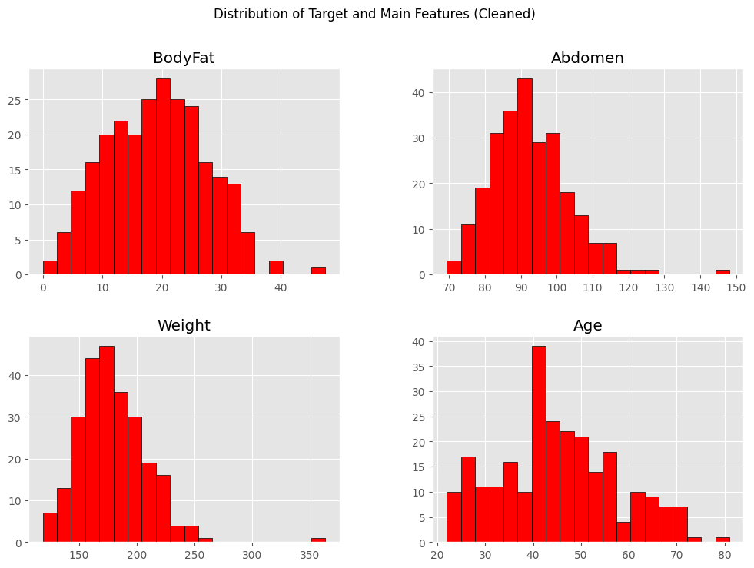
Figure 5:Distribution Histograms
Correlation Heatmap & Feature Selection
The heatmap showed a very high correlation (almost 1.0) between Density and BodyFat.
- Decision: I decided to drop the Density column. Why? Because it’s calculated using a direct mathematical formula with body fat. If I leave it, the model will just "cheat" by using it to predict the answer instead of learning from the body measurements.
- I also noticed that Abdomen circumference has the highest correlation with body fat, making it one of the most important predictors.
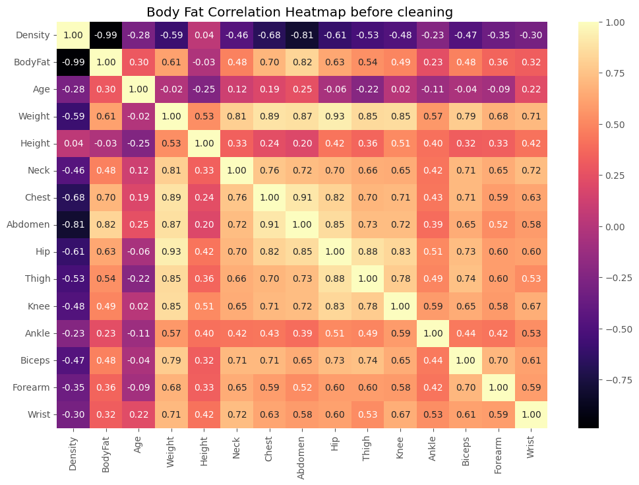
Figure 5:Correlation Heatmap for Body Fat
Note: "As shown in the heatmap, the correlation between Density and BodyFat is -0.99. This is why I decided to drop the Density column to prevent data leakage."

Preprocessing Final Steps
Finally, I applied StandardScaler to all features to ensure they are on the same scale before moving to the regression models. The data is now clean, scaled, and ready for Phase Two.

Categorical Encoding: I performed a data type check using df.dtypes for all features. Since both datasets consist entirely of numerical values (integers and floats), no categorical encoding (such as One-Hot or Label Encoding) was required for the features.

Date Parsing: I verified that neither dataset contains date or time-related information; therefore, date parsing was not applicable for this project.

5. Summary
Step | Fetal Health | Body Fat
Missing Values | None (Verified via isnull()) | None (Verified via isnull())
Outlier Detection | No outliers found | Boxplot + IQR + manual check
Outlier Handling | N/A | Height > 40 filter; IQR for Weight
Column Removal | Redundant features & Target | Density removed (leakage)
Label Encoding | Labels shifted: {1,2,3} → {0,1,2} | Not applicable
Scaling | StandardScaler applied | StandardScaler applied
Class Imbalance | Identified; to handle in Phase Two | Not applicable
Categorical Encoding | None (All features are numerical) | None (All features are numerical)
Date Parsing | Not Applicable (No date features) | Not Applicable (No date features)

