Assignment 2
2025-03-22
library(ggplot2)
library(ggridges) #for ridgeline plot
library(ggforce) #for pie chart
data = read.csv("workout_fitness_tracker_data.csv")
head(data)
## User.ID Age Gender Height..cm. Weight..kg. Workout.Type
## 1 1 39 Male 175 99 Cycling
## 2 2 36 Other 157 112 Cardio
## 3 3 25 Female 180 66 HIIT
## 4 4 56 Male 154 89 Cycling
## 5 5 53 Other 194 59 Strength
## 6 6 33 Male 162 81 Yoga
## Workout.Duration..mins. Calories.Burned Heart.Rate..bpm. Steps.Taken
## 1 79 384 112 8850
## 2 73 612 168 2821
## 3 27 540 133 18898
## 4 39 672 118 14102
## 5 56 410 170 16518
## 6 11 301 142 10895
## Distance..km. Workout.Intensity Sleep.Hours Water.Intake..liters.
## 1 14.44 High 8.2 1.9
## 2 1.10 High 8.6 1.9
## 3 7.28 High 9.8 1.9
## 4 6.55 Medium 5.8 1.9
## 5 3.17 Medium 7.3 1.9
## 6 6.53 Low 4.2 1.9
## Daily.Calories.Intake Resting.Heart.Rate..bpm. VO2.Max Body.Fat....
## 1 3195 61 38.4 28.5
## 2 2541 73 38.4 28.5
## 3 3362 80 38.4 28.5
## 4 2071 65 38.4 28.5
## 5 3298 59 38.4 28.5
## 6 2401 69 38.4 28.5
## Mood.Before.Workout Mood.After.Workout
## 1 Tired Fatigued
## 2 Happy Energized
## 3 Happy Fatigued
## 4 Neutral Neutral
## 5 Stressed Energized
## 6 Happy Neutral
#pie chart
ggplot(data, aes(x = "", y = Sleep.Hours, fill = Gender)) +
geom_col(width = 1) +
coord_polar(theta = "y") +
labs(title = "Pie Chart of Sleep Hours for each Gender", x = "", y = "") +
scale_fill_manual(values = c("#B5E48C", "#34A0A4", "#1E6091"))
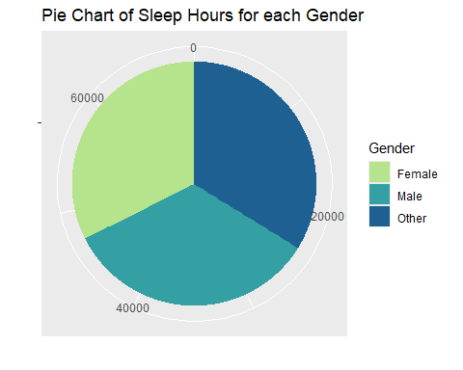
#stacked bar plot
ggplot(data, aes(x = Mood.Before.Workout, fill = Gender)) +
geom_bar(width=.5) +
scale_fill_manual(values = c("#B5E48C", "#34A0A4", "#1E6091")) +
labs(title = "Side-by-Side Bar Plot of Gender Workout Intensity", x = "Mood before Workout")
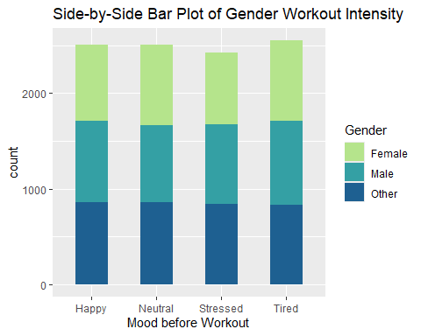
#side-by-side bar plots
ggplot(data, aes(x = Workout.Intensity, fill = Gender)) +
geom_bar(width=.5, position = "dodge") +
scale_fill_manual(values = c("#B5E48C", "#34A0A4", "#1E6091")) +
labs(title = "Side-by-Side Bar Plot of Gender Workout Intensity", x = "Intensity of Workout")
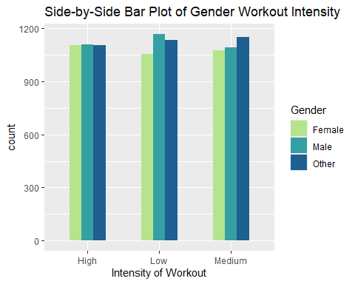
#stacked densities
ggplot(data, aes(x = Mood.After.Workout, fill = Workout.Intensity)) +
geom_density(alpha = 0.35) +
scale_fill_manual(values = c("#B5E48C", "#34A0A4", "#1E6091")) +
labs(title = "Stacked Density of Workout Intensity VS Mood after Workout", x = "Mood after Workout",
fill = "Workout Intensity")
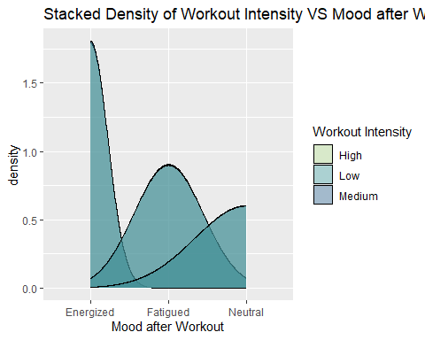
#box plot
ggplot(data, aes(x = Workout.Type, y = Heart.Rate..bpm., fill = Workout.Type)) +
geom_boxplot(outlier.colour = "red", outlier.shape = 16, outlier.size = 2) +
scale_fill_manual(values = c("#D9ED92", "#99D98C", "#52B69A", "#34A0A4", "#1A759F", "#184E77")) +
labs(title = "Boxplot of Heart Rate (bpm) for Workout Types", x = "Workout Type",
y = "Heart Rate (bpm)", fill = "Workout Type")
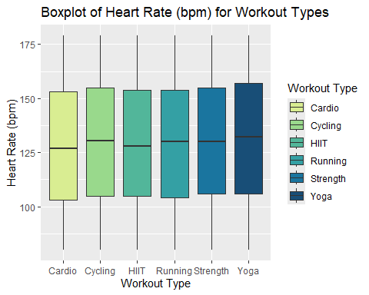
#violin plot
ggplot(data, aes(x = Gender, y = Steps.Taken, fill = Gender)) +
geom_violin() +
scale_fill_manual(values = c("#B5E48C", "#34A0A4", "#1E6091")) +
labs(title = "Violin Plot for Steps Taken for Genders", y = "Steps Taken")
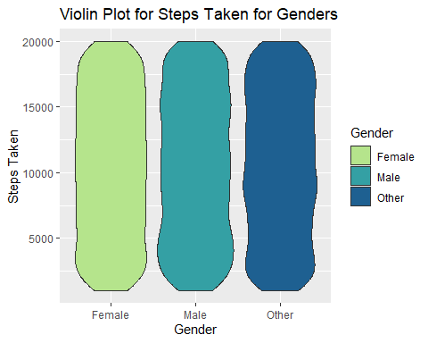
#ridgeline plot
ggplot(data, aes(x = Workout.Duration..mins., y = Workout.Type, fill = Workout.Type)) +
geom_density_ridges() +
scale_fill_manual(values = c("#D9ED92", "#99D98C", "#52B69A", "#34A0A4", "#1A759F", "#184E77")) +
labs(title = "Ridgeline Plot for Workout Duration and Workout Type", x = "Workout Duration (mins)", y = "Wourkout Type", fill = "Workout Type")
## Picking joint bandwidth of 6.49
