AI-Driven Atmospheric Drag Sail for Rapid CubeSat Deorbiting
Team AnaMALY · AESS Hackathon Concept Document
1. Problem & Proposed Solution
A 6U CubeSat at 600 km sun-synchronous orbit takes 25–50 years to deorbit naturally — violating the ESA Zero Debris 5-year rule (ESSB-ST-U-007 §SDM-50). Passive drag sails alone often miss this target because density at this altitude swings ~10× with the 11-year solar cycle: a sail deployed at the wrong moment delivers only a fraction of its potential drag.
Our Smart Deorbit Subsystem pairs a thin-film drag sail with an AI Inference IC governed by a Subsystem MCU (Manager) with ECC memory. F10.7 solar flux data is uplinked via COM, processed on the ground into a probabilistic forecast and a distilled deployment policy, and stored on the IC pre-launch. In flight the IC issues WAIT/DEPLOY each orbit; ADCS holds the deployed sail perpendicular to the velocity vector for maximum drag.
2. Operating Logic (Adaptive Algorithm)
- Mission Phase: AI Inference IC power-gated; periodic health checks only.
- EOL Trigger: mission ends, or Watchdog Timer fires after 365-day loss of ground heartbeat.
- Data Harvest: OBC fetches NOAA F10.7 via COM; ADCS provides altitude/state via CAN to the Subsystem MCU.
- AI Inference (two-stage). Ground: Gaussian Process forecaster trained on 21 yr of NOAA SWPC F10.7 → probabilistic forecast. A robust optimizer scores each candidate day across 30 sampled futures. Flight: the policy is distilled into a depth-5 decision tree, exported to 970 bytes of portable C, and runs on the AI Inference IC each orbit. Inputs: mission day, current F10.7, F10.7 30-day slope, altitude, days since EOM. Output: WAIT or DEPLOY (microseconds).
- Sequential Verification: Subsystem MCU requires two DEPLOY signals 60 s apart before arming the Deployment Driver (rejects bit-flip transients).
- Active Aerobraking: ADCS locks Max-Drag attitude; MCU monitors decay until reentry.
3. System Architecture
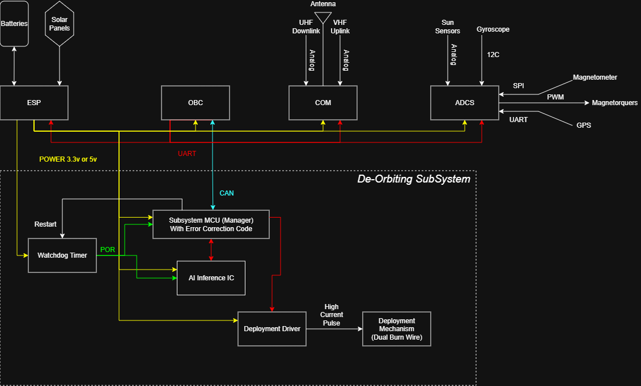
Figure 1 — De-Orbiting Subsystem block diagram (dashed boundary). ESP supplies 3.3/5 V; single CAN link to OBC. The AI Inference IC reports WAIT/DEPLOY to the Subsystem MCU (Manager); the MCU arms the Deployment Driver to fire the dual burn-wire mechanism. The Watchdog Timer provides POR + 365-day EOL fail-safe.
4. Deorbit KPI Comparison (Simulation Output)
6U CubeSat at 600 km, 8 kg, 0.40 m² deployed sail (≈13× stowed). Drag model: F = ½ρ(h, F10.7)·v²·A·C_d (C_d = 2.2). Decay integrated via da/dt = −(C_d·A/m)·ρ·v·a. Atmospheric density: Vallado exponential profile with empirical F10.7 modulation matching NRLMSIS-2.1. The p95 column is the 95th-percentile worst-case post-EOM lifetime across 30 GP forecast samples — a bound only the AI strategies can quantify.
Scenario | Strategy | Post-EOM (yr) | p95 worst (yr) | ESA 5-yr
Baseline | No sail (natural decay) | ≈37 | — | FAIL
Naive | Sail at EOM, no timing | 4.77 | 5.30 | PASS
AI-Adaptive | GP-forecast robust timing | 4.77 | 5.30 | PASS (bounded)
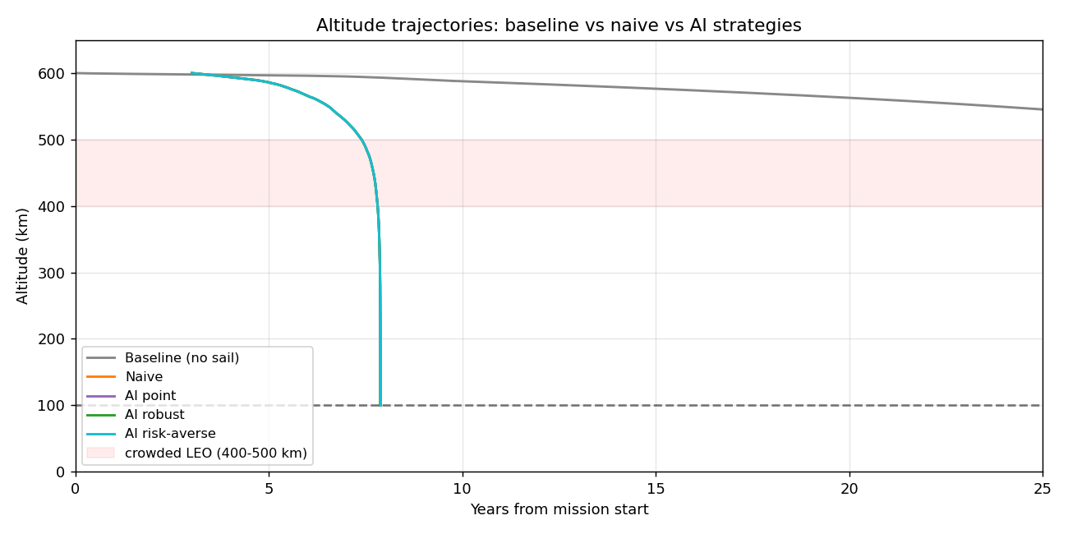
Figure 2 — Altitude vs time. Baseline (grey, no sail) lingers in LEO for decades; sail strategies (overlapping coloured lines) reach 100 km reentry by year ~8. The pink band marks the 400–500 km crowded LEO shell — sail scenarios reduce that residence by ~15×.
5. Impact & References
By cutting orbital graveyard time by >80% and providing a quantified worst-case bound under solar uncertainty, the system aligns with the ESA Zero Debris Charter 2030 and keeps the 600 km shell sustainable for future missions. Layered fail-safes (ECC memory, dual-YES protocol, redundant burn-wires, subsystem isolation, dual-function watchdog) and a fully auditable deterministic policy make this design credible as a flight subsystem rather than a paper concept.
References: ESA ESSB-ST-U-007 Issue 1 §SDM-50 · NOAA SWPC observed solar cycle indices · Underwood et al. 2019 (InflateSail, Acta Astronautica 162) · Bonin/Risi/Zee 2018 (CanX-7, AIAA SmallSat) · Furano et al. 2020 (AI on the Edge in Space, IEEE A&E Sys Mag) · Vallado 2013 Table 8-4 · Moe & Moe 2005 (C_d) · ESA Phi-Sat-1 · BayesWatch m2cgen.

