a. Use ssh command to connect to localhost:

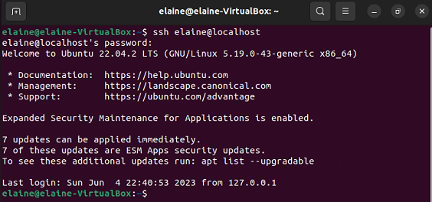

b. using ssh-kengen to create private/public keys

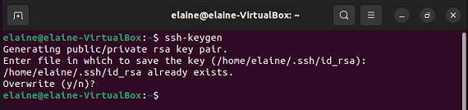

c. using scp to upload file to server

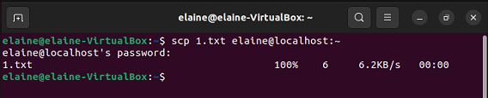

d.using history command to display command history

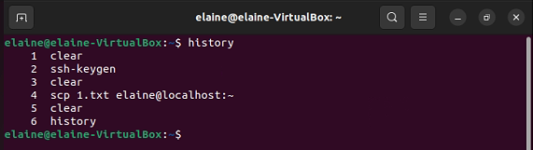

e. using sudo command to get root privilege temporary

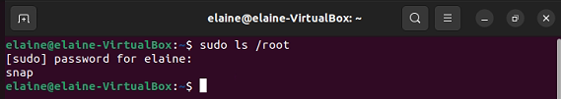

f. using ip command to display ip address

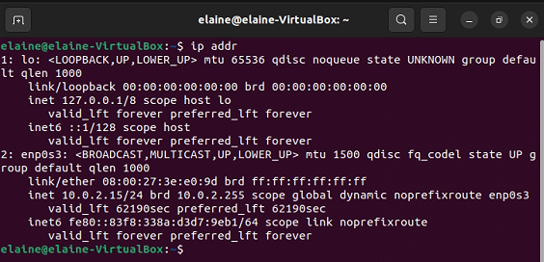

g. using dd command to generate file with size 5MB

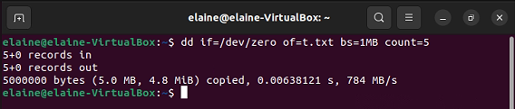

h. using fdisk command to display disk partition list

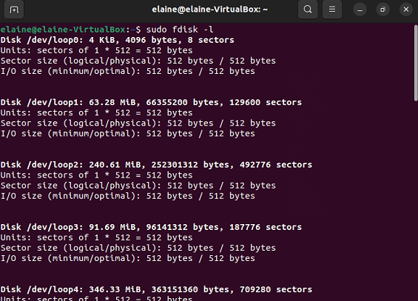

i. using apt command to install software

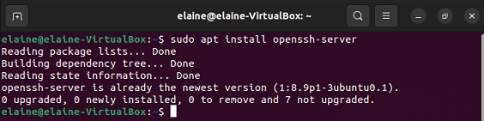

j. using vi command to edit file

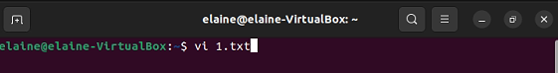

k. using time command to display used time when run command ls

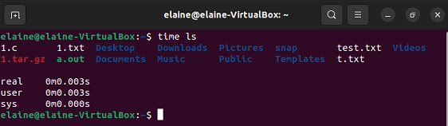

l. using tar command to create archive file

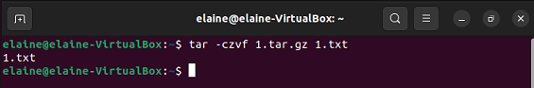

m. using cat command display file content

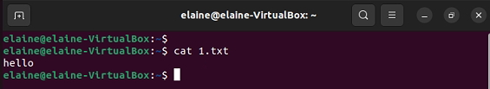

n. using watch command to run ps command in every second

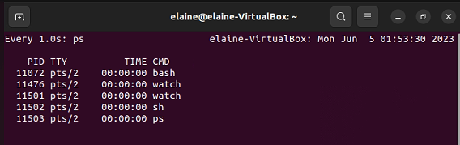

o. using ps command to display current running process

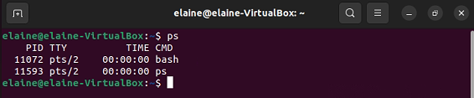

p. using top command to monitor system resources

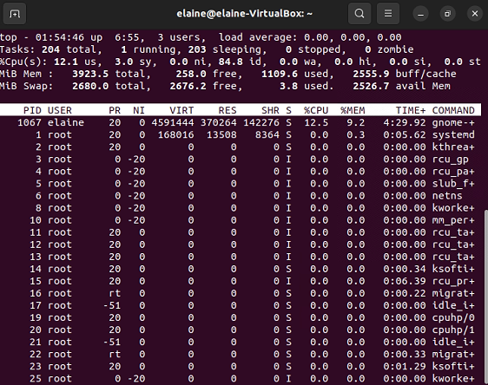

q. using htop command to monitor system resources

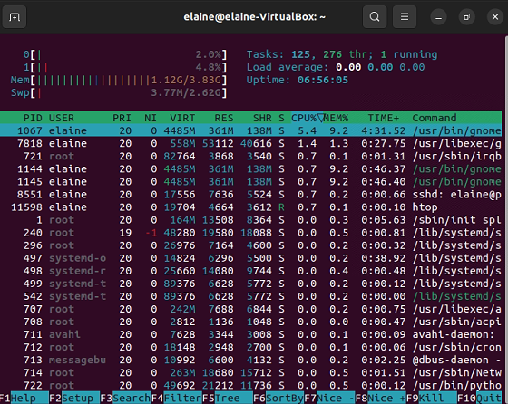

r. using gcc command to compile file

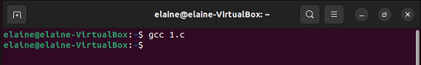

s. using tail command to display file content in last few lines

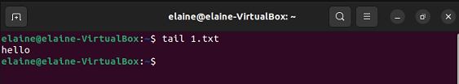

t. using grep command to search keyword in file

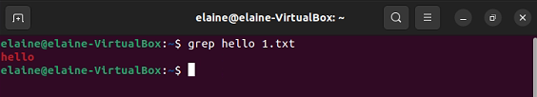

u. using kill command to kill process

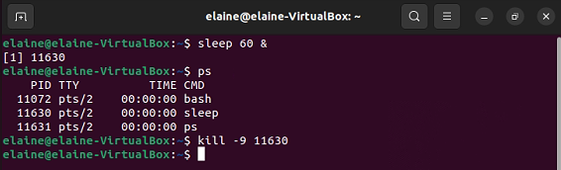

v. using killall command to kill process by name

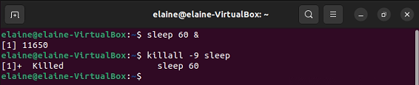

w. using du command to display file space usage

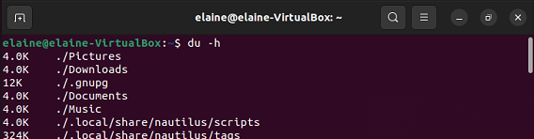

x. using df command to display disk usage

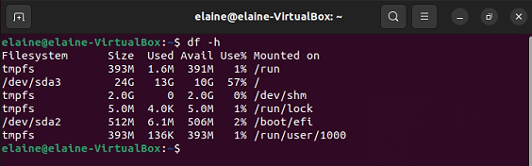

y. using screen command to open terminal simulation screen

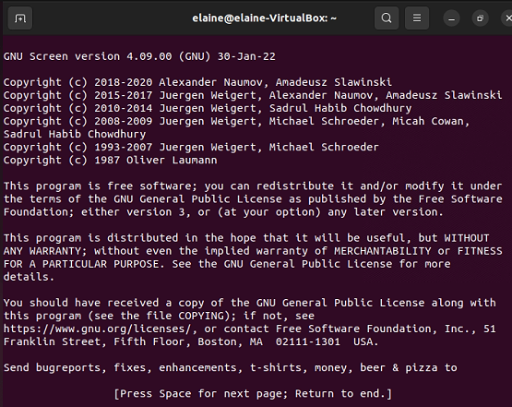

z. using vim command to edit file

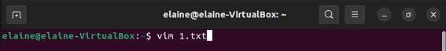

aa. using chmod command to change file's permission

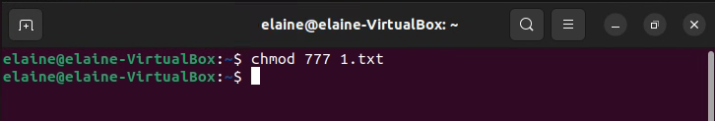

bb. using chown command to change file's owner

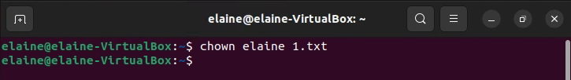

cc. using useradd command to add user

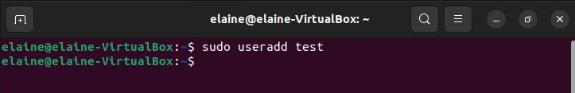

dd. using man command to display command's manual text

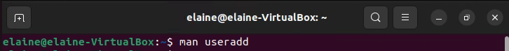

ee. using locate command to locate file's location

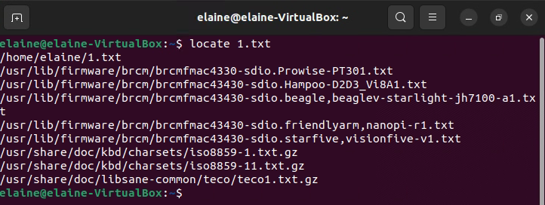

ff. using find command to search file

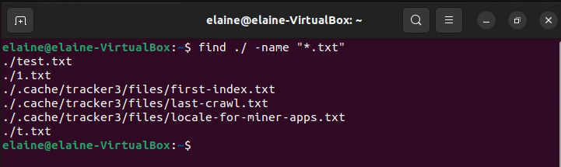

gg. using sed command to replace text

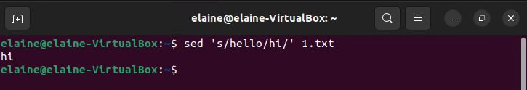

hh. using awk command to print file content

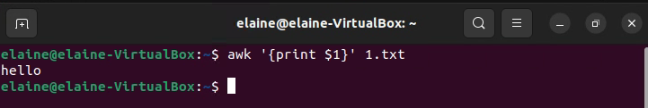

ii. using diff command to compare two file's contents

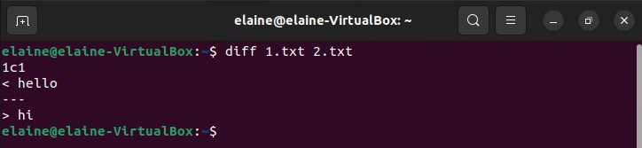

jj. using sort command to sort file content

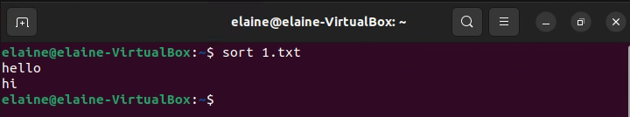

kk. using export command to define system variable

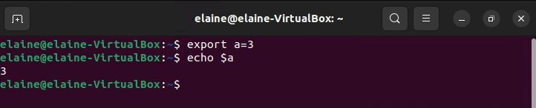

ll. using pwd command to display current working directory

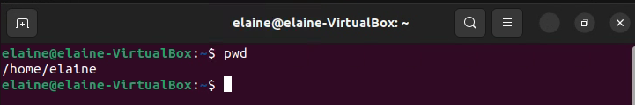

mm. using crontab command to display schedule plan

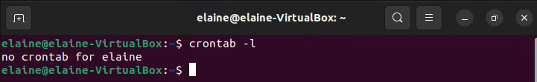

nn. using mount command to display mounted file system

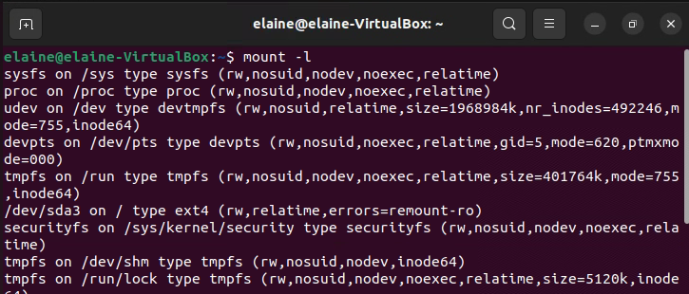

oo. using passwd command to change user's password

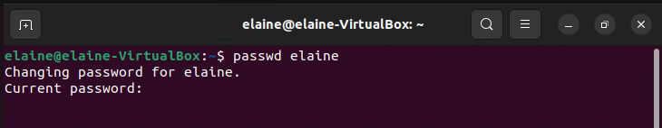

pp. using uname command to display system's name

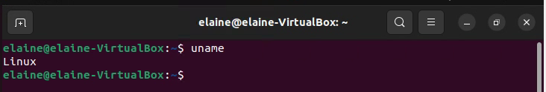

qq. using whereis command to find command's path

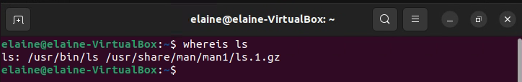

rr. using whatis command to display command's short description

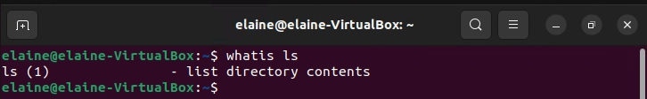

ss. using su command to switch user's account

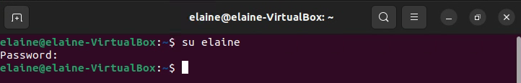

tt. using ping command to test network connection

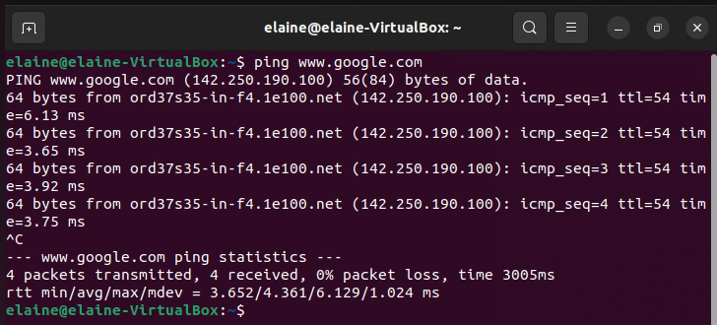

uu. using traceroute command to display the route to server

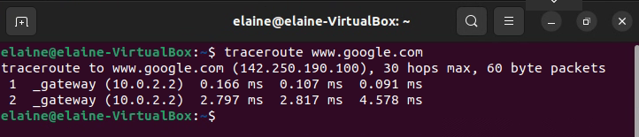

vv. using date command to display current date and time

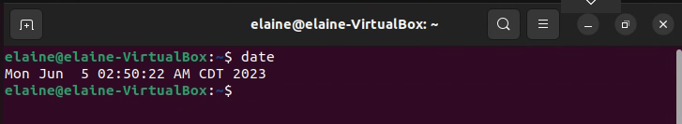

ww. using time command to display command's used time

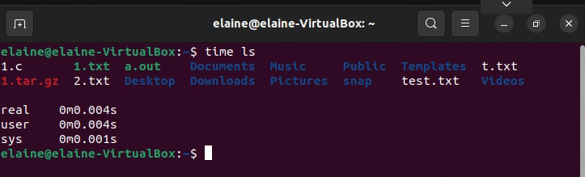

xx. using wget command to download file by url

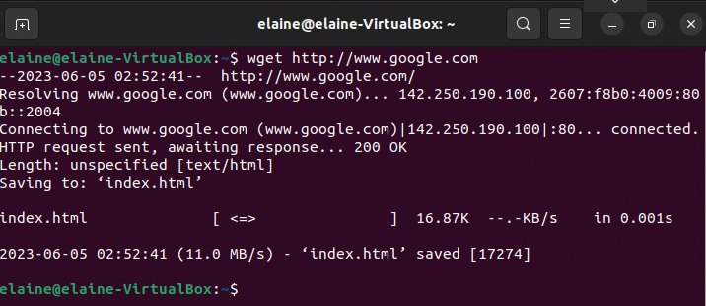

yy. using wc command to count the number of lines in file

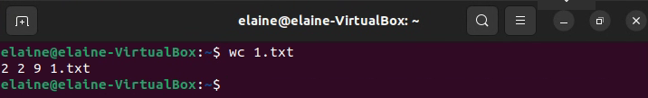

zz. using pwgen command to generate random password

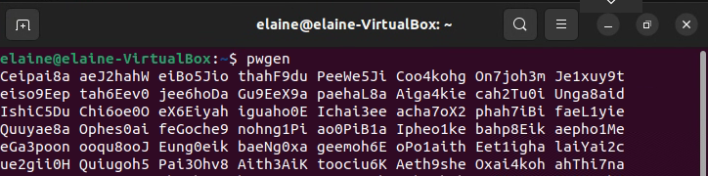

3.a

time bash generate-dataset.sh lines.txt 1000 #run this script file

vi generate-dataset.sh #enter this command to edit file, enter following code

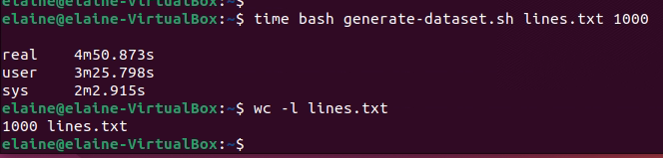

3.b

time bash sort-data.sh lines.txt #run this script file

vi sort-data.sh #enter this command then enter following code

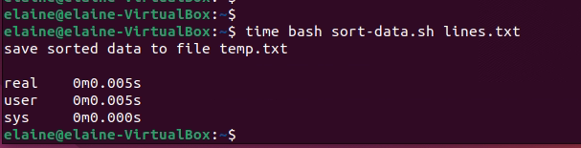

3.c

As it take very long time to generate 100000 records, test with smaller number of records:

time bash generate-dataset.sh 1000.txt 1000

time bash generate-dataset.sh 500.txt 500

time bash generate-dataset.sh 100.txt 100

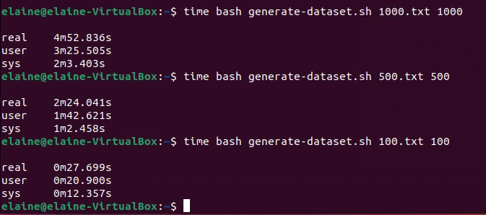

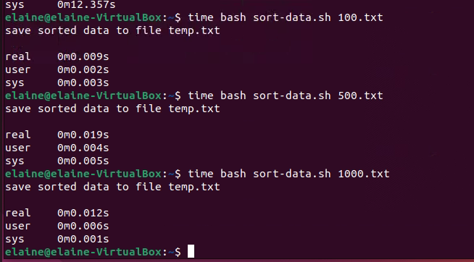

4.a

set it to the minimum: when it used in non CPU intensive server.

set it to the maximum: when it used in CPU intensive server, like complicated compuattion.

because when setting it to the maximum, the server may not use it efficiently and result in decreased performance, it should setting suitable number of processors based on the CPU requirement of the server.

4.b

None: It disable paravirtualization.

Legacy: It support basic paravirtualization for older operating system.

Minimal: It provide lightweight paravirtualization interface, it improved compared to Legacy.

Hyper-V: It's developed by Microsoft and enhance performance on Windows Server operating systems.

KVM: It's virtualization technology for Linux based operating system.

It's best to use KVM in Ubuntu Linux, because Ubuntu is a Linux based operating system.

4.c

IDE: IDE is very old controller which use parallel data transfer,

It used to connect device like hard drives, may want to use IDE controller when want to connect hard drives which has IDE interface.

SATA: It support higher transfer speed compared to IDE as it uses serial data transfer.

May want to use SATA when want to high speed in data transfer.

NVMe: It's designed for solid state drives which has high transfer speed.

NVMe is used when need high performance in storage data.

4.d

NAT: It share the host system's IP address and network connection.

May want to use NAT when it shortage in ip address and want it connected to network.

Bridged Adapter: It can directly access the physical network which the host system is connected,

May want to use Bridged Adapter when setup server which can be accessed in local area network.

Internal Network: It's a virtual network created within the host system,

it can only communicate with each other inside this Internal Network.

May want to use Internal Network when setting up isolated environments.

Host-only Network: It can only communicate between virtual machine and host system,

can't connect to network and other virtual machine.

May want to use Host-only Network when it need isolate virtual machine from the external network,

and need communicate with host system.

4.e

USB 1.1: It's a very old USB standard, it support speed 12 Mbps.

USB 2.0: It's published in 2000 which support speed of 480 Mbps.

USB 3.0: It support speed of 5 Gbps.