Generalized elliptic curves based human modelling

- Generalized ellipses

In the work of Hyun et al. [1], sweep surfaces with elliptic cross section have been used to approximate human arms, legs, torso and neck, and carry out human deformation. The mathematical description of sweep surfaces has the form of [1]
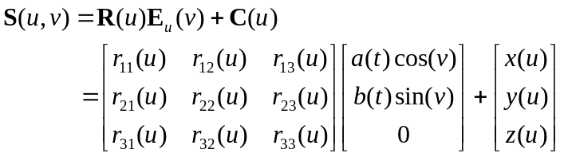 (1)
where 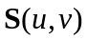 is a sweep surface, 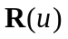 and 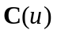 stand for rotation and translation, respectively, and 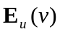 is a standard ellipse of variable size.
Since the cross sections of the most parts of human body are irregular curves. Using standard ellipses to approximate these cross sections will bring in large differences leading to unrealistic human modelling.
As indicated in Fig. 1, we give cross-section curves human arms, legs, torso and neck from the existing human model and those approximated by elliptic cross sections where Fig. 1a is taken from human left arm, Fig. 1b from human right leg, Fig. 1c from human torso and Fig. 1d from human neck. Clearly, for these human parts, there are noticeable differences between the real cross sections and elliptic ones.
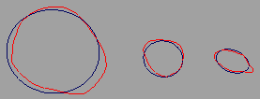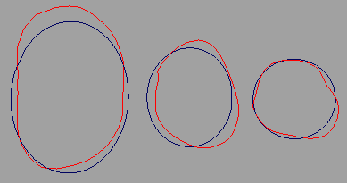
Right leg Left arm
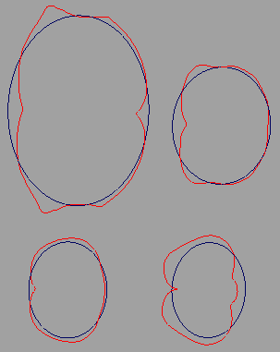
Torso
Fig. 1 Comparison between real human cross sections and approximated ellipses
In addition, for a certain value 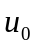 of the parametric variable , Eq. (1) can be written as the following form
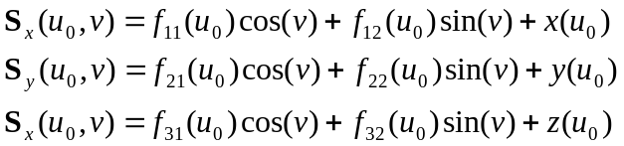 (2)
The above equation indicates that at the plane determined by a point 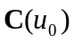 and a unit normal vector 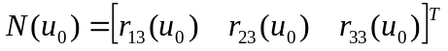, the cross section of the sweep surface is still a simple curve which is described with two trigonometric functions 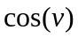 and 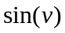.
In order to characterize the cross sections of human body, we introduce the conception of generalized elliptic curves which are represented by a number of trigonometric functions 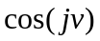 and 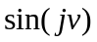 (j=1,2,…). With the application of more trigonometric functions, the cross sections of human body can be approximated much more accurately.
We divide generalized elliptic curves into two classes: generalized ellipses and generalized elliptic segments. The former is used for the approximation cross section curves with a simple shape, and the latter aims at those with very complicated shapes. In the following, we introduce the construction of generalized ellipses. The generation of generalized elliptic segments will be discussed in a separate section.
Assuming that the generalized ellipse is perpendicular to one of x-y, x-z and y-z plane, with the centre 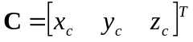, taking that perpendicular to x-y plane as an example, the mathematical equation of the generalized ellipse can be written as
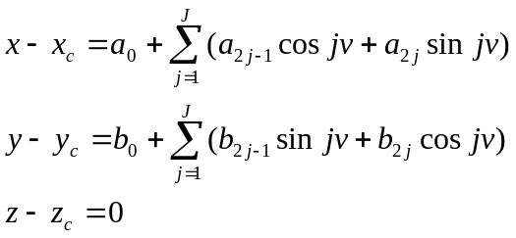 (3)
where 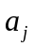 and 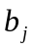 (j=1,2,3,…,J) are unknown constants.
If there is a cross section curve determined by a number of points 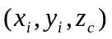 (i=1,2,3,…,I), the centre of the generalized ellipse can be determined by the average values of each component x and y. That is
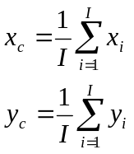 (4)
Then, we use curve fitting and the least square algorithm to determine the unknown constants in Eq. (3). To this aim, we calculate the squares sum of the errors between the curve and the generalized ellipse at the points (i=1,2,3,…,I) for x and y position components, respectively
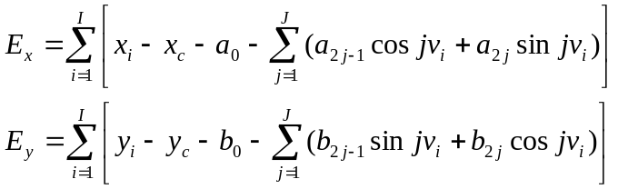 (5)
The errors in Eq. (5) are minimized by setting the derivatives of the square sums with respect to the unknown constants to zero
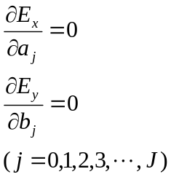 (6)
which leads to the following linear algebraic equations
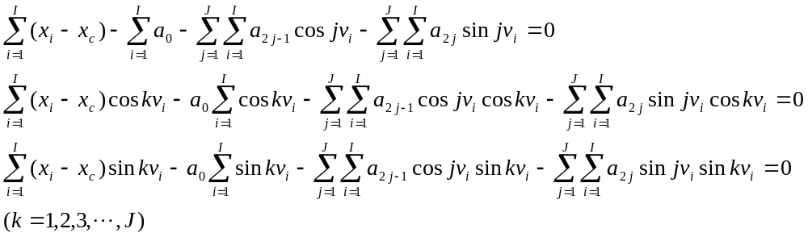 (7)
and
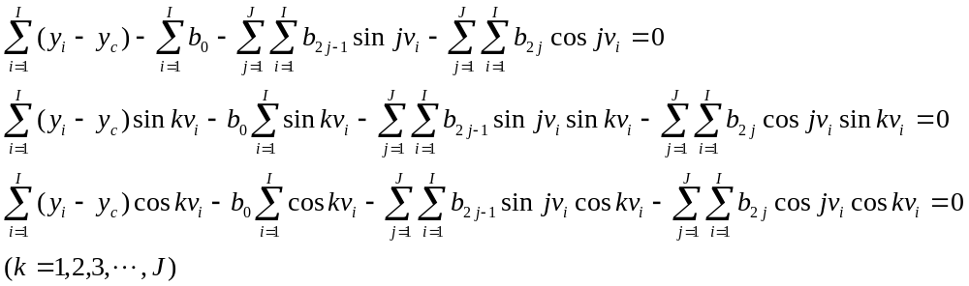 (8)
Solving equations (7) and (8) for, respectively, we determine all unknown constants and obtain the generalized ellipse representation of the curve.
For the curves which are not perpendicular any coordinate planes, we must carry out the coordinate transformation and find the mathematical description of the curve in the local coordinate system one of whose coordinate axes is perpendicular to the curve plane.
For the representative curves taken from human leg and torso, we use the generalized ellipse (3) and standard ellipse to regenerate them and the obtained results were depicted in Fig. 2 where J is defined Eq. (3), the curve in red is the original one, the one in green is from the algorithm of the generalized ellipse, and that in blue is created with the equations of the standard ellipse.
It can be seen from these figures that the algorithm of the generalized ellipse can approximate the cross section curves of human body quite well and the approximation can be greatly improved by increasing the terms of the generalized ellipse. Since most cross section curves of human body have the similar complexity to those in this figure, the proposed approach can use few terms to achieve high accuracy of curve modelling.
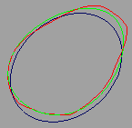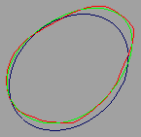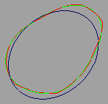
J=2 J=3 J=4
a) Cross section curve of human leg
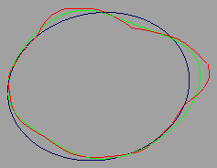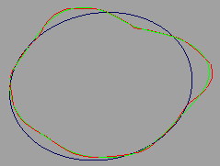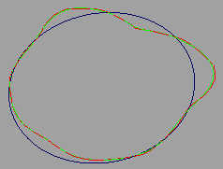
J=3 J=7 J=10
b) Cross section curve of human torso
Fig. 2 Curve generation with different approaches
Due to different shapes of cross section curves, different terms in Eq. (3) will be used to generate the required accuracy. Too few terms in Eq. (3) will cause too large errors. Too many terms will increase the computational cost and slow down the human modelling process. Therefore, suitable terms should be used. However, in the situation of interactive modelling, it is time consuming to find out which value of the term J is the best. In order to tackle this issue, we here propose the following strategy.
First, we define an average error 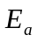 and a maximum error 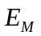 below. The former is used to measure the global approximation of the generalized ellipse to the original curve and the latter quantifies the maximum difference between the generalized ellipse and the original curve.
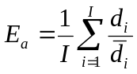 (9)
where
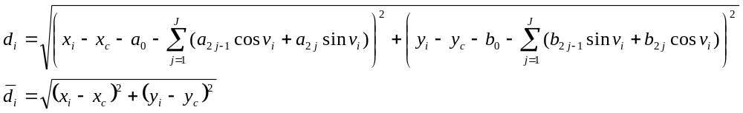 (10)
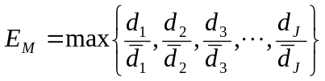 (11)
Then, we can set different errors to determine the required terms in Eq. (3). For example, we take the average error and maximum error not more than 1% and 5%, respectively. That is
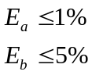 (12)
A linear interpolation operation is employed to find out the suitable terms efficiently. Initially, we take J=3 and J=10, and calculate the average errors 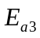 and 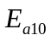 and the maximum errors 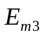 and 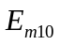 where the subscripts 3 and 10 stands for the values of J. If both and have met Eq. (12), or one of and does not satisfy Eq. (3), a linear extrapolation operation is used to find a smaller 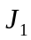 for the former and a larger for the latter. Otherwise, a linear interpolation is applied to calculate the between J=3 and J=10. The obtained is usually not an integer. We round off it to the nearest integer. With , we calculate the average errors 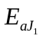 and the maximum errors 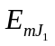 and examine whether they have met Eq. (3). If both and have met Eq. (12) and 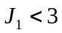, the linear extrapolation operation occurs with and J=3. If one of and does not satisfy Eq. (3) and 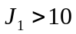, the linear extrapolation operation is performed with J=10 and . If both and have met Eq. (12) and 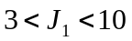, the linear interpolation operation is conducted between J=3 and . If one of and does not satisfy Eq. (3) and , the linear interpolation operation is carried out between and J=10.
Since there are two quantities 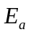 and 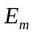 which can be employed for the interpolation, we must determine which one should be used. Obviously, if only one of and does not meet Eq. (3), this error is used for the interpolation. If both of them do not satisfy Eq. (3), we always use the average error for the interpolation since the average error is a global measurement of the difference between the original curve and the generalized ellipse.

- Human parts defined with generalized ellipses

In order to build a human model, we draw some cross section curves which characterize the human profiles. Then we approximate the original cross sections with the generalized ellipses. After that, we can construct surface patches from these generalized ellipses with the following treatment.
If a surface patch will be constructed from K generalized ellipses 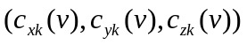 (k=1,2,3,…,K) where 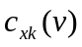, 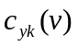and 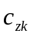 are determined by Eq. (3), we use the following equation to describe the surface to be constructed
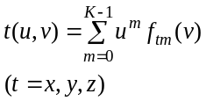 (13)
where 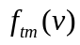(m=1,2,3,…,K) are unknown functions.
Uniformly dividing the region u=0 to u=1 into K-1 equal intervals with the interval length to be 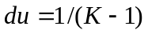, we have 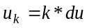 (k=0,1,2,3,…,K-1). The unknown functions (m=0,1,2,3,…,K-1) can be determined by solving the following linear algebraic equations
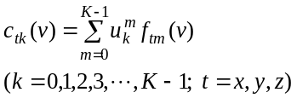 (14)
Expanding Eq. (14) and rewriting it into the form of matrix, we obtain the following mathematical expression
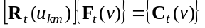 (15)
where 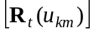 is a 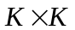 square matrix with the elements 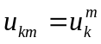, and are two vectors with K elements.
Using 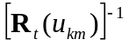 to indicate the inverse matrix of and left multiplying this inverse matrix at the both sides of Eq. (15), we obtain the unknown functions with the following equation
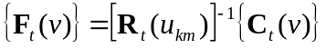 (16)
At the boundary curves where two different surface segments are to be connected together, we must consider the continuity between the two surface segments. For an existing surface segment indicated by Eq. (13), the boundary tangents and boundary curvature etc. can be determined from the different order partial derivatives 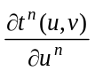 (n=1,2,3,…) of the surface segment with respect to the parametric variable u. By introducing these partial derivatives into the above operation, different order continuities between two connected surface segments can be obtained.
For example, if we intend to connect two surface segments with the tangent continuity at u=1 of the existing surface segment 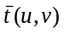, we obtain the mathematical expressions of the first partial derivative 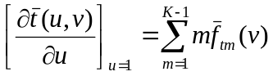 and 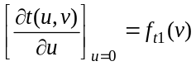 of the existing surface segment and the unknown surface segment 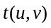with respect to the parametric variable u from Eq. (13), respectively. Then the following tangential continuity constraint is added to Eq. (14).
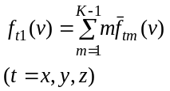 (17)
Since one more linear algebraic equation is introduced, the unknown functions in Eq. (13) should be raised from 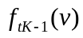 to 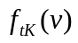 and all K in Eq. (13) and thereafter will be replaced by (K+1).
If both opposite edges of a surface segment will be connected to two separate surface segments and 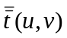, the continuity at the boundary curve u=0 of the exiting surface segments should also be considered. Similar to the above treatment, the following boundary condition for the tangential continuity will be added to Eq. (14)
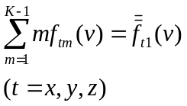 (18)
and the unknown functions in Eq. (13) will be increased from to 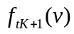 and all (K+1) in Eq. (13) and thereafter will be replaced by (K+2).
With the above constructed surface function, we create human torso, neck, legs and arms as shown in Fig. 3 where the left images are from originally generated surfaces, the middle ones are constructed from the standard ellipses without considering displacement mapping, and the right ones are produced with the generalized ellipses.
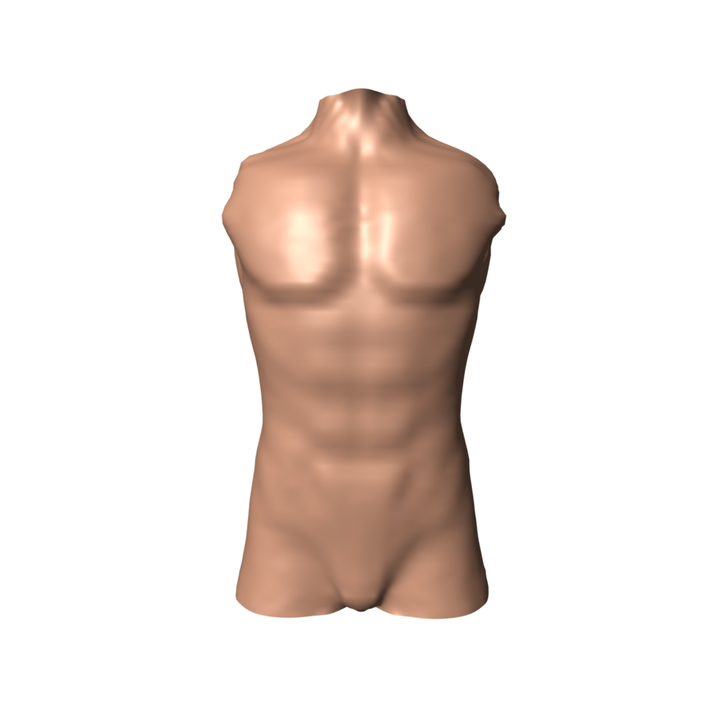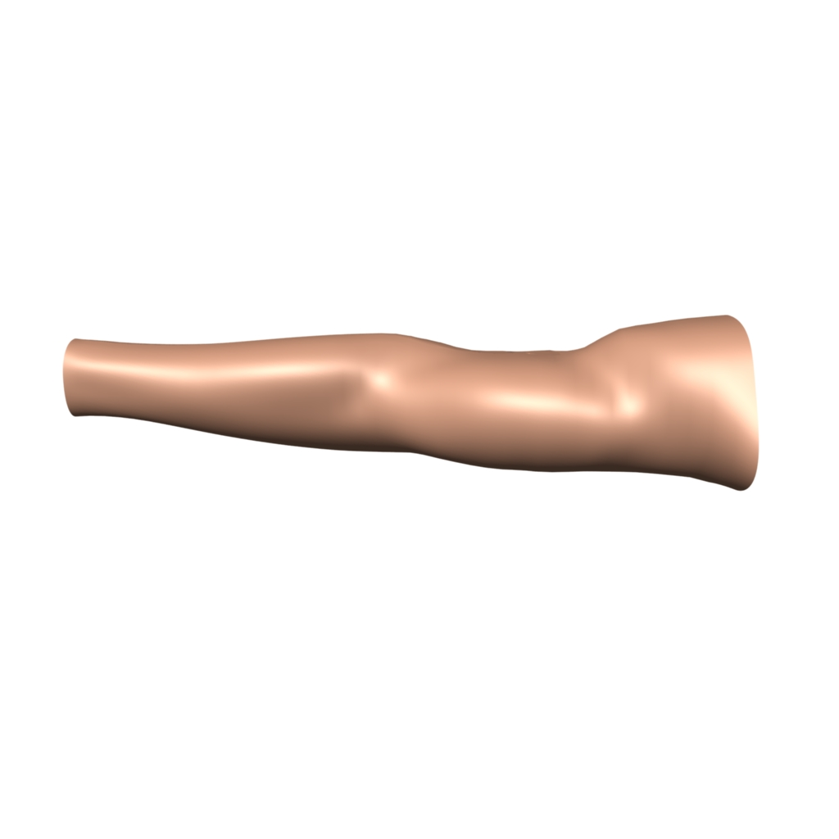
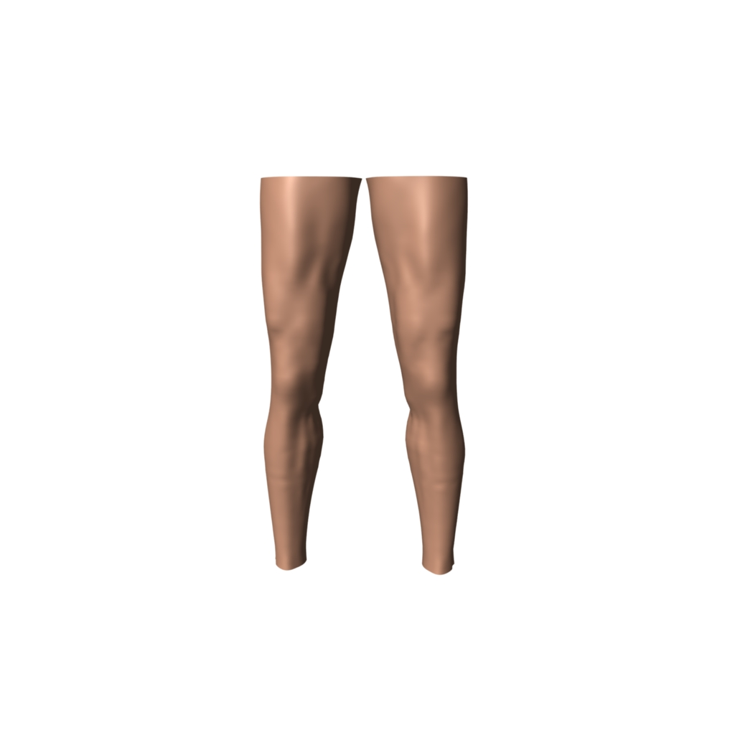
Fig. 3 Human torso, arms and legs created from generalized ellipses

- Generalized elliptic segments
For very complicated cross section curves, using generalized ellipses to approximate them may require comparatively large terms in Eq. (3). In order to raise computational efficiency and improve interactive model building performance, it is worthy of developing a more efficient approach to tackle cross section curves with very complicated shapes and the corresponding surface modeling.
A very complicated cross section curve can be decomposed into several simpler ones. In order to approximate these decomposed curves, we change Eq. (3) into the following form by removing the term representing the centre of generalized ellipses
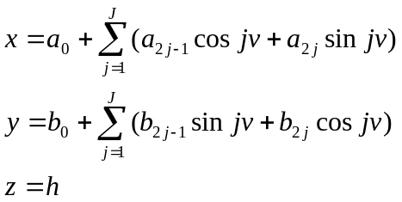 (19)
The curves described with the above equation are called generalized elliptic segments. The curve consisting of these generalized elliptic segments is a composite generalized elliptic curves.
In order to guarantee two adjacent generalized elliptic segments are smoothly connected together, the continuity between these two segments should be investigated.
As an example, we here consider how to use two generalized elliptic segments to approximate a closed cross section curve with a complicated shape and how to guarantee the tangential continuity between the two generalized elliptic segments. For the curves consisting of more than two generalized elliptic segments and with higher order continuity between connected generalized elliptic segments, the basic principle is the same.
Firstly, we divide a cross section curve from human hip into two separate curve segments ABC and CDA as indicated in Fig. 4a. With Eq. (19) and curve fitting algorithm, we can determine the first generalized elliptic segment corresponding to the curve segment ABC. The next task is to determine the second generalized elliptic segment corresponding to the curve segment CDA. Using a bar and a double bar to indicate the first and second segments respectively, the positional values of the first generalized elliptic segment at 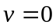 and should be equal to those of the second generalized elliptic segment at 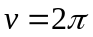 and , respectively. Therefore, we have the following positional continuity conditions
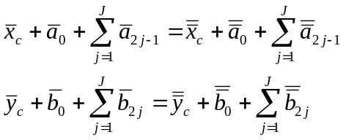 (20)
Similarly, the tangential values of the first generalized elliptic segment at and should be equal to those of the second generalized elliptic segment at and , respectively which leads to the following tangential continuity conditions
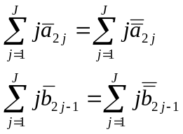 (21)
From Eqs. (20) and (21), we can determine four unknown constants 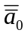, 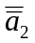, 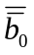 and 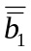 which can be written as the following equations
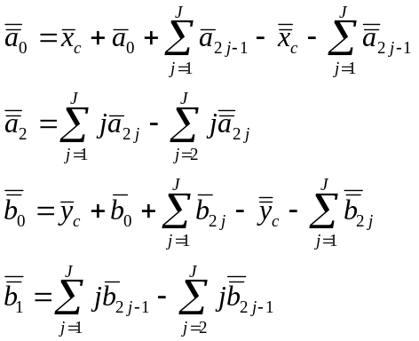 (22)
Substituting Eq. (22) into (19), the positional functions for the second generalized elliptic segment are changed into
(23)
For Eq. (23), performing curve fitting for the curve segment CDA, we determine all remaining unknown constants and achieve the mathematical description of the second generalized elliptic segment. With the obtained composite generalized elliptic curve depicted in Fig. 4b where the curve in blue stands for the original one, that in red was produced from the composite generalized elliptic curve and that in green was created with a generalized ellipse. From these images, we know both composite generalized elliptic curve and generalized ellipse approach the original curve very well. However, the composite generalized elliptic curve only has £££ unknown constants. In contrast, the generalized ellipse raises this number to ***.

Fig. 4 Comparison of curve approximation between different approaches

- Surfaces defined with composite generalized elliptic curves
Since standard ellipses cannot approximate the cross section of human body well enough, the sweep surface of a moving ellipse is far from the practical shape of the human body. In order to remedy this shortcoming, sweep-based human deformation introduces the concept of displacement map.
For most cases, the vertex of human body is not exactly located on an ellipse. Therefore, the algorithm of the displacement map first brings the vertex back to the coordinate system of the ellipse. Then, the relative displacement of the vertex from the moving ellipse is measured and a continuous displacement map is constructed by approximating or interpolating a set of relative displacements.
Although the introduction of the displacement map can greatly improve the realism of human modeling, from the above discussion, it can be seen that such a method is also an approximate one and requires more computer memory and additional computational cost.
Since generalized ellipses and composite generalized elliptic curves can represent the cross section curves of human body, the accuracy improvement using the displacement map or other approaches is not required. Therefore, the method proposed in this paper can significantly reduce the requirement for computer memory and obviously increase modelling efficiency.
With the introduction of composite generalized elliptic curves, human parts can be constructed from these curves and the combinations of these curves and generalized ellipses apart from those created from the generalized ellipses only.
Whether the curves are generated from composite generalized elliptic curves or generalized ellipses, they must have the same curve segments if a surface is constructed from these curves. Therefore, when some generalized ellipses are to be combined with other composite generalized elliptic curves for generating a same surface, these generalized ellipses should be firstly divided into the same segments as those of composite generalized elliptic curves. For example, a composite generalized elliptic curve consisting of three generalized elliptic segments which are connected at v=0, v= 2pi/3, v=4pi/3 and 2pi, respectively. To construct a surface from these segments and a generalized ellipse, we simply divide the ellipse into 0 to 2pi/3, 2pi/3 to 4pi/3, and 4pi/3 to 2pi.
The continuity of different surface patches along the v parametric direction can be achieved by taking the mathematical expressions for u parametric variable of the adjacent two surface patches to be the same form. For example,

- Assembly human parts by surface blending and extrusion deformation

After successful construction of human parts such as human torso, arms and legs, the remaining task is how to assemble them together which maintains smooth transition between different human parts and ensures the surface in the transition region has the realistic appearance of the part.
There are two approaches which can be used to achieve this aim: one is surface blending and the other is extrusion deformation. Here we take the connection between the torso and right arm as an example to indicate the operation of surface blending.
given in Fig. introduce surface blending.

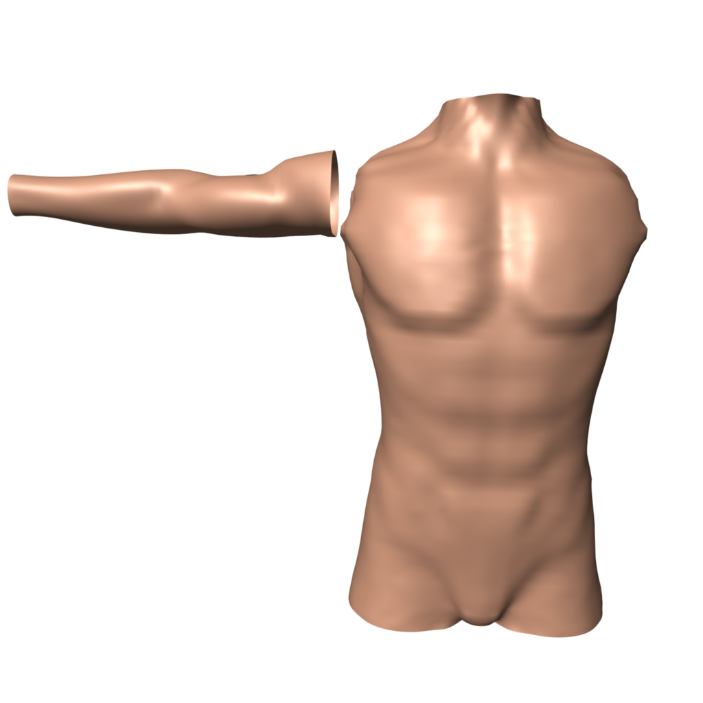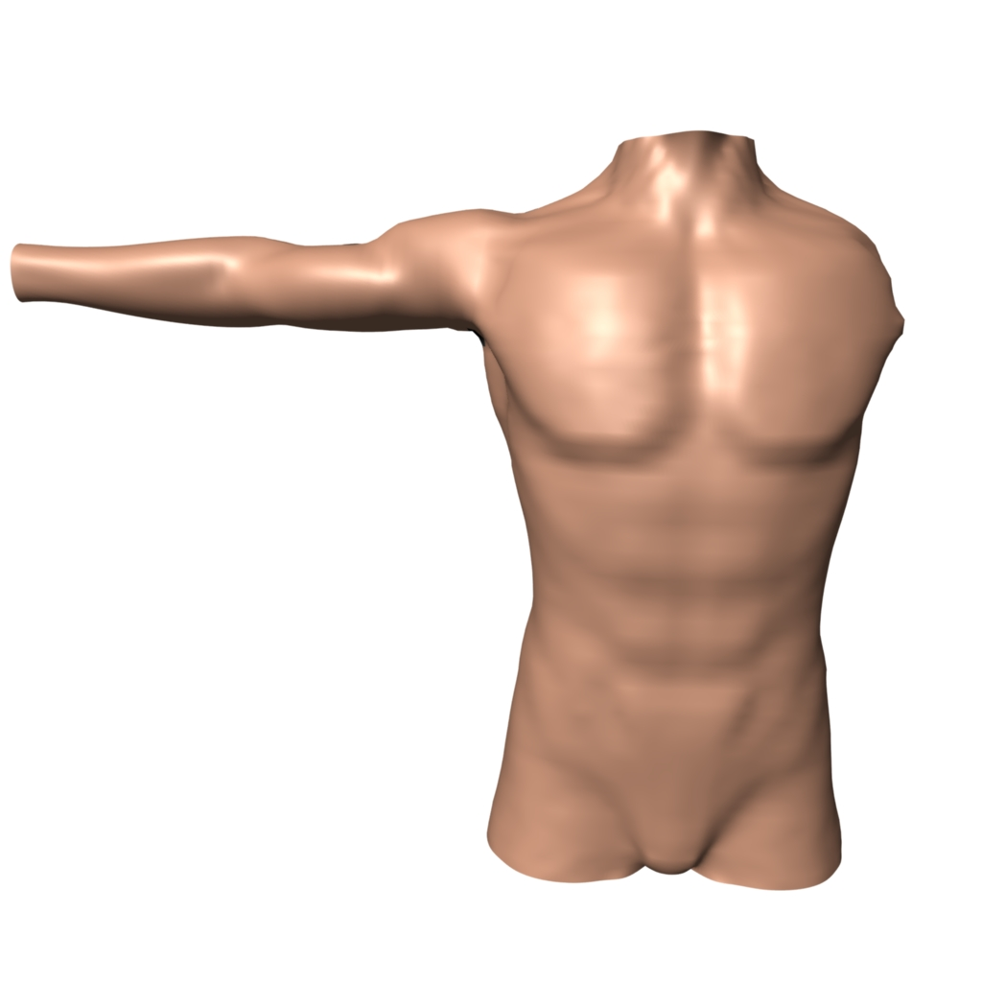
Fig. 5 Connection of different human parts
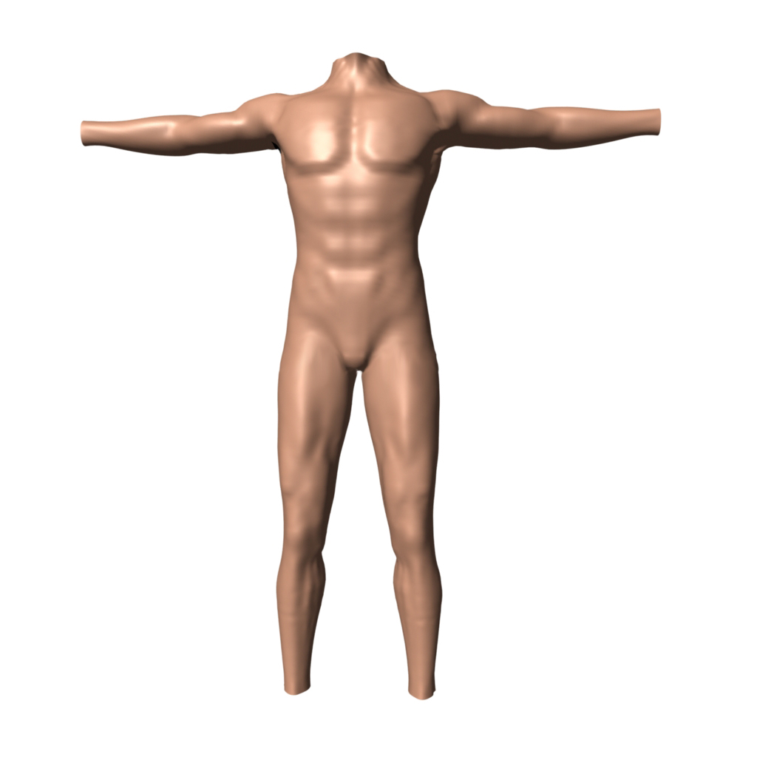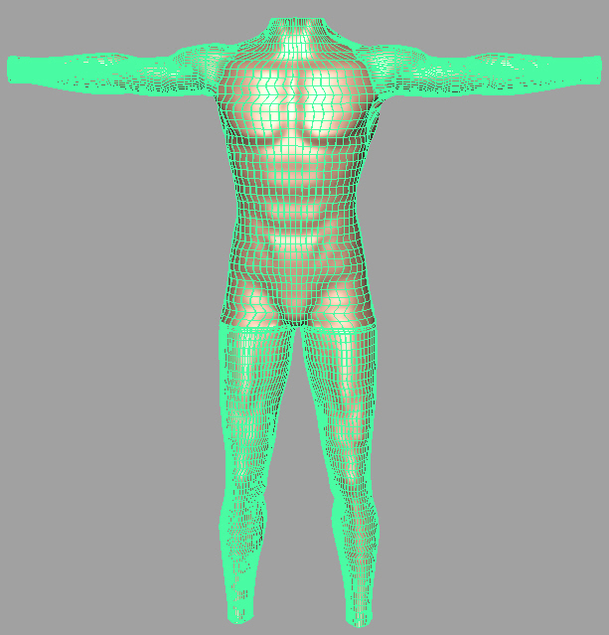
- Conclusions

References

[1] Hyun D.-E., Yoon S.-H., Chang J.-W., Kim M.-S., Jüttler B. Sweep-based human deformation. Visual Computer 2005; 21:542-550.
[2] mmmm

