Advanced File Type Identification Project
This Python project identifies the type of a given file using multiple methods:
file signature (magic numbers), MIME type detection, and file extension analysis.
It uses the libraries python-magic-bin and colorama for system compatibility and colored output.
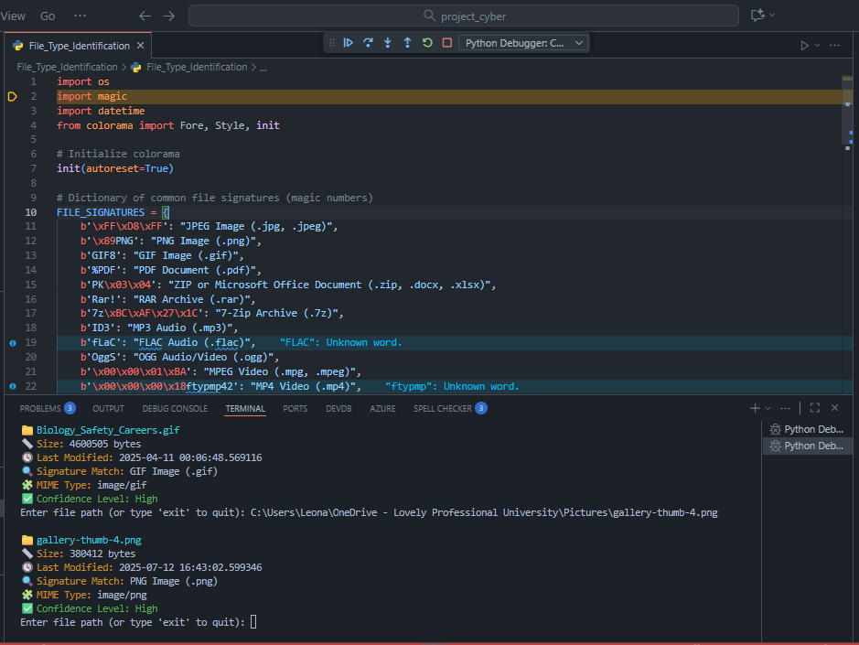

Code Implementation (Python)
import os
import magic
import datetime
from colorama import Fore, Style, init
# Initialize colorama
init(autoreset=True)
# Dictionary of common file signatures (magic numbers)
FILE_SIGNATURES = {
b'\xFF\xD8\xFF': "JPEG Image (.jpg, .jpeg)",
b'\x89PNG': "PNG Image (.png)",
b'GIF8': "GIF Image (.gif)",
b'%PDF': "PDF Document (.pdf)",
b'PK\x03\x04': "ZIP or Microsoft Office Document (.zip, .docx, .xlsx)",
b'Rar!': "RAR Archive (.rar)",
b'7z\xBC\xAF\x27\x1C': "7-Zip Archive (.7z)",
b'ID3': "MP3 Audio (.mp3)",
b'fLaC': "FLAC Audio (.flac)",
b'OggS': "OGG Audio/Video (.ogg)",
b'\x00\x00\x01\xBA': "MPEG Video (.mpg, .mpeg)",
b'\x00\x00\x00\x18ftypmp42': "MP4 Video (.mp4)",
b'MZ': "Windows Executable (.exe, .dll)",
}
def identify_file_type(file_path):
if not os.path.isfile(file_path):
print(Fore.RED + "❌ File not found.")
return
file_name = os.path.basename(file_path)
file_size = os.path.getsize(file_path)
file_ext = os.path.splitext(file_path)[1].lower()
last_modified = datetime.datetime.fromtimestamp(os.path.getmtime(file_path))
with open(file_path, "rb") as f:
file_start = f.read(20)
file_type = None
for signature, description in FILE_SIGNATURES.items():
if file_start.startswith(signature):
file_type = description
break
mime_type = magic.from_file(file_path, mime=True)
if not file_type:
file_type = f"Unknown (based on signature). Possible extension: {file_ext}"
print(f"\n📁 {Fore.CYAN}{file_name}{Style.RESET_ALL}")
print(f"{Fore.YELLOW}📏 Size:{Style.RESET_ALL} {file_size} bytes")
print(f"{Fore.YELLOW}🕓 Last Modified:{Style.RESET_ALL} {last_modified}")
print(f"{Fore.YELLOW}🔍 Signature Match:{Style.RESET_ALL} {file_type}")
print(f"{Fore.YELLOW}🧩 MIME Type:{Style.RESET_ALL} {mime_type}")
if "Unknown" in file_type:
print(Fore.RED + "⚠️ Confidence Level: Low")
else:
print(Fore.GREEN + "✅ Confidence Level: High")
def main():
print(Fore.CYAN + "=== ADVANCED FILE TYPE IDENTIFICATION SYSTEM ===\n")
while True:
file_path = input("Enter file path (or type 'exit' to quit): ").strip()
if file_path.lower() == 'exit':
print(Fore.YELLOW + "\nExiting program. Goodbye! 👋")
break
identify_file_type(file_path)
if __name__ == "__main__":
main()

Explanation
1. Imports: Uses os, magic, and datetime for file operations, MIME detection, and metadata extraction.
2. Colorama: Adds color to terminal outputs for readability.
3. FILE_SIGNATURES: Dictionary stores common file header bytes for identification.
4. identify_file_type(): Reads the first 20 bytes, checks for known signatures, and compares with MIME type.
5. main(): Provides a user-friendly interactive loop for repeated analysis.

Installation Instructions
1. Install dependencies using pip:
pip install python-magic-bin colorama
2. Run the program:
python File_Type_Identification.py
3. Enter the file path when prompted.

