Appendix

# Initial Variable Summary Plots

## Figure 1: CD19 Histogram

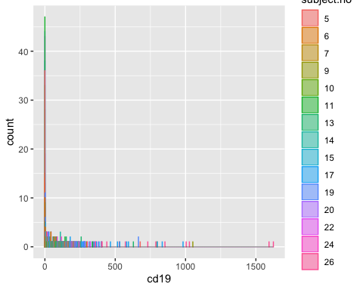

## Figure 2: MALAT1 Histogram

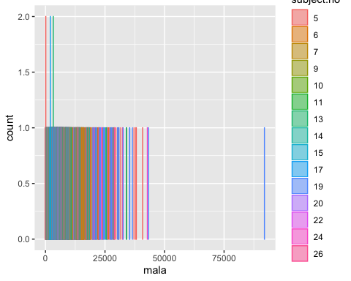

## Figure 3: MALAT1 vs CD19 Scatter Plot

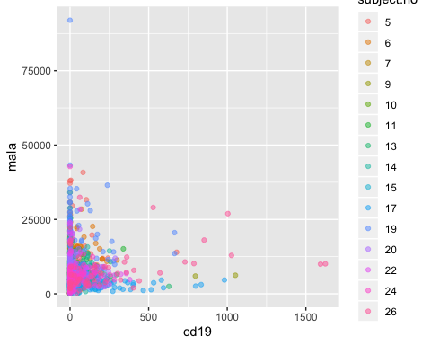

# Log Transformed Variables

## Figure 4: CD19 Histogram

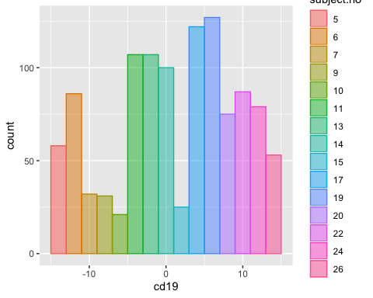

## Figure 5: MALAT1 Histogram

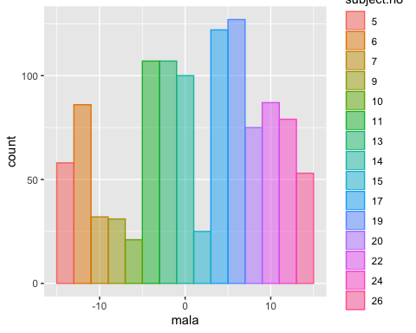

## Figure 6: MALAT1 vs CD19 Scatter Plot

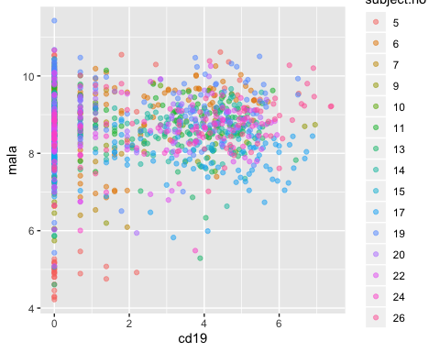

Linear Predictor

$$η_{ij}=β_{0}+β_{1} CD19$$