Comparing Models of Subject-Clustered Single-Cell Data

Version 2.0

Lee Panter

# Abstract

Single-cell RNA sequencing (scRNA-seq) represents a revolutionary shift to approaches being used to decode the human transcriptome. Single-cell data is used to: visualize cellular subpopulations with unsupervised clustering methods, test for differential expression rates across conditions using logistic and mixture modeling, and reconstruct spatio-temporal relationships in the microbiome using network analysis. While these accomplishments demonstrate the utility and promise of single-cell research, they do not explicitly account the correlated structure of the data caused by gathering single-cell data within multiple individuals. ;

* Single cell RNA sequencing is becoming more prevalent and is being widely used for a variety of purposes
* More single cell data is being produced on many individuals enabling analysis of subject level relationships for single cell data…
* However, it is not clear how to analyze this data given the nested study design
* Current analyses do not account for subject correlated study designs – do not account for having nested study designs were data in hundreds to thousands of cells are gathered in multiple individuals.

however, if numerical results are desired, methods that appropriately model the correlated structure of the data across multiple individuals are needed. Since single-cell data acquisition is increasing in efficiency and decreasing in cost, data sets featuring single-cell observations from more than a few subjects are becoming increasingly common. Therefore, there is a need to outline, analyze, and compare methods for estimating subject level relationships between single-cell expression. Here, we compare three modeling strategies for scRNA-seq expression estimation in data with subject-level clustering: XXX. We first describe each method’s framework and then compare the regression estimates and standard errors using real data from a Lupus Nephritis study of XX people with XX. It is hoped that this paper presents insights into modeling single-cell expression data, as well as aids researchers with down-stream analyses, and future theoretical/analytic methodology development.

# Introduction

Single-cell analysis has emerged as a leading methodology for transcriptome analytics. [1] Single-cell data sets (i.e. data involving measurements with single-cell resolution) demonstrate their utility in research contexts for identifying rare subpopulations, characterizing genes that are differentially expressed across conditions, and infering spatio-temporal relationships within the microbiome. [2] Additionally, technological advances in whole genome sequencing have made generating single-cell data most cost effective ultimately leading to an increase in the amount of data both within the same person and across multiple people. [1] Therefore, there is a clear need to compare, test, and integrate methods that can accurately and precisely model single-cell data and account for the correlation of repeated measures within subject samples.

Here, we compare three methods for modeling scRNA-seq expression profiles that account for within-subject correlation: XXXX, XXXX, and XXXX. We compare the methods using data from a study of XXX Lupus Neprhitis cases. General modeling theory is provided in the context of this example and we discuss relevant conclusions, implications, limitations and future research to illustrate our findings.

## Previous Results

The following studies use single-cell data to make “down-stream” conclusions. A down-stream analysis will incorporate information generated from a statistical study to make conclusions about relateable biological concepts. During this process, the conclusions drawn from statistical inference are logically equated to biological implications. Therefore, each “down-stream” result is dependent upon a coherent statistical analysis. The examples below show that coherent statistical inference will be unreasonable when the underlying data exhibits subject-clustering.

### Sub-Population Detection

Traditional methods for subpopulation exploration using single-cell data commonly involve unsupervised clustering techniques including Principle Components Analysis (PCA) and K-Nearest Neighbors (KNN). These methods can effectively identify rare neurological cells within a homogeneous population. [3] Such clustering methods, and additional (non-linear) methods such as the t-distributed stochastic neighborhood embedding (t-SNE) are also useful for visualizing high-dimensional data are used to find multi-dimensional boundary values for distinguishing healthy and cancerous bone marrow samples. [4] While all these studies involve single-cell data that incorporates multiple subjects, the modeling methodologies do not provide numerical estimates for the effects of subject-clustered sampling, and therefore can only be used heuristically.

### Test for Differential Expression Across Conditions

Single-cell data is used to target treatments by characterizing differential expression by condition. Model-based Analysis of Single-cell Transcriptomics (MAST) is used to compare “primary human non-stimulated” and “cytokine-activated” mucosal-associated invariant T-cells. [5] Additionally, Single-Cell Differential Expression (SCDE) is used to compare 92 embryonic mouse fibroblasts to 92 embryonic human stem cells. [6] Neither of these studies included samples across multiple subjects (excluding paired/treatment sample assumptions used for parameteric tests).

### Investigate Spatio-Temporal Microbiome Relationships

Network modeling approaches, in conjunction with single-cell data provides the opportunity to learn about cellular heirarchies, spatial relationships, and temporal progressions within the microbiome. Weighted Gene Co-Expression Network Analysis (WGCNA) is used to find delineations in both human and mouse embryonic transcriptome dynamics during progression from oocyte to morula. [7] A similar analysis is performed using Single-cell Clustering Using Bifurcation Analysis (SCUBA), and is verified using Reverse Transcription Polymerase Chain Reaction (RT-PCR) data over the same single-cell measurements. [8] The studies conducted using network modeling approaches target single-cell sources at multiple time points, or distinct measures that could be compared using a pseudo-time mapping. Diversification of the single-cell data by incorperating multiple subjects is not considered or adressed.

# Description of Motivating Example

Throughout the course of this paper, references are made to the 20XX manuscript entitled “The immune cell landscape in kidneys with lupus nephritis patients” [9]. In this manuscript XX et al compare XXXX for XX Lupus Nephritis cases vs. XX population??? Controls. Kidney tissue single-cell data for the 27 individuals was collected as part of a cross-sectional, case-control study from ten clinical sites across the United States. Each sample was crygenically frozen and shiped to a central processing facility were samples were thawed, dissociated, and sorted into single-cell suspension across 384-well plates using FlowJo 10.0.7, 11-color flow cytomery [10]. sc-RNA sequencing was performed using a modified CEL-Seq2 method [11], followed by 1 million paired-end reads per cell. Data can be accessed through the ImmPort repository with accession code SDY997.

## Data Quality Control

The Seurat Guided Clustering Tutorial [12] is used to examine intial data and perform quality control (QC) filtering. The Seurat package allows for easy classification of low-quality observations by setting threshold values for:

1. the number of unique genes detected in each cell (nFeature), and
2. the percentage of reads that map to the mitochondrial genome (perctMT)

Item (1) is used for identifying empty or broken-cell measurements (indicated by abnormally low gene detection numbers), or duplicate/multiplicate cells measures (indicated by abnormally high gene detection numbers). Item (2) is used to identify dead and/or broken cells since dead or dying cells will retain RNAs in mitochondria, but lose cytoplasmic RNA [2].

The original dristribution of the variable across subjexts is displayed in (Figure 1) below:

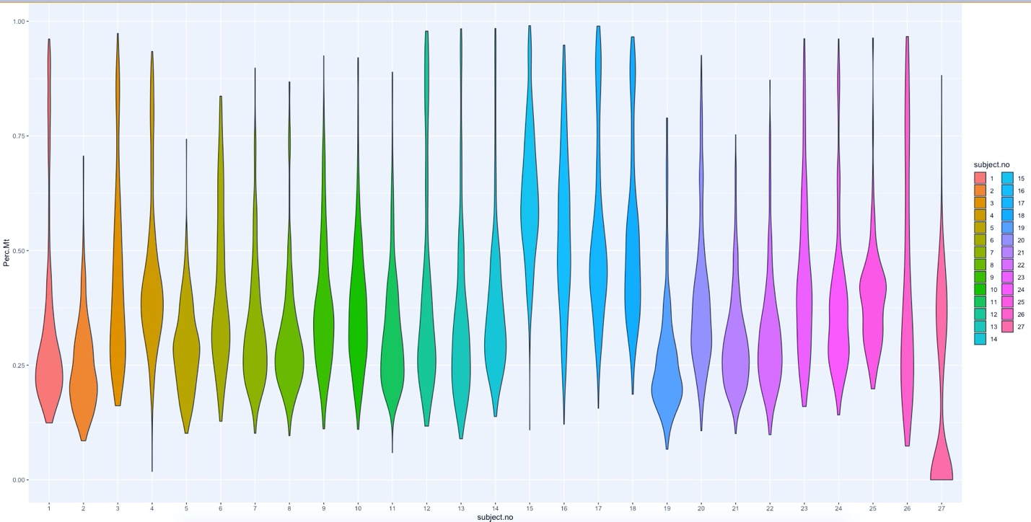

Figure 1

The QC measures employed by (Arazi A, Rao DA, Berthier CC, et al.) and implemented using the Seurat package required:

and the resulting distribution of the variable is displayed in (Figure 2):

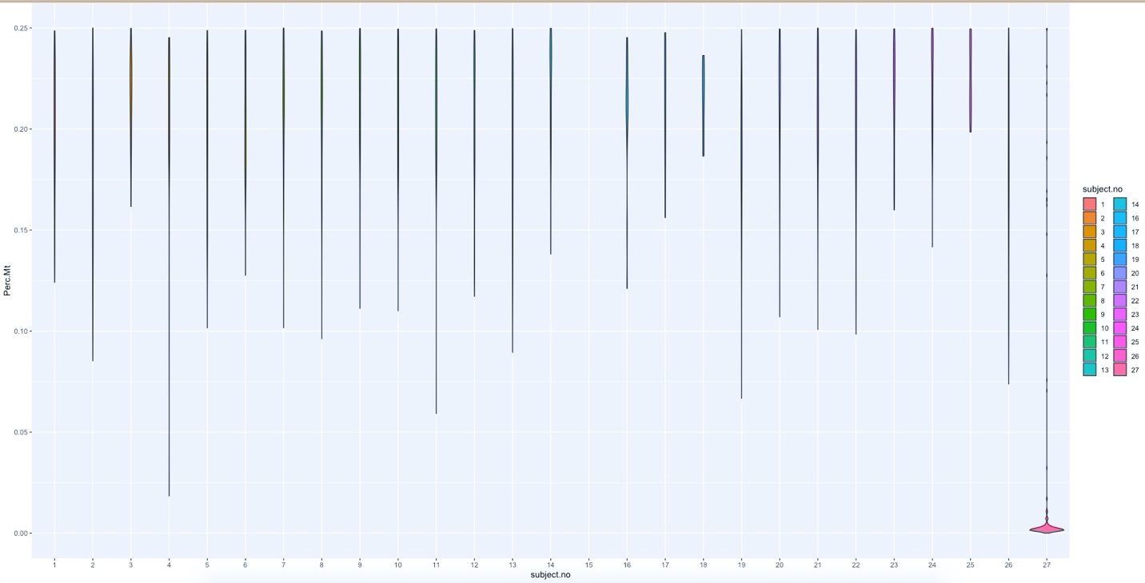

Figure 2

a decision to increase the threshold to 60% is made to preserve the inherent distribution structure across and within subjects (Figure 3).

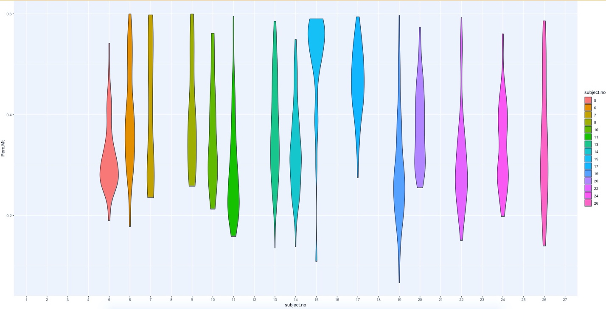

Figure 3

Further subsetting measures are made to reduce sources of possible conflicting information, by reducing the cellular data types to B-Cells only. This will allow for a more accurate representation of the covariance parameters between-subjects since contributions of variation from inconsistency in cell-structure will be less dramatic.

The distribution of observations across subjects after the quality control thresholds are imposed is also show numerically in Table 1:

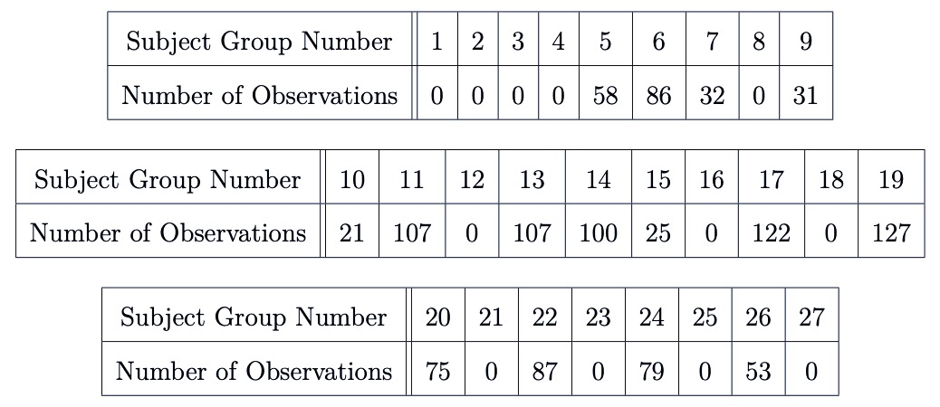

Table 1

We note that the quality control process is an active population restriction, and the data being eliminated do not constitute “missing data” under the assumption that these values poorly represented the population of interest due to innacurate measurement. As a result, subjects which lack observations can be interpreted as non-informative as opposed to missing or drop-out events. This realization will allow us to reduce the data set distribution to informative subjects, for which the observational distribution is displayed in Table 2:

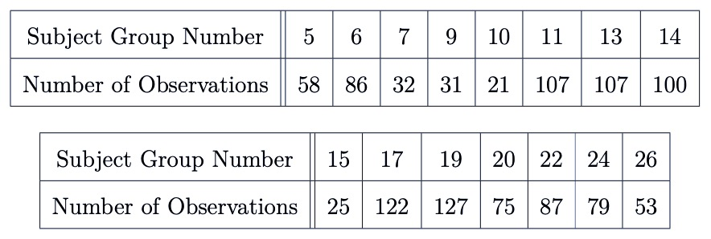

Table 2

Table 3 displays a 5 number summary of the observational distribution:

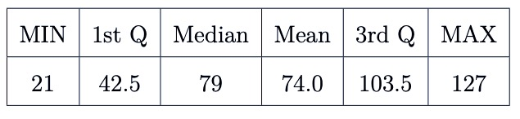

Table 3

## Variable Selection and Summaries

In order to simplify analysis and make more significant insights into model comparisons, we choose two pairs of variables from the 38,354 genetic markers in the Lupus Data to model in a predictor-response relationship. These variables indicate higher values of correlation than arbitrary pairings, and are associated with important outcomes of interest (e.g. cancer treatment research in the case of MALAT1 [13], or observed limb malformations in the case of FBLN1 variation [14]). An attempt is also made to choose predictor-pairings of interest. The CD19 marker (paired with MALAT1) is a transmembrane protein, encoded by the CD19 gene. Since the FlowJo cytometry measurements contain CD19 protein readings, the relationship between a proteomic predictor and the outcome of interest can be modeled transitively as well as directly, which allows for more thourogh investigation of results. CD34, the predictor which we link with FBLN1 is also a transmembrane protein encoded by a gene, and similarly interesting.

Without undergoing the process of expression normalization, single-cell RNA sequencing data is represented as non-negative integer count data. Higher counts correspond to higher detection frequencies and (without compensating for expected expression frequency) these detection frequencies can be interpreted as a quantification of the magnitude of expression for a transcriptomic marker.

The variables that we study here are summarized in Table (4) - (8). Each describes selected variable summary statistics for subset samples specific to the subject identifiers used in Tables (1) - (3).

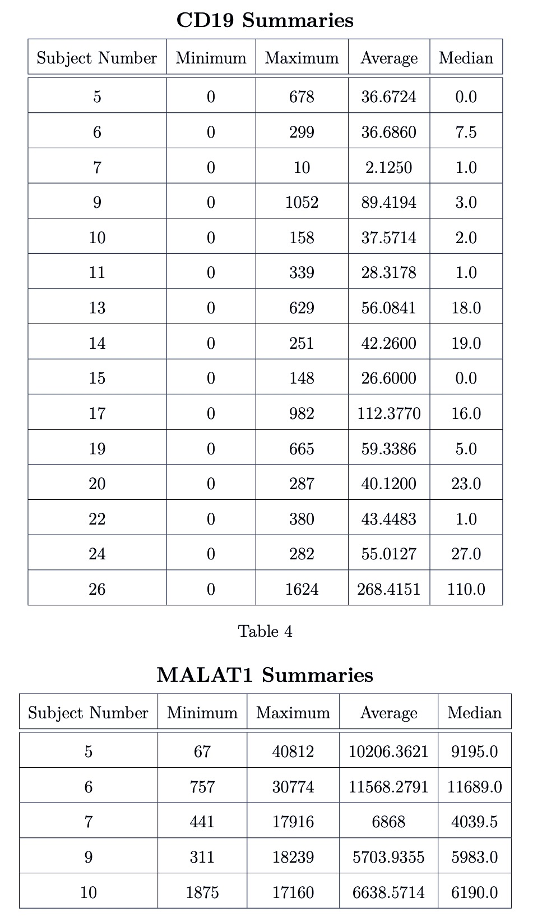

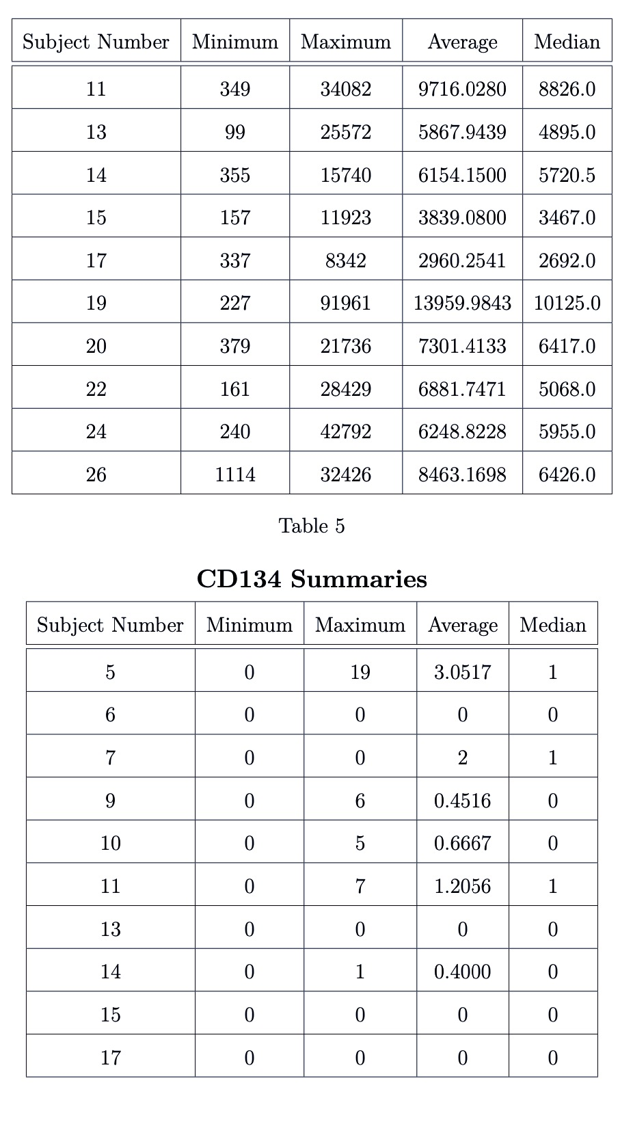

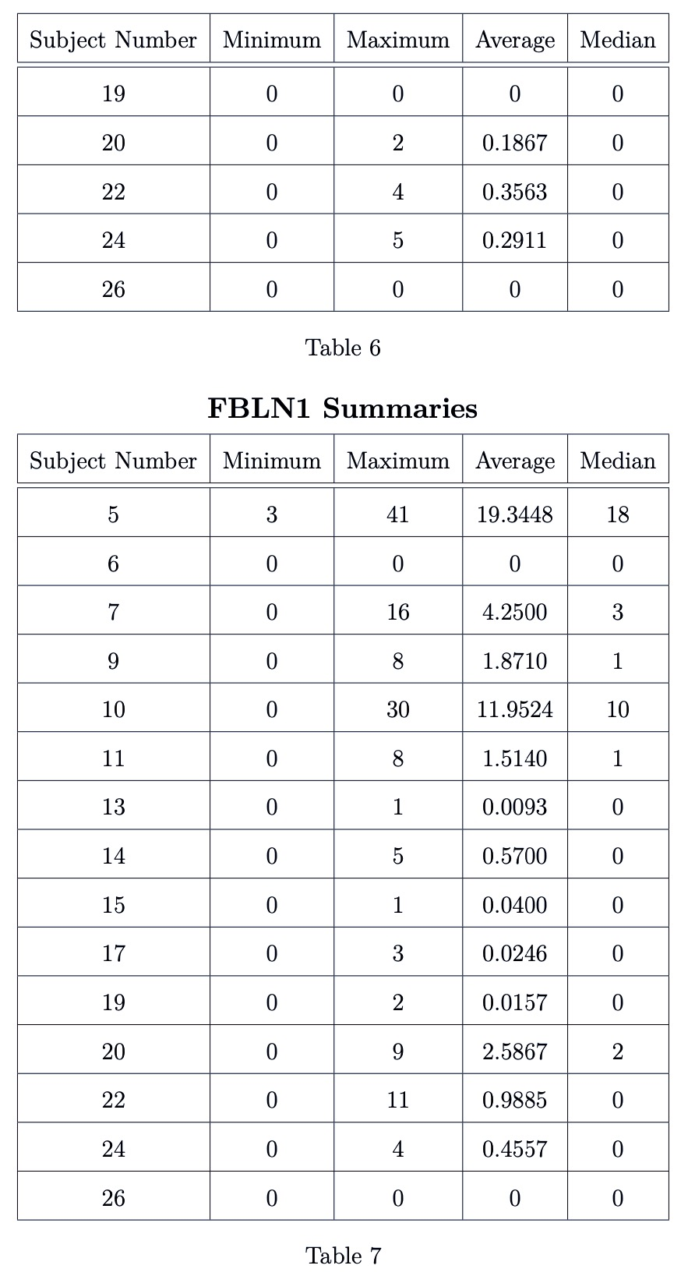

Measurements of RNAseq data can highly specific to very precise transcriptomic targets, so while the agglomerated scope of gene expression is the same as a traditional bulk experiment, individual observations have a biologically inflated zero-component. Additionally, there are technical zero-inflation components that are associated with protocol variations.

This is evident in the case of the FBLN1 ~ CD34 pairing, where we see that expression values for several subject exhibit:

where

Which implies that:

We expect the additional presence of zeros to be attributable to both biological and technical sources. Together, these factors contribute to heavily right-skewed variable distributions (Figure 4)

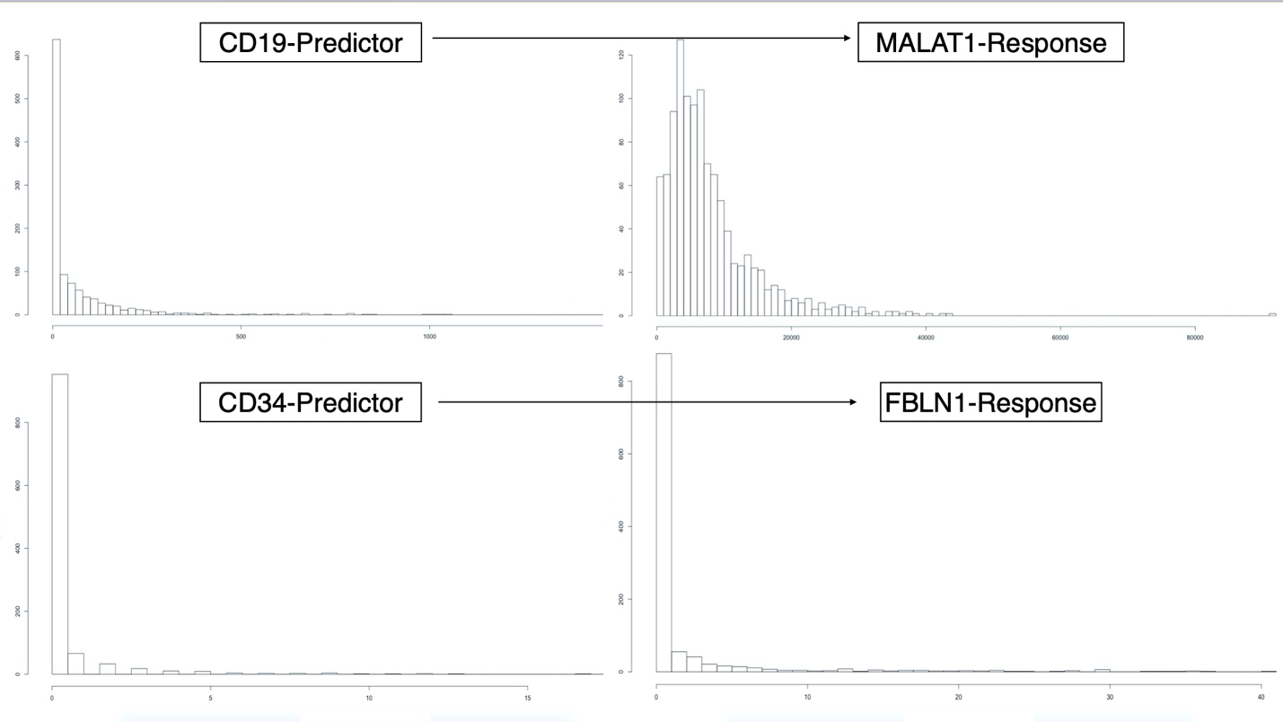

Figure 4

Since the MALAT1 variable had an abnormally large minimum outcome compared to the other variables, the minimum (67) outcome is subtracted from all MALAT1 values. This process would be incorperated into the model-fitting procedure automatically.

The modeling methodologies we employ motivates a log-transformation in an attempt to achieve approximate variable distribution normality, especially for the outcome variables. We perform the “log plus +1” transformation on all variables:

The resulting distributions are shown in Figure (5):

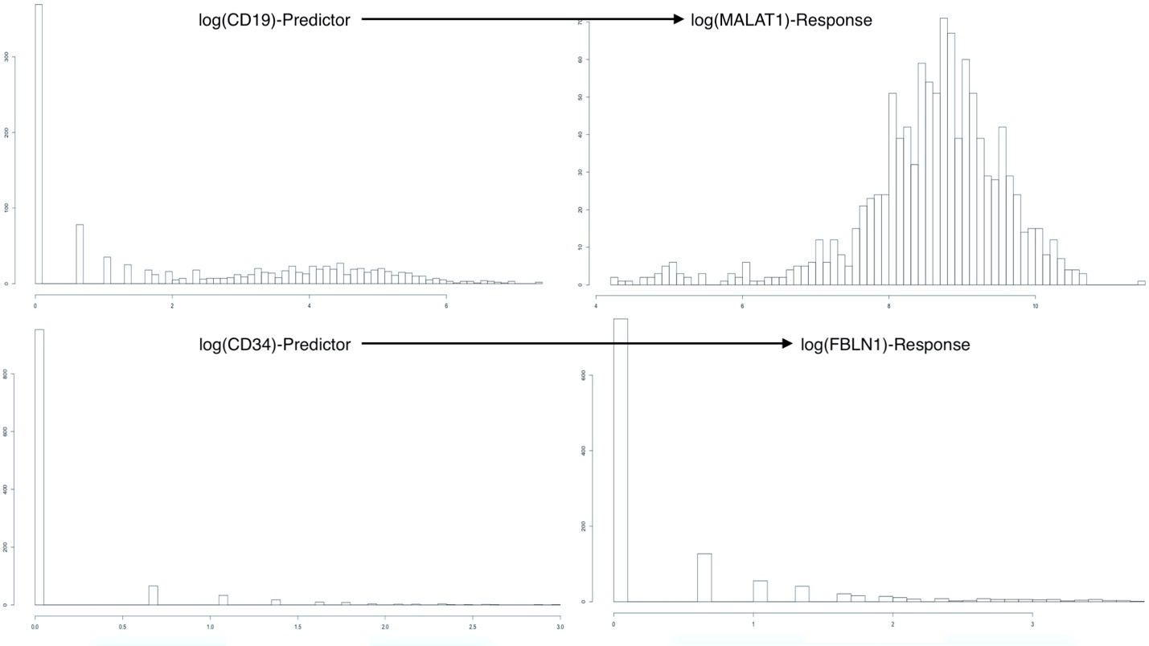

Figure 5

We see that the log-transformed response MALAT1 has resulted in an approximately normal distribution. Conversely, the log-transformed response FBLN1 is not inherently better than the un-transformed response. We can clearly see the heavy influence of zero-inflation in these variables.

Regardless, we model each outcome under the assumption that: compensating for observational clustering will sufficiently account for non-normality of the responses. This is not generally the case, and additional transformations or modeling methodologies may be needed to improve model error distributions.

# Model Descriptions

We define our outcome(s) of interest to be one of the following transformed variables as taken from (Arazi A, Rao DA, Berthier CC, et al):

where

We aslo define the predictor attached to as:

where

Let a single response be designated as: . The index represents the subject (name of subject by number) from which the observation originated, and the index represents the repeated observation number within subject-i. We note that in the context of the Lupus Data. We present the theoretical model frameworks here as “Less Than Full Rank” (LTFR) representations. The Full-Rank model results presented create full-rank model and design matrices by droping the first level in all factors, and using this as the referrence level.

## Linear Regression

We begin the model definitions by describing three linear regression models, with parameters estimated using Least Squares optimization. It should be noted that these methods make the assumption that observations are independent, and should therefore be used for comparison to modeling methods to come. However, the linear regression models we present here can account for some observational clustering with the use of subject specific intercept and slope terms.

Ultimately, though, all the methods defined in this section assume an identical error structure across all observations of the form:

where we are assuming that is a common variance parameter for all subjects and is the 1110 X 1110 identity matrix.

### Simple Linear Regression (Model 0)

Using the notation we defined above, we write the first model as:

which is equivalent to:

We note that this model does not account for any observational clustering.

### Fixed-Effect Subject-Intercept (Model 1)

Adding a subject-specific intercept term, allows us to account for within-subject correlation by uniformly shifting the fitted values specific to a subject. This model may be written as:

where we define the term:

### Fixed-Effect Subject-Slope (Model 2)

We may further account for observational clustering by adding a term which will ensure that individual subjects’ relationships with the covariate of interest is accounted for. This will help to reduce within-subject variation across the predictor space, and will be more noticable for stronger, subject-specific interactions with covariates.

This model may be written as:

where we are using the same definitions of , , and as in Models 0 and 1.

## Linear Mixed Effects Models

The next category of modeling approached we describe is Linear Mixed Effect Models. Specifically, we describe two distinct Linear Mixed Effect Models that account for subject-clustering differently than the previously discussed Linear Regression models. Linear Mixed Efffects Models do not neccessarily assume observational independence. Correlation structures such as AR(1), independence, spatial power, or unstructured can be used to estimate parameters determining covariance amongst repeated measures within a subject and between observations across subjects. Additionally, if we can rationally assume that the responses shown in Figure 3 have a multivariate distribution, the model parameters can be easily estimated using Maximum Likelihood Estimation techniques [15].

### Linear Mixed Effects Model with Random Intercept (Model 3)

Model 1 accounts for subject-clustering by assuming that observations within a subject are uniformly influenced by the nested nature (observations within subjects) of the sampling method. However, this assumption may not always be reasonable, as we could imagine that responses within each subject exhibit random variation that is also related to nested sampling methods.

A Linear Mixed Effects Model that includes a Random Intercept accounts for observational covariation due to subject-clustering by assuming that observations within a subject are a consequence of the nested nature of the sampling method, and therefore a consequence of an additive (covariate-independent), subject-specific, effect; AND due to subject-specific random variation in response measurement associated with measurement instatbility for THAT subject.

This model may be written as:

where

and we assume that and are independent.

We note that both random-components can be assumed to have a mean of zero as non-zero components are inherently deterministic and can be integrated into intercept terms.

### Linear Mixed Effect Model with Random Slope (Model 4)

Model 2 implements a Fixed Effect slope in an attempt to reconcile the effects of observational clustering that was inadequately accounted for by the subject-specific Fixed Effect Intercept in Model 1. However, in light of the information surrounding the development of Model 3, it is incumbent for us to develop an analogous correction for Model 2. Such a correction will allow us to account for observational correlation due to subeject-clustering as sourced from:

* additive, effects due to subject-clustered nested sampling methods
* subject-specific random variation associated with measurement instability
* covariate-dependent, subject-specific effects
* covariate-dependent, subject-specific random variation associated with measurement instability

We write this model as:

where

## Generalized Estimating Equations (Model 5)

Our final method for modeling scRNA-seq expression profiles is Generalized Estimating Equations (GEE). Dissimilar to each of the methods previously described, GEE regression esitimates are obtained using methodologies that allow for non-continuous responses. GEE extrapolates on the techniques used for estimating Generalized Linear Models by incorperating the effects of observational correlation and clustering.

GEE estimates are computed by solving the estimating equation(s):

where:

represents the relationship between the expected value of the response (not necessarily assumed to be related to a distribution) and the linear predictor ,

is the first derivative matrix, and

We note that and are hyperparameters defined so that we may know the variance as a function of the mean and a scale parameter, i.e:

The GEE algorithm is iterative and used the following steps to converge at an estimate:

1. Generalized Linear Modeling methods employing Maximum Likelihood Estimation are used to obtain intial estimates for
2. Estimates for used to compute hyper-parameters
3. New estimates for hyper-parameters and working covariance matrix () used to obtain new estimates for by solving (1)
4. Repeat Steps 2 & 3 until algorithm converges

The GEE algorithm has a quality which makes it very appealing for many applications with observational clustering. Specifically, the algorithm is robust to misspecification of the observational correlation structure. That is, the estimates are consistent with irrespective of the estimates for within-subject correlation.

The stability of the GEE algorithm is in-part due to the effects that it estimates. Whereas each of the previous methods (Model 0 withstanding) had subject-specific interpretations, the GEE algorithm provides marginal parameter estimates. These values do not represent any specific subject, but rather the population-average.

According to (Fitzmaurice GM, Laird NM, Ware JH (2012)) [15] we also need to ensure that any responses modeled in the GEE process are stationary, i.e:

The scRNA-seq data has been assumed to be independent within-subject, therefore we have:

Since the use of the scRNA-seq data would not violate the GEE assumptions, we proceed with the description of the model that we will fit.

The three-part specification includes:

1. The link function and linear predictor
2. Variance function
3. A working covariance matrix

The link function and linear predictor are chosen so that the resulting model estimates will be comparable to preceeding estimates for intercept and slope. Therefore, we will use the identity link function in conjunction with the linear predictor:

which implies we will be assuming the general modeling structure:

In the abscence of further information, we will assume a variance function of the form:

and we will be using a working covariance matrix structure for repeated measures that corresponds to the assumption of independence of observations within a subject.

# Code and Data

All code for the above analysis was written and evaluated in RStudio Version 1.2.1335, and is available for download at the following GitHub repository:

<https://github.com/leepanter/MSproject_RBC.git>

Additionally, a link to all necessarry and referrence data files (including original data) are contained in the following Google Drive:

<https://drive.google.com/open?id=1gjHaMJG0Y_kPYWj5bIE4gRJU5z9R2Wqb>

# References

1. Macaulay IC, Voet T (2014) Single cell genomics: Advances and future perspectives. *PLoS genetics* 10: e1004126.

2. Bacher R, Kendziorski C (2016) Design and computational analysis of single-cell rna-sequencing experiments. *Genome biology* 17: 63.

3. Ståhlberg A, Andersson D, Aurelius J, et al. (2010) Defining cell populations with single-cell gene expression profiling: Correlations and identification of astrocyte subpopulations. *Nucleic acids research* 39: e24–e24.

4. Amir E-aD, Davis KL, Tadmor MD, et al. (2013) ViSNE enables visualization of high dimensional single-cell data and reveals phenotypic heterogeneity of leukemia. *Nature biotechnology* 31: 545.

5. Wang Z, Gerstein M, Snyder M (2009) RNA-seq: A revolutionary tool for transcriptomics. *Nature reviews genetics* 10: 57.

6. Kharchenko PV, Silberstein L, Scadden DT (2014) Bayesian approach to single-cell differential expression analysis. *Nature methods* 11: 740.

7. Xue Z, Huang K, Cai C, et al. (2013) Genetic programs in human and mouse early embryos revealed by single-cell rna sequencing. *Nature* 500: 593.

8. Marco E, Karp RL, Guo G, et al. (2014) Bifurcation analysis of single-cell gene expression data reveals epigenetic landscape. *Proceedings of the National Academy of Sciences* 111: E5643–E5650.

9. Arazi A, Rao DA, Berthier CC, et al. (2018) The immune cell landscape in kidneys of lupus nephritis patients. *bioRxiv* 363051.

10. FlowJo X V10. 0.7 r2 flowjo. *LLC https://www flowjo com*.

11. Hashimshony T, Senderovich N, Avital G, et al. (2016) CEL-seq2: Sensitive highly-multiplexed single-cell rna-seq. *Genome biology* 17: 77.

12. Satija R, others (2018) Seurat: Guided clustering tutorial. *Satija Lab http://satijalab org/seurat/pbmc3k_tutorial html*.

13. Gutschner T, Hämmerle M, Diederichs S (2013) MALAT1—a paradigm for long noncoding rna function in cancer. *Journal of molecular medicine* 91: 791–801.

14. Debeer P, Schoenmakers E, Twal W, et al. (2002) The fibulin-1 gene (fbln1) is disrupted in at (12; 22) associated with a complex type of synpolydactyly. *Journal of medical genetics* 39: 98–104.

15. Fitzmaurice GM, Laird NM, Ware JH (2012) Applied longitudinal analysis, John Wiley & Sons.