**Analysis on   
Hardware Sales and Purchase System**

**LIRAJ MAHARJAN**

**00162808**

**Computing Project**

**Level 5 Diploma in Computing**

**Softwarica College of IT and E-Commerce**

**Kathmandu, Nepal**

**23 April 2017**

Table of Contents

Analysis 4

Rich picture 4

System Requirement Specification (SRS) 5

Functional Requirements 5

Non-functional Requirements 7

Prioritization 9

Use case diagram 10

Architecture 13

System Architecture 13

Initial Class Diagram 13

Natural Language Analysis (NLA) 13

Conclusion 15

**Table of Figures**

Figure 1 4

Figure 2 9

Figure 3 10

Figure 4 11

Figure 5 14

# Analysis

System analysis identifies the information requirements that must be met by a system solution. It helps to known to current situation of the shop and gather information or requirements to upgrade the shop status. In this phases details analysis of the systems is conducted to access the feasibility of solution and alternative solutions, cost benefits, advantage and disadvantage of each alternative. It is up to the user to decide most suitable solution.

Better analysis produces better and reliable output. So analysis must be done as deep as it can go so it won`t be any problem in future. I have done analysis by distributing it into many parts such as rich picture, system requirements specification, use case and initial class diagram which help to understand the requirements of the shop.

## Rich picture

It is a diagrammatical way of relating the system and its requirements. It shows how the system is going to work. It only shows the processes included in the system rather than functions.

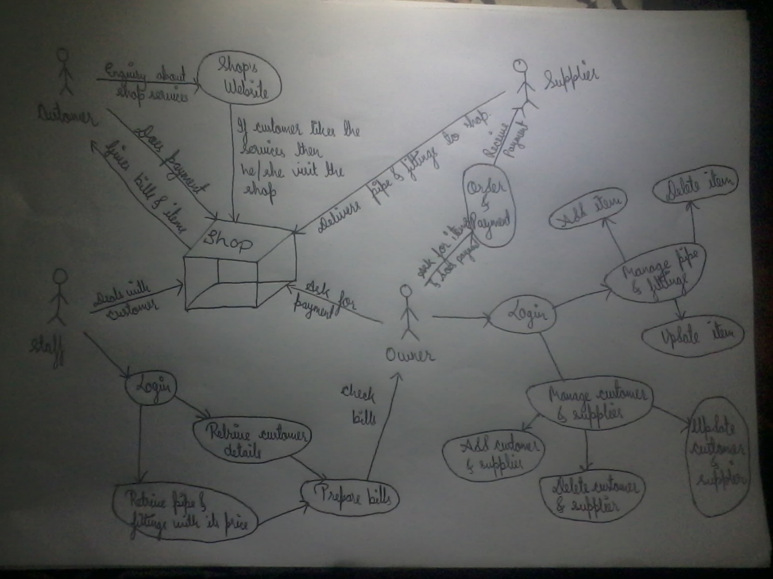

Figure 1: Rich picture for Hardware Sales and Purchases System

Figure

## System Requirement Specification (SRS)

It refers to analyzation summarization of system requirements by conducting various methods or processes like interview by preparing appropriate questionnaire, observation of staff and customer and other similar activities related to gathering information. It is further divided into functional and non-functional requirements.

### Functional Requirements

It describes the functional requirements of the system; like what it really need to do. It includes data control, authentication, verification, function and methods, rules and regulation and many more which is required to run the system. However, its defines set of inputs, processes and required outputs.

Some of the functional requirements for HSPS are given below:

**ID:** FR1

**Title:** Owner/Staff Registration

**Description:** Owner/Staff must be able to register themselves in the system. They should provide username and password for registration.

**Rational:** To get information to logged into system

**ID:** FR2

**Title:** Owner/Staff Login

**Description:** Owner/Staff must be able to logged into system with their username and password. After login they can get access to other function of the system.

**Rational:** To be able to get access into system.

**ID:** FR3

**Title:** View Report

**Description:** Owner/Staff should be able to view information of customer and supplier.

**Rational:** To know the details information of customer and supplier.

**ID:** FR4

**Title:** Sale and Purchase

**Description:** The system should provide platform to perform sale and purchase task for owner and staff.

**Rational:** Owner/Staff can recheck the data entered and correct if they any confusing data.

**ID:** FR5

**Title:** Stock Management

**Description:** The system must be able to manage stock so that it can display sales, purchases and balance of the pipe and fittings.

**Rational:** Sometimes shop might be run out from the stock. So to prevent from this risk stock management can inform before all the stock are cleared out.

**ID:** FR6

**Title:** Prepare bills/print

**Description:** The system should be able to generate bills with automatic calculation including all the taxes.

**Rational:** To make the bill system automated and reliable.

**ID:** FR7

**Title:** Shop details and its services

**Description:** The system must be able to provide required information to new customer and supplier such as contact number, address, email and many more.

**Rational:** To keep in touch with customer and supplier.

**ID:** FR8

**Title:** Details of pipe & fittings, customer and supplier

**Description:** System must be able to provide details information of pipe & fittings, customer and supplier quickly as per needed.

**Rational:** To do further study and produce better output.

**ID:** FR9

**Title:** Manage Customer and Supplier

**Description:** It must be able to add new customer and supplier and edit or update and delete existing customer and supplier details.

**Rational:** To be updated with information of customer and supplier.

**ID:** FR10

**Title:** Mange pipe & fittings

**Description:** It must be able to add pipe & fittings with their price and edit or update and delete existing pipe & fittings details.

**Rational:** To be updated with price and other products of the shop.

### Non-functional Requirements

The system can`t be totally successful with only functional requirements, there are many other things which help the system more efficient and effective. Such things are known as non-functional requirements. It defines the accuracy, capacity, smoothness and dependencies of the system.

Some of the non-functional requirements of HSPS are given below:

**ID:** NR1

**Title:** Speed

**Description:** System must perform the all the activities within certain period of time with accurate data processing.

**Rational:** To get the required data quickly and effectively.

**ID:** NR2

**Title:** Availability

**Description:** The system must be available for all the time when the shop is opened whereas website is for 24 X 7.

**Rational:** To access the database and features in working hours.

**ID:** NR3

**Title:** Reliability

**Description:** All the activities of shop are going to be automated so it should be reliable and cannot harm others also.

**Rational:** To make owner/staff use the system more often rather than doing manually.

**ID:** NR4

**Title:** Maintainability

**Description:** It should me maintainable if any problem occurs and system must be up to date.

**Rational:** To run the system smoothly without any disturbance.

**ID:** NR5

**Title:** Security

**Description:** Security is most important part of the system nowadays. So security must be provided in every required places.

**Rational:** To make data more secure.

**ID:** NR6

**Title:** Usability

**Description:** Moreover, the system must be usable and provide required platform.

**Rational:** To make understandable and informative system for owner/staff.

**ID:** NR7

**Title:** Compatibility

**Description:** It should be able to work with any devices and any browser.

**Rational:** To provide facility to every possible user.

**ID:** NR8

**Title:** Data Integrity

**Description:** The data must be accurate and consistency in the output.

**Rational:** To provide accurate data.

**ID:** NR9

**Title:** Adaptability

**Description:** It should be able to adjust with the new requirements of the shop.

**Rational:** To perform continuously without any problem

**ID:** NR10

**Title:** Back up

**Description:** Backup must be done daily because daily sales and purchase activities are carried out so to prevent from data loss back up must be done.

**Rational:** To recovery of data in case of loss of data.

## Prioritization

It is the process of identifying the important needs of the system. While performing SRS many requirements are identified. Although, all the features and functions are needed to be develop there are some requirements which are less prioritized for the moment. I have use MoSCow for performing prioritization. MoSCow refers to

**Must Have:** It refers to most important requirements of the system

**Should Have:** It refers to important but not necessary for delivery for current time.

**Could Have:** It refers to desirable but not important and can be update later.

**Won’t Have:** It refers the features that have been demanded but unfortunately can’t develop at a given time.

|  |  |  |
| --- | --- | --- |
| **ID** | **Functional and Non-functional Requirements** | **MoSCoW** |
| FR1 | Owner/Staff Registration | Must have |
| FR2 | Owner/Staff Login | Must have |
| FR3 | View Report | Won`t have |
| FR4 | Sales and Purchase | Must have |
| FR5 | Stock management | Could have |
| FR6 | Prepare bills/ print | Should have |
| FR7 | Shop details and its services | Should have |
| FR8 | Details of pipe & fittings, customer and supplier | Must have |
| FR9 | Manage Customer and Supplier | Should have |
| FR10 | Manage pipe & fittings | Should have |
| NR1 | Speed | Won`t have |
| NR2 | Availability | Must have |
| NR3 | Reliability | Could have |
| NR4 | Maintainability | Should have |
| NR5 | Security | Could have |
| NR6 | Usability | Must have |
| NR7 | Compatibility | Should have |
| NR8 | Data Integrity | Could have |
| NR9 | Adaptability | Won`t have |
| NR10 | Back up | Should have |

Figure 2: MoSCoW of HSPS

Figure

# Use case diagram

It is the diagrammatical representation of identifying, analyzing, clarifying and organizing system requirements in a scientific manner. It shows the activities done by each individual suck as owner, staff, customer and supplier. They are represented by stickman whereas activities or process of the system is represented by entities and its dependencies. It also help to identifies functional and non-functional requirements of the system

Use case diagram for HSPS are given below

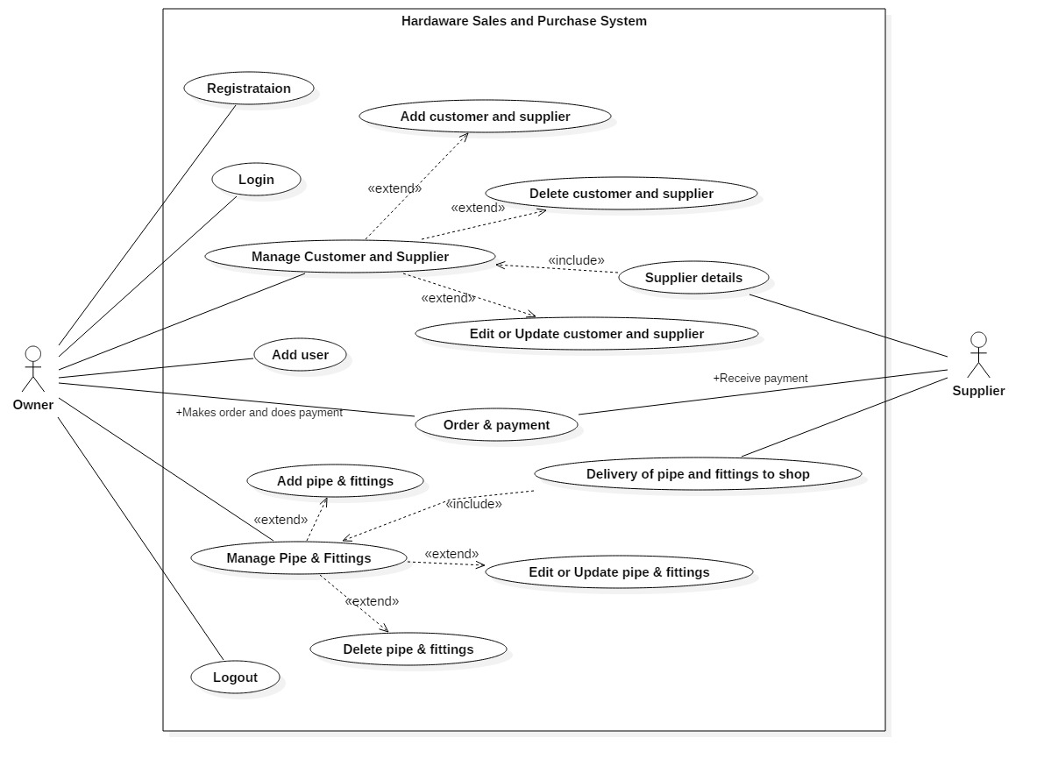

Figure 3: Use case of actor and supplier of HSPS

Figure

Use case description of Hardware Sales and Purchases System for Owner and Supplier are listed below:

1. Owner can register himself by providing his required personal details.
2. After registration he/she can login to access the features and functions of the system.
3. He/she can manage customer, supplier and pipe & fittings like add, update or delete.
4. He/she can make order to supplier for required pipe and fittings and make payment after the delivery.
5. Owner can make themselves logged out if there are no any work to perform.
6. Supplier provides a details information of themselves including products they have manufactured.
7. Supplier takes order from owner and delivery as per required list and takes payment.

Use case for staff and customer for HSPS

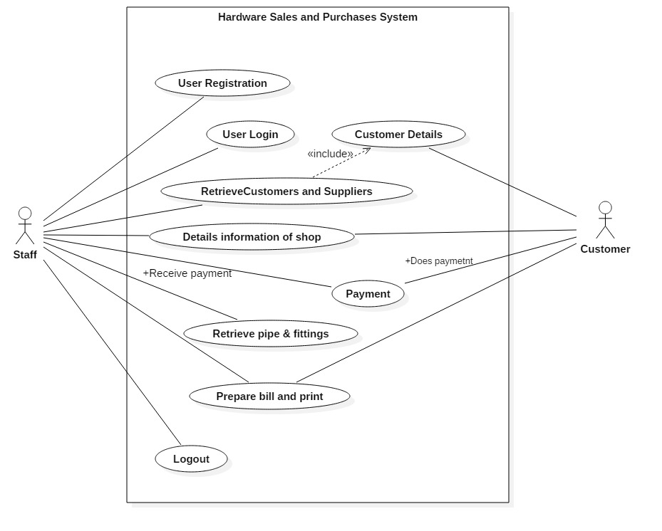

Figure 4: Use case of staff and customer HSPS

Figure

Use case description of Hardware Sales and Purchases System for Staff and Customer are listed below:

1. Staff also can register themselves by providing their information.
2. After registration he/she can login to access the features and functions of the system.
3. Staff can retrieve data which the Owner has entered into database for sales and purchase system.
4. He/she can also view the webpage of shop and update them if required.
5. Staffs also prepare bills and print them if required.
6. Staffs are also able to logged out from the webpage while it is not required.
7. Customer also visit the website and later goes to shop for purchasing pipe & fittings.
8. Payment is done at the same time when customer visit the shop.

# Architecture

Architecture refers to structure of how the whole system is going to be completed or develop. It is a prototype of system that explains how all the features and functions are going to work together for better output. It also includes system performance, usability, availability, security and many more related to non-functional requirements.

## System Architecture

It defines the structure and behavior of the system that represents how the whole system is going to work. It is based on a tool known as architecture frame work. It is the platform where functional activities are divided into different object and makes them easier to handle in complex situation. I have chosen Model View Controller (MVC) design pattern to work with. Model refers to data and method used to work with. View represents the visualization of the data that model contains whereas Controller represents the classes connecting the model and the view and relation between them.

## Initial Class Diagram

Class diagram refers to diagrammatical represents of classes including their attribute of HSPS. It also shows the relationship and cardinality between classes used in HSPS. It also gives the function or methods that are used in this HSPS.

Initial class diagram is just a prototype of original class diagram that shows there would be following classes with its functions.

## Natural Language Analysis (NLA)

It is the process of identifying classes, attributes and its function by doing proper analysis of system. It identifies nouns, verbs and adjectives which represents classes, attributes and functions respectively.

Here, are the initial NLA process done by analyzing the system requirements.

|  |  |
| --- | --- |
| Classes (Noun) | Verb (methods) |
| owner, staff, customer, user, shop, login, vendor, item, supplier, pipe & fittings, retailer, wholesaler. | Monitor, order, add, update, delete, report, view, control and many more. |

After doing the initial NLA process the proper classes and methods are identified.

|  |  |
| --- | --- |
| Classes | Verb |
| Owner, Staff, Customer, Supplier, Shop | Add, update, delete, view, register, login etc. |

Initial class diagram of HSPS

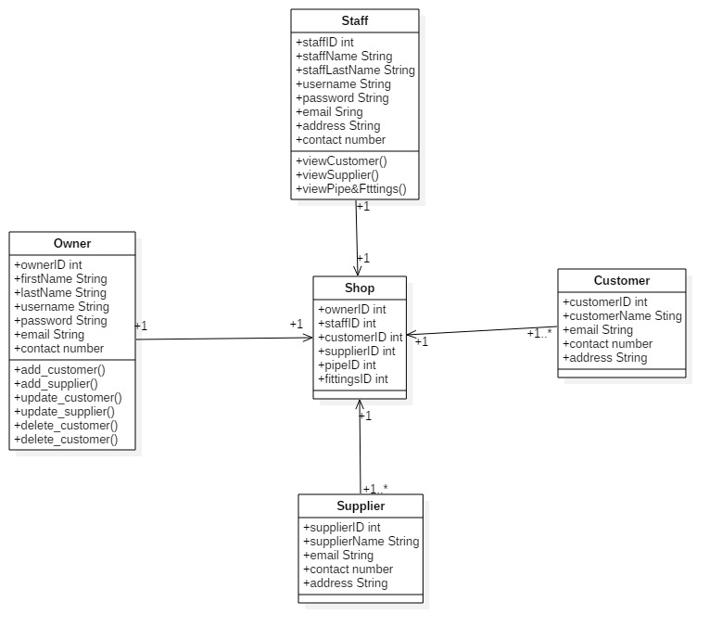

Figure 5: Initial class diagram of HSPS

Figure

# Conclusion

Finally, the analysis was done using various traditional and modern technology for Hardware Sales and Purchases System. Firstly, I have done requirements analysis which consists of functional and non-functional requirements. Later prioritization was conducted using MoSCoW method which helps to identify the must have, should have, could have and won`t have features and functions of the HSPS. Use case diagram was also prepared while doing analysis for better understanding of the system and relation among the entities of HSPS. Lastly, the initial class diagram was prepared to know the functions that must be used to develop the system.