**Design on   
Hardware Sales and Purchase System**

**LIRAJ MAHARJAN**

**00162808**

**Computing Project**

**Level 5 Diploma in Computing**

**Softwarica College of IT and E-Commerce**

**Kathmandu, Nepal**

**24 May 2017**

Table of Contents

Design 4

Structural Diagram 4

Class Diagram 4

Behaviour Diagram 6

Activity Diagram 6

Sequence Diagram 9

Database Design 17

Entity Relationships (ER) Diagram 17

Data Dictionary 19

Conclusion 23

References 24

**Table of figures**

**Figure 1: Final class diagram of Hardware Sales and Purchases System** 5

**Figure 2:Activity diagram of Hardware Sales and Purchases System for customer and staff** 7

**Figure 3:Activity diagram of Hardware Sales and Purchases System for owner and supplier** 8

**Figure 4:Sequence diagram of owner registration** 9

**Figure 5:Sequence diagram of owner login** 10

**Figure 6:Sequence diagram of owner activities** 11

**Figure 7:Sequence diagram of staff login** 12

**Figure 8:Sequence diagram of staff login** 12

**Figure 9:Sequence diagram of staff page** 13

**Figure 10:Sequence diagram for customer registration** 14

**Figure 11:Sequence diagram of customer login** 14

**Figure 12:Sequence diagram of customer page** 15

**Figure 13:Sequence diagram of payment** 16

**Figure 14:ER diagram of Hardware Sales and Purchases System** 18

**Figure 15:Data dictionary of table CUSTOMER** 19

**Figure 16:Data dictionary of table STAFF** 19

**Figure 17:Data dictionary of table SUPPLIER** 20

**Figure 18:Data dictionary of table ORDER** 20

**Figure 19:Data dictionary of table PIPE&FITTINGS** 20

**Figure 20:Data dictionary of table PURCHASE** 21

**Figure 21:Data dictionary of table SALE** 21

**Figure 22:Data dictionary of table STAFCUSTOMER** 22

**Figure 23:Data dictionary of table STAFFSUPPLIER** 22

**Figure 24:Data dictionary of table STAFF_TYPE** 22

# Design

Analysis describes what a system should do to meet the requirements of the Hardware Sales and Purchases System (HSPS) and design shows how the system will fulfil the objectives of system. The design of the system is the overall plan or model for that system. To design the system, the team or an individual can use top-down design or bottom-up design model. A design can be conceptual, logical and physical. It must be done with proper visualization of the system for better result in the development. The system design method such as activity diagram, class diagram, ER-diagram, flow-charts, data flow diagram (DFD) etc. are used in this phase.

For the designing phase I have use Unified Modelling Language (UML) diagrams for better understanding of the system. UML is a platform for designing, portraying and documenting the concept of how the system works and its functional and non-functional activities. It can represent both static and dynamic view of the system. It`s just a platform for designing or modelling language which helps to develop (coding) the system easily and effectively.

With various IDE available for modelling, I have preferred StarUML and Visual Paradigm tool to construct the various diagram. It provides necessary tools while drawing such diagram. I have used StarUML for Class diagram and for ER-diagram, Sequence diagram and Activity diagram in Visual Paradigm. Data dictionary is also included which is construct in MS Excel.

I have further divided design methodology into structural, behavioural and design related to database design.

# Structural Diagram

Structural modelling refers to the static features and framework for the system. It works as a elements and the mechanism to assemble system effectively. It consists of class diagram, deployment diagram, component diagram and many other diagrams. Among them I have chosen to class diagram to go with.

## Class Diagram

It represents the static view of the HSPS by analysing and designing. It describes the attributes, operation and constraint used in the system. It is not only used for describing the aspects of a system but also for constructing executable code. It shows relationships, association, aggregation, interface among two different classes.

Here, is the final class diagram of Hardware Sales and Purchases System (HSPS).

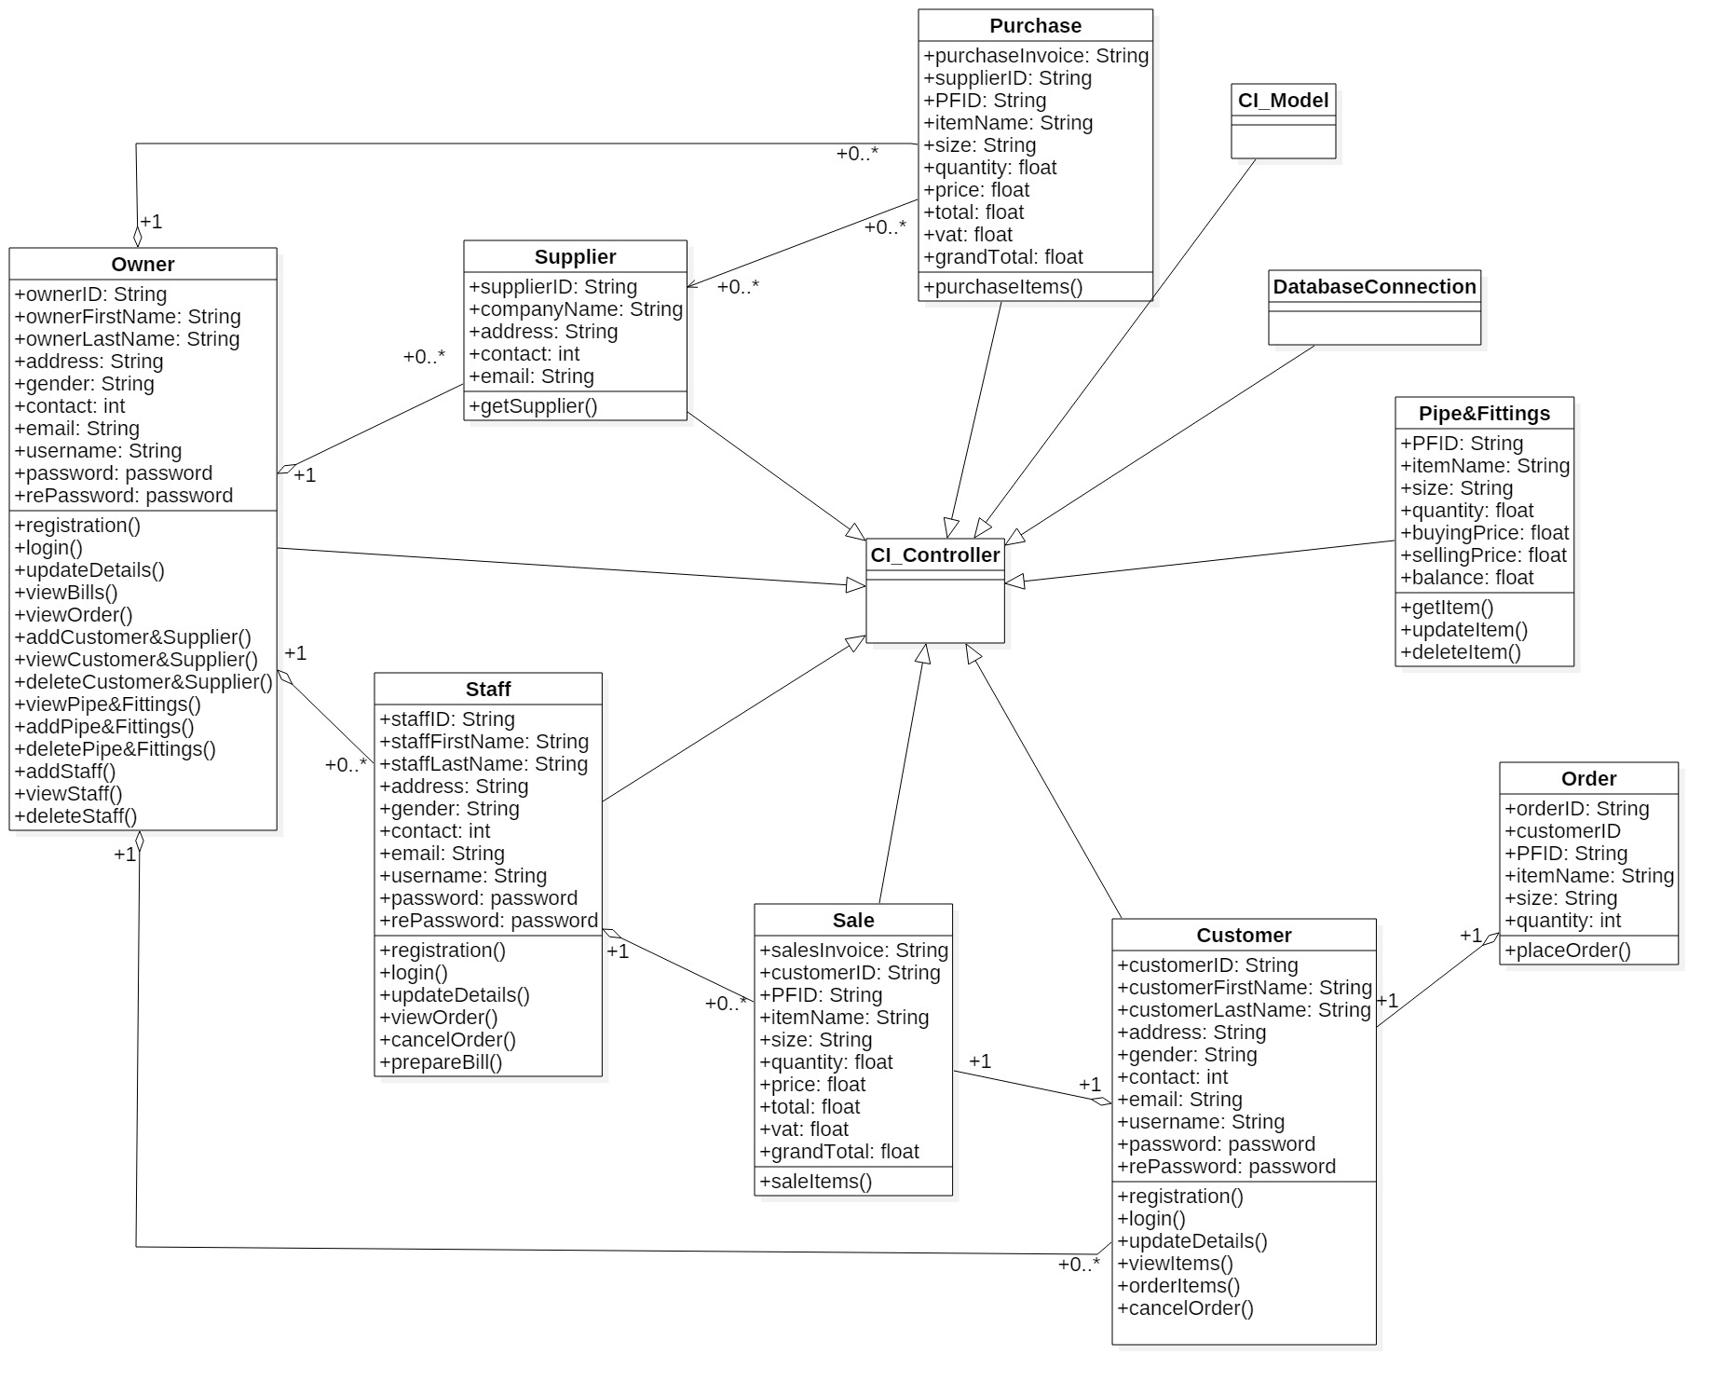

**Figure 1: Final class diagram of Hardware Sales and Purchases System**

In the above Figure 1, it contains of different classes having specific attributes and functions along with CI_Controller, CI_Model and DatabaseConnection. CI_Controller controls all the classes and make relationship with other classes to operate the system smoothly where as CI_Model is the collection of data and methods. DatabaseConnection is used to configure the database connection for storing the data generated through controller, view and model. The class diagram shows generalization, relationship and aggregation between two classes.

# Behaviour Diagram

Behaviour modelling represents the interaction between user and system of HSPS. It refers to dynamic features of the system. It shows the functions or logic of the system how the system should perform. It consists of Activity diagram, Sequence (Interaction) Diagram, Use case diagram and many more. Among them I have chosen activity diagram and sequence diagram to go with.

## Activity Diagram

It refers to activity that flows within the system. Basically, it’s a flowchart that represents the flow from one activity to another activity. It shows how owner, staff and customer of HSPS are going to interact with the system. It is used to modelling work flow of the stakeholders, business requirements, understanding high level of system`s functions and for further studies of business.

Here is the activity diagram of staff and customer for Hardware Sales and Purchases System (HSPS).

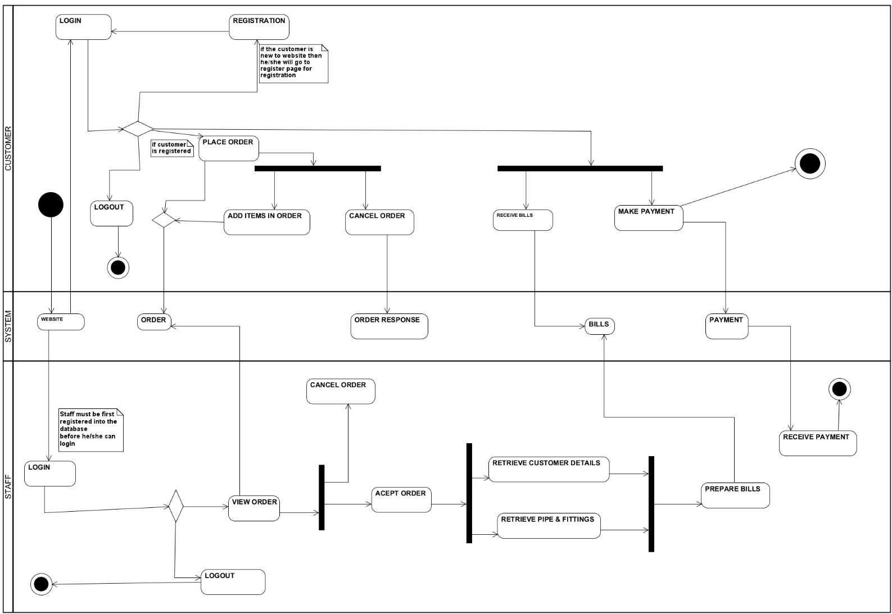

**Figure 2:Activity diagram of Hardware Sales and Purchases System for customer and staff**

In the above Figure 2, it consists of activities and interaction between system that are done by staff and customer simultaneously. Here, the customer logged into website (if the customer is not registered he/she must have registered themselves) and place order of his/her required pipe and fittings and does payment after the bills is prepared by staff. He/she can also cancel the order if they don’t want ordered items anymore. And in terms of staff, after he/she logged in, they view order placed by the customer and prepare bills from retrieving data from database and receive payment made by customer. Customer and staff also can log out from website if they done have anything to do.

Here, is activity diagram of owner and supplier of HSPS.

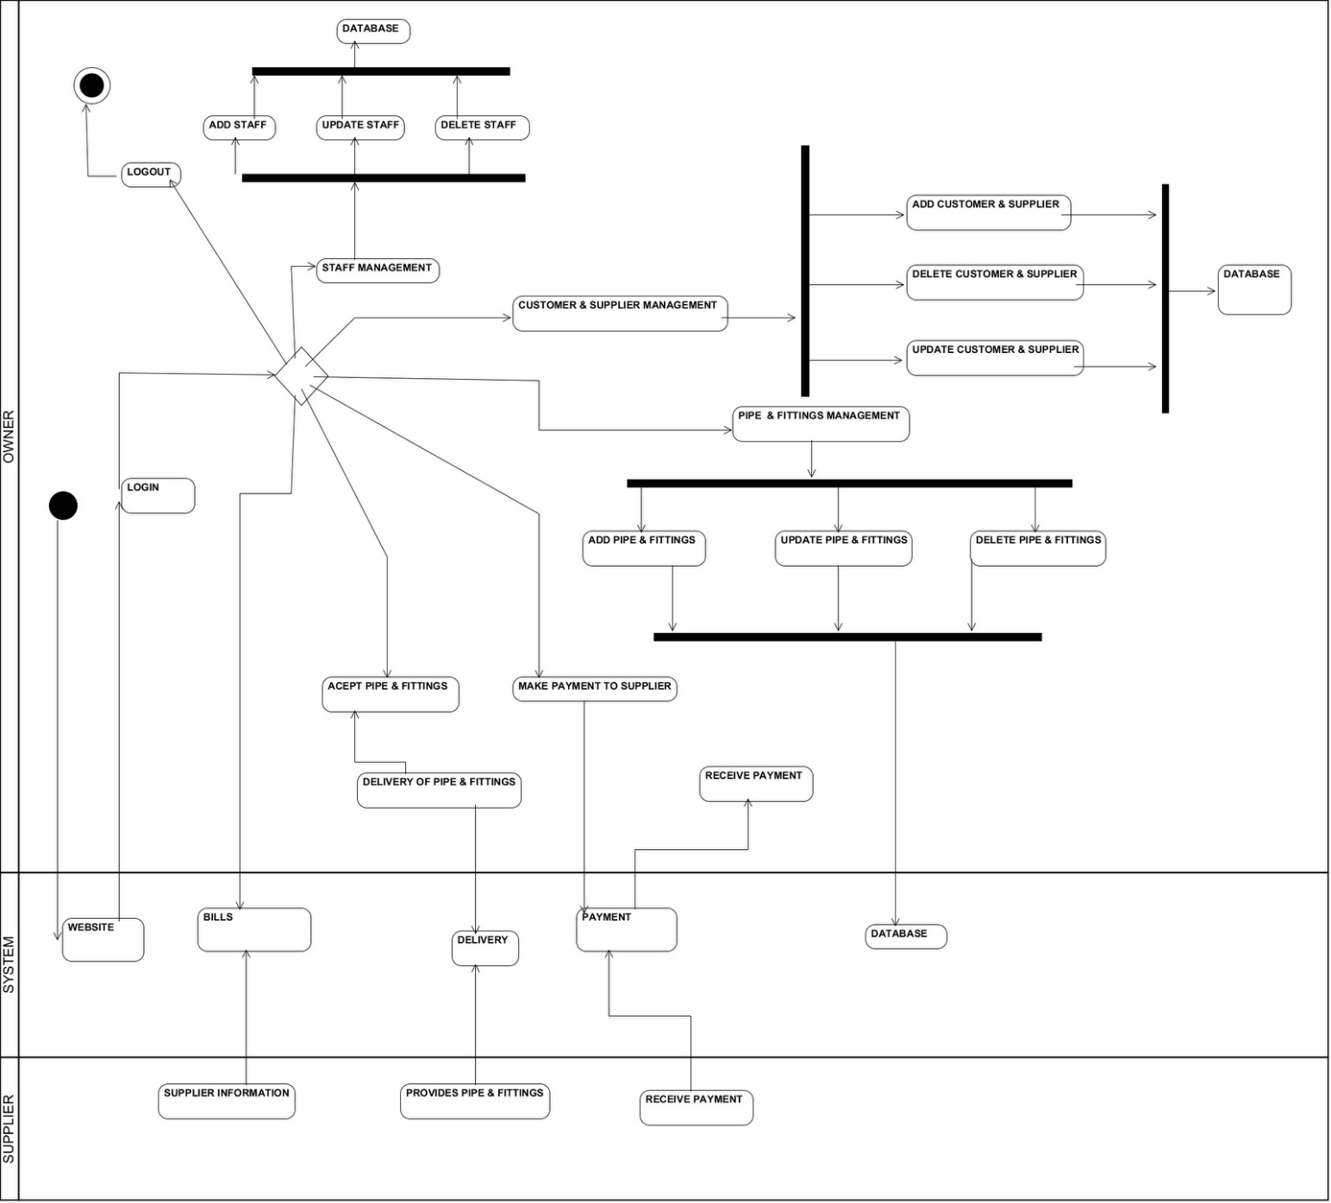

**Figure 3:Activity diagram of Hardware Sales and Purchases System for owner and supplier**

In the above Figure 3, it shows the activity done by owner and supplier. Owner logged into website and does various related CRUD operation. He/she can add staff, customer & supplier and pipe & fittings and can manipulate them as per requirements. He/she also makes deals with supplier and does payment for purchased item. Supplier provides his/her information and product they have manufactured.

## Sequence Diagram

It is a diagrammatical representation of message flow within the system that makes alert to the user of the website. It not only shows the interaction between users and system but also passage the message as per which activity is currently in operation. It is also dynamic behaviour of the system. It is used for flow control of time sequence and structural organization and message passed by specific activity.

Here, is the collection of sequence diagram of Hardware Sales and Purchases System (HSPS).

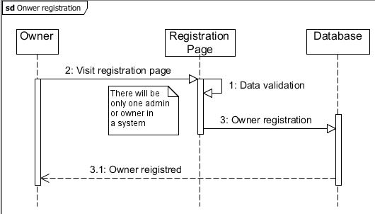

**Figure 4:Sequence diagram of owner registration**

In the above Figure 4, it consists of owner, registration page and database, where owner is getting registered him/her selves by accessing to registration page. Here, database refers to store the register details into specific table.

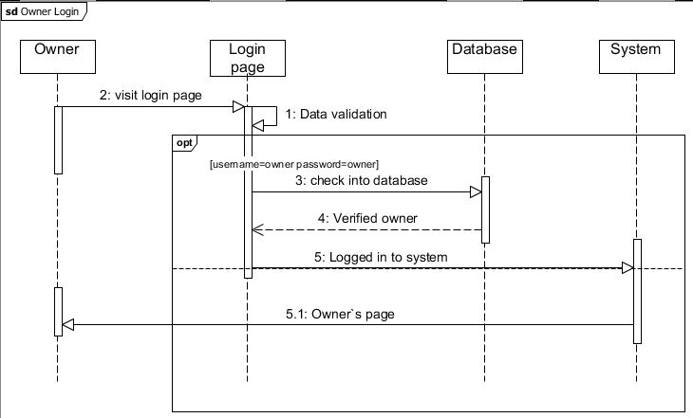

**Figure 5:Sequence diagram of owner login**

In the above Figure 5, it consists of owner, login page, database and system. Here, owner is trying to logged in with username: owner and password: owner, which helps him to get access to the system and perform several activities. As the username and password matches as per specified then system redirect owner to owner`s page.

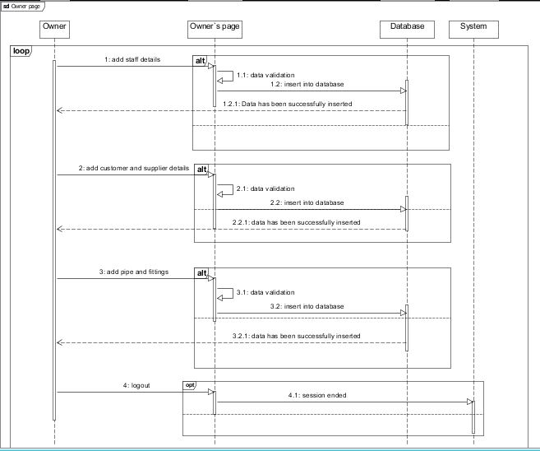

**Figure 6:Sequence diagram of owner activities**

In the above Figure 6, it consists of owner, owner`s page, database and system. After the owner get logged in into owner`s page, he/she can perform various CRUD operation. System and database collaborate with each other to provide smooth platform for owner to perform his/her activity without any disturbances.

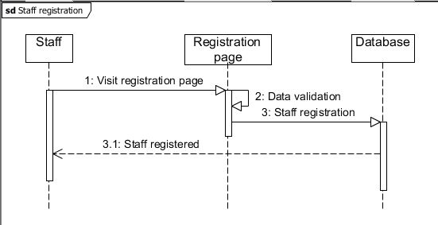

**Figure 7:Sequence diagram of staff login**

In the above Figure 7, it consists of staff, registration page and database where staff can get registered him/her selves. He/she can later perform activities by getting logged into the system or website. After the completion of registration, staff will be informed with popup message in a dialogue box.

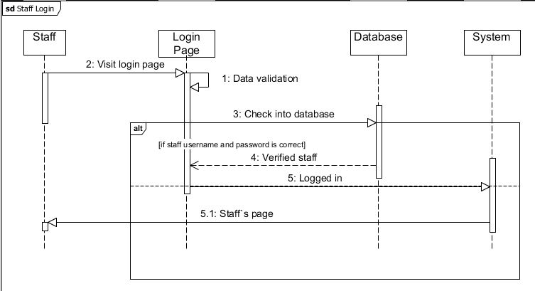

**Figure 8:Sequence diagram of staff login**

In the given Figure 8, it consists of staff, login page, database and system. With the help of staff username and password he/she can get access to the website and perform various task. If the username and password provided by the staff matches with username and password that is in the database, then system redirect them into staff`s page.

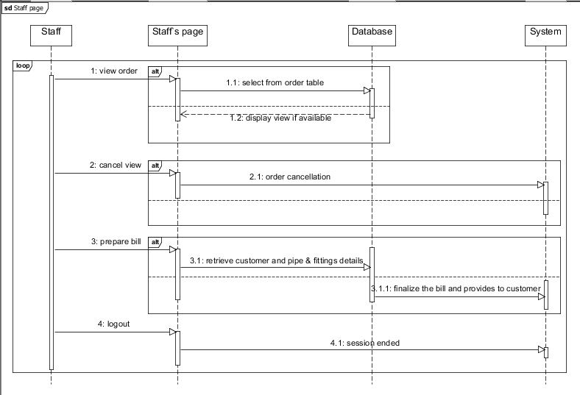

**Figure 9:Sequence diagram of staff page**

In the above Figure 9, it consists of staff, staff`s page, database and system. After the staff get logged into the system he/she can view order placed by the customer and cancel the order. He/she also prepare the bills as per the customer order and ask for the payment. Here, system plays a vital role for interaction between customer and staff.

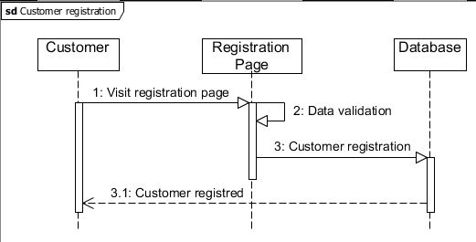

**Figure 10:Sequence diagram for customer registration**

In the above Figure 10, it consists of customer, registration page and database. It shows how the customer is going to get registered into the system for purchasing the pipe and fittings of available in the database. If customer make it to register him/her selves successfully then pop up message with information will appear.

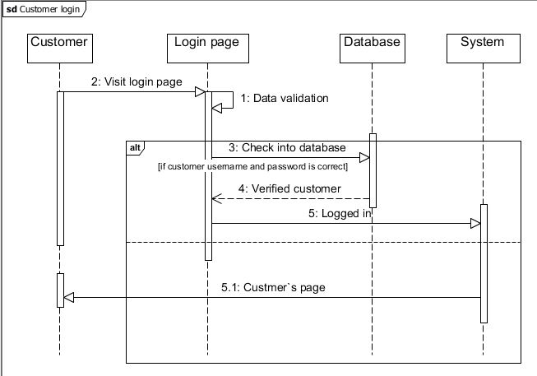

**Figure 11:Sequence diagram of customer login**

In the given Figure 11, it consists of customer, login page, database and system. Customer can only log in if he/she is registered into database. If the username and password provided by the customer matches will the database username and password, then he/she is redirected to customer`s page.

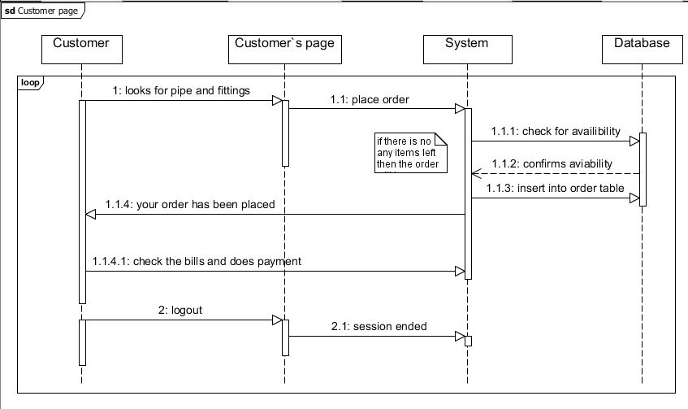

**Figure 12:Sequence diagram of customer page**

In the above Figure 12, it consists of customer, customer`s page, system and database. When the customer is redirected to customer` page, he/she can place order of the pipe and fittings he/she is willing to buy. He/she also received the bills prepare by the staff and does payment according to particular bill.

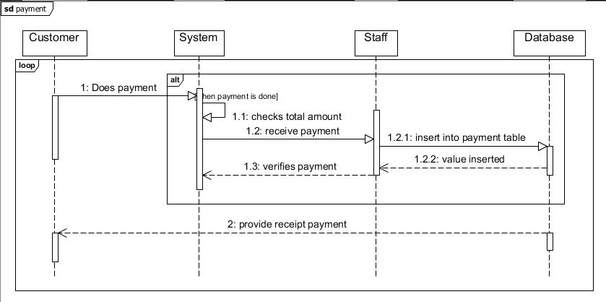

**Figure 13:Sequence diagram of payment**

In the above Figure 13, it consists of customer, system, staff and database. Customer does payment for the purchased item and Staff received the payment and provide the receipt voucher whereas System works as an interaction between customer and staff.

# Database Design

Database design specifies the data and its structure that should be stored in the database. A good database design is a list of appropriate data that will be included into the database and can be change in the future as per requirements. It also helps in handling the data in easy way as well as enhance the performance of the system. It also shows the relation among the different entities and attributes contain in the entity. Database design can be further divided into Conceptual, Logical and Physical database design. Conceptual design helps to figure out the specific entities and relationships among those entities, Logical design determine the attributes and keys for that entity with the help of normalization whereas Physical design helps to create entity as per definition provided by the Logical design.

There are many different database systems available, among them I have chosen MySQL for HSPS project which I found more comfortable than others. I have considered ER diagram and Data dictionary for this project as a part of database design.

## Entity Relationships (ER) Diagram

ER diagram illustrates how entities are related to each other within a system. It consists of entity, attributes, keys, relationship. Entity refers to the tables of database which can be object, person, animals that provides meaning full information. Attributes refers to properties of that entity where the raw data are stored and make it meaningful. Keys represents the uniqueness of that entity. That can be either primary key, super key, composite key and foreign key represents primary key of another entity. Relationship is the association among two or more entities. It is also known as cardinalities. There are three types of cardinalities One-to-one, One-to-many and Many-to many.

Here, is the ER diagram of HSPS as per analysis done in previous Analysis phase.

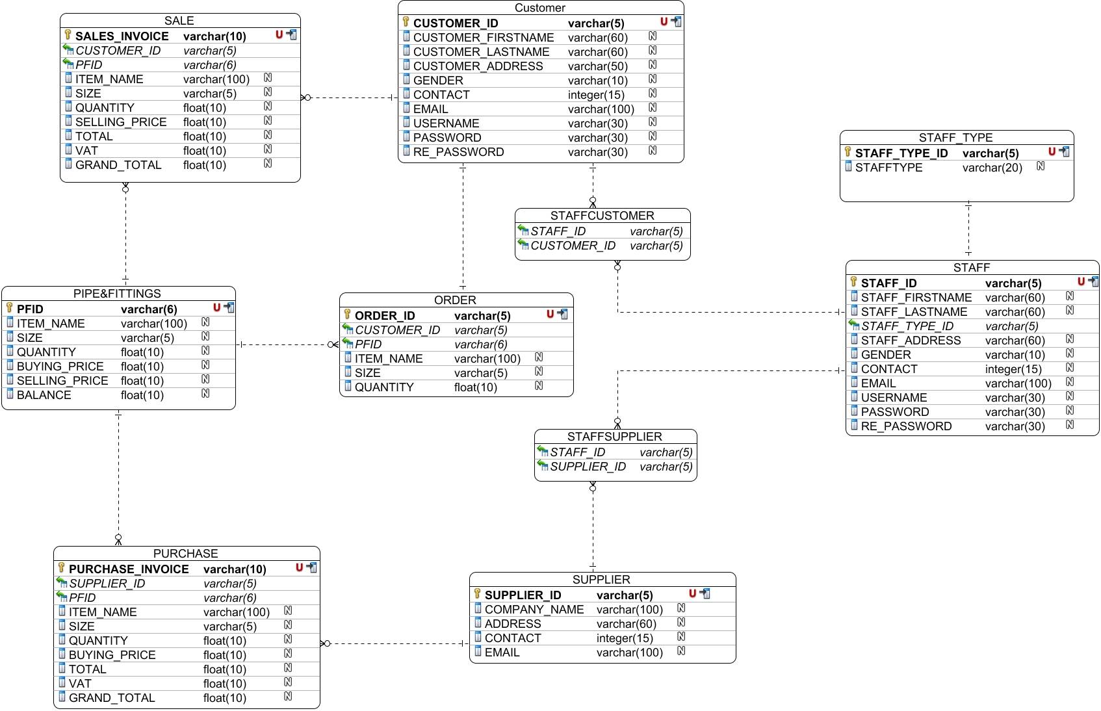

**Figure 14:ER diagram of Hardware Sales and Purchases System**

In the above Figure 14, there are total of 10 tables such as STAFF, CUSTOMER, SUPPLIER, PIPE&FITTINGS, PURCHASE, SALES, STAFF_TYPE, ORDER, STAFFCUSTOMER, STAFFSPPLIER. Here, yellow key represents Primary Key, red U represents Uniqueness and column with black arrow represents indexes whereas column with green arrow represents foreign key. Dotted lines represents the different type of cardinality separated by its ending. It also shows the dependency of the one entity into another. STAFF, CUSTOMER, AND SUPPLIER tables holds the details information of staff, customer and supplier respectively. PIPE&FITTINGS table holds the item with their respective price. ORDER tables holds the items data that are ordered by the customer, STAFF_TYPE holds the records of staff type, SALE and PURCHASE record the data that have been sold and purchased respectively. And STAFFCUSTOMER and STAFFSUPPLIER is the junction table for CUSTOMER, STAFF and SUPPLIER because of many to many relationships.

## Data Dictionary

Data dictionary is a set of detail information describing structure, format and contents of database. It also describes the entity`s attributes such as its data type, key, length, null able value and its constraint and relationship between among attributes or elements of two different entities.

Data dictionary of table CUSTOMER

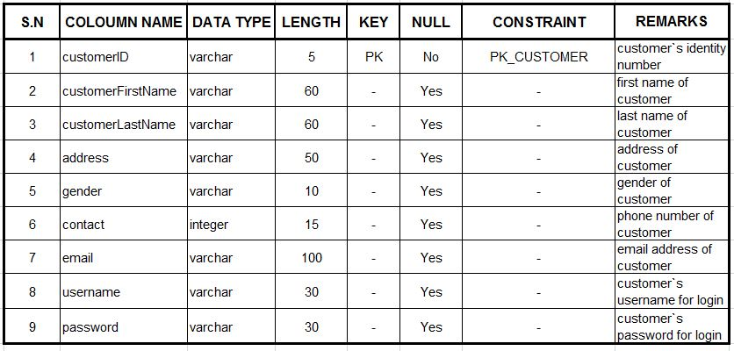**Figure 15:Data dictionary of table CUSTOMER**

Data dictionary of table STAFF

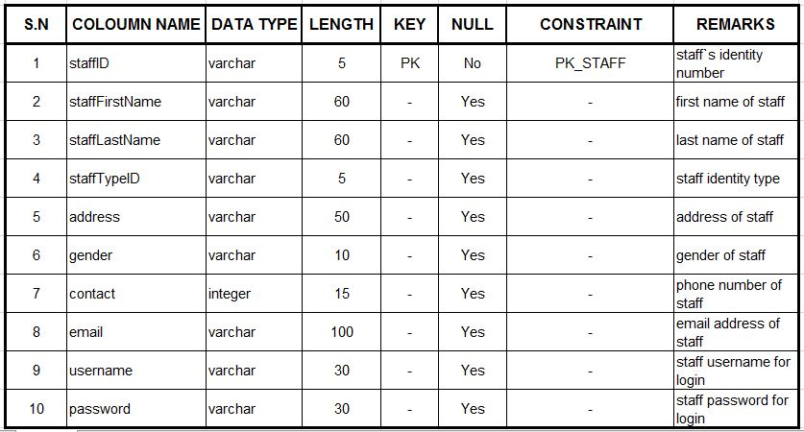

**Figure 16:Data dictionary of table STAFF**

Data dictionary of table SUPPLIER

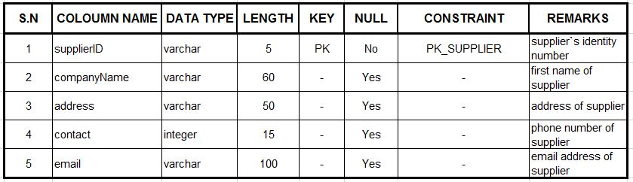

**Figure 17:Data dictionary of table SUPPLIER**

Data dictionary of table ORDER

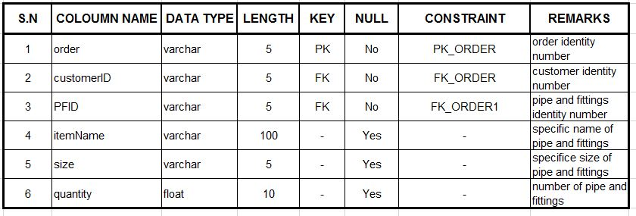

**Figure 18:Data dictionary of table ORDER**

Data dictionary of table PIPE&FITTINGS

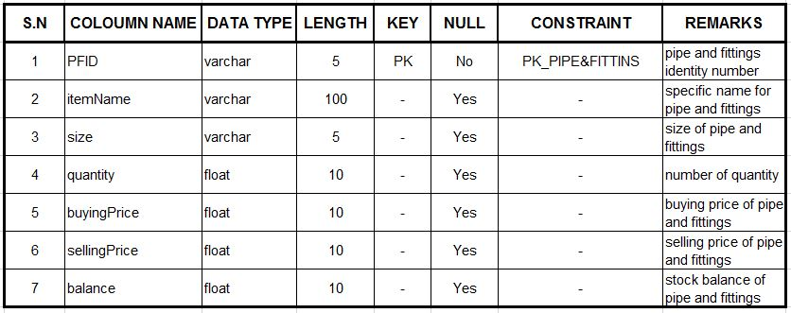

**Figure 19:Data dictionary of table PIPE&FITTINGS**

Data dictionary of table PURCHASE

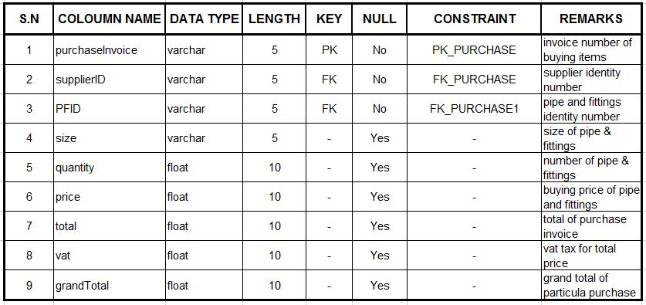

**Figure 20:Data dictionary of table PURCHASE**

Data dictionary of table SALE

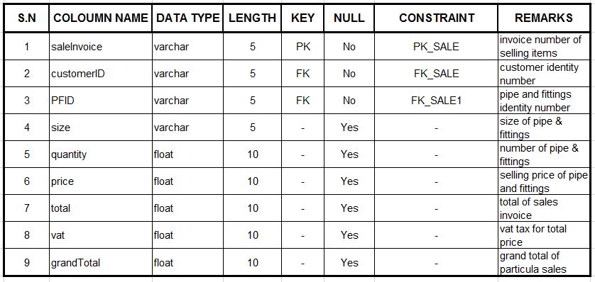

**Figure 21:Data dictionary of table SALE**

Data dictionary of table STAFFCUSTOMER

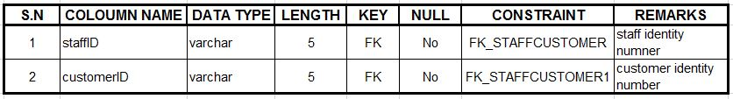

**Figure 22:Data dictionary of table STAFCUSTOMER**

Data dictionary of table STAFFSUPPLIER

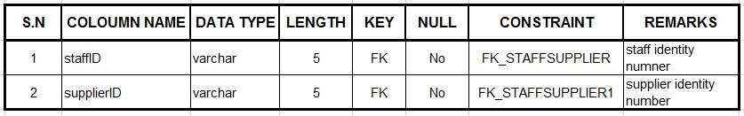

**Figure 23:Data dictionary of table STAFFSUPPLIER**

Data dictionary of table STAFF_TYPE

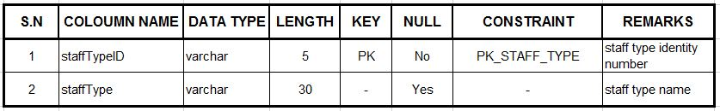

**Figure 24:Data dictionary of table STAFF_TYPE**

# Conclusion

Finally, the designing phase was completed successfully. Though the diagram construction was a bit difficult, proper guidance of tutor helps me to complete this phase. The designing was done with different type of UML diagrams which gives meaningful information to the viewers. The designing was divided into three different parts Structural, Behaviour and Database design for better understanding. Structural design consists of class diagram, Behaviour diagram consists of activity diagram and sequence diagram whereas Database design consists of ER diagram and data dictionary in this project.The diagrams are constructed in StarUML and Visual Paradigm which has all the necessary tools to make the diagram meaningful. Class diagram is constructed in StarUML whereas all the other diagrams such as Activity diagram, ER diagram, Sequence diagram are construct in Visual Paradigm. Data dictionary were built in MS Excel. With the help of these diagram development (coding) of system has been much easier.

# References

Lucidchart, n.d. *Activity Diagram Tutorial.* [Online]   
Available at: https://www.lucidchart.com/pages/uml/activity-diagram  
[Accessed 20 May 2017].

Lucidchart, n.d. *Class Diagram Tutorial.* [Online]   
Available at: https://www.lucidchart.com/pages/uml/class-diagram  
[Accessed 20 May 2017].

Lucidchart, n.d. *Sequence Diagram Tutorial.* [Online]   
Available at: https://www.lucidchart.com/pages/uml/sequence-diagram  
[Accessed 20 May 2017].

Lucidchart, n.d. *What is an Entity Relationship Diagram.* [Online]   
Available at: https://www.lucidchart.com/pages/er-diagrams  
[Accessed 21 May 2017].

Solutions, D., n.d. *Introduction to database design.* [Online]   
Available at: http://www.datanamic.com/support/lt-dez005-introduction-db-modeling.html  
[Accessed 21 May 2017].

tutorialspoint, n.d. *ER Model - Basic Concepts.* [Online]   
Available at: https://www.tutorialspoint.com/dbms/er_model_basic_concepts.htm  
[Accessed 21 May 2017].

tutorialspoint, n.d. *UML - Activity Diagrams.* [Online]   
Available at: https://www.tutorialspoint.com/uml/uml_activity_diagram.htm  
[Accessed 20 May 2017].

tutorialspoint, n.d. *UML - Class Diagram.* [Online]   
Available at: https://www.tutorialspoint.com/uml/uml_class_diagram.htm  
[Accessed 20 May 2017].

tutorialspoint, n.d. *UML - Interaction Diagrams.* [Online]   
Available at: https://www.tutorialspoint.com/uml/uml_interaction_diagram.htm  
[Accessed 20 May 2017].

WebStrom, n.d. *Software QA and Testing Reasearch Center.* [Online]   
Available at: http://sqa.fyicenter.com/FAQ/Testing-Techniques/What_is_the_difference_between_top_down_and_bott.html  
[Accessed 21 May 2017].