**Project Proposal on   
Hardware Sales and Purchase System**

**LIRAJ MAHARJAN**

**00162808**

**Computing Project**

**Level 5 Diploma in Computing**

**Softwarica College of IT and E-Commerce**

**Kathmandu, Nepal**

**9 April 2017**

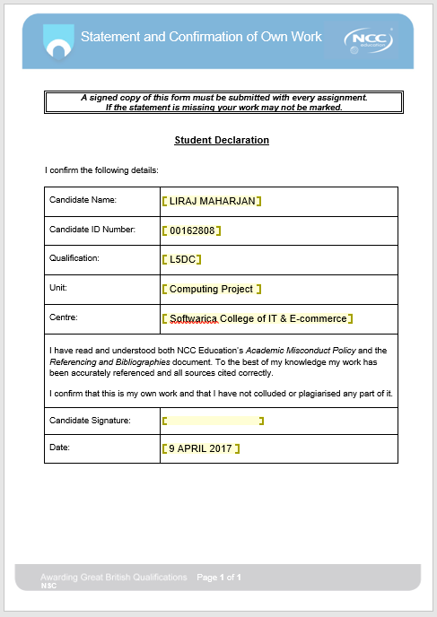

Table of Contents

INTRODUCTION 4

Main features 4

Aim of the project 4

Objectives of the project 4

Development Methods 5

Project Plan 8

Work Breakdown Structure (WBS) 8

Time Estimation 9

Milestones 10

Schedule 10

Gantt Charts 11

Risk Management 12

Identifying Risks 12

Assess of impact of risks. 12

Alleviate Critical Risks 14

Configuration Management 15

Conclusion: 16

References 17

# INTRODUCTION

The system I will be developing is Hardware Sales and Purchase System (HSPS) for one the leading dealer as well as retailer shop for pipe and fittings located at Teku, Kathmandu. The main objectives of this shop is to provide customer satisfaction. The system will keep the records of customer and supplier information and their transaction. The system also shows the stock of pipe and fittings like item purchased, sold and remaining balance. The user interface of the system will be user friendly and easy to use all the services easily. The UI contains the buttons to perform shop`s activities.

Currently shop is using simple software for recording the transaction between customers and suppliers. There is no any means to promote shop to others customers so I am trying to develop a web-based application that will help to promote shop worldwide. This system is made for easy and reliable storage data of customers and suppliers. The objective for choosing this project was to keep the records of office activities, staffs, customer and suppliers details. It will help in managing all the transaction, customer`s and supplier`s details as well as their respective balance, stock information and many more.

The application is web-based so I will be using following language to accomplish my project like HTML, CSS, PHP, JavaScript and SQL queries. HTML and CSS is for design the user interface, PHP and JavaScript are used for functions and validation whereas SQL queries is for connection to database and for CRUD operation. The project contains and website of the company for advertisement of the shop and it’s information. There will be buttons for inserting, updating, retrieving and deleting the data from the database in each form of customers and suppliers. The application also provides the inventory management for checking around the stocks of the shop. It provides stocks report as purchased, sales and balance remaining.

## Main features

* Details information of shop and its facilities.
* Insert and update information of customers and suppliers.
* Pipe and fittings details.
* Staffs details.

## Aim of the project

* To automate the financial transaction.
* Provide information about pipe and fittings, customers and suppliers.
* Provide customers satisfaction.

## Objectives of the project

* To gather and analysis current status of the shop.
* To keep all the records of customers and suppliers.
* To analyze most product consumed by customers.
* To bring the latest or upgraded products in the market.
* To easy and reliable use of application.
* To keep record of staff attendance.
* To provide information of sales and purchased.

## Development Methods

In this project, I am going to develop a system through waterfall model. The waterfall model is a development model in which development process is done sequential one after another. It consists of following steps.

* **Feasibility Study**

In this phase the current situation of the shop is gathered and identifying of problems are done. All the gathered information is further analysis and possible solution are defined. The possibility of economic and financial status of the shop is analyzed. All the possible solution is check according to their cost, quality, behavior and suitable solution is applied for the shop.

* **Requirements Analysis**

In this phases, the planning and strategy is done for the project. The requirements and the needs of the shop is defined in this phase. If this phase is done with proper analysis, then the system might meet the requirements of the shop.

* **System Design**

In this phase, the system is design according to planning and analysis done in the previous phases. More the analysis and planning is done, it will be much easier to develop a system for a developer without any confusion.

* **Implementation**

In this phase, system is implemented or established in the shop for its operation. Initially the testing is done before it is completely implemented.

* **Testing**

In this phase, if the system does not work or operate as per its requirements then the system is further analyzed and maintenances is done.

* **Maintenance**

It also includes further maintenance of the system if it is crashed

Fig: Waterfall Method

The reasons why I choose Waterfall model are:

* It is simple to implement and easy to make use of it.
* Each step of it helps to accomplish this project smoothly and efficiency.
* The phases are taken one after another so proper completion of one step helps another step.
* It is traditional development method and less economic.
* It the requirements are well known, fixed and clear then it is much easier to work with.
* It is better for smaller project.
* A schedule can be set with deadlines to accomplish one step at a particular time.

# Project Plan

Project plan includes the steps used for accomplish the task or project. It contains concept to develop project, schedule, scope, project management, roles and responsibilities of the stakeholders, staff and users and analysis of project quality and risks. A plan must be able to fulfill the objects smoothly. Therefore, proper planning should be done for better result. I have done planning on the following basics:

## Work Breakdown Structure (WBS)

WBS is used to organize the work or task into manageable section. It is done by identifying the major functional steps and subdividing those steps for better output. Each steps are performed in a specific set of days. It specifics the task to be performed in a estimated days to accomplish the task at the given period of time.

Fig: WBS for Hardware Sale and Purchase System

## Time Estimation

It prefers to time estimates to complete this project. By being in track of this time estimation this project will be complete without any problem.

|  |  |  |
| --- | --- | --- |
| **WBS** | **Task Name** | **Days** |
| **1** | **Hardware Sales and Purchase System** | **80** |
| **2** | **Project Management** | **61** |
| 2.1 | Scoping & Brainstorming | 5 |
| 2.2 | Planning | 3 |
| 2.3 | Monitoring & Controlling | 53 |
| **3** | **Analysis** | **14** |
| 3.1 | Gathering Requirements | 3 |
| 3.2 | Interview | 3 |
| 3.3 | Feasibility Study | 3 |
| 3.4 | Architecture | 4 |
| **4** | **Design** | **31** |
| 4.1 | Structural Model | 10 |
| 4.2 | Behaviour Model | 10 |
| 4.3 | User Interface Design | 11 |
| **5** | **Implementation** | **21** |
| 5.1 | System Implementation | 21 |
| **6** | **Testing** | **7** |
| 6.1 | Unit Testing | 3 |
| 6.2 | White Box Testing | 2 |
| 6.3 | Black Box Testing | 2 |
| **7** | **Maintenances** | **58** |
| 7.1 | Preventive Maintenances | 32 |
| 7.2 | Corrective Maintenances | 26 |
| **8** | **Reporting** | **7** |
| 8.1 | User Manual | 2 |
| 8.2 | Presentation Materials | 3 |
| 8.3 | Final Report | 2 |

Fig: Time Estimation of HSPS

## Milestones

It is used for specifying the days to accomplish a certain task at a given time. It the estimation of completing the task step by step. I have following milestones to accomplish this project

|  |  |
| --- | --- |
| Milestones | Date |
| Project Proposal | 9 April 2017 |
| Analysis Specification | 23 April 2017 |
| Design Specification | 24 May 2017 |
| Implementation | 14 June 2017 |
| Testing | 5 July 2017 |
| Final Project Submission | 11 July 2017 |

Fig: Milestones of Hardware Sales and Purchase System

## Schedule

It is a time schedule to complete a specific task at particular given time. I have estimated following schedule to accomplish this project.

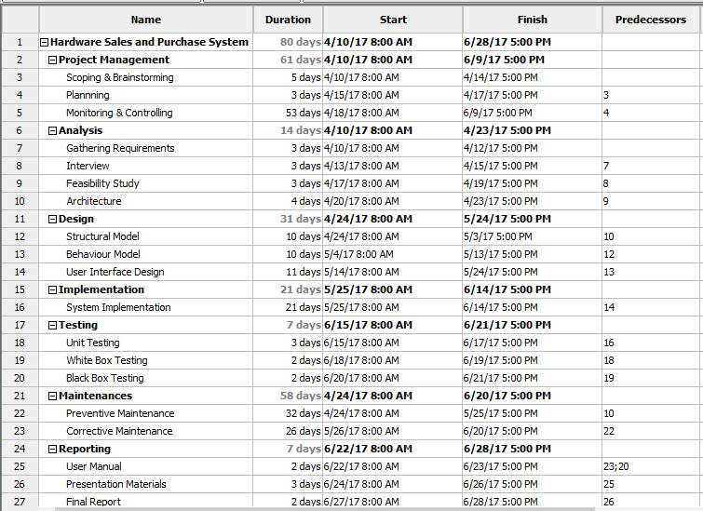

Fig: Time schedule for HSPS

## Gantt Charts

It is diagrammatical representation of time schedule of Hardware Sales and Purchase System. It is show as bar diagram.

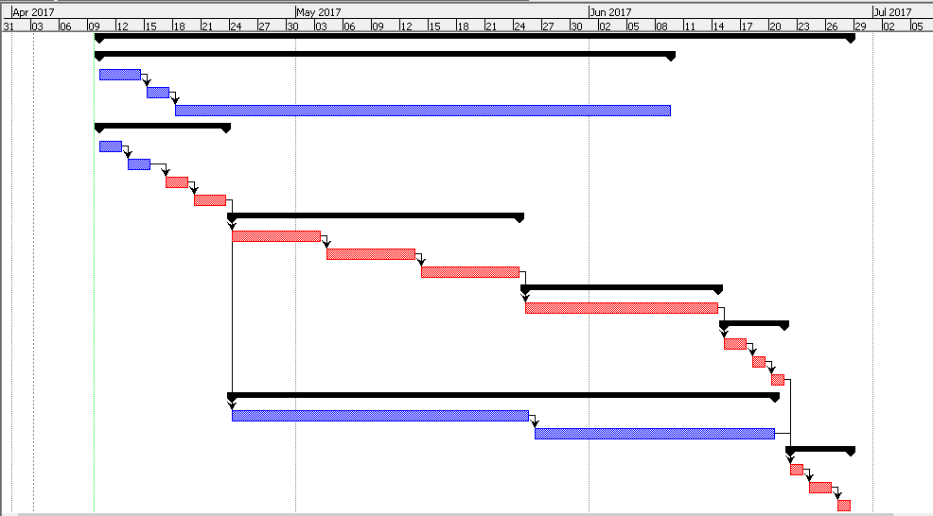

Fig: Gantt charts for HSPS

# Risk Management

Risk management is on the major aspect of project management. It ensures to deal with the possible risk that may arise while developing the project or system. I have chosen following stages for managing and controlling risk for this project

## Identifying Risks

* Event-driven risks
* Failure to save files.
* Hard disk crashing.
* Laptop OS crashing.
* Long term or chronic risks
* Wrong formulas.
* Bad estimation of functions.
* Bad analysis.
* Technical risks
* Are specific methods used for software analysis?
* Are code and documents defined?
* Are software supports the analysis and design process? Etc.
* Non-technical risks
* Natural calamities.
* Sickness.
* Busy schedule.

## Assess of impact of risks.

* Risk likelihood

|  |  |
| --- | --- |
| **Risk likelihood** | **Score** |
| Low | 1 |
| Medium | 2 |
| High | 3 |

Fig: Risk likelihood values

* Risk consequences

|  |  |
| --- | --- |
| **Risk Consequence** | **Score** |
| Very low | 1 |
| Low | 2 |
| Medium | 3 |
| High | 4 |
| Very high | 5 |

Fig: Risk consequence values

* Impact = Likelihood * Consequence

The risk management table is given below.

|  |  |  |  |  |
| --- | --- | --- | --- | --- |
| **Risk** | **Likelihood** | **Consequence** | **Impact** | **Action** |
| Failure to save files. | 1 | 4 | 4 | Saving files time certain time interval |
| Hard disk crashing. | 1 | 5 | 5 | Handling laptop with care. |
| Laptop OS crashing | 1 | 3 | 3 | Protecting from malware and viruses. |
| Wrong formulas. | 2 | 3 | 6 | Analyzing and applying right formulas. |
| Bad estimation of functions. | 3 | 4 | 12 | Calling right functions at right time. |
| Bad analysis | 3 | 5 | 15 | Proper analysis of project and its requirements |
| Are specific methods used for software analysis? | 2 | 4 | 8 | Checking the methods or testing them time and again. |
| Are code and documents defined? | 3 | 4 | 12 | Good application is only possible when the codes are corrected so proper documentation of codes and its functions. |
| Are software supports the analysis and design process? | 2 | 5 | 10 | Proper analysis and designing must to done to prevent from such risks. |
| Natural calamities | 1 | 5 | 5 | Proper back up of data and documents must be done for further use. |
| Sickness. | 1 | 4 | 4 | Health should be cared and maintain time and again. |
| Busy schedule | 1 | 3 | 3 | Time schedules should be well managed so that the project can be completed in time. |

Fig: Risk Management table for HSPS.

## Alleviate Critical Risks

It is the process of handling the risk that have been identified during development of project.

* **Avoidance**

It is main known for reducing chances of risk occurrence in the project. Proper analysis is done and identify its risk and provides alternative solution to it.

* **Deflection**

It refers to transferring the risk onto another step or something else for a certain period of time and later the risk is handle by providing specific solution to it.

* **Contingency**

It refers to knowing the risk may occur and being ready to handle such risk when it really does occur.

# Configuration Management

Configuration management is the process of identifying and tracking down the task that have been carried out while developing a software. It increases efficiencies, stability and control by improving visibility and tracking. It keeps the historical records of the system state like what changes has been done and identify the fault cause by possible changes. It helps to decrease risk and provides higher level of security.

I have chosen GitHub to save all the data and information related with this project. GitHub is a platform to share ideas among the team, it helps to manage chaos, show how many task has been completed and task to be completed. It is like a cloud storage so data if the system crashes then GitHub will help to recover the file. All the files related to the project is kept in GitHub in organized way so it will be easy to access and find any folder we need. I have also used Google Drive to keep the data and documents related to this project safely and can be easy to access anywhere any time.

Hardware_Sales_and_Purchase_System

Analysis

Design

Project_Management

Planning

00162808_LIRAJ_MAHARJAN_Porposal.docs

Scope

Reporting

Testing

Fig: Configuration Management for GitHub

# Conclusion:

Thus, Hardware Sales and Purchase System was designed using waterfall model, WBS, estimated time and schedule. The designed system might fulfill the above objectives to provide as much as more information about customers, staff, suppliers and items. It is web-based application so users will might get more user friendly and so more interest in using this application. I am going to use various programing language to accomplish this project such as HTML, CSS, PHP, JavaScript and SQL Queries. Project Plan helps to analysis the requirements and needs of the shop. It also provides days estimated or milestones to complete a certain task at a given time and helps to know whether the project is on track or not. Risk management helps to deals with the possible risks and also provide alternative solution to deal with such risks. Configuration Management is the process of tracking down the project activities carried out while developing a project.

# References

https://www.youtube.com/watch?v=97cih-bWyNs. (2013, April 04). *Duration and calendar settings in ProjectLibre.* Retrieved from https://www.youtube.com/watch?v=97cih-bWyNs

*List of risks*. (n.d.). Retrieved from http://groups.engin.umd.umich.edu/CIS/course.des/cis375/projects/risktable/risks.htm

TechTarget. (2017, March). *configuration management (CM)*. Retrieved from http://searchitoperations.techtarget.com/definition/configuration-management-CM

times, P. (2012, May 17). *10 Steps To Creating A Project Plan*. Retrieved from https://www.projecttimes.com/articles/10-steps-to-creating-a-project-plan.html

workbreakdownstructure.com. (n.d.). *Work Breakdown Structure (WBS)*. Retrieved from http://www.workbreakdownstructure.com/