1. Download source code from github
2. Create DB

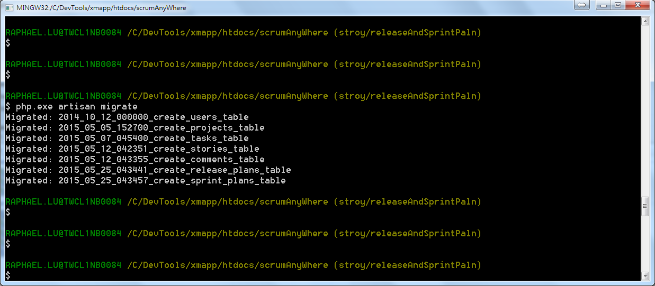

1. Restore default data

# sqlite3.exe storage/database.sqlite '.read doc/installation/userTable.sql'