Case Study: Bellabeat

Robia Lee

10/03/2021

## How Can a Wellness Technology Company Play it Smart?

### About Bellabeat

Bellabeat is a high-tech manufacturer of health-focused products for women. Urška Sršen and Sando Mur founded Bellabeat in 2013 and since then, the company and community has grown rapidly. The company focuses on digital marketing by investing in Google Search, staying active on Facebook and Instagram, engaging with consumers on Twitter, and running ads on Youtube videos and Google Display Network.

For more details on Bellabeat’s mission statement click here [link](https://bellabeat.com/about/).

## ASK

#### Business Task

* Analyze smart device usage data, FitBit Fitness Tracker Data, in order to gain insight into how consumers use non-Bellabeat smart devices. Then to select one of Bellabeat’s product to apply these insights for the marketing team.

##### Bellabeat Products

* Bellabeat app: The Bellabeat app provides users with health data related to their activity, sleep, stress, menstrual cycle, and mindfulness habits. This data can help users better understand their current habits and make healthy decisions. The Bellabeat app connects to their line of smart wellness products.
* Leaf: Bellabeat’s classic wellness tracker can be worn as a bracelet, necklace, or clip. The Leaf tracker connects to the Bellabeat app to track activity, sleep, and stress.
* Time: This wellness watch combines the timeless look of a classic timepiece with smart technology to track user activity, sleep, and stress. The Time watch connects to the Bellabeat app to provide you with insights into your daily wellness.
* Spring: This is a water bottle that tracks daily water intake using smart technology to ensure that you are appropriately hydrated throughout the day. The Spring bottle connects to the Bellabeat app to track your hydration levels.
* Bellabeat membership: Bellabeat also offers a subscription-based membership program for users. Membership gives users 24/7 access to fully personalized guidance on nutrition, activity, sleep, health and beauty, and mindfulness based on their lifestyle and goals.

#### Key Stakeholders

* Urška Sršen: Bellabeat’s cofounder and Chief Creative Officer
* Sando Mur: Mathematician and Bellabeat’s cofounder; key member of the Bellabeat executive team
* Bellabeat marketing analytics team: A team of data analysts responsible for collecting, analyzing, and reporting data that helps guide Bellabeat’s marketing strategy.

## PREPARE

#### Source

* The data used for the analysis is a public dataset available on Kaggle through [Mobius](https://www.kaggle.com/arashnic).
* It consists of 18 CSV files containing information about 30 FitBit users’ personal tracker data.
* The data was generated by surveys via Amazon Mechanical Turk from 2016-03-12 to 2016-05-12.
* Data consists of minute-level output for physical activity, heart rate, sleep monitoring, daily steps, etc.

#### Limitations

* Data is outdated; the survey was done 5 years ago. Since then, FitBit and smart devices in general, have improved features and products that effect its usage.
* Data is not representative. Sample size of 30 does not represent all of FitBit’s users. FitBit is marketed towards all genders while Bellabeat focuses on creating products for women.
* Data was collected in a survey through a third-party source so we are not confident in its accuracy and integrity.

##### Is Our Data ROCCC?

* Reliable? LOW; Sample size is only 30. We also don’t know how many are women.
* Original? LOW; Third-party source. (Amazon Mechanical Turk)
* Comprehensive? AVG; The main parameters match those of Bellabeat products’.
* Current? LOW; Data is from 2016. Many changes have been made to smart devices in the last 5 years.
* Cited? LOW; Public data on Kaggle from third-party.

In conclusion, I would not recommended using this dataset to deduce business strategies; however, there is no applicable alternative.

#### Selected Data

The following CSV files will be used for our analysis.

* dailyActivity_merged.csv
* sleepDay_merged.csv

Lets focus on files regarding Daily Activity and Sleep patterns in efforts to avoid the limitations listed above and observe the engagement of users.

## PROCESS & ANALYZE

Lets process the data for analysis using SQL in BigQuery. The SQL code used to clean and analyze the data can be found [here](https://github.com/leerobia/Bellabeat/blob/f28ae9361f11a3e20b25b5ccebf69d256d43f2d7/SQL).

#### Cleaning The Data

* Incorrect inputs: 1.) We count how many distinct ID values there are in each file. We see we are working with 33 Ids in dailyActivity.csv and 24 Ids in sleepDay.csv. To make sure they weren’t inputted incorrectly, we confirm they are all strings of 10 characters. 2.) We confirm the date range of both files align.
* Amount of Data: We are working with significantly more rows of data ins dailyActivity.csv(940 rows) than sleepDay.csv(413 rows).
* Duplicates: We observe and delete 3 duplicate rows in sleepDay_merged.csv.

#### Analyzing the Data

* Observe that activity was logged from 2016-04-12 to 2016-05-12. We have one month of data which may not be sufficient to track health/fitness habits. Holidays, vacations, and new users just starting their fitness journey may affect the confidence of our data.
* Calculating sums of Very Active Minutes, Fairly Active Minutes, Lightly Active Minutes, and Sedentary Minutes, we see a majority(82%) of the users are tracking Sedentary Activity.
* With 33 Ids and 940 rows of data in dailyActivity.csv and 24 Ids and 413 rows of data in sleepDay.csv, we see many users did not log their sleep activity during the survey duration.
* We don’t see a huge difference in the Total Minutes Asleep and Total Time In Bed. Only about 8.5% of the time in bed was not spent asleep. However, when comparing the amount of data we have for the Total Minutes Asleep to the huge amount of Sedentary Minutes logged, there is a disconnect. This may be because not all Ids reported their sleep log giving us very little, incomparible data.

## SHARE

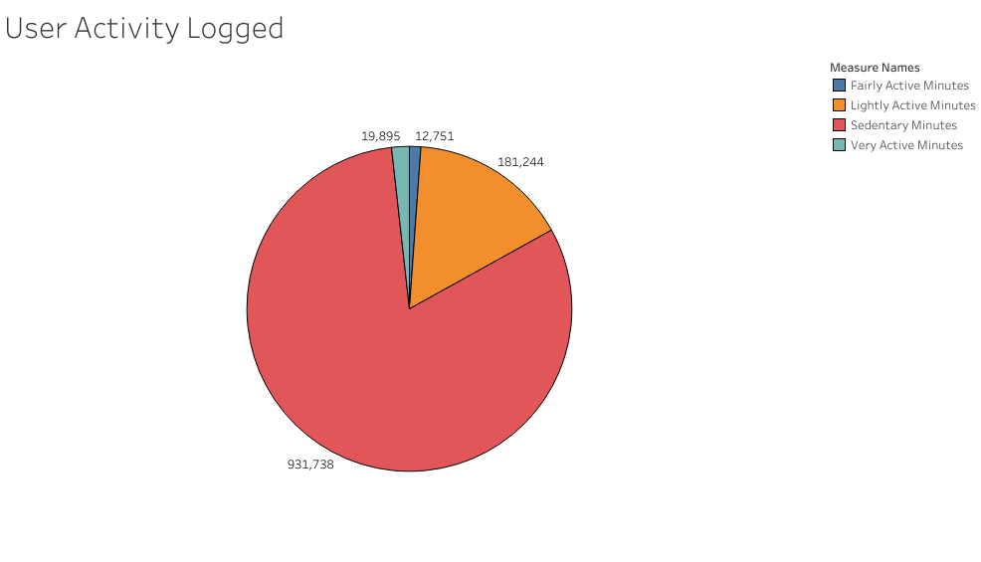

* Majority (81%) of FitBit’s users are tracking Sedentary Activity. FitBit is a popular fitness smart device among users; however, the data does not show the users are meeting the companies mission statement in encouraging healthier habits.

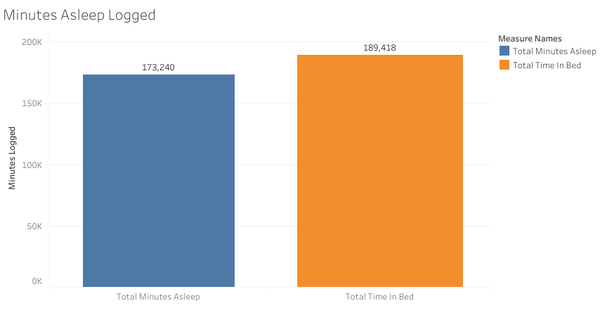

* We can use the data in this file to see that about 8.5% of the time in bed is not spent asleep. This data cannot be used in relation to the dailyActivity.csv because the Id’s and amount of data do not align.

## ACT

#### Conclusion

##### Recommendations

* Majority(81%) of FitBit’s users are tracking Sedentary Activity. In order to fulfill Bellabeat’s mission statement of encouraging healthier habits, the Bellabeat marketing team should push advertisements for the Bellabeat app. Engagement is a huge component of a company’s success; in order to prompt fun fitness habit to its users through the app, the marketing team can work with the engineering team to:

1. install a push notification feature during long minutes of sedentary activity.
2. create a rewards program/“Bellapoints” feature to encourage users to stay active.

* Majority of the FitBit users did not log sleep information. To encourage users to use their product to track their sleep, the Bellabeat marketing team can:

1. advertise their products’ comfort to push its users into wearing the device to bed.
2. showcase the variety of data that can be collected in our sleep.