**Date Submitted: 11/17/2019**

**------------------------------------------------------------------------------------**

**Task 01:**

Youtube Link:

<https://youtu.be/I_6NqveWY1Q>

**Modified Code:**

/* TI-RTOS Header files */

#include <xdc/std.h>

#include <ti/sysbios/BIOS.h>

#include <ti/sysbios/knl/Task.h>

#include <ti/drivers/GPIO.h>

/* Example/Board Header files */

#include "Board.h"

void myDelay(int count);

/* Could be anything, like computing primes */

#define FakeBlockingSlowWork() myDelay(12000000)

#define FakeBlockingFastWork() myDelay(2000000)

Task_Struct workTask;

/* Make sure we have nice 8-byte alignment on the stack to avoid wasting memory */

#pragma DATA_ALIGN(workTaskStack, 8)

#define STACKSIZE 1024

static uint8_t workTaskStack[STACKSIZE];

void doUrgentWork(void)

{

GPIO_write(Board_GPIO_LED1, Board_GPIO_LED_OFF);

FakeBlockingFastWork(); /* Pretend to do something useful but time-consuming */

GPIO_write(Board_GPIO_LED1, Board_GPIO_LED_ON);

}

void doWork(void)

{

GPIO_write(Board_GPIO_LED0, Board_GPIO_LED_OFF);

FakeBlockingSlowWork(); /* Pretend to do something useful but time-consuming */

GPIO_write(Board_GPIO_LED0, Board_GPIO_LED_ON);

}

Void workTaskFunc(UArg arg0, UArg arg1)

{

while (1) {

/* Do work */

doWork();

/* Wait a while, because doWork should be a periodic thing, not continuous.*/

myDelay(24000000);

}

}

/*

* ======== main ========

*

*/

int main(void)

{

Board_initGeneral();

GPIO_init();

/* Set up the led task */

Task_Params workTaskParams;

Task_Params_init(&workTaskParams);

workTaskParams.stackSize = STACKSIZE;

workTaskParams.priority = 2;

workTaskParams.stack = &workTaskStack;

Task_construct(&workTask, workTaskFunc, &workTaskParams, NULL);

/* Start kernel. */

BIOS_start();

return (0);

}

/*

* ======== myDelay ========

* Assembly function to delay. Decrements the count until it is zero

* The exact duration depends on the processor speed.

*/

__asm(" .sect \".text:myDelay\"\n"

" .clink\n"

" .thumbfunc myDelay\n"

" .thumb\n"

" .global myDelay\n"

"myDelay:\n"

" subs r0, #1\n"

" bne.n myDelay\n"

" bx lr\n");

**------------------------------------------------------------------------------------**

**Task 02:**

**Modified Code:**

/* TI-RTOS Header files */

#include <xdc/std.h>

#include <ti/sysbios/BIOS.h>

#include <ti/sysbios/knl/Task.h>

#include <ti/sysbios/knl/Clock.h>

#include <ti/drivers/GPIO.h>

/* Example/Board Header files */

#include "Board.h"

void myDelay(int count);

/* Could be anything, like computing primes */

#define FakeBlockingSlowWork() myDelay(12000000)

#define FakeBlockingFastWork() myDelay(2000000)

Task_Struct workTask;

/* Make sure we have nice 8-byte alignment on the stack to avoid wasting memory */

#pragma DATA_ALIGN(workTaskStack, 8)

#define STACKSIZE 1024

static uint8_t workTaskStack[STACKSIZE];

void doUrgentWork(void)

{

GPIO_write(Board_GPIO_LED1, Board_GPIO_LED_OFF);

FakeBlockingFastWork(); /* Pretend to do something useful but time-consuming */

GPIO_write(Board_GPIO_LED1, Board_GPIO_LED_ON);

}

void doWork(void)

{

GPIO_write(Board_GPIO_LED0, Board_GPIO_LED_OFF);

FakeBlockingSlowWork(); /* Pretend to do something useful but time-consuming */

GPIO_write(Board_GPIO_LED0, Board_GPIO_LED_ON);

}

Void workTaskFunc(UArg arg0, UArg arg1)

{

while (1) {

/* Do work */

doWork();

/* Wait a while, because doWork should be a periodic thing, not continuous.*/

myDelay(24000000);

}

}

/*

* ======== main ========

*

*/

int main(void)

{

Board_initGeneral();

GPIO_init();

/* Set up the led task */

Task_Params workTaskParams;

Task_Params_init(&workTaskParams);

workTaskParams.stackSize = STACKSIZE;

workTaskParams.priority = 2;

workTaskParams.stack = &workTaskStack;

Task_construct(&workTask, workTaskFunc, &workTaskParams, NULL); // Uses the GPIO Driver to toggle a LED. -Steven

/* Start kernel. */

BIOS_start();

return (0);

}

/*

* ======== myDelay ========

* Assembly function to delay. Decrements the count until it is zero

* The exact duration depends on the processor speed.

*/

__asm(" .sect \".text:myDelay\"\n"

" .clink\n"

" .thumbfunc myDelay\n"

" .thumb\n"

" .global myDelay\n"

"myDelay:\n"

" subs r0, #1\n"

" bne.n myDelay\n"

" bx lr\n");

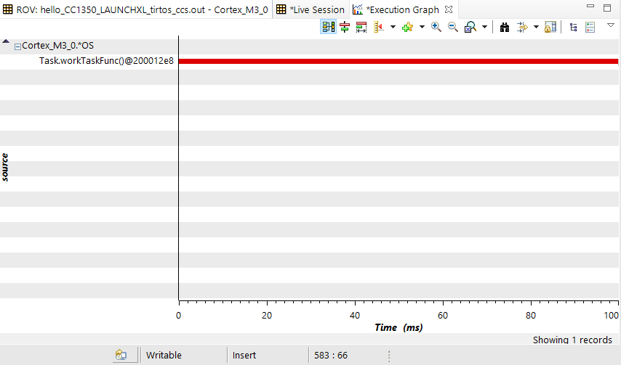

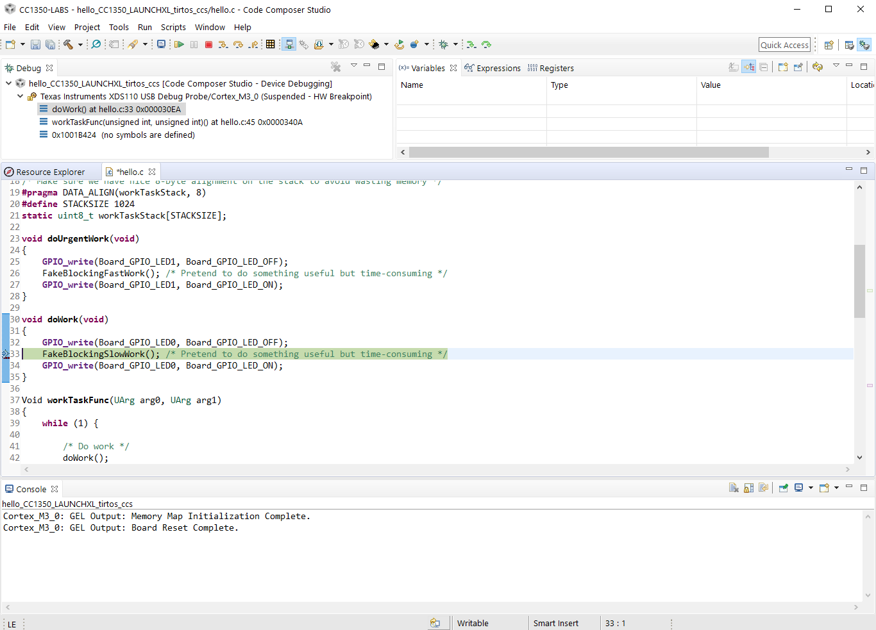

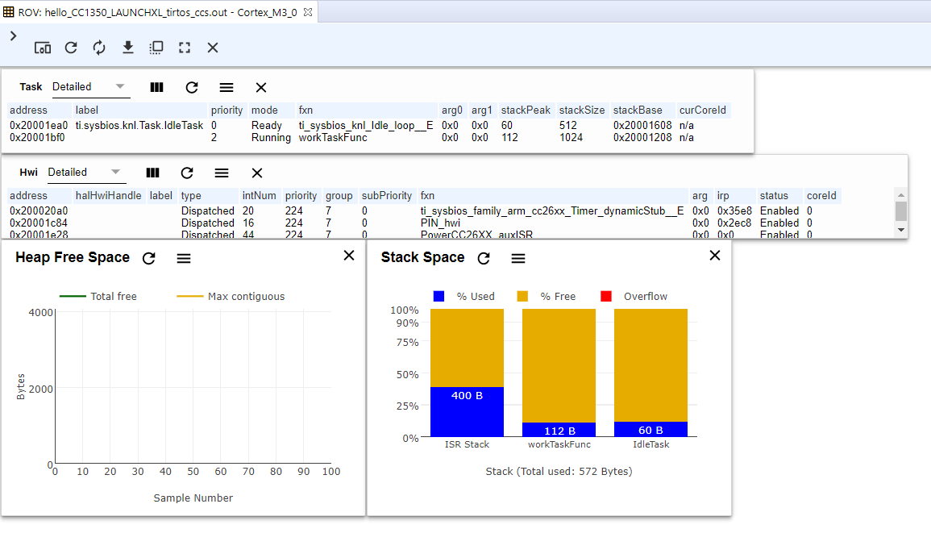

**------------------------------------------------------------------------------------**

**Task 03:**

**Modified Code:**

/* TI-RTOS Header files */

#include <xdc/std.h>

#include <ti/sysbios/BIOS.h>

#include <ti/sysbios/knl/Task.h>

#include <ti/sysbios/knl/Clock.h>

#include <ti/drivers/GPIO.h>

/* Example/Board Header files */

#include "Board.h"

void myDelay(int count);

/* Could be anything, like computing primes */

#define FakeBlockingSlowWork() myDelay(12000000)

#define FakeBlockingFastWork() myDelay(2000000)

Task_Struct workTask;

/* Make sure we have nice 8-byte alignment on the stack to avoid wasting memory */

#pragma DATA_ALIGN(workTaskStack, 8)

#define STACKSIZE 1024

static uint8_t workTaskStack[STACKSIZE];

void doUrgentWork(void)

{

GPIO_write(Board_GPIO_LED1, Board_GPIO_LED_OFF);

FakeBlockingFastWork(); /* Pretend to do something useful but time-consuming */

GPIO_write(Board_GPIO_LED1, Board_GPIO_LED_ON);

}

void doWork(void)

{

GPIO_write(Board_GPIO_LED0, Board_GPIO_LED_OFF);

FakeBlockingSlowWork(); /* Pretend to do something useful but time-consuming */

GPIO_write(Board_GPIO_LED0, Board_GPIO_LED_ON);

}

void workTaskFunc(UArg arg0, UArg arg1)

{

while (1) {

/* Do work */

doWork();

//myDelay(24000000);

Task_sleep(500 * (1000 / Clock_tickPeriod));

}

}

/*

* ======== main ========

*

*/

int main(void)

{

Board_initGeneral();

GPIO_init();

/* Set up the led task */

Task_Params workTaskParams;

Task_Params_init(&workTaskParams);

workTaskParams.stackSize = STACKSIZE;

workTaskParams.priority = 2;

workTaskParams.stack = &workTaskStack;

Task_construct(&workTask, workTaskFunc, &workTaskParams, NULL); // Uses the GPIO Driver to toggle a LED. -Steven

/* Start kernel. */

BIOS_start();

return (0);

}

/*

* ======== myDelay ========

* Assembly function to delay. Decrements the count until it is zero

* The exact duration depends on the processor speed.

*/

__asm(" .sect \".text:myDelay\"\n"

" .clink\n"

" .thumbfunc myDelay\n"

" .thumb\n"

" .global myDelay\n"

"myDelay:\n"

" subs r0, #1\n"

" bne.n myDelay\n"

" bx lr\n");

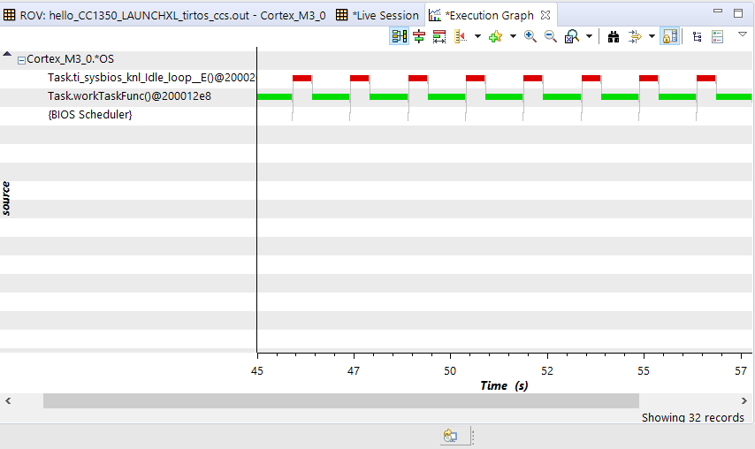

**------------------------------------------------------------------------------------**

**Task 04:**

Youtube Link:

<https://youtu.be/LDpkqYH8ifc>

**Modified Code:**

/* TI-RTOS Header files */

#include <xdc/std.h>

#include <ti/sysbios/BIOS.h>

#include <ti/sysbios/knl/Task.h>

#include <ti/sysbios/knl/Clock.h>

#include <ti/drivers/GPIO.h>

/* Example/Board Header files */

#include "Board.h"

void myDelay(int count);

/* Could be anything, like computing primes */

#define FakeBlockingSlowWork() myDelay(12000000)

#define FakeBlockingFastWork() myDelay(2000000)

Task_Struct workTask;

Task_Struct urgentWorkTask;

/* Make sure we have nice 8-byte alignment on the stack to avoid wasting memory */

#pragma DATA_ALIGN(workTaskStack, 8)

#define STACKSIZE 1024

static uint8_t workTaskStack[STACKSIZE];

static uint8_t urgentWorkTaskStack[STACKSIZE];

void doUrgentWork(void)

{

GPIO_write(Board_GPIO_LED1, Board_GPIO_LED_OFF);

FakeBlockingFastWork(); /* Pretend to do something useful but time-consuming */

GPIO_write(Board_GPIO_LED1, Board_GPIO_LED_ON);

}

void doWork(void)

{

GPIO_write(Board_GPIO_LED0, Board_GPIO_LED_OFF);

FakeBlockingSlowWork(); /* Pretend to do something useful but time-consuming */

GPIO_write(Board_GPIO_LED0, Board_GPIO_LED_ON);

}

void workTaskFunc(UArg arg0, UArg arg1)

{

while (1) {

/* Do work */

doWork();

/* Wait a while, because doWork should be a periodic thing, not continuous.*/

//myDelay(24000000);

Task_sleep(500 * (1000 / Clock_tickPeriod));

}

}

Void urgentWorkTaskFunc(UArg arg0, UArg arg1)

{

while (1) {

/* Do work */

doUrgentWork();

/* Wait a while, because doWork should be a periodic thing, not continuous.*/

//myDelay(24000000);

Task_sleep(50 * (1000 / Clock_tickPeriod));

}

}

/*

* ======== main ========

*

*/

int main(void)

{

Board_initGeneral();

GPIO_init();

/* Set up the led task */

Task_Params workTaskParams;

Task_Params_init(&workTaskParams);

workTaskParams.stackSize = STACKSIZE;

workTaskParams.priority = 2;

workTaskParams.stack = &workTaskStack;

Task_construct(&workTask, workTaskFunc, &workTaskParams, NULL);

workTaskParams.priority = 1;

workTaskParams.stack = &urgentWorkTaskStack;

Task_construct(&urgentWorkTask, urgentWorkTaskFunc, &workTaskParams, NULL);

/* Start kernel. */

BIOS_start();

return (0);

}

/*

* ======== myDelay ========

* Assembly function to delay. Decrements the count until it is zero

* The exact duration depends on the processor speed.

*/

__asm(" .sect \".text:myDelay\"\n"

" .clink\n"

" .thumbfunc myDelay\n"

" .thumb\n"

" .global myDelay\n"

"myDelay:\n"

" subs r0, #1\n"

" bne.n myDelay\n"

" bx lr\n");

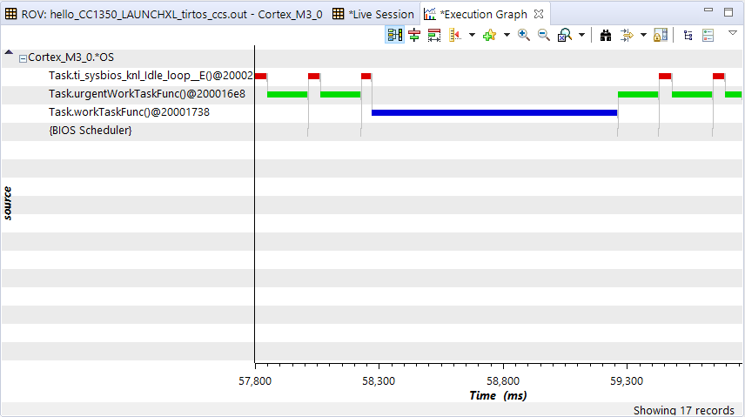

**Modified Code Changed Priority:**

/* TI-RTOS Header files */

#include <xdc/std.h>

#include <ti/sysbios/BIOS.h>

#include <ti/sysbios/knl/Task.h>

#include <ti/sysbios/knl/Clock.h>

#include <ti/drivers/GPIO.h>

/* Example/Board Header files */

#include "Board.h"

void myDelay(int count);

/* Could be anything, like computing primes */

#define FakeBlockingSlowWork() myDelay(12000000)

#define FakeBlockingFastWork() myDelay(2000000)

Task_Struct workTask;

Task_Struct urgentWorkTask;

/* Make sure we have nice 8-byte alignment on the stack to avoid wasting memory */

#pragma DATA_ALIGN(workTaskStack, 8)

#define STACKSIZE 1024

static uint8_t workTaskStack[STACKSIZE];

static uint8_t urgentWorkTaskStack[STACKSIZE];

void doUrgentWork(void)

{

GPIO_write(Board_GPIO_LED1, Board_GPIO_LED_OFF);

FakeBlockingFastWork(); /* Pretend to do something useful but time-consuming */

GPIO_write(Board_GPIO_LED1, Board_GPIO_LED_ON);

}

void doWork(void)

{

GPIO_write(Board_GPIO_LED0, Board_GPIO_LED_OFF);

FakeBlockingSlowWork(); /* Pretend to do something useful but time-consuming */

GPIO_write(Board_GPIO_LED0, Board_GPIO_LED_ON);

}

void workTaskFunc(UArg arg0, UArg arg1)

{

while (1) {

/* Do work */

doWork();

/* Wait a while, because doWork should be a periodic thing, not continuous.*/

//myDelay(24000000);

Task_sleep(500 * (1000 / Clock_tickPeriod));

}

}

Void urgentWorkTaskFunc(UArg arg0, UArg arg1)

{

while (1) {

/* Do work */

doUrgentWork();

/* Wait a while, because doWork should be a periodic thing, not continuous.*/

//myDelay(24000000);

Task_sleep(50 * (1000 / Clock_tickPeriod));

}

}

/*

* ======== main ========

*

*/

int main(void)

{

Board_initGeneral();

GPIO_init();

/* Set up the led task */

Task_Params workTaskParams;

Task_Params_init(&workTaskParams);

workTaskParams.stackSize = STACKSIZE;

workTaskParams.priority = 2;

workTaskParams.stack = &workTaskStack;

Task_construct(&workTask, workTaskFunc, &workTaskParams, NULL);

workTaskParams.priority = 3;

workTaskParams.stack = &urgentWorkTaskStack;

Task_construct(&urgentWorkTask, urgentWorkTaskFunc, &workTaskParams, NULL);

/* Start kernel. */

BIOS_start();

return (0);

}

/*

* ======== myDelay ========

* Assembly function to delay. Decrements the count until it is zero

* The exact duration depends on the processor speed.

*/

__asm(" .sect \".text:myDelay\"\n"

" .clink\n"

" .thumbfunc myDelay\n"

" .thumb\n"

" .global myDelay\n"

"myDelay:\n"

" subs r0, #1\n"

" bne.n myDelay\n"

" bx lr\n");

