**Date Submitted: 12/11/19**

**------------------------------------------------------------------------------------**

**Task 01:**

**------------------------------------------------------------------------------------**

**Task 02:**

**------------------------------------------------------------------------------------**

**Task 03:**

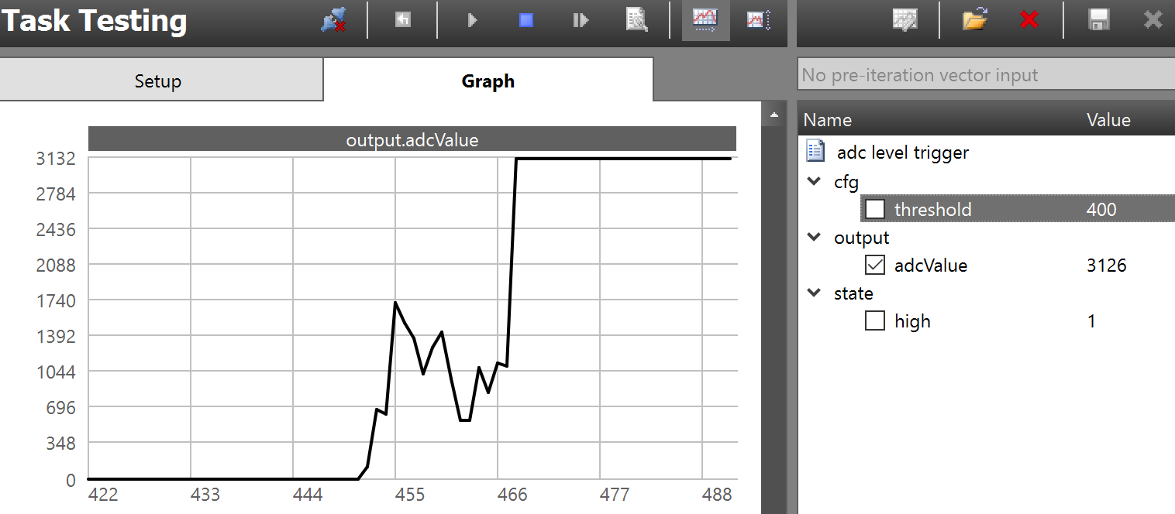 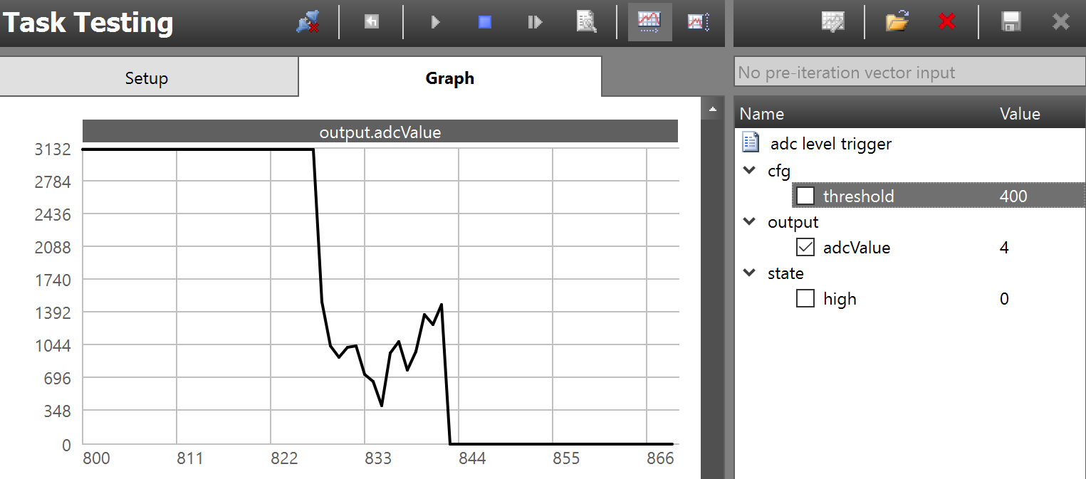

**-----------------------------------------------------------------------------------**

**Task 04:**

**Modified Code:**

/*

* ======== empty.c ========

*/

/* For usleep() */

**#include** <unistd.h>

**#include** <stdint.h>

**#include** <stddef.h>

/* Driver Header files */

**#include** <ti/drivers/GPIO.h>

// #include <ti/drivers/I2C.h>

// #include <ti/drivers/SPI.h>

// #include <ti/drivers/UART.h>

// #include <ti/drivers/Watchdog.h>

/* Board Header file */

**#include** "Board.h"

**#include** "scif.h"

**#define** BV(x) (1 << (x))

**void** **processTaskAlert**(**void**) {

//clear the alert interrupt source

scifClearAlertIntSource();

//do sc task processing here

uint8_t high = scifTaskData.adcLevelTrigger.state.high; //fetch "state.high" from sc

**GPIO_write**(Board_GPIO_RLED, high); //set red led state equal to the state.high variable

//acknowledge the ALERT event

scifAckAlertEvents();

}//processTaskAlert

**void** **scCtrlReadyCallback**(**void**) {

} //scCtrlReadyCallback

**void** **scTaskAlertCallback**(**void**) {

} //scTaskAlertCallback

/*

* ======== mainThread ========

*/

**void** \***tirtosScThread**(**void** *arg0)

{

/* 1 second delay */

// uint32_t time = 1;

/* Call driver init functions */

//Initialize the Sensor Controller

scifOsalInit();

scifOsalRegisterCtrlReadyCallback(scCtrlReadyCallback);

scifOsalRegisterTaskAlertCallback(scTaskAlertCallback);

scifInit(&scifDriverSetup);

// Set the Sensor Controller task tick interval to 1 second

uint32_t rtc_Hz = 1; // 1Hz RTC

scifStartRtcTicksNow(0x00010000/ rtc_Hz);

//configure sensor controller tasks

scifTaskData.adcLevelTrigger.cfg.threshold = 600;

//start sensor controller task

scifStartTasksNbl(BV(SCIF_ADC_LEVEL_TRIGGER_TASK_ID));

**GPIO_init**();

// I2C_init();

// SPI_init();

// UART_init();

// Watchdog_init();

/* Configure the LED pin */

**GPIO_setConfig**(Board_GPIO_LED0, GPIO_CFG_OUT_STD | GPIO_CFG_OUT_LOW);

/* Turn on user LED */

**GPIO_write**(Board_GPIO_LED0, Board_GPIO_LED_ON);

**while** (1) {

// sleep(time);

// GPIO_toggle(Board_GPIO_LED0);

}

}

//INITIALIZATION CODE in SENSOR CONTROL STUDIO

**//Set 'DIO28' High**

**gpioSetOutput(AUXIO_O_HIGH);**

**//Set 'DIO30' Low**

**gpioClearOutput(AUXIO_O_LOW);**

**//Set ADC input**

**adcSelectGpioInput(AUXIO_A_ADC_INPUT);**

**//Schedule the first execution**

**fwScheduleTask(1);**

**//EXECUTION CODE IN SENSOR CONTROL STUDIO**

**//Enable the ADC**

**adcEnableSync(ADC_REF_FIXED, ADC_SAMPLE_TIME_2P7_US, ADC_TRIGGER_MANUAL);**

**//Sample the analog sensor**

**adcGenManualTrigger();**

**adcReadFifo(output.adcValue);**

**//Disable the ADC**

**adcDisable();**

**U16 oldState = state.high;**

**if(output.adcValue > cfg.threshold) {**

**state.high = 1; //High input -> High state**

**gpioClearOutput(AUXIO_O_GREEN_LED);**

**} else {**

**state.high=0; //Low input->low state**

**gpioSetOutput(AUXIO_O_GREEN_LED);**

**}**

**if(oldState!=state.high) {**

**//signal the application processor**

**fwGenAlertInterrupt();**

**}**

**//Schedule the next execution**

**fwScheduleTask(1);**

**------------------------------------------------------------------------------------**

**Task 05:**

/***** Includes *****/

/* Standard C Libraries */

**#include** <stdlib.h>

**#include** <unistd.h>

**#include** <string.h>

**#include** <ti/sysbios/knl/Semaphore.h>

/* TI Drivers */

**#include** <ti/drivers/rf/RF.h>

**#include** <ti/drivers/PIN.h>

**#include** <ti/drivers/pin/PINCC26XX.h>

/* Driverlib Header files */

**#include** DeviceFamily_constructPath(driverlib/rf_prop_mailbox.h)

/* Board Header files */

**#include** "Board.h"

**#include** "smartrf_settings/smartrf_settings.h"

**#include** "scif.h"

**#define** BV(x) (1 << (x))

Semaphore_Struct semMainLoop;

Semaphore_Handle hSemMainLoop;

/***** Defines *****/

/* Do power measurement */

//#define POWER_MEASUREMENT

/* Packet TX Configuration */

**#define** PAYLOAD_LENGTH 30

**#ifdef** POWER_MEASUREMENT

**#define** PACKET_INTERVAL 5 /* For power measurement set packet interval to 5s */

**#else**

**#define** PACKET_INTERVAL 500000 /* Set packet interval to 500000us or 500ms */

**#endif**

/***** Prototypes *****/

/***** Variable declarations *****/

**static** RF_Object rfObject;

**static** RF_Handle rfHandle;

/* Pin driver handle */

**static** PIN_Handle ledPinHandle;

**static** PIN_State ledPinState;

**static** uint8_t packet[PAYLOAD_LENGTH];

**static** uint16_t seqNumber;

/*

* Application LED pin configuration table:

* - All LEDs board LEDs are off.

*/

PIN_Config pinTable[] =

{

Board_PIN_LED0 | PIN_GPIO_OUTPUT_EN | PIN_GPIO_LOW | PIN_PUSHPULL | PIN_DRVSTR_MAX,

**#ifdef** POWER_MEASUREMENT

**#if** defined(Board_CC1350_LAUNCHXL)

Board_DIO30_SWPWR | PIN_GPIO_OUTPUT_EN | PIN_GPIO_HIGH | PIN_PUSHPULL | PIN_DRVSTR_MAX,

**#endif**

**#endif**

PIN_TERMINATE

};

**void** **scCtrlReadyCallback**(**void**){

//do nothing

} //scCtrlReadyCallback

**void** **scTaskAlertCallback**(**void**) {

//signal main loop

Semaphore_post(hSemMainLoop);

}//scTaskAlertCallback

**void** **TxTask_init**(**void**) {

//main loop semaphore init

Semaphore_Params semParams;

Semaphore_Params_init(&semParams);

semParams.mode = Semaphore_Mode_BINARY;

Semaphore_construct(&semMainLoop, 0, &semParams);

hSemMainLoop = Semaphore_handle(&semMainLoop);

}

/***** Function definitions *****/

**void** \***mainThread**(**void** *arg0)

{

RF_Params rfParams;

**RF_Params_init**(&rfParams);

/* Open LED pins */

ledPinHandle = **PIN_open**(&ledPinState, pinTable);

**if** (ledPinHandle == NULL)

{

**while**(1);

}

**#ifdef** POWER_MEASUREMENT

**#if** defined(Board_CC1350_LAUNCHXL)

/* Route out PA active pin to Board_DIO30_SWPWR */

PINCC26XX_setMux(ledPinHandle, Board_DIO30_SWPWR, PINCC26XX_MUX_RFC_GPO1);

**#endif**

**#endif**

RF_cmdPropTx.pktLen = PAYLOAD_LENGTH;

RF_cmdPropTx.pPkt = packet;

RF_cmdPropTx.startTrigger.triggerType = TRIG_NOW;

/* Request access to the radio */

**#if** defined(DeviceFamily_CC26X0R2)

rfHandle = RF_open(&rfObject, &RF_prop, (RF_RadioSetup*)&RF_cmdPropRadioSetup, &rfParams);

**#else**

rfHandle = **RF_open**(&rfObject, &RF_prop, (RF_RadioSetup*)&RF_cmdPropRadioDivSetup, &rfParams);

**#endif**// DeviceFamily_CC26X0R2

/* Set the frequency */

**RF_postCmd**(rfHandle, (RF_Op*)&RF_cmdFs, *RF_PriorityNormal*, NULL, 0);

**while**(1)

{

/* Create packet with incrementing sequence number and random payload */

packet[0] = (uint8_t)(seqNumber >> 8);

packet[1] = (uint8_t)(seqNumber++);

uint8_t i;

**for** (i = 2; i < PAYLOAD_LENGTH; i++)

{

packet[i] = **rand**();

}

/* Send packet */

RF_EventMask terminationReason = **RF_runCmd**(rfHandle, (RF_Op*)&RF_cmdPropTx,

*RF_PriorityNormal*, NULL, 0);

**switch**(terminationReason)

{

**case** RF_EventLastCmdDone:

// A stand-alone radio operation command or the last radio

// operation command in a chain finished.

**break**;

**case** RF_EventCmdCancelled:

// Command cancelled before it was started; it can be caused

// by RF_cancelCmd() or RF_flushCmd().

**break**;

**case** RF_EventCmdAborted:

// Abrupt command termination caused by RF_cancelCmd() or

// RF_flushCmd().

**break**;

**case** RF_EventCmdStopped:

// Graceful command termination caused by RF_cancelCmd() or

// RF_flushCmd().

**break**;

**default**:

// Uncaught error event

**while**(1);

}

uint32_t cmdStatus = ((**volatile** RF_Op*)&RF_cmdPropTx)->status;

**switch**(cmdStatus)

{

**case** PROP_DONE_OK:

// Packet transmitted successfully

**break**;

**case** PROP_DONE_STOPPED:

// received CMD_STOP while transmitting packet and finished

// transmitting packet

**break**;

**case** PROP_DONE_ABORT:

// Received CMD_ABORT while transmitting packet

**break**;

**case** PROP_ERROR_PAR:

// Observed illegal parameter

**break**;

**case** PROP_ERROR_NO_SETUP:

// Command sent without setting up the radio in a supported

// mode using CMD_PROP_RADIO_SETUP or CMD_RADIO_SETUP

**break**;

**case** PROP_ERROR_NO_FS:

// Command sent without the synthesizer being programmed

**break**;

**case** PROP_ERROR_TXUNF:

// TX underflow observed during operation

**break**;

**default**:

// Uncaught error event - these could come from the

// pool of states defined in rf_mailbox.h

**while**(1);

}

**#ifndef** POWER_MEASUREMENT

**PIN_setOutputValue**(ledPinHandle, Board_PIN_LED1,!**PIN_getOutputValue**(Board_PIN_LED1));

**#endif**

/* Power down the radio */

**RF_yield**(rfHandle);

**#ifdef** POWER_MEASUREMENT

/* Sleep for PACKET_INTERVAL s */

sleep(PACKET_INTERVAL);

**#else**

/* Sleep for PACKET_INTERVAL us */

**usleep**(PACKET_INTERVAL);

**#endif**

}

}