**Date Submitted: 11/26/2019**

-------------------------------------------------------------------------------------

**Modified Code:**

**#include** <stdint.h>

**#include** <stdbool.h>

**#include** "inc/hw_types.h"

**#include** "inc/hw_memmap.h"

**#include** "driverlib/sysctl.h"

**#include** "driverlib/gpio.h"

**#include** "inc/hw_ints.h"

**#include** "driverlib/interrupt.h"

**#include** "driverlib/timer.h"

**#include** <time.h>

//----------------------------------------

// Prototypes

//----------------------------------------

**void** **hardware_init**(**void**);

**void** **ledToggle**(**void**);

**void** **delay**(**void**);

//---------------------------------------

// Globals

//---------------------------------------

**volatile** int16_t i16ToggleCount = 0;

//---------------------------------------------------------------------------

// main()

//---------------------------------------------------------------------------

**void** **main**(**void**)

{

hardware_init(); // init hardware via Xware

BIOS_start(); // Start BIOS Scheduler

}

//---------------------------------------------------------------------------

// hardware_init()

//

// inits GPIO pins for toggling the LED

//---------------------------------------------------------------------------

**void** **hardware_init**(**void**)

{

//Set CPU Clock to 40MHz. 400MHz PLL/2 = 200 DIV 5 = 40MHz

**SysCtlClockSet**(SYSCTL_SYSDIV_5|SYSCTL_USE_PLL|SYSCTL_XTAL_16MHZ|SYSCTL_OSC_MAIN);

// ADD Tiva-C GPIO setup - enables port, sets pins 1-3 (RGB) pins for output

**SysCtlPeripheralEnable**(SYSCTL_PERIPH_GPIOF);

**GPIOPinTypeGPIOOutput**(GPIO_PORTF_BASE, GPIO_PIN_1|GPIO_PIN_2|GPIO_PIN_3);

// Turn on the LED

**GPIOPinWrite**(GPIO_PORTF_BASE, GPIO_PIN_1|GPIO_PIN_2|GPIO_PIN_3, 4);

}

//---------------------------------------------------------------------------

// ledToggle()

//

// toggles LED on Tiva-C LaunchPad

//---------------------------------------------------------------------------

**void** **ledToggle**(**void**)

{

// LED values - 2=RED, 4=BLUE, 8=GREEN

**if**(**GPIOPinRead**(GPIO_PORTF_BASE, GPIO_PIN_2))

{

**GPIOPinWrite**(GPIO_PORTF_BASE, GPIO_PIN_1|GPIO_PIN_2|GPIO_PIN_3, 0);

}

**else**

{

**GPIOPinWrite**(GPIO_PORTF_BASE, GPIO_PIN_2, 4);

}

}

//---------------------------------------------------------------------------

// delay()

//

// Creates a 500ms delay via TivaWare fxn

//---------------------------------------------------------------------------

**void** **delay**(**void**)

{

**SysCtlDelay**(6700000); // creates ~500ms delay - TivaWare fxn

}

**------------------------------------------------------------------------------------**

**Screenshots:**

**Cfg:**

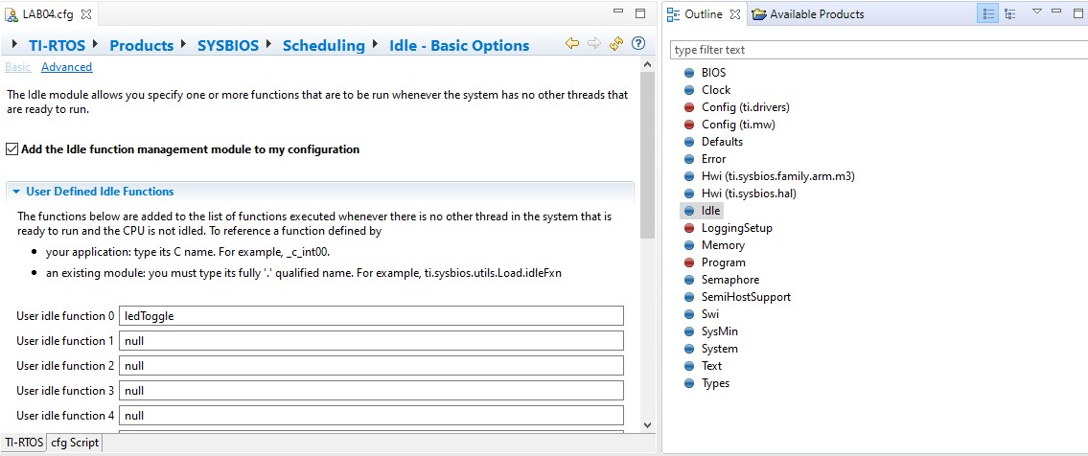

**Log Output:**

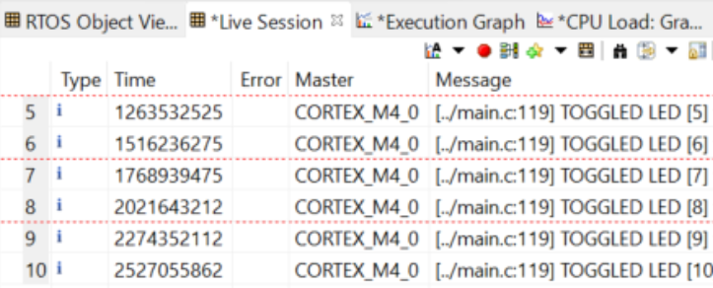

**Execution Graph:**

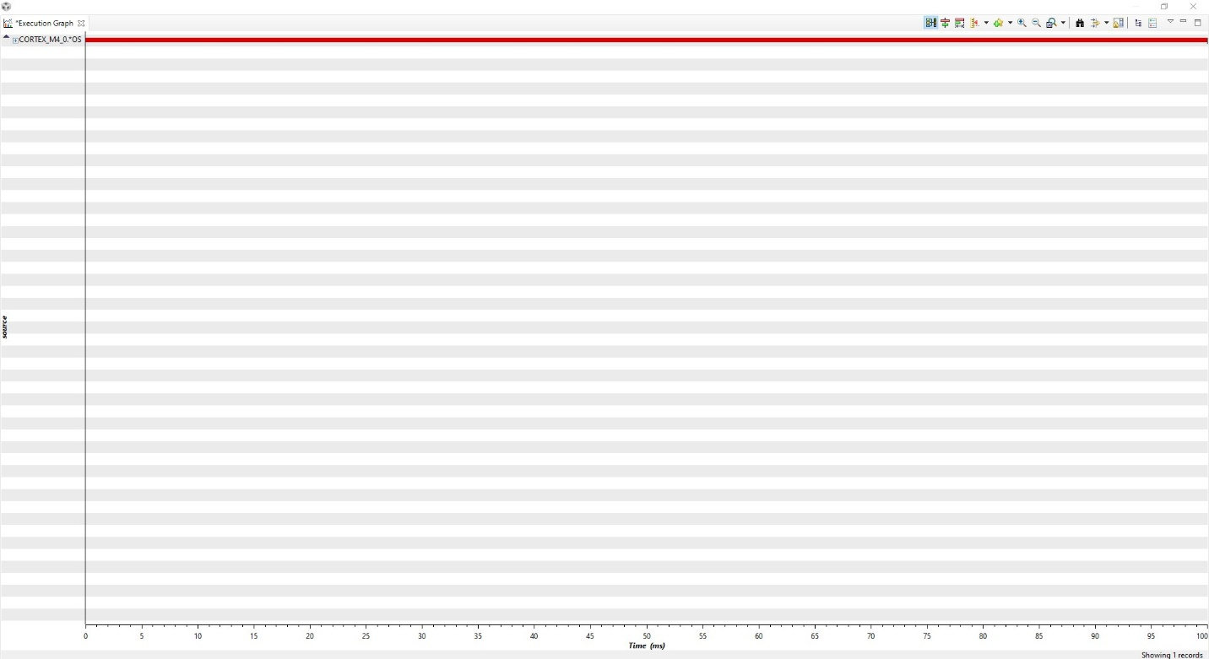

**Stack Usage:**



