**Date Submitted: 11/29/2019**

--------------------------------------------------------------------------------

**Modified Code:**

//----------------------------------------

// BIOS header files

//----------------------------------------

#include <xdc/std.h> //mandatory - have to include first, for BIOS types

#include <ti/sysbios/BIOS.h> //mandatory - if you call APIs like BIOS_start()

#include <xdc/runtime/Log.h> //needed for any Log_info() call

#include <xdc/cfg/global.h> //header file for statically defined objects/handles

//------------------------------------------

// TivaWare Header Files

//------------------------------------------

#include <stdint.h>

#include <stdbool.h>

#include "inc/hw_types.h"

#include "inc/hw_memmap.h"

#include "driverlib/sysctl.h"

#include "driverlib/gpio.h"

#include "inc/hw_ints.h"

#include "driverlib/interrupt.h"

#include "driverlib/timer.h"

//----------------------------------------

// Prototypes

//----------------------------------------

void hardware_init(void);

void ledToggle(void);

void Timer_ISR(void);

//---------------------------------------

// Globals

//---------------------------------------

volatile int16_t i16ToggleCount = 0;

//---------------------------------------------------------------------------

// main()

//---------------------------------------------------------------------------

void main(void)

{

hardware_init(); // init hardware via Xware

BIOS_start();

}

//---------------------------------------------------------------------------

// hardware_init()

//

// inits GPIO pins for toggling the LED

//---------------------------------------------------------------------------

void hardware_init(void)

{

uint32_t ui32Period;

//Set CPU Clock to 40MHz. 400MHz PLL/2 = 200 DIV 5 = 40MHz

SysCtlClockSet(SYSCTL_SYSDIV_5|SYSCTL_USE_PLL|SYSCTL_XTAL_16MHZ|SYSCTL_OSC_MAIN);

// ADD Tiva-C GPIO setup - enables port, sets pins 1-3 (RGB) pins for output

SysCtlPeripheralEnable(SYSCTL_PERIPH_GPIOF);

GPIOPinTypeGPIOOutput(GPIO_PORTF_BASE, GPIO_PIN_1|GPIO_PIN_2|GPIO_PIN_3);

// Turn on the LED

GPIOPinWrite(GPIO_PORTF_BASE, GPIO_PIN_1|GPIO_PIN_2|GPIO_PIN_3, 4);

// Timer 2 setup code

SysCtlPeripheralEnable(SYSCTL_PERIPH_TIMER2);

TimerConfigure(TIMER2_BASE, TIMER_CFG_PERIODIC);

ui32Period = (SysCtlClockGet() /2);

TimerLoadSet(TIMER2_BASE, TIMER_A, ui32Period);

TimerIntEnable(TIMER2_BASE, TIMER_TIMA_TIMEOUT);

TimerEnable(TIMER2_BASE, TIMER_A);

}

//---------------------------------------------------------------------------

// ledToggle()

//

// toggles LED on Tiva-C LaunchPad

//---------------------------------------------------------------------------

void ledToggle(void)

{

while(1)

{

Semaphore_pend(LEDSem, BIOS_WAIT_FOREVER);

// LED values - 2=RED, 4=BLUE, 8=GREEN

if(GPIOPinRead(GPIO_PORTF_BASE, GPIO_PIN_2))

{

GPIOPinWrite(GPIO_PORTF_BASE, GPIO_PIN_1|GPIO_PIN_2|GPIO_PIN_3, 0);

}

else

{

GPIOPinWrite(GPIO_PORTF_BASE, GPIO_PIN_2, 4);

}

i16ToggleCount += 1; // keep track of #toggles

Log_info1("LED TOGGLED [%u] TIMES",i16ToggleCount); // send toggle count to UIA

}

}

//---------------------------------------------------------------------------

// Timer ISR - called by BIOS Hwi (see app.cfg)

//

// Posts Swi (or later a Semaphore) to toggle the LED

//---------------------------------------------------------------------------

void Timer_ISR(void)

{

TimerIntClear(TIMER2_BASE, TIMER_TIMA_TIMEOUT); // must clear timer flag FROM timer

Semaphore_post(LEDSem); // post LEDSem

}

--------------------------------------------------------------------------------

**Screenshots:**

**Cfg:**

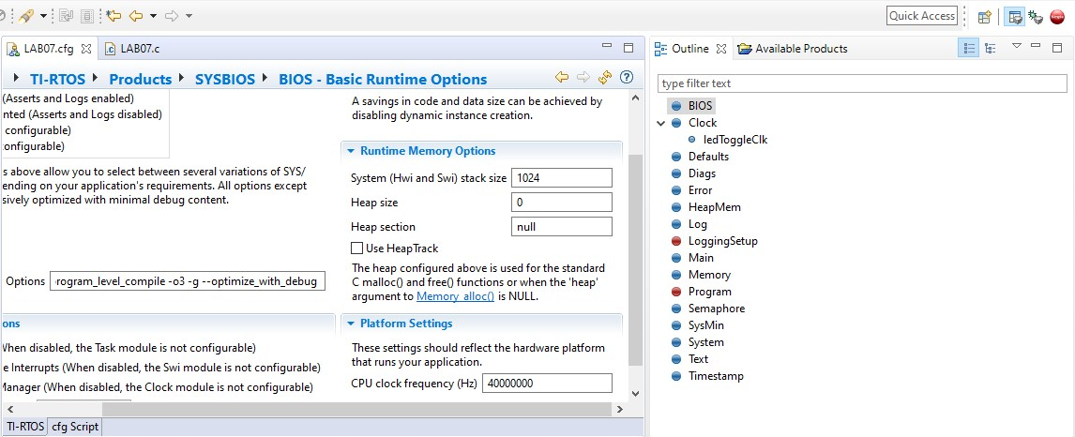

**Log Output:**

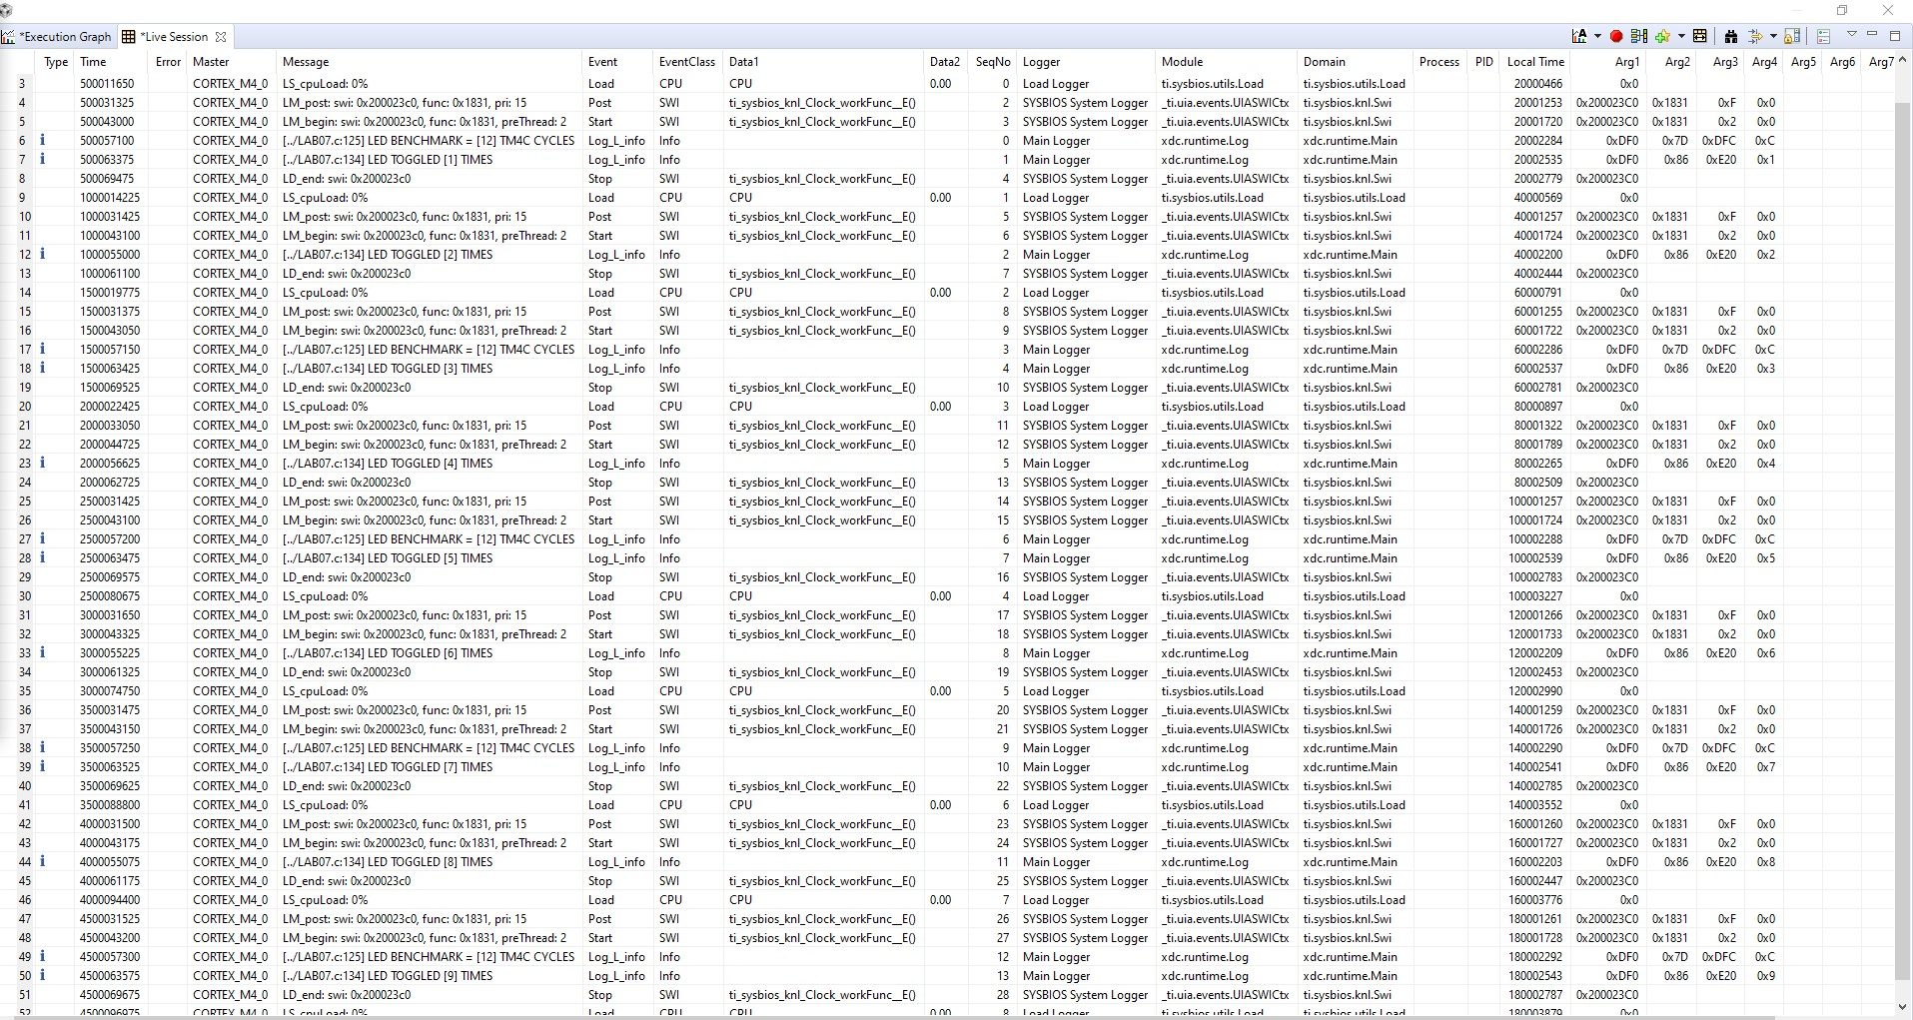

**Execution Graph:**



