CPE301 – SPRING 2019

Design Assignment 2A

Steven Lee

5003887117

Lees106@Unlv.nevada.edu

Primary Github address: <https://github.com/lees106>

Directory: /submission_da/DesignAssignments/DA2

1. **COMPONENTS LIST AND CONNECTION BLOCK DIAGRAM w/ PINS**

Atmel Studio 7

1. **DEVELOPED CODE OF TASK 1**

/*

* Steven Lee, 5003887117, Created 3/4/2019

* CPE 301 Design Assignment 2AT1

*/

.include <m328pdef.inc>

.CSEG

.org 0

LDI R16,0b0000_0100

OUT DDRB, R16

LDI R17,0

LDI R20,5

STS TCCR1B,R20

begin:

LDI R20, 0b0000_0000

STS TCNT1H,R20

STS TCNT1L,R20

RCALL delay_one

OUT PORTB,R17

LDI R20, 0b0000_0000

STS TCNT1H,R20

STS TCNT1L,R20

RCALL delay_two

OUT PORTB,R17

RJMP begin

delay_one:

LDS R29, TCNT1H

LDS R28, TCNT1L

CPI R28,0x8C

BRSH body

RJMP delay_one

body:

CPI R29,0x1A

BRLT delay_one

RET

delay_two:

LDS R29, TCNT1H

LDS R28, TCNT1L

CPI R28,0xB2

BRSH body_two

RJMP delay_two

body_two:

CPI R29,0x11

BRLT delay_two

RET

1. **DEVELOPED AVR C CODE OF TASK 1**

/*

* Steven Lee, 5003887117, Created 3/4/2019

* CPE 301 Design Assignment 2AT1

*/

#include <avr/io.h>

#include <stdio.h>

int main(void) {

DDRB = (1<<2);

TCCR1B = 5;

while(1) {

TCNT1 = 0;

while (TCNT1 < 6796){}

PORTB ^= (1<<2);

TCNT1 = 0;

while (TCNT1 < 4530){}

PORTB ^= (1<<2);

}

return 0;

}

1. **SCREENSHOTS OF EACH TASK 1 ASSEMBLY OUTPUT (ATMEL STUDIO OUTPUT)**

Before debugging:

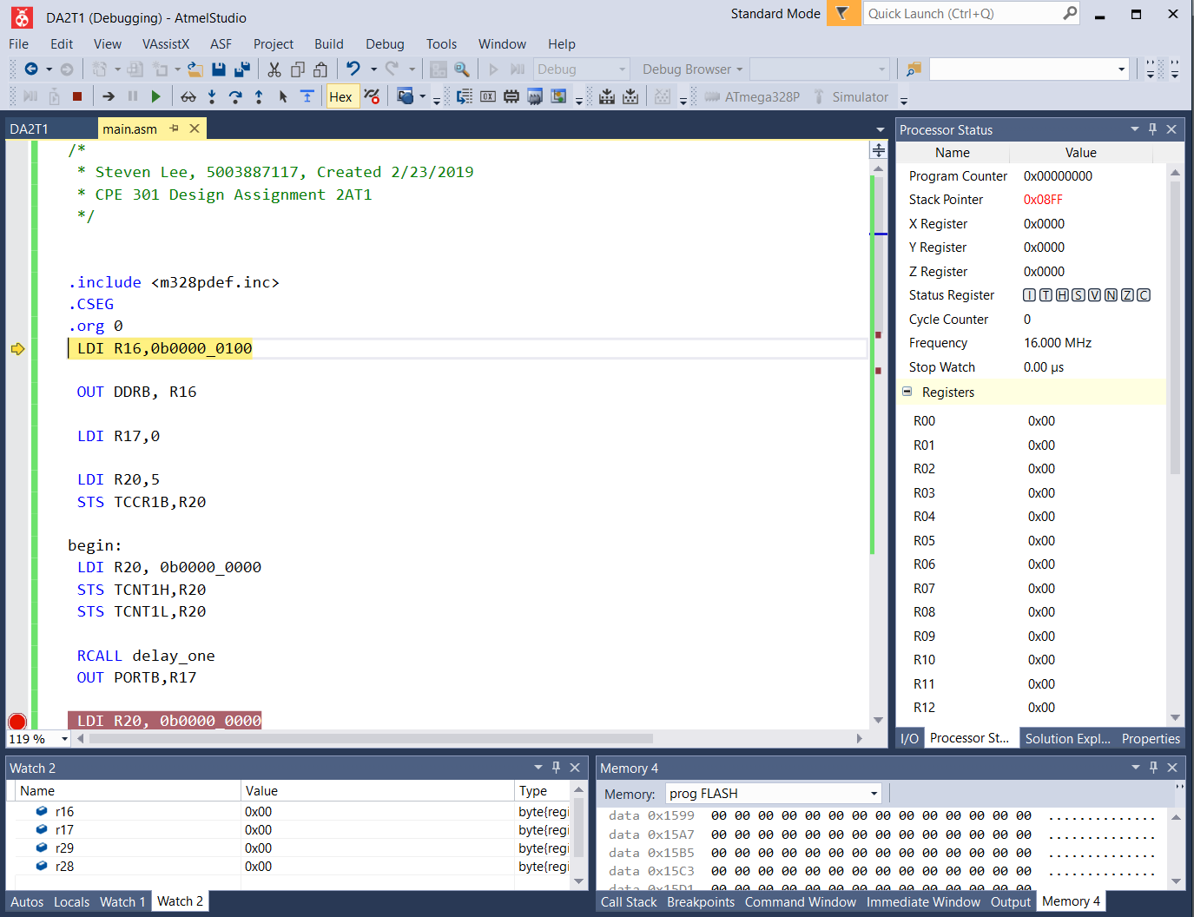

Post Debugging:

First break Point

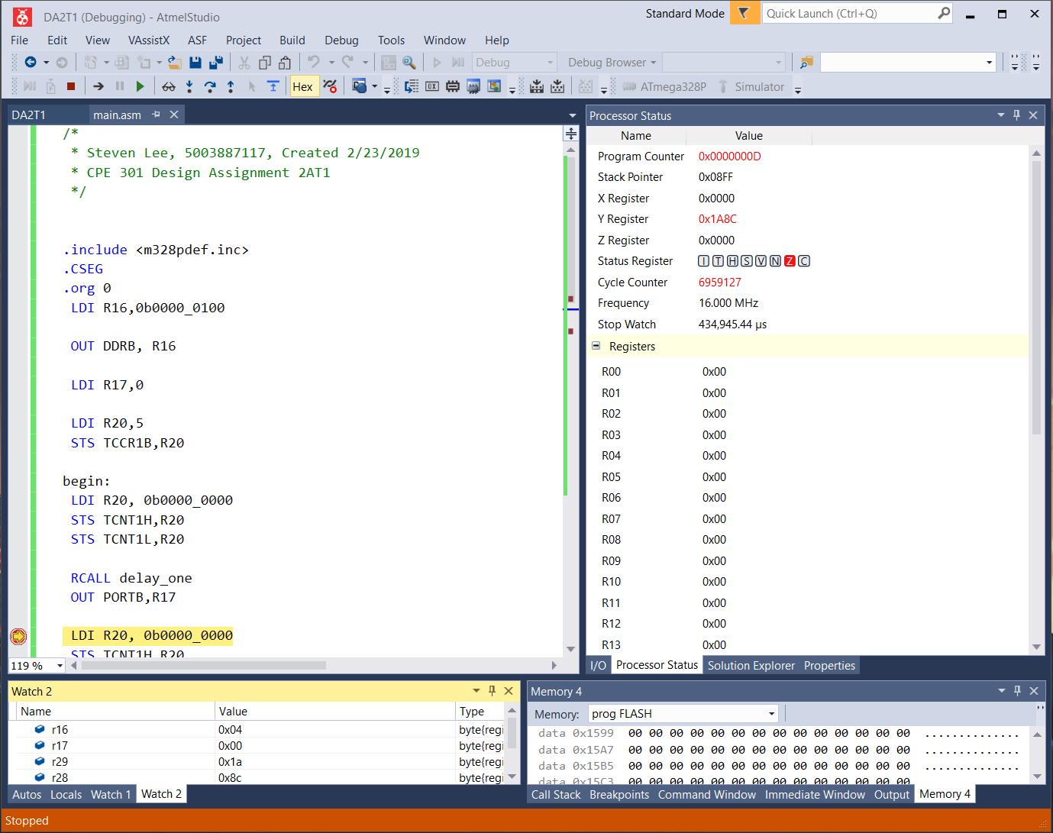

Second Break Point

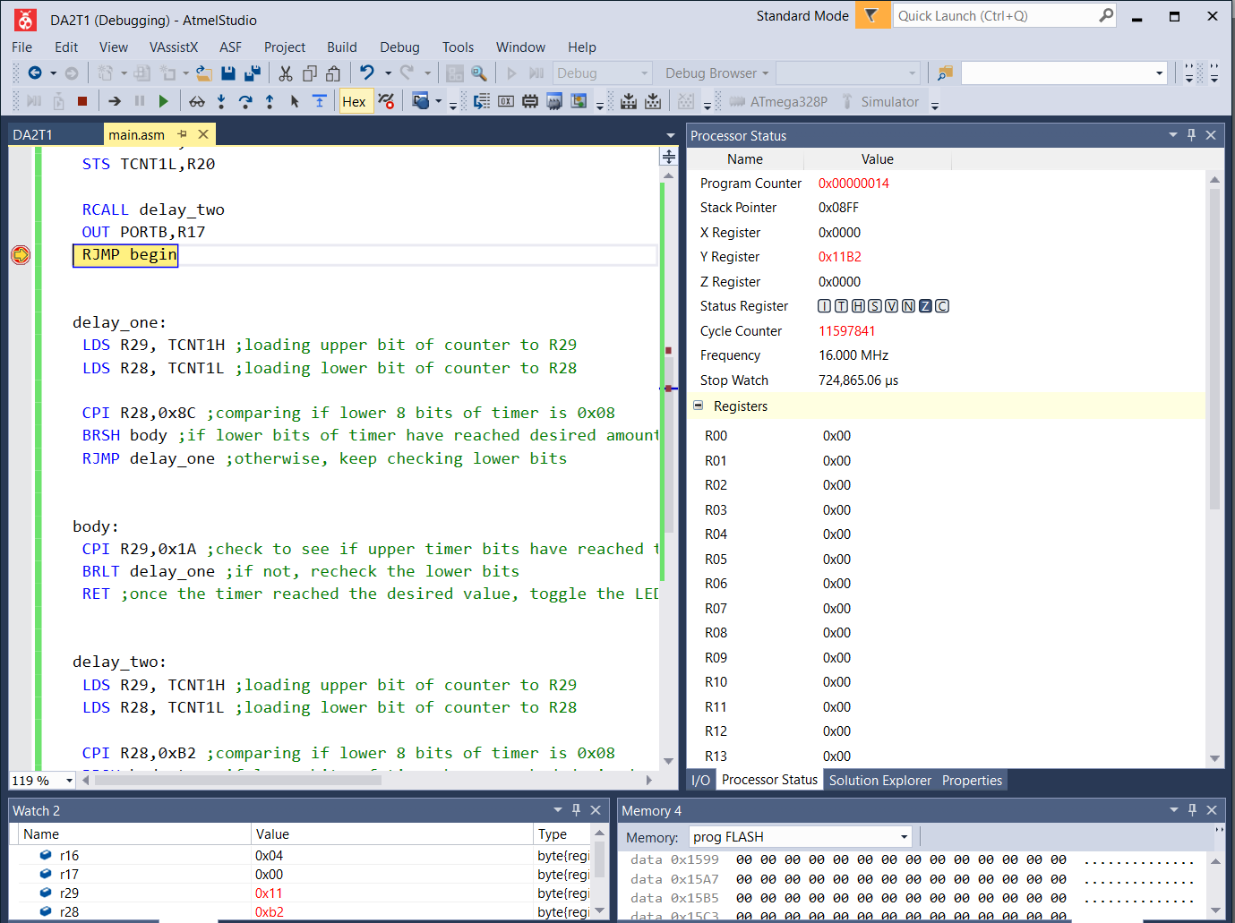

1. **SCREENSHOT OF EXECUTION TIME @ 16MHz /#CYCLES AT FIRST BREAK POINT**

$$TCNT=\left(\frac{16*{10}^{6}}{1024}*0.435\right)-1=0x1A8C$$

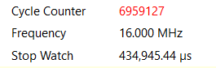

$$60\%: 435945μs ≈0.435s$$

1. **SCREENSHOT OF EXECUTION TIME @ 16MHz /#CYCLES AT SECOND BREAK POINT**

$$TCNT=\left(\frac{16*{10}^{6}}{1024}*0.290\right)-1=0x11B2$$

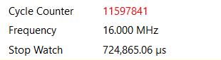

$$40\%: 724865μs- 435945μs ≈0.290s$$

1. **SCREENSHOTS OF TASK 1 AVR C OUTPUT (ATMEL STUDIO OUTPUT)**

Before debugging:

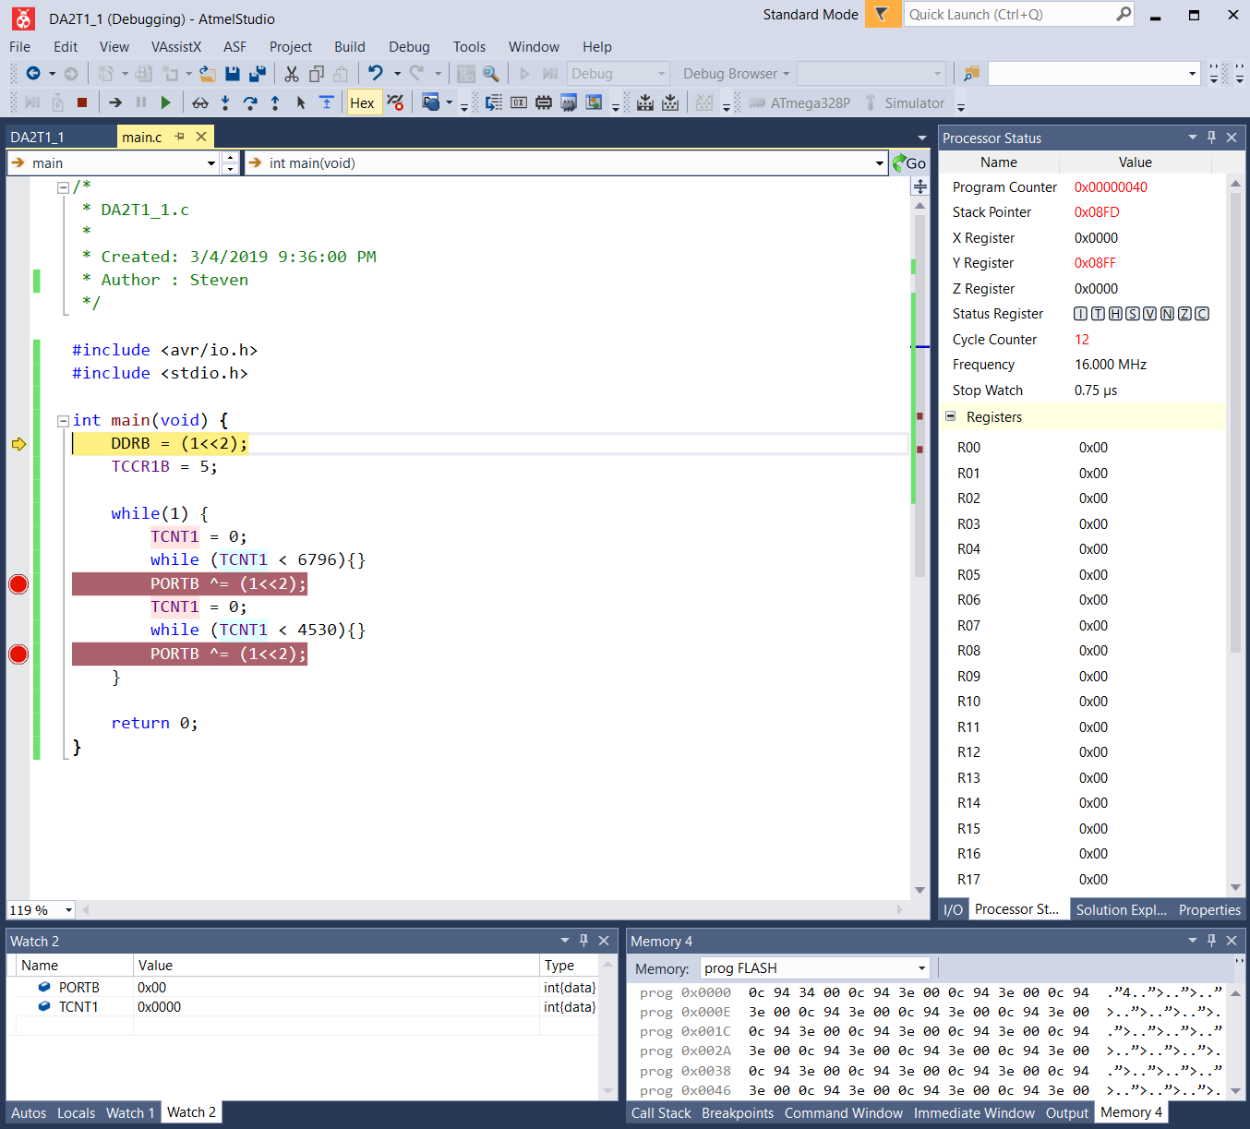

After debugging:

First break point

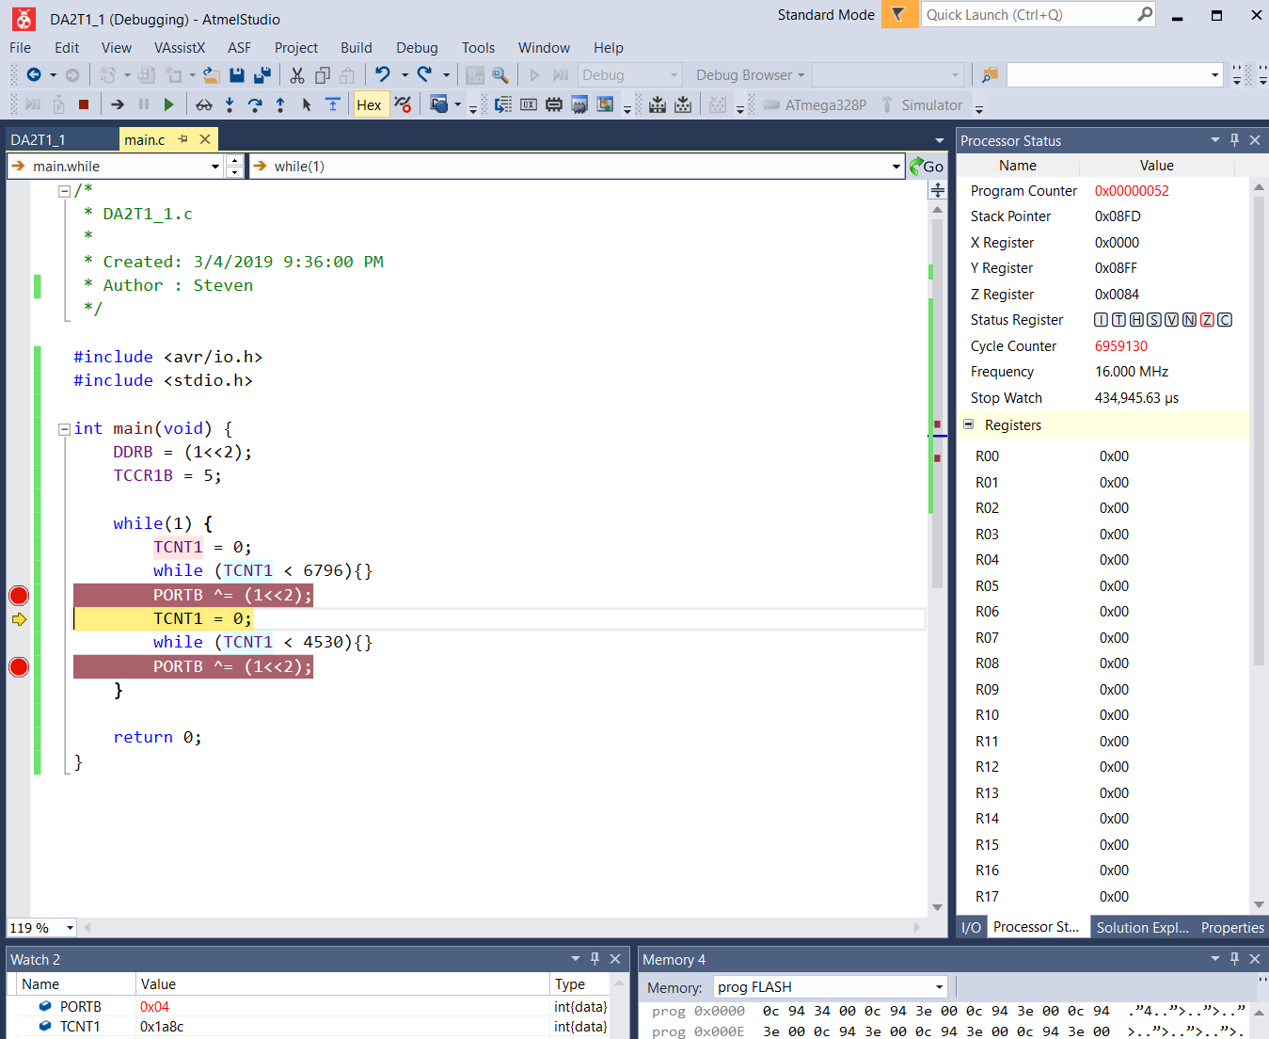

Second Break Point

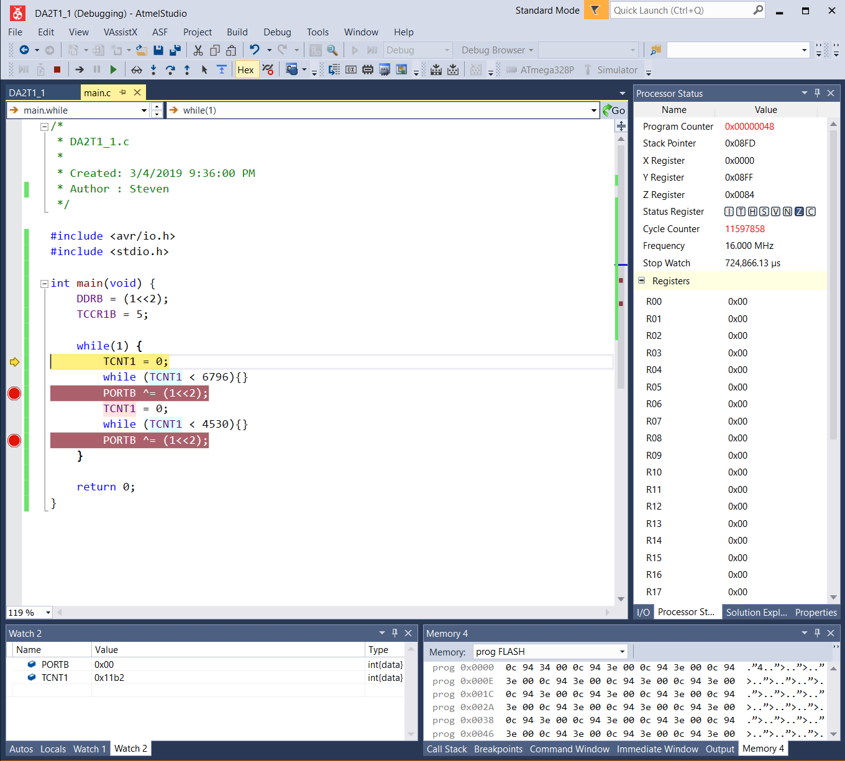

1. **SCREENSHOT OF EXECUTION TIME @ 16MHz /#CYCLES AT FIRST BREAK POINT**

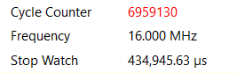



1. **SCREENSHOT OF EXECUTION TIME @ 16MHz /#CYCLES AT SECOND BREAK POINT**

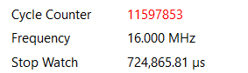



1. **GITHUB LINK OF THIS DA**

<https://github.com/lees106/submission_da/tree/master/DesignAssignments/DA2>

**Student Academic Misconduct Policy**

<http://studentconduct.unlv.edu/misconduct/policy.html>

“This assignment submission is my own, original work”.

STEVEN LEE