CPE301 – SPRING 2019

Design Assignment 2B

Steven Lee

5003887117

Lees106@Unlv.nevada.edu

Primary Github address: <https://github.com/lees106>

Directory: /submission_da/DesignAssignments/DA2B

1. **COMPONENTS LIST AND CONNECTION BLOCK DIAGRAM w/ PINS**

Atmel Studio 7, Atmega328P, Wire, Arduino Shield

1. **DEVELOPED CODE OF TASK 1**

/*

* Steven Lee, 5003887117, Created 3/9/2019

* CPE 301 Design Assignment 2B

*/

.include <m328pdef.inc>

.org 0

jmp main

.org 0x02

jmp EX0_ISR

main:

LDI R20,HIGH(RAMEND)

OUT SPH,R20

LDI R20,LOW(RAMEND)

OUT SPL, R20

LDI R16, 0xFF

LDI R20, 0x2

STS EICRA, R20

SBI DDRB, 2

SBI PORTD, 2

LDI R20, 1<<INT0

OUT EIMSK, R20

SEI

HERE:

OUT PORTB, R16

JMP HERE

EX0_ISR:

IN R21, PORTB

LDI R22, (1<<2)

EOR R21, R22

OUT PORTB, R21

CALL delay

RETI

delay:

LDI R20, 30

D0:

LDI R21, 160

D1:

LDI R22, 250

D2:

NOP

NOP

DEC R22

BRNE D2

DEC R21

BRNE D1

DEC R20

BRNE D0

RET

1. **DEVELOPED AVR C CODE OF TASK 2**

/*

* Steven Lee, 5003887117, Created 3/9/2019

* CPE 301 Design Assignment 2B

*/

#define *F_CPU* 16000000UL

#include <avr/io.h>

#include <avr/interrupt.h>

#include <util/delay.h>

int main(void) {

DDRB |= (1<<5) | (1<<2); // Set PB5 and PB2 as output

PORTB |= (1<<5); // Set PB5 high to turn off LED

PORTD |= 1<<2; // Enable Pull Up on PD2

EICRA = 0x2; // Make INTO falling edge triggered

EIMSK = (1<<INT0); // Enable external INT0

sei(); //Enables global interrupt

while (1) {};

}

ISR (INT0_vect) { // ISR for external INT0

PORTB ^= (1<<2); //Toggle LED

*_delay_ms*(1250);

}

1. **SCREENSHOTS OF EACH TASK (ATMEL STUDIO)**

DA2T1 Debug

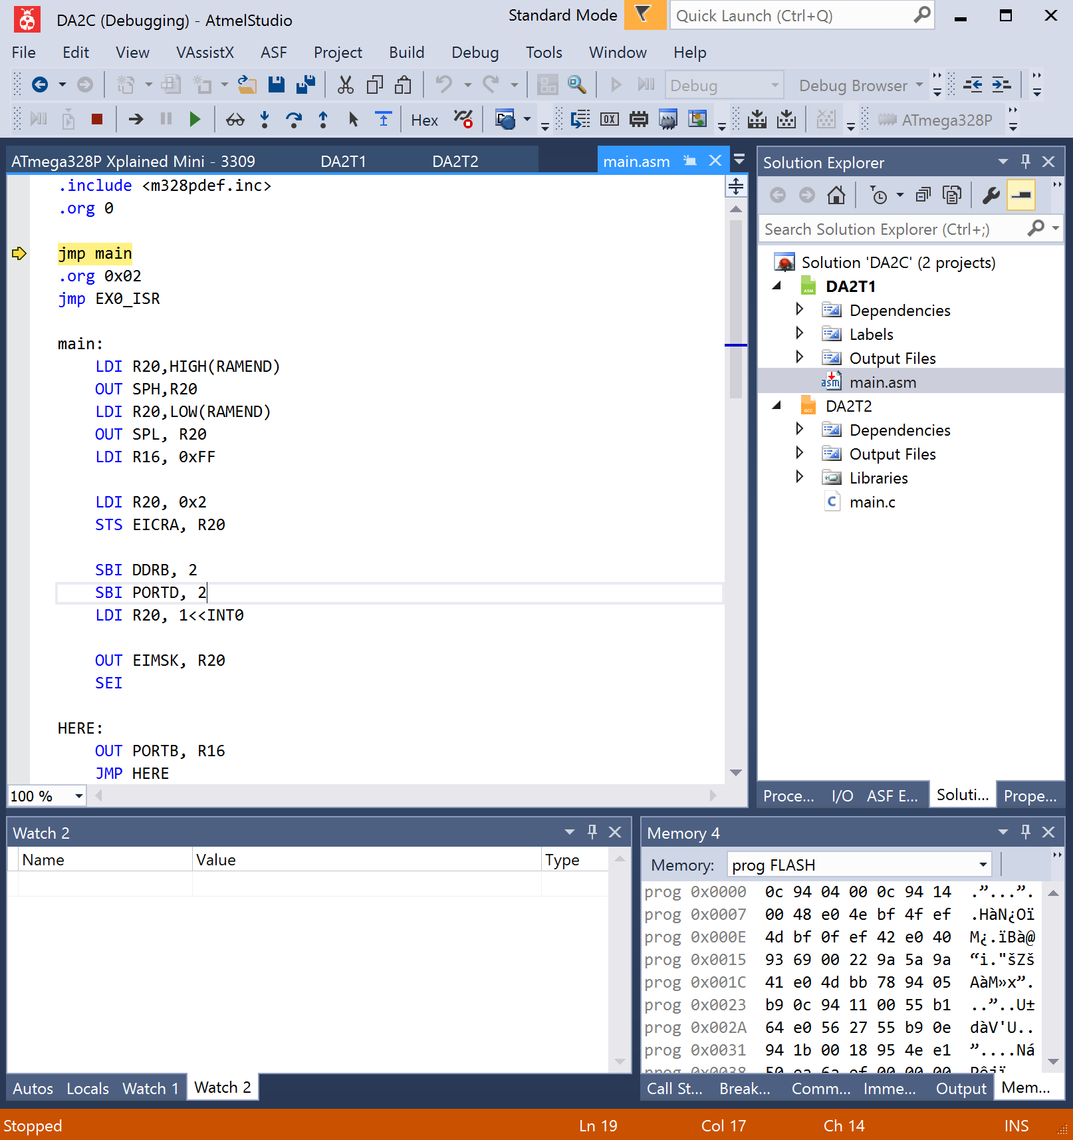

DA2T2 Debug



1. **SCREENSHOT OF EXECUTION TIME @ 16MHz /#CYCLES FOR DELAY**

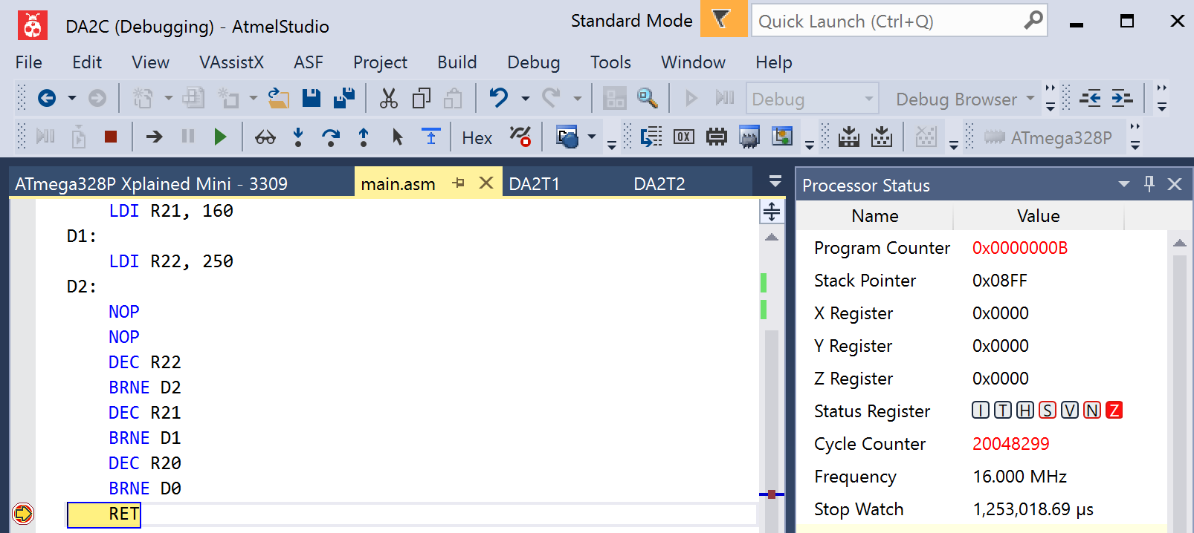

$$Delay=1253018μs ≈1.250s$$

1. **YOUTUBE LINK OF THIS DA**

<https://youtu.be/D5t_zEcqORs>

1. **GITHUB LINK OF THIS DA**

<https://github.com/lees106/submission_da/tree/master/DesignAssignments/DA2B>

**Student Academic Misconduct Policy**

<http://studentconduct.unlv.edu/misconduct/policy.html>

“This assignment submission is my own, original work”.

STEVEN LEE