CPE301 – SPRING 2019

Design Assignment 3A

Steven Lee

5003887117

Lees106@Unlv.nevada.edu

Primary Github address: <https://github.com/lees106>

Directory: /submission_da/DesignAssignments/DA3A

1. **COMPONENTS LIST AND CONNECTION BLOCK DIAGRAM w/ PINS**

* Atmel Studio 7
* Atmega328p
* UART transmitter
* USB cable x2

1. **DEVELOPED CODE OF TASK 1**

/*

* Steven Lee

* 5003887117

* CPE 301 - DA3A

*/

#include <avr/io.h>

#include <stdio.h>

#include <util/delay.h>

#include <avr/interrupt.h>

#define BAUDRATE 9600

#define *F_CPU* 16000000UL

#define USART_BAUDRATE *F_CPU*/16/BAUDRATE-1

void USART_init( void ) {

UBRR0L = USART_BAUDRATE;

UCSR0C = _BV(UCSZ01) | _BV(UCSZ00); // 8-bit data

UCSR0B = _BV(RXEN0) | _BV(TXEN0); // Enable RX and TX

TIMSK1 = (1 << TOIE1); // Enables overflow flag

TCNT1 = 49911; //Calc to start the timer overflow

sei(); //Enable interrupts

TCCR1A |= 0;

TCCR1B |= (1 << CS12) | (1 << CS10); // Sets prescaler to 1024

}

ISR (TIMER1_OVF_vect) {

char newline_result[] = "\n";

char string_result[] = "String - ";

char string_result1[] = "My name is Steven!";

USART_putstring(string_result);

USART_putstring(string_result1);

USART_putstring(newline_result);

char int_result[] = "Integer - ";

USART_putstring(int_result);

USART_send('66');

USART_putstring(newline_result);

char float_result[] = "Floating Point - ";

volatile float num = 12.0416;

char outs[20];

USART_putstring(float_result);

*snprintf*(outs, sizeof(outs), "%f\r\n", num);

USART_putstring(outs);

USART_putstring(newline_result);

USART_putstring(newline_result;

TCNT1 = 49911;

}

void USART_send(char data) {

while (!(UCSR0A & (1 << UDRE0)));

UDR0 = data;

}

void USART_putstring(char *Ptr) {

while ((*Ptr != '\0')){

while (!(UCSR0A & (1 << UDRE0)));

UDR0 = *Ptr;

Ptr++;

}

}

int main(void) {

USART_init(); // Initializes A -> D

while(1){}

}

1. **SCREENSHOTS OF EACH TASK OUTPUT (ATMEL STUDIO OUTPUT)**

Before debugging task 1:

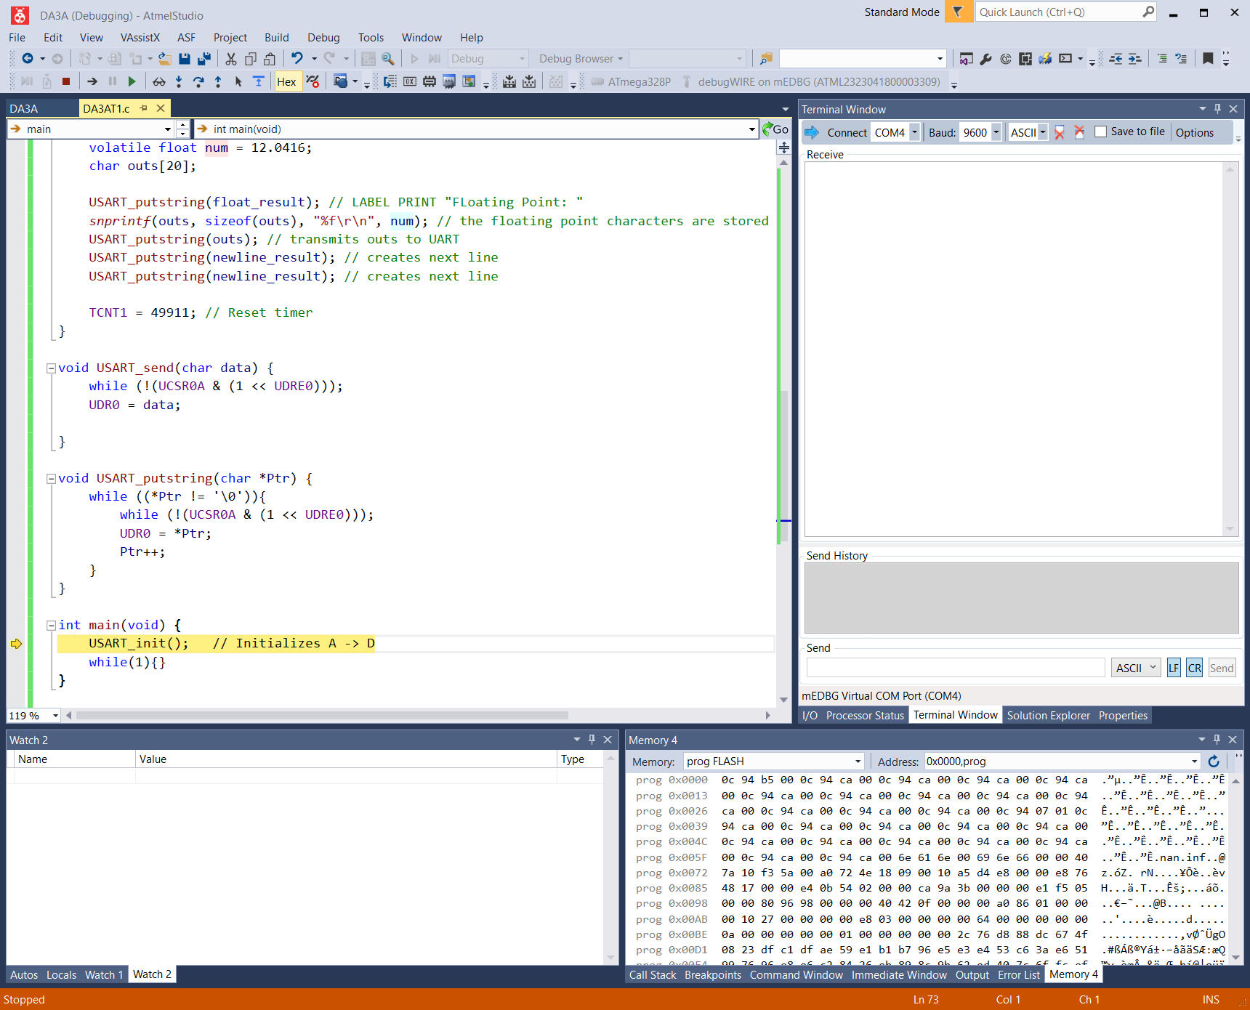

Post Debugging task 1:

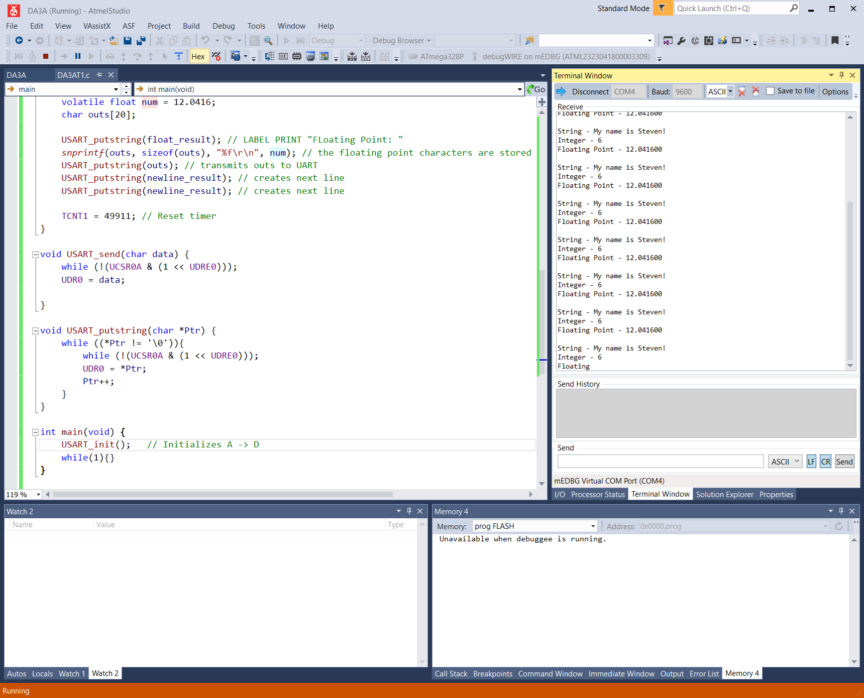

1. **YOUTUBE LINK OF TASK DEMONSTRATION**

<https://www.youtube.com/watch?v=ReqJiJMVSro>

1. **GITHUB LINK OF THIS DA**

<https://github.com/lees106/submission_da/tree/master/DesignAssignments/DA3A>

**Student Academic Misconduct Policy**

<http://studentconduct.unlv.edu/misconduct/policy.html>

“This assignment submission is my own, original work”.

STEVEN LEE