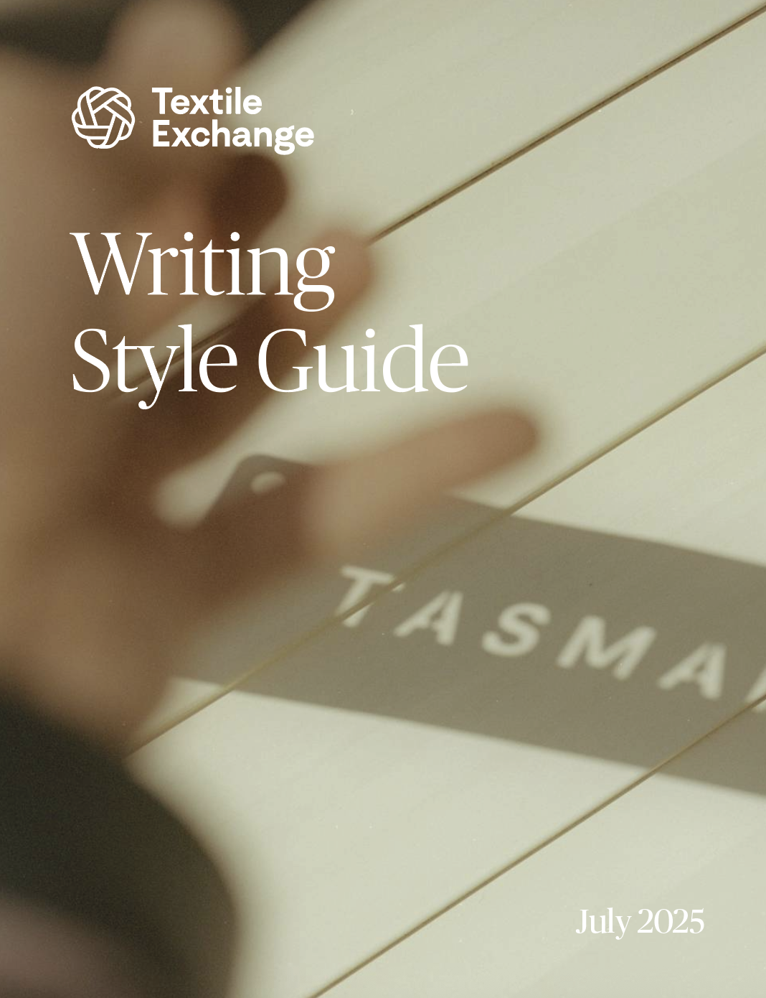
Writing Style Guide
This guide has been created to ensure consistency of punctuation, terms, and phrasing across all Textile Exchange communications.
NOTE: Language evolves. This document will too, as we adapt to the ever-changing world around us. Whenever there is the need for major changes, we will consult and collaborate with the relevant teams and make all users aware through internal communications.
Key principles
Language: Spellings and general usage should match the standard usage in the United States. However, for names of institutions, be consistent with their usage (for example, International Labour Organization).
Referring to Textile Exchange: Use the first person when talking about Textile Exchange in most contexts. For example, “we sit at the heart of our global community, and we want to feel like a part of it.”
In press releases and more technical writing, use the third person. For example, “Textile Exchange will release its Materials Matter criteria.”
It’s never “The Textile Exchange” or “TE.”
When referring to the Textile Exchange conference, don’t forget to use an article.
Do say: the agenda for our conference; sessions at the conference
Don’t say: the agenda for conference; sessions at conference
Formatting
These formatting guidelines should be used across all written documents, such as reports, press releases, and internal communications. They apply for all large bodies of text and, where possible, tables and infographics.
Alignment: When not in a table or graphic, text should be aligned to the left. Text should not be justified.
Bullet points and lists: For bullet points, always use a capital letter at the beginning. If it is a full sentence or multiple sentences, use a full stop at the end. If it is just one word or concept, no full stop is needed but try to keep this consistent within each bulleted list.
NOTE: See SOP-111a guidelines for use in technical documents.
Captions: If a caption is a complete sentence, use a full stop; for fragments, do not use a full stop. No italics. Avoid repetition of the title of the chart/table/graphic.
NOTE: Captions should offer context and increase understanding of why the chart/table/graphic is being used.
Font, font size, and headings: For Word files, use the document template.
Document title: Title case; Publico Banner, size 24pt font.
Subheader: Sentence case; Publico Banner, size 16pt font.
Third-level subheader: Sentence case, Untitled Sans, size 11pt font, bold.
Fourth-level subheader: Sentence case, Untitled Sans, size 10pt font, bold.
Main copy: Sentence case, Untitled Sans, size 10pt font.
References: For most reports with many sources, references should be found as endnotes, to keep the page design clean. There are some exceptions, such as the Materials Market Report, where footnotes are used. In-text citations are not to be used, to ensure streamlined readability.
Within the body of the text, place a footnote/endnote directly after the passage to which it refers. This should be placed after punctuation and at the end of sentences. The only exception is when using an em dash (—), in which case the footnote/endnote comes before, not after.
The footnote/endnote should appear as a superscript number (not as Roman numerals or letters) and should appear in sequential order throughout the publication.

In the rare occasion endnotes and footnotes are needed in the same document, endnotes should be numbers and footnotes should be Roman numerals.

When using a footnote/endnote to cite a publication or website, the relevant source information should be entered (as available), such as author/organization, date of publication, title of the report/article, title of publication, and full URL.

Examples:
¹World Economic Forum. (2022). What is ‘greenhushing’ and is it really a cause for concern? https://www.weforum.org/agenda/2022/11/what-is-greenhushing-and-is-it-really-a-cause-for-concern/
²Born, D. (2019). Bearing Witness? Polar Bears as Icons for Climate Change Communication in National Geographic, Environmental Communication. 13 (5), 649-663
³Textile Exchange. (2022). Preferred Fibers and Materials Market Report. https://textileexchange.org/app/uploads/2022/10/Textile-Exchange_PFMR_2022.pdf
⁴Tonti, L. (2022, November 18). Fashion brands grapple with greenwashing: ‘its not a human right to say something is sustainable. The Guardian. https://www.theguardian.com/fashion/2022/nov/19/fashion-brands-grapple-withgreenwashing-its-not-a-human-right-to-say-something-is-sustainable

Citations: See references
Punctuation and grammar
(In alphabetical order)
Item | Guidance
Abbreviations | Avoid wherever possible—use the full words or alternative phrasing.  If there is a need, use a full stop and a comma after.  Examples: etc., e.g., i.e.
Acronyms | Avoid where possible. If used, make sure the full name of the organization or program has been introduced on the first usage in each section/page, with the acronym in brackets.  NOTE: There are some instances when the acronym is more well known than the name, for example UNESCO or BBC. In these instances, acronyms can be used, but please consider the intended audience’s level of awareness.
Ampersand | Do not use unless part of a brand name (such as M&S). Sometimes, for title pages and in charts or tables, an ampersand is needed to save space—this is at the discretion of the design team.
And/But | It is acceptable to start sentences with these in informal copy, such as social media posts, but not in formal copy, such as technical reports.
Bold | Bold may be used for certain words/terms to ensure clarity, show importance, or to call attention to that word/term.
Capital letters | Minimize use of capitalization except for names and titles. Where lowercase would cause confusion to the reader, such as in the name of a project or talk within a sentence, capitals are acceptable.  Example: the findings from the Tracing Textile Waste project...  See glossary below for more specific examples.
Colon | If a colon appears in a title or heading, use a capital letter after.  In body copy, if the colon introduces a full sentence, use a capital letter after; if it introduces a list, use a lowercase letter.  Do not use colons or semicolons at the end of titles, headings, or section titles.
Comma | Use the Oxford comma/serial comma before and in lists of three or more items.  Example: for example, brands, suppliers, and farmers
Companies/organizations | Always use singular when referring to organizations or companies.  Example: Textile Exchange is working toward its Climate+ goal.
Currencies | Currency should be expressed in USD (United States dollar); if you need to reference another currency, specify the USD equivalent, and make it should be clear which currency (if either) is an exact value.
Dates | Use weekday + month + date (+ comma + year when necessary).  Example: Monday January 1  Example: Monday January 1, 2022  NOTE: See SOP-111a guidelines for use in technical documents.
Decades | Do not use an apostrophe at the end and preferably write out in full. If there’s a need to shorten, add an apostrophe at the beginning.  Examples: the 1970s, the ‘70s
Degrees | Use the symbol with no spaces.  Example: 1.5°C
En-dash | Use an en-dash (with no spaces) to separate numbers in numerical ranges where a unit is used.  Examples: 30–35°C, 80–90%  For ranges with no unit, use “to” instead.  Examples: from 1922 to 1932, young people aged 18 to 30
Endnotes | See references section above
Em-dash | Use an em-dash (not an en-dash) to separate clauses in a sentence. Do not add spaces around the slash. Use em-dashes sparingly.  Example: Explore the journey of textiles—from fiber to fabric.
Footnotes | See references section above
Headings | Document titles (not subheadings) should be in title case. This means that all words over three letters should have a capital letter (even conjunctions such as Through and Against). Conjunctions three letters or fewer should not be capitalized (two-letter verbs, nouns, and pronouns take a capital letter).
Hyperlinks | See links
Hyphens | Hyphens are used to join words. Do not use them in place of em-dashes or en-dashes (see above).  To check whether a word uses a hyphen or not, see the glossary below or use the Merriam-Webster Dictionary.  Compound modifiers  Use a hyphen when a compound modifier comes before the word it modifies. If it comes after, no hyphen is needed.  Example: this is a well-known fact  Example: this fact is well known across the industry  For modifiers of multiple words, use multiple hyphens (if the sentence can’t be reworded to avoid this).  Example: climate-crisis-related policies  Suspended hyphen  Use a suspended hyphen to avoid repetition.  Example: left- and right-handed people
Inverted commas | Use double speech marks for quotes. Do not use inverted commas for word emphasis; quotation marks should only be used to denote a direct quote from a source.  For a quote within a quote, use single quotation marks.  Always place the full stop inside the quotation marks.
Italics | Italics should be used for names of published works (including Textile Exchange documents), publications (such as newspapers and journals) and scientific names.  Do not use for emphasis.
Links | Links and email addresses should be in all lowercase, underlined and in colored text (as formatting allows).  In Word documents the color should be blue, specifically #7582A6.
Lists | For bulleted lists, see the formatting section above.  For lists within a sentence, if needed (a), (b), and (c) can be used to distinguish entries.  Example: this affects (a) xxxx and (b) yyyy.  NOTE: See SOP-111a guidelines for use in technical documents.
Measurements | Generally, all measurements should be in metric units.  The exception are the textile measurements outlined below:  - English Count (Ne) (number of 840 yard lengths per pound) may be used for yarn count of cotton fibers.  - Worsted Count (Nw) (number of 560 yard lengths per pound) may be used for yarn count of wool fibers.  - Tex (number of grams per kilometer); and/or Decitex (Dtex) (number of grams per 10,000 meters) may be used for yarn count and fiber fineness of manmade cellulosic (MMCF) and synthetic fibers.  - Metric Count (Nm) (number of kilometers per kilogram) may be used for yarn count of cotton, wool, manmade cellulosic (MMCF), and synthetic fibers.
Numbers | Spell out one to nine; use figures from 10 onwards. Always use figures for times and with units.  Use commas in thousands or above.  Example: 1,000 or 1,1000,000  Use a period/full stop instead of a comma as a decimal point.
Note | Note should be in capitals and bold, to draw attention to it.  Example: NOTE: The graphic is included for illustrative purposes only.
Page numbers | Use a lowercase p and an en-dash when giving a page range.  Example: p3–11
Percentages | Use % symbol with no spaces.
Period/full stop | There should only be one space after, not two.
Publications | When referring to a specific article in a publication within the body of the text, the publication name should be capitalized and italicized, and the specific article or title should be in quotes.  Examples:  - Investors are taking note: the Wall Street Journal titled a recent article “The Hidden Cost of Cheap Fashion Could Catch up with Investors.”  - In a 2020 review published in the journal Frontiers in Sustainable Food Systems, titled “What is Regenerative Agriculture? A Review of Scholar and Practitioner Definitions Based on Processes and Outcomes,” Newton et al. reviewed 229 peer-reviewed journal articles…
Quotes | See inverted commas
References | See formatting section above
References to charts, figures, and tables | When referring to supporting graphics or design elements in the body of the text, always use the exact name rather than a generality and capitalize what it is referring to.  Example:  Do say: as shown in Figure 1…  Don’t say: as the figure on the following page conveys….
Semicolons | If a semicolon appears in a title or heading, use a capital letter after; otherwise, use lowercase.  Do not use colons or semicolons at the end of titles, headings, or section titles.
Sentƒence spacing | See period/full stop
Slashes | Do not use gaps around slashes.  Example: date/time
Subheadings | Subheadings of a document should not be in title case.
Times | Do not use a space between number and am/pm. No need for zeroes after a number on the hour.  Examples: 5pm, 5:30pm  For ranges, close up gap between times and use an en-dash.  Examples: 10am–2pm, 10–11am
Time zones | For in person events, use the time zone of the relevant country. Where events are hybrid or online and open to all, use Eastern Time (ET) and Central European Time (CET)  Example: Monday July 21 at 10:00 ET/16:00 CET
Trademarks | When using Textile Exchange trademarks that are already designated with a trademark symbol (™), use such symbol on the first and/or most prominent appearance of the said trademark in a document. Once used, it may be omitted from subsequent appearances in the same document.  A symbol should appear immediately adjacent to a trademark. A trademark should always be identified as an adjective used in conjunction with a generic term or noun.  Examples: dTrackit™ system, eTrackit™ platform, dTrackit™ dashboard  Use of fonts, formatting, or spelling related to trademarks should be consistent.  Do not use: DTRACKIT, Dtrackit, d-Trackit, di-track-it, dTrackit

Terms and phrases
This section is to assist with providing consistent spelling and phrasing across communications for commonly used words and terms. It does not provide definitions. To find out more about definitions of words which are used throughout Textile Exchange standards and other related documents, please use the Textile Exchange glossary. https://textileexchange.org/glossary/
If you are unsure of the spelling or hyphenation of a specific word that does not appear here, look it up in the Merriam-Webster Dictionary.
Word(s) | Guidance
animals (species of) | Do not capitalize species names
backward | Rather than backwards
century | Lowercase, with number and suffix not in superscript  Example: 19th century
climate change | Rather than global warming
compass points: north, south, east, west | Lowercase if just referring to the direction; uppercase if a recognized name for a region Hyphenate compounds  Examples: south-west Scotland, West Midlands, northern China, South America  Exception: Southeast Asia
cooperate | No hyphen
coordinate | No hyphen
country and region names | If in doubt, check the spelling of a country name on the ISO list here.  NOTE: Some country names can be shortened if the shortened version is more familiar with the desired audience, for example the United Kingdom of Great Britain and Northern Ireland, which would be shortened to the United Kingdom.
data | For most audiences, treat it as singular, with singular verbs and pronouns.  Example: The data is sound.  If there is a need to specify, use data as the plural and datum as the singular.
dataset, database | One word
decision-maker, decision-making | Always hyphenated
dos and don’ts | Just one apostrophe
e-learning | Lowercase e, apostrophe
email | No hyphen, lowercase unless at the start of a sentence
ethnic descriptors: Black, African American, Brown, and White | Capitalize when used to describe a person or group, as in Black people, Brown people, White people. Use only when ethnicity is relevant.  NOTE: Stage two of the style guide will offer more guidance on ethical language use.
fashion week | Lowercase when used generally; uppercase when used as part of a reference to a specific one  Examples: New York Fashion Week, Paris Fashion Week, London Fashion Week, Milan Fashion Week
fiber/fibers | Use US spelling
forward | Rather than forwards
Global North/Global South | Use capital letters  NOTE: More guidance to follow in stage two, for referring to countries and regions.
government | Lowercase if talking about governments in general; uppercase if talking about a specific government in power. In the UK, be mindful of devolved powers and make sure it is appropriate for the audience.  Example: local governments must secure funding...  Example: the UK Government has stated that...
greenhouse gas emissions | Specify greenhouse gas instead of just using “emissions”
hemisphere | Capitalize when referring to a specific hemisphere  Example: most of the Earth’s land mass is in the Northern Hemisphere
in-conversion | Use a hyphen, not “in conversion”
Indigenous Peoples | Capitalize
Indigenous Peoples and Local Communities | Capitalize, but use lowercase for local communities on its own
industry | Write fashion, textile, and apparel industry on first reference for clarity; second and future references can use textile industry
job titles | Use uppercase for a specific position, lowercase for general positions  Examples: Chief Executive, project managers
life cycle | Always two words, no hyphen
Life Cycle Assessment | Use capital letters. When abbreviated use LCA in the singular and LCA studies in the plural.  Example: What is LCA? There were six LCA studies.
manmade cellulosic fibers | No hyphen in manmade
Materials Matter | Do not abbreviate to MM  NOTE: In standards documents, some exceptions may apply. Please refer to their guide, SOP-111a.
member | Lowercase
Native Peoples | Capitalize
nonconformity | No hyphen
non-profit | With hyphen
OK | Not ok, Ok, or okay
organic | Lowercase
Policy Hub | An initiative to develop and promote a unified European policy framework for the apparel and footwear industry; the Policy Hub (always lowercase “the”). Never shorten to “The Hub” to avoid confusion with Textile Exchange’s community platform.
references | Lowercase r when mentioned in copy (for reference style guide, see above)  Example: see references
round tables | Lowercase, unless talking about a specific event  Example: the Cotton Round Table  Example: we hosted a round table to discuss...
Scope 1/2/3 emissions | Capital S in the context of industry emissions; lowercase in other contexts
seasons: summer, fall, winter, spring | Lowercase
slow growth | Use the term slow growth, not degrowth or reduced growth
standards | Lowercase s, unless full name is written out  Example: Responsible Wool Standard  Example: the criteria for the standard are...
supply system | Instead of supply chain
The Hub | Always capital T (for the Textile Exchange platform)
tier | Capital T for specific supply chain tiers (Tiers 1-4) when used with a number, but lowercase otherwise  Example: across all tiers in the supply system...  Example: groups in Tier 4 suggested...
toward | Rather than “towards”
unified standard | Lowercase
US/UK | No full stops
well-being | Hyphen

Words to use sparingly
Be careful of the context when using these words in external communications, and try to avoid them if possible.
- partner
We refer to our global network as our community. When it comes to one-to-one relationships, we get specific. We call our members “members” and our sponsors “sponsors”—we avoid the terms “partner” or “partnering” unless we are referring to a direct collaboration or project done together.
- sustainable, eco-friendly, green, responsible, conscious
We avoid using generic words like “sustainable” or “ethical” when talking about fibers, materials, brands, or suppliers. Instead, we opt for claims that are supported by concrete evidence or commitments.

Helpful resources
Whilst we develop stage two of the style guide, which will deal with tone of voice and making thoughtful choices to ensure the language we use is inclusive and reflects our values as an organization, these resources may be helpful.
- Editing for Environmental Equity
- Oxfam Inclusive Language Guide
- Textile Exchange Internal Glossary
- USA Today Network Style Guide

