haley [picture haley, one of our stories]
[facebook announcement]



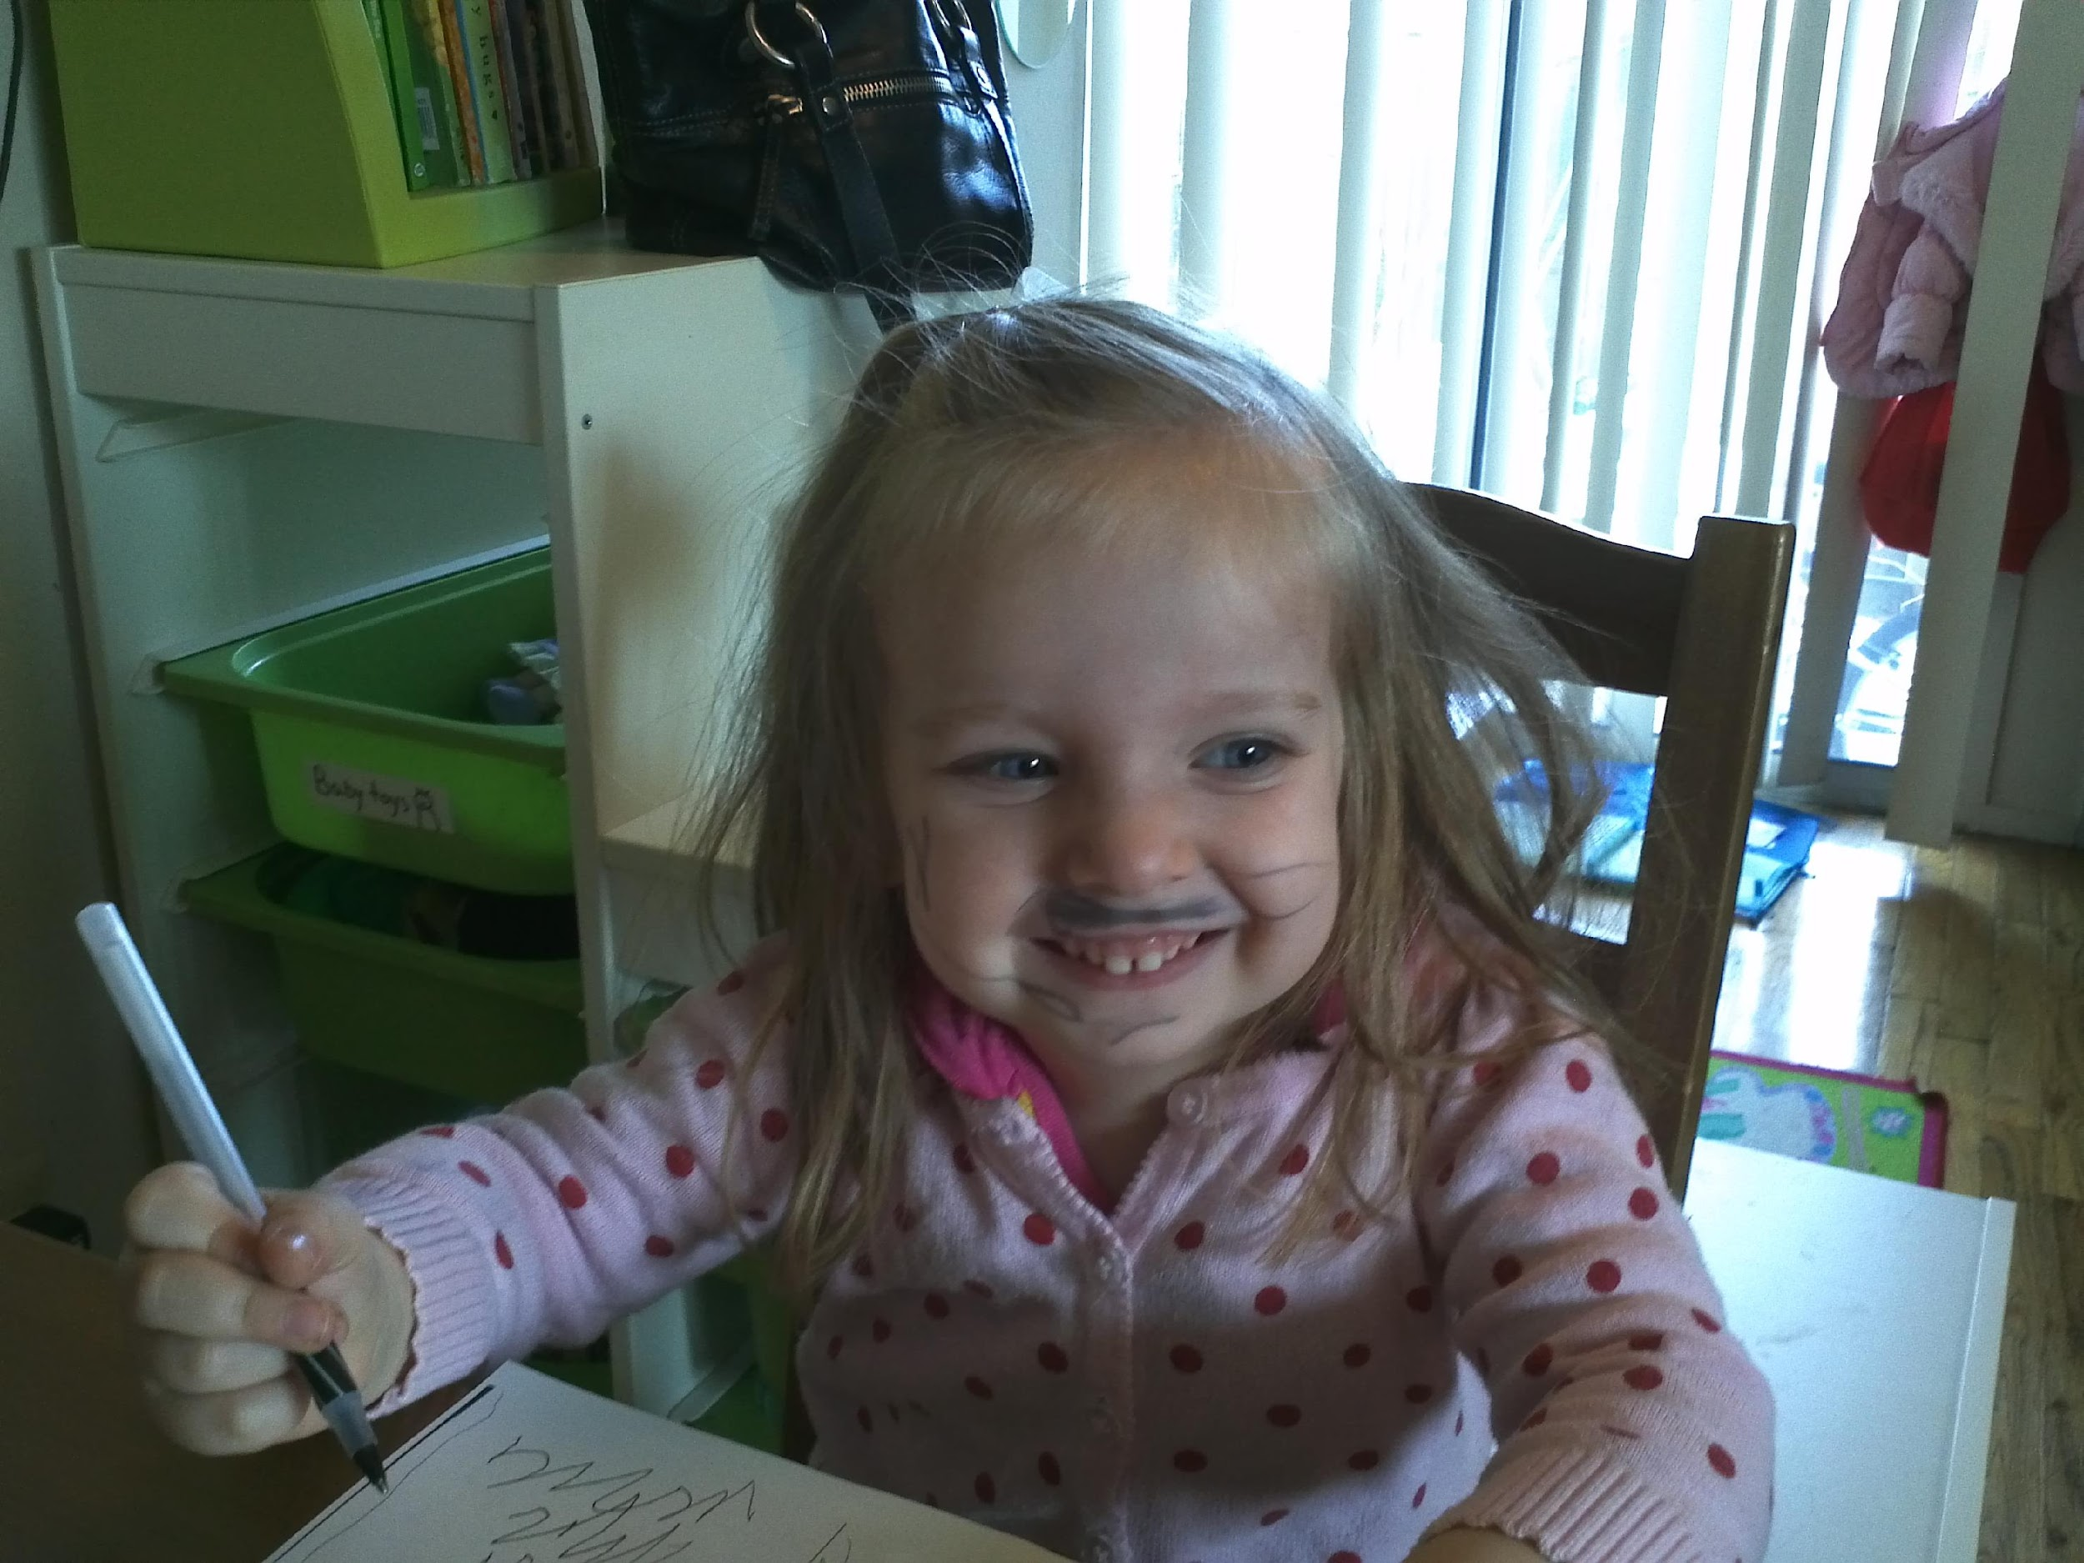
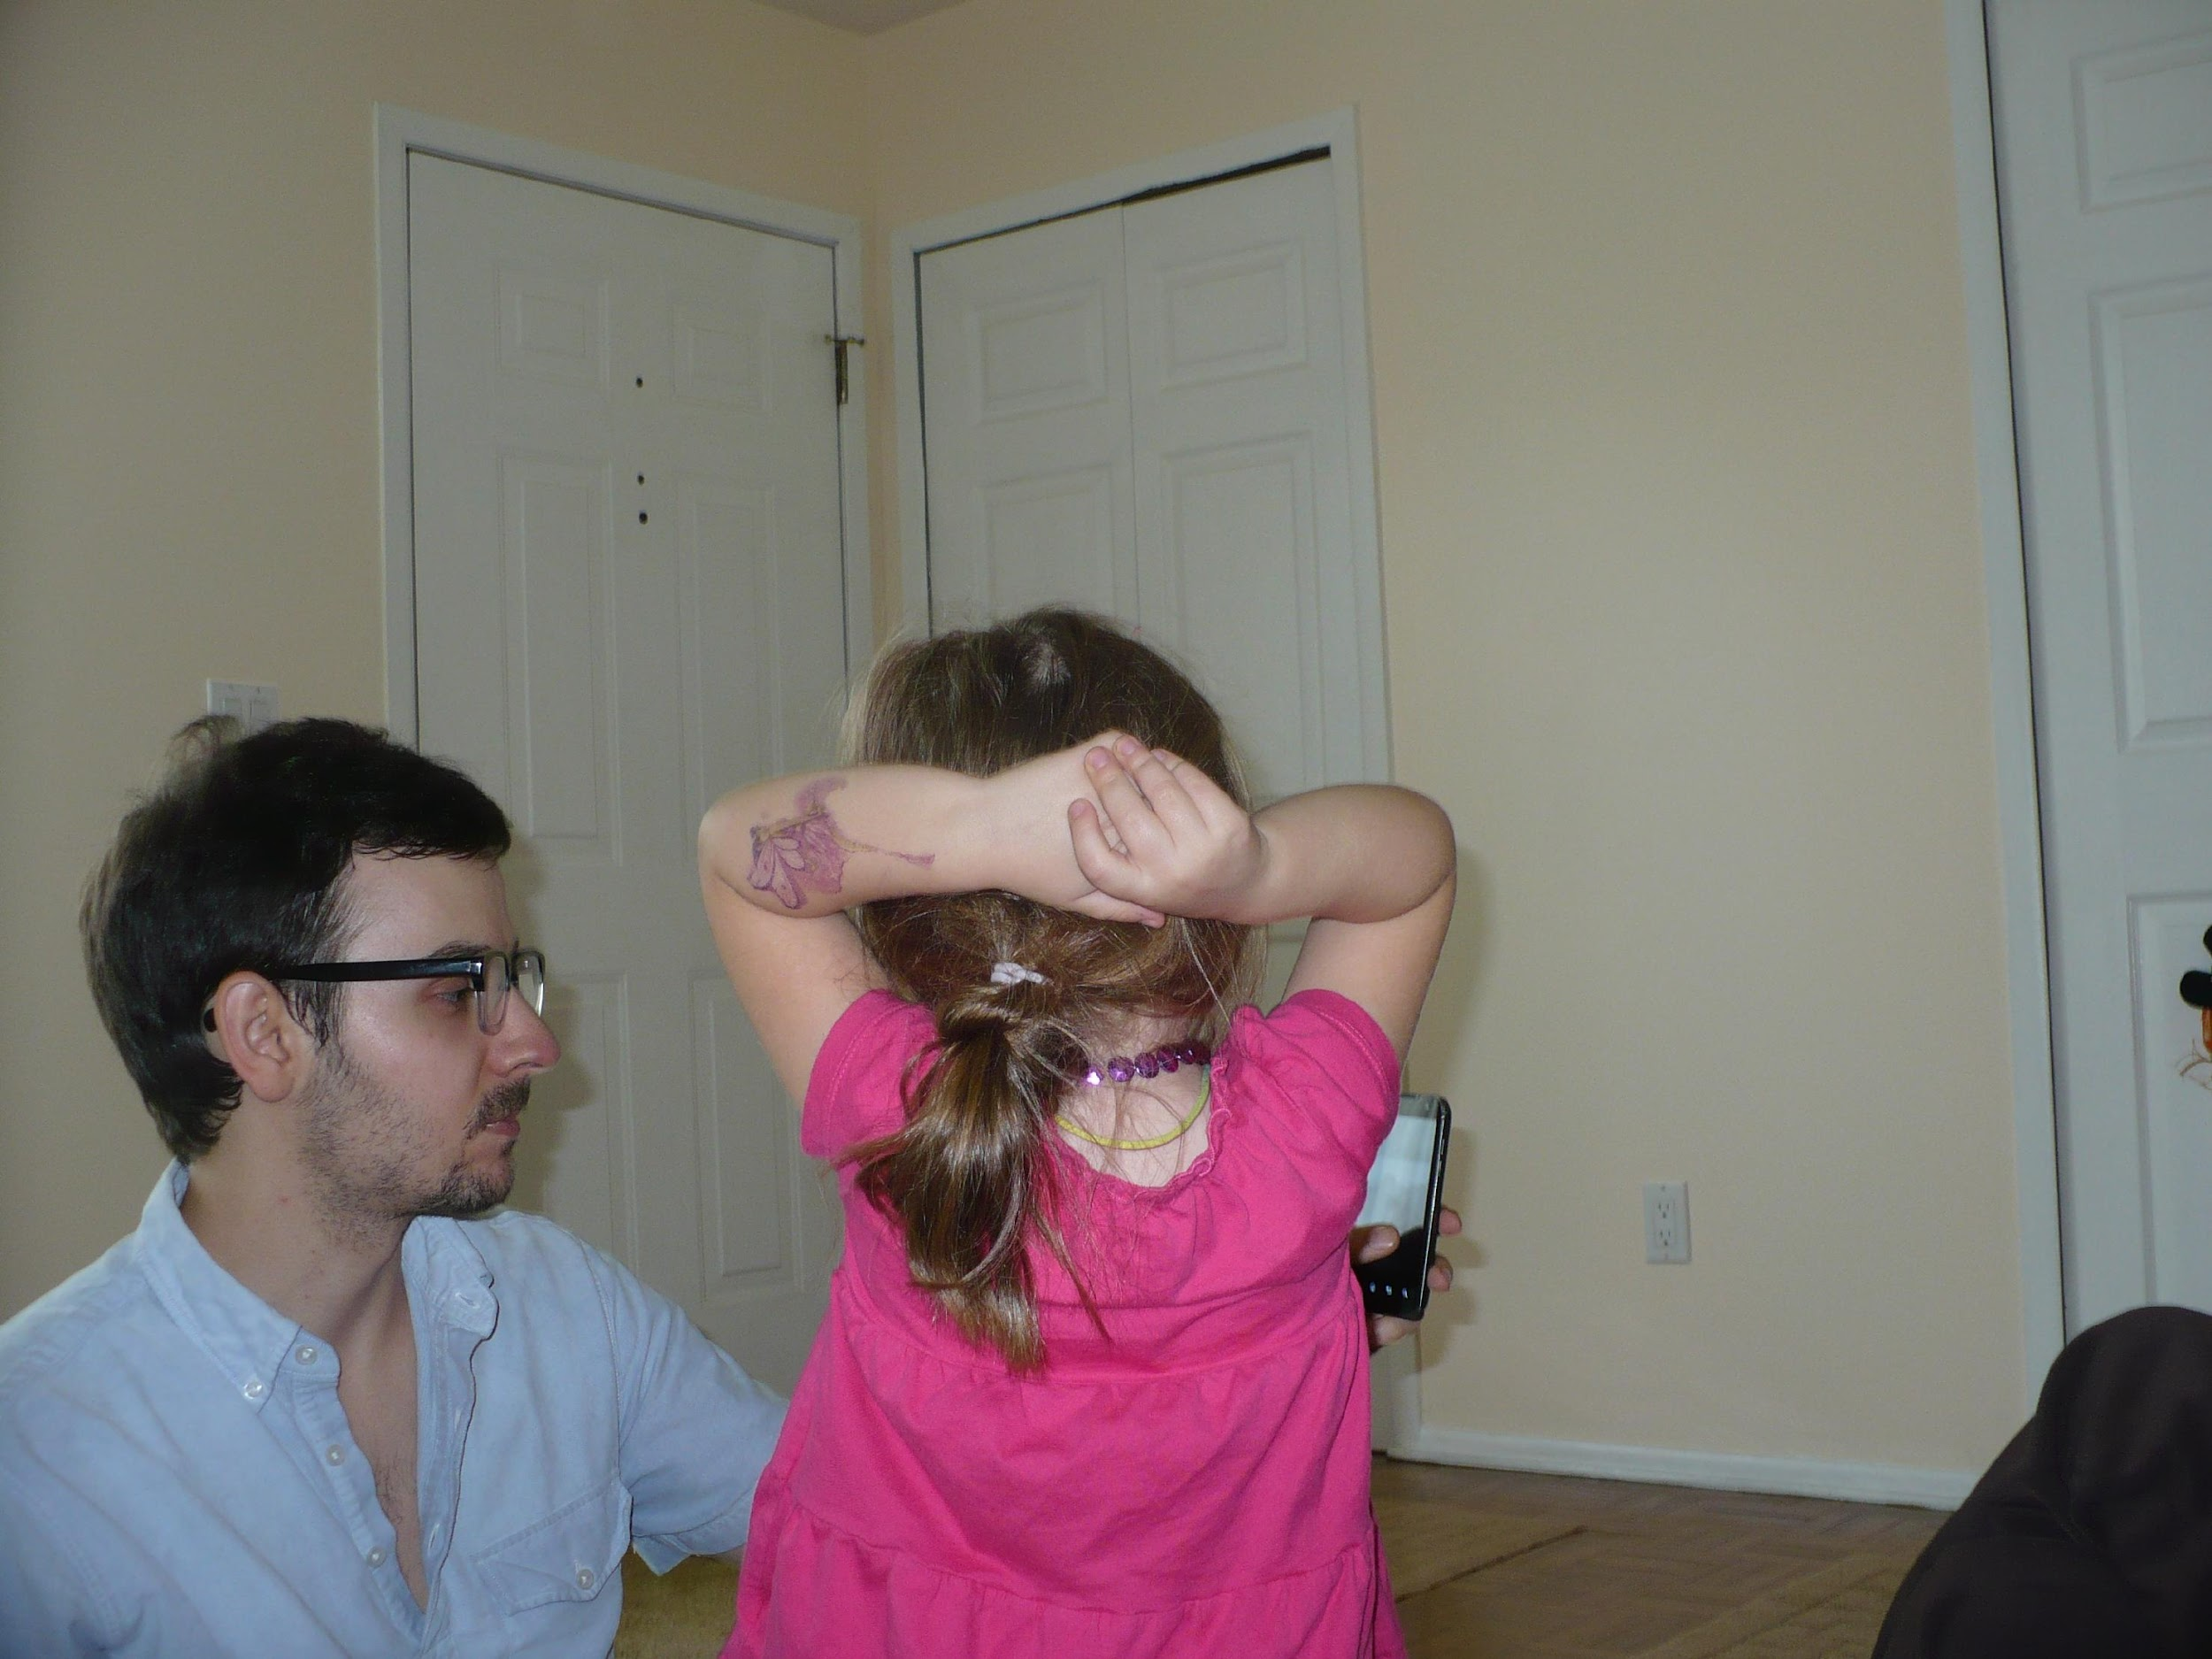


like a mountain
rose, thick
with thorns in the rocks, bright
with thin sun-
light: little girl your face

*

likeamountain
rosethick
withthornsintherocksbright
withthinsuns
lightlittlegirlyourface

*

frail pattering
fingers,
teeth: my baby
girl like
halcyon or
violets.

the conditions that make idealism impossible likewise / preclude song-speech

*

with the passage
of time: your fingers

teeth and
hair;
your innocent stare.

your hair wisps surround you,
veil your face from the breeze
of hands that awkwardly
brush them
away.
dandelion. sunblossom:

death came in
to the world w/
you--you are my
life, my
death--to know
that in you i live,
and likewise you
in me; + in you
yr fragile
baby-face, yr hands yr
hair the way you fall
on yr butt:

you are my sad-
soft chain
to forever. you could
break
whenever.

*
Sappho 132
My little girl’s face,
like bright
yellow flowers: Cleis,
more precious to me
than all Lydia.

Sappho 98b
but Cleis I don’t know
where to get the special
ribbons to hold
your hair back:
there’s nowhere, Cleis.
just one more reminder that Myrsilus
has exiled us
from Mytilene.
Sappho 102
Mother I do
love you, but I really can’t
work the loom –
Aphrodite is making me need that boy

Sappho 24

Remember:
we too did the same
in our youth.

we are many
and lovely in the city,
in the city’s foundations we live
at a whisper

*
Sappho 105b

like the mountain hyacinth
trampled by shepherd men’s
feet,

and on the ground
the purple flower

*

Sappho 88
There’s little you could
wish for
sweeter:
Some might say
you’ve forgotten, but I
will love
as long
as I
have breath.
I have been
a friend
to you.
sweet and
bitter, yes.
but know that I
will love you.

*

Haley,

you could never know how much you've meant to me. My heart breaks into tiny pieces with the weight of this gift God's given. You are my light song, yr halo hair like sunflowers, leaves yr brown-gold tuft of feathers--sad-precious-sweet, and the love is bittersweet, to know you'll grow. Remember your daddy. i love you so.

Haley I want you, more than anything, to know how much your daddy loves you.

Dear Haley,

I have not been the strongest man. I have failed, and buckled, and surrendered to life. I have done the wrong thing. I have lied and deceived. I want to be a better man for you, dearheart. I want to love you with a love so full and real it surrounds you, and stays with you forever, wherever you go. I want to love you with a love so great it / clamors to you in all your silences and says to you--"i love you, i love you, i love you." i want the smell of my love to linger in your hair, + on your little purple dress so that it covers you all day long. i want to love you with a love so real, it comes to you in your dark hours, when the sting is too much, and when the lights are out and you feel like life has forgotten you, and the tiny day of your oh-so-fading life--all our lives so fleeting--and says to you, "light, comfort, a bandage. a song to fill you up, a reminder that i'm with you." life so brief, baby girl. here and gone. i will be there for you.

i never knew a love like this that could call out from the deeps, that could rattle me apart to find my deepest recesses to empty them empty them out and fill them back up with love.

is this the love God feels for us?

oh how we break his heart! oh how his heart breaks with love!

everyday we experience things that go so far beyond what we understand, our whole clothing of skin and flesh--and the deeper clothing "soul"--is filled with veils that lift, but do not reveal.

all uncovered in my deeps
and yet i can't see a thing!

what silly creatures we are, who break apart + return to dust in the space of a day. what creatures of a day who carry this impossible pearl.

some day you'll read this (i hope) and someday far from here, when you yourself have felt the whisper of night and tasted the breeze of the fading day--it might even reach you--my letter might even / read you!

*

The Botanist’s Daughter

“Or I guess the grass is itself is a child...”

i.

Sloppy blue track jacket
nylon netting lines the pockets

ii.

we gather dandelions in a pewter pail
streams of sand and gravel. She plants
three crumpled handfuls of stalks,
breathing life through clay,
hunched like a surgeon.

iii.

carpet of dandelion shooting down
to explore with shallow fingers
the history of dirt,
the etymology of gravel,
and all the individual parts of sand

drawing dull mineral granules
to radiate in its dust-gold brain

iv.

bedtime, girls asleep, half-heartedly shuffling through floor's
sullen clutter. upend jacket to find
flowers spilling out.

but mostly dirt

v.

in the crack between porch and shrub
assorted grimy weeds, chunks
of sidewalk stone, intricate
arrangements of pinecones,
void space:

little girl's zen garden

*

the valley of shattered wildflowers

and when my skin is gone will you see me
opened up in my ugliness
and stripped of the lies that hide in flesh?

or will it be a subtle thing, a soft
voice struggling against the muffling skin
that then breaks free to honor you over
and over again?

what will you find inside me?

how is it that you know
while I don’t? that you see
inside all my layers to know the truth
that hides there? if I am evil then i
most certainly have hidden it
deep as deep as deep in the skin
and away from the sun as I
was able – and yet if I am evil you
know that truth of me and i
am ignorant

and again, if I am good I cannot
see it, covered up with all this
filth and muck, too
shot through with doubt and dust, but you
you knew my secret heart from before
the world began, and loved me because
I loved you back – before I knew, you loved, before I loved,
you knew –

even my desire for your softness, and to rest
in the shadow of your wings, and to lay
my head on your chest, my savior, to love
you face to face, to be forgiven and finally
set free, and clean: this too could be
deceit, a lie I tell myself to hide from my own
damnation. who can know the heart? not me.

but you search the hearts and the anxious thoughts,
you search out all the darknesses, and the drawers

*

ragweed

my little girl’s hair
like love-burnt stalks,
like wheat-tan weeds or
dandelions bound
in a row: a braid her summer
face. or milk thistle sap
when she breaks with tears, the rag-
sewn dress her glory.

in time to come there will be no
weeds, but bodies of light and power.

remember me
little flower.

What fills up a poem
w power?

That brass heart, love, I guess, the impossible
crown of ivy,
r the cruciform rope
of roses.

If I were to eat
yr startled images
or yr bloated
surface emotion,

r the silt-heavy
tear on yr lip
r the crumb from potato
chips:

now what to do with it
when it’s empty?

A Compendium of Flowers and Weeds (w/ images)

I. Flowers:

1. Anthema: From Classical Greek, the generic word for a blossom, or the anthem, a kind of choreograph set to song

2. The Meadowsweet (also know as ulmaria, fen-meadow, and brideswort): Moist-dark, born in dew

3. The Oak (quercus): Catkins—elegant hanging cyllinders covered with testicular lavender fuzz—purple w/ growth. Seeds in its crowny cupule. Its serrated leaves rising up in a spiral.

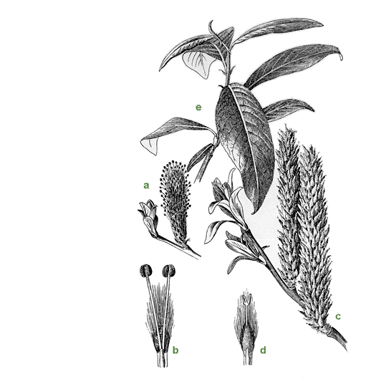

4. Broom (also laburnum, ulex, Cytisus): Slender green stems, delicate leaves with yellow petals clustered in stubborn bunches, close to the branch. Can often take root in thin soil or white-knuckled in sandy scree. A fire-climax species, it germinates in the seasonal burns even as it unravels in ash.

5. Ashborn

6. From meadowsweet, broom, and oak, the magicians Math and Gwyddion formed a bride for Lleu, to lift the tynge laid upon him by his mother, Arianrhod. They called her Bloddieu-wedd, Blossomface.

7. Columbine in a lime outcropping, caught in a rift in stone. The spur of the petal whirs like a single, tiny sparrow.

8. “Vast whisp-whisp of wingbeats / minute-long string of black geese”

9. Adonis mauled by a boar. Aphrodite takes the blood, and from it makes the common poppy.

10. The Poppy, anemone coronaria: anemone for its wind-bleeding seeds, coronaria for its circlet of blood. Purpura (violet, bright), Purpureus (for its murmuring dress)

11. Blood and sap, sap and blood

12. The blood is thin or thick. The blood is blue or red. The child / takes after her mother.

13. Asphodels: like great white ashes, or ghostflowers laid against tombs. Smoky enough to feed the thin dead with forgetfulness.

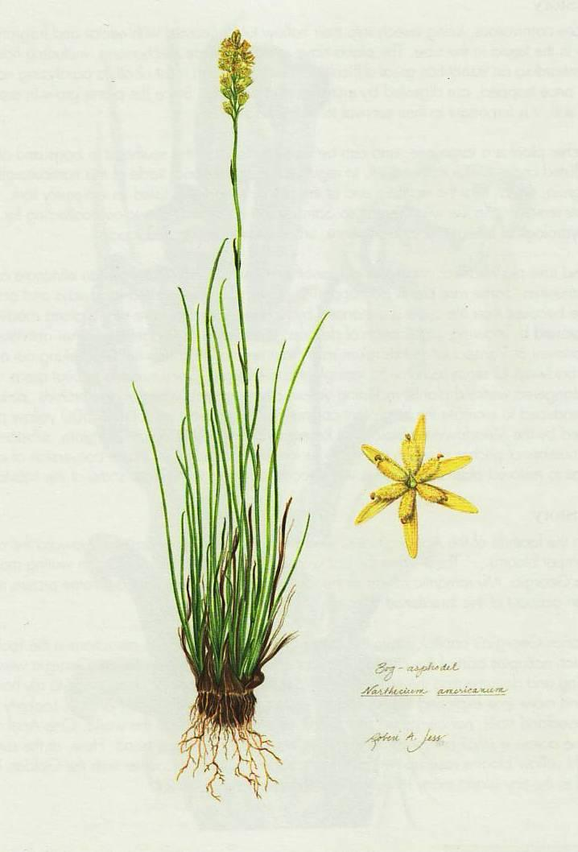

14. “The beautiful uncut hair of graves”

15. “skeleton thick sunflower, saw- / dust root, corolla of spikes, seeds / fallen out of its face / dress of dust and soot-blue eyes”

16. Chrysanthemum psalms

II. Weeds

i’ve never paid attention to roses,
or to any other flowers
but weeds

1. Clover (seanrog, trifolium cloeferwort): small white, pale pink flowers

2. Milkthistle: The zebra-stripe yellow of the monarch worm, chewing through w bright precision / the dullcolor leaves. Characterized by popping sap pods and common, purple blossoms.

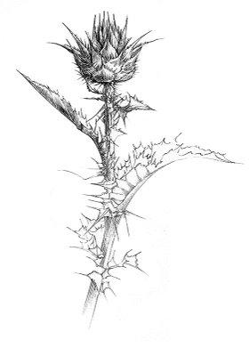

3. Taraxacum Officinate, ME dent-de-lioun, (lion’s tooth, for its coarsely jagged leaves. Dens leonis, Lowenzahn, dog’s milk, gyermeklancfu (the grass of the child’s / chain), butter blossom.

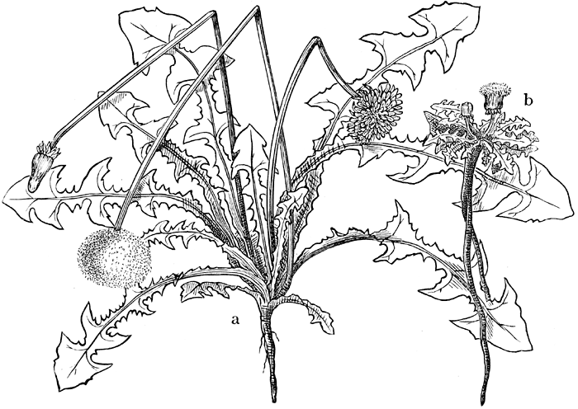

4. Horse-flower

5. Ablutions of subtle poisons will protect the lawn, drying up the stalk and blossoms before even the late dry / summer heat can change the upturned cheeks / to the puff-white manes of grandfather stalks.

6. “This grass is very dark / to be from the white heads of / old mothers,”
“Dark to come from under the faint red roofs of mouths”
“Or I guess the grass is itself a child. . . .”

7. The Dandelion Flotilla: the needle-like beak lifts a tuft of feathers, the pappus carrying fruit, above the dangling Achene sheathed in spines.

8. The flowerhead: A ribbon-like corolla of petals, golden. Inside, the stigma catches seed above a cylinder of woven anthers. The hollow stem supports the fragrant flowerhead, and bitter white juice runs through the rosette circumference of fingers.

9. The taproot, sinking deep

we bound them up in chains
twisted split stems in a helix
pattern, wending down through
tawny braids, a garland of golden
weeds

*

*

i.

dried petals of dusk.

the husk of yr dress.

an echo.

*

hiding from me
behind figs: your blue eyes
can't cover the liquid-
dark sleep.

*

hush, dear hands--this song is enough.

*
lovewords.

father teach me.

*
from moleskine #5 sept 2010

language burns away like fog--
a dream at dawn.

ii.

i know your face
even fogged in fingers of sleep.

iii.

glistening in the fingers of sleep, yr skin.
the shadows play across iris-bright eyes

iv.

yr face like a whisper late at night:
musky hummingbird hearts of speech.
a finger of song in sleep.

v.

white shards burst:
a sleepy blink

vi.

the very stones would sing
the earth cry out in wonder

vii.

the ancient rain wells up,
a drop of blood.

viii.

speak to me, living being.
use my voice like a body.

reach past skin and teeth
down throat to find the fingers of flesh
gripping the groin like roots,
drawing moisture from deep earth oceans.
continue thru lotus-fringed caverns
of sleep, where forgetfulness laps
along icy banks and the ancient city
echoes.

from that place,
draw song.

from that place fill
my body with longing.

a new song, come.

ix.

empty buildings at night--
the house of the Moon.

the voice is gone--again--
and nothing comes in its place.

not pain, not joy, not loss.

some reserve of strength
like a dandelion mane--
released

*

by Haley--(transcription)

Once upon a time, there was a Lady named Aunt Amy. She was going to walk on the stairs, and she knew why run on a treadmill she was having a baby, but she knew why that she played and

THE END

*
[from moleskine#6]

2/6/09 7:40pm

where there
is a will there
is a way. i think.
in
private here i'm
thinking, about how
to solve the problem of
the Absolute and put
words down here
in words. how to put words
in words, accompanied
by power? if i
to you
the touch
here
of silences
that break open:

ii.

eyes
leak
speechless-
ness like
dreams: i'm
coming
soon
to you
my darling, soon
i'll come
to you.

but until then dreams
break open, tiny
shells w/ yolks, like
statuettes
of silence: light blue
shell like
tiny
skies. i
rise
to you my
darling. rise.

and the skies
rise too on top
of water, floating on the
atmosphere
in oceans
bright
and deep:

these motions of the
element
time, like liquid
darkness and
wine, bead:
spinning dusky and
blue, like flowers
on a stain-etched
face.

yr eyes are a winedeep blue
and stain-etched,
dear,
yr face like
snarls
of rain. there is no
tenderness so
open. for you i put
the words
here
back
in the form
of words.

if the line
is a breath and i
am the lines
that burst
across college-ruled
angles, running
parallel
to robins--then
my life lives
in the reading. my life breathes
on your lips.

iii.

slowly, golden city,

i will build you

from drops of blood.

*

Mountain rose, your brittle white
edges singed
by frost. Ringed by tufts of hard
dark grass. This love I have
is the love that breathes, without you i…

… arch fires, patterns of fingers, hard
white capillaries cracked
in a desert: your face
burning: shall i

set you on a pedestal or as
a star hang you with embroidery
in the midnight sky, as a setting? or see you
as you are, baby girl – which would not be much of a poem
to write. Words break

shakily
on the shore – one by one they die. The sentence, then
flows over them and breathes them back
to the sea. These things break and must do so until the end of time.

Phrasewordsentencesoundsongsymphonypoemlifeblood. Though I am crippled,
I walk. Though deaf I hear, though dumb I speak. And though the grave has claimed me, live.

You belong to me. Soften yourself to me, let me sleep. Sho la la la la, sho la la la. Sprish sha sha sha sha

Singing in time
with pattern

*

to write life in telegraphic prose-poem style of Ginsberg poem-prefaces and cover-backs:
born awhile ago as a baby. small with tiny fingers and pink. from hospital returns with parents to mobile home before growing up. meanwhile shy and smart wins writing prizes and school spelling bee in sixth grade. before that sister born when nine with mental retardation. moves around starts using drugs at fourteen huffing gasoline in parents’ garage taking long pink codeine pills four at a time first time i drank throwing up two days straight. at seventeen finally finding morphine and later the needle at last chained to my incredible illness. before that reading ginsberg’s howl kerouac’s on the road ayn rand’s atlas shrugged plato’s apology some of nietzsche’s thus spake zarathustra which i never finished all in the space of a year when fifteen. decides to get “integrity” tattooed across chest in old english lettering but never follows through. becoming a neo-Beat poet winning high school poetry contest first place for “you have opiate tongue when / fluttering in my mouth.”

in a hospital room npw sleeping on the chair my wife with her breast out and our baby girl having lost 9% body weight and tiny jaundice because of hunger and difficult time with breast-feeding looking forward to lack of sleep and midnight poesy made out of crazy.

**

Dear All,

I had planned on being back for teaching tomorrow, but early Wednesday morning we took Haley to the emergency room with a fever, and have been here since. We should be home tomorrow afternoon, but not in time for teaching.

I will be back next week, but until then I need to give you some direction for your final paper. I have been remiss in my duties, as I know that you are all eagerly bursting to begin work on your papers. I am sure that you want to spend as much time as possible in diligent labor, and I would hate to be the one to stand in your way.

Below I’ve given some general guidelines and possible areas of inquiry. If these are helpful to you – fine. If not, and you would prefer to develop your own topics – all the better. The possibilities I’ve provided for you are already quite open-ended. You can get started on a draft and bring me something substantial (6pp. or so) to class on Friday, 12/7, when we will be doing an in class peer-editing exercise. We might also spend some time on free writing Wednesday, 12/5. I suggest that you read ahead to Euripides’ Bacchae, as it is an incredible play and provides a great deal to think about for papers. I will be available Monday, 12/3, for optional meetings. Please email me if you would like input and suggestions for final paper topics. We will schedule something for that Monday. You will have until the day of your final exam (12/13) to finish your papers, which you may bring to the exam or put in the Great Books drop box outside the GSI offices in Angell Hall.

I look forward to seeing you next week, where we will be nearing the close of our semester’s reading.

Until then,
Matt

Some ideas:

* genealogy of a particular concept – for example, some of you chose to trace the lineage of various concepts of happiness in your second exercise. You may also wish to expand or modify one of your exercises that you felt was particularly successful, or adapt your strategy in that exercise to our current readings.

* a comparison of the characters of Euripides’ Dionysus and Plato’s Socrates

* representations of Socrates in Aristophanes and Plato

* is Socrates a mystic or a rationalist? Are these two concepts exclusive of each other? How is Plato’s Apology a rich site for working through the meaning of these terms?

* representations of gender and authority in Euripides Bacchae

* the rational and irrational in Euripides Bacchae

Keep the focus on the literature that we have read over the last few weeks of class. Of course, if you need to call on a text that we covered earlier in the semester to make your case, do so. But allow the bulk of your argument and writing to center on things we have covered recently. If adapting a precious exercise or paper, expand its scope to include our recent readings.

Use the skills we’ve developed over the course of the semester. Support your insights with the reference to and analysis of the text, use evidence, develop your argument by means of close reading. You may draw on concepts from other disciplines or use diagrams if you feel they will help you make your point, but they are not a required part of the writing.

* 5-6pp. draft due in class Friday 12/7 (the draft should have a clearly formulated thesis and a general idea of where you’d like to take it for the final version)

* 9-10pp final paper due Thursday, 12/13

*
“the practice of sincerity”

how do I see her?

Through a subtle but cloying film of guilt, knowing
all of it is passing. Out of the corner of my eye
I ignore you, while I type these twice useless
words. One set of words paves the narrow way
to a palace of words in heaven: words exchanged in
committees, words securing money, words
dumped out in lecture halls--a wall of words to brick up
a life in stupid promotions, tenure, and petty
animosities endless. And what else is there?

You, I know. But I haven’t a clue how to get to you.

The other set of words is equally useless, more so
because of their beauty. They brush up against
nothing and bridge nothing and build no towers
of Babel. Just trinkets, gleaming things in the window,
things I put in my amazon basket. Is that what I’d give you,
this gift of….? This ache to push through the skein of
words?

But I don’t even have any arms I’m a
brain on ice. I interface with an invisible
keyboard digitized in my genome. It’s all I
am, these symbols, twice useless bolts of ones
and zeros, a cloth of just two colors.
I weave it together, I pick it apart, I
weave it together, I pick it apart. And so on.
Nothing that could end up
as an object, or as a three-dimensional
flower.

So you have chosen to reveal
with words, the purple-blue bruise
outbleeding, while I sit here and
cover it up, with language slightly
purple:

Little flower
remember, little flower
forget.

*

“or I guess the grass is itself a child…”

i.

the magicians Math and Gwyddion
taking the seeds and stems
of meadowsweet, broom, and oak
fashion the bride unborn: Bloddeu-Wedd / Blossom-Face

Vast whisp-whisp of wingbeats
minute-long string of black geese

the meadowsweet (also ulmaria, fen-
meadow, brideswort): moist-
dark, born in dew

the broom (also laburnum, ulex, Cystius):
slender green stems and delicate leaves
yellow petals in stubborn clusters
bunched up close to the branch. fire-
climax species, white-knuckled on sandy
scree. unfolds its tender palms in fire,
germinates in the seasonal burns:
ashborn

the oak, or quercus:

its catkins w purple growth, the seed in its crowny
cupule, serrated leaves rising up in a spiral
elegant hanging cyllinders, testicular lavender fuzz

blood and sap, sap and blood
the blood is thin or thick
the blood is blue or red, the child
takes after her mother

all down the limbs
the flowing stains
touch the blond trunk like wine

the way the stain of blood
like a vibrant dye:

ion, iona, violets
bower of veins and woven
vines
violets for the blood

to care for a word, to fiercely adore it,
to send shooting love down its roots
to call it by its rightful name:

seanrog, little clover,
trifolium cloeferwort
with your small white, pale pink flowers

ii.

what kind of flowers
were the golden ones
to which Sappho compares
her Cleis?

anthemoisiv:

the generic word for a blossom
or the anthem, a kind of choreograph
set to song

the naturalist’s notebook:

columbine
in a lime outcropping
caught in a rift in stone
the spur of the petal whirs
like a single, tiny sparrow

anemone coronaria: anemone for its wind-
bleeding seeds, coronaria
for its circlet of blood
purpura – violet, bright,
purpureus for its murmuring dress

asphodel, like great white ashes: ghostsflowers
laid against tombs, smoke enough – like a rain of ash –
to feed the thin dead with forgetfulness

skeleton thick sunflower, saw-
dust root, corolla of spikes, seeds
fallen out of its face
dress of dust and soot-blue eyes

i’ve never paid attention to roses
or any other flowers but weeds –

like the zebra-stripe yellow of milkthistle worm (the monarch)
chewing through w bright precision
the dullcolor leaves,
w popping sap pods,
the common purple blossoms

and dandelions for the way they
carpet – the same thing that makes them
weeds. each spring a mannered pogrom
lawn ablutions of subtle poisons
before even the late dry
summer heat can change the upturned cheeks
to the puff-white manes of grandfather stalks

This grass is very dark
to be from the white heads of
old mothers,

Dark to come from under the faint red roofs of mouths.

Or I guess the grass is itself a child. . . .

the dandelion flotilla:

the needle-like beak lifts a tuft
of feathers, the pappus carrying fruit
the dangling Achene sheathed in spines

ribbon-like corolla of petals, golden,
inside, the stigma catches seed. a cylinder of
woven anthers. the fragrant flowerhead
above a hollow stem. bitter white juice
in the rosette circumference of fingers

the taproot, sinking deep:

taraxacum officinate
dent-de-lioun, lion’s
tooth, for its coarsely
jagged leaves. dens leonis.

Lowenzahn, dog’s milk,
pissabed, gyermeklancfu: the grass of the child’s
chain. butter blossom, worm rose, horse-flower.

we bound them up in chains
twisted split stems in a helix
pattern, wending down through
tawny braids, a garland of golden
weeds

why not the groomed
bright bowers of dandelion
blossoms, twined in
gentle growth?

the dandelions also dance
in a chrysanthemum psalm, or a
honeysuckle anthem i guess:

why liken a little girl to a weed, or to a dew-
heavy poppy, clipped by the plough’s neat edge?

the beautiful uncut hair of graves

because a little girl, like a weed,
is everything lovely that falters

But how will you get there
the poet asked

I’ll go along with the tachyon showers
faster than light

for blood, crushed violets
ion, iona:

the silphium-bearing riverbanks

