ix. Amnesia
march 2002—sept. 2002


[longhair / stoned looking photo]

Light. Blackness. Yellow blur. Blackness. My eyes peel open again. I can almost make out my hand. The rest slowly resolves. I’m sitting at a half-sanded and ancient table, papers scattered across its back like scales, head slowly jostling back and forth on an unsteady spine. A blanket’s draped around my sunken shoulders. Hapless, naked hairy tree-trunks are rooted in the floor that quivers in a forty-degree morning far beneath me. A memory flails, then gently falls apart in broken pixels. My eyelids are soft and cold and wet when they settle across skin; I let them linger on the bottom for a long, long blink. Something fights weakly in the darkness there, twitches vaguely and shudders until it’s still.
Tense. Seize. Ugly orange vision bursts into life. The summer. Cotton dresses. A bottle. Sweat drying on her forehead. Revolving doors. I try to hold my head together, but my hands are tatters. Tears seep out between the scattered gashes in their shielding. The memory slips back into the deep, dark blissful shadows that kill in one breath. Northern ice. I cringe from the smell of whiskey and realize I’m taking a drink. Jesus Christ. It starts to rain. Perceptions sting my ears, my skin. There are sleeping bodies on the floor. I can hear two people fucking through razor-thin walls. Just where the fuck am I? I sit still. Inhale. Exhale. The sound of air being pulled into lung holds its own sort of rawness. I think I’m falling. A desperate trance closes over red eyes. Glazed and dreaming. I wonder faintly, before I go, just who the fuck I am.

*

jumping on the bed
late night drinking games
thought breaks apart, hard to catch wisps--

but just keep writing. writing as hiding
my ripped apart pictures in collage,
dipped in glue and stuck to the wall
for the world to see.

someday, someone will discover
the pearl i've hidden in plain sight.

ii.

two shoes move telepathic brooms
and wash the walls in the paneled room, dim
the lights, grin and take a taste.

i wake, i sleep, i wake, i weep
while the sky falls down and
henny penny picks up a piece.

ii.

there's something stuck in my head and i
can't explain i--

there's a shadow dancing in my eyes i
can't describe i--

i'll try:

worm-tooth sensation

a bowl of chipotle cheerios.

iii.

i'm not trendy, asshole.
it's not about a pack of
cigarettes, anymore it's about
a pack of syringes.

dem sunz uh bitchez.

iv.

i'll never forget
what i hid down deep
i'll never lose
what i didn't keep.

stay
away
from me.

*

They ignored it for as long as they could, but the night was heavy, sweating. Each time they thought they’d left it behind it snickered from the startled shadows of their plastered smiles. It perched on branches, draping low to scrape against their dreams.
It waited in corners of ceilings, in heavy spots behind their back, in the distance between their laughter. It crushed air tight to lungs and smothered bodies in torn sheets.
They’d fallen into a circle by 4:00 in the morning. Three of them, jittering and lifeless, noses cracked by powdered iron that shifted in their heads to the tugging of a great magnet, bits of it trailing behind as clumps converged, bringing Rob to Jesse, Zack to Rob, Jesse to them both, until they stuttered into gasping orbit around a talk of what was. The night was too lonely to let them talk about anything else. Zack sat to the side, radiating skepticism. Jesse defended while facing Rob.
Jesse always defended against skepticism. It was simple; Jesse had faith. Jesse had always had faith. When his world was younger, Jesse was bursting to touch people, ecstatically jubilant to feel out the edges of their humanity or dip fingers into night whispers of conversation. He’d lie on the floor after a birthday party and turn, over and over in eager hands, the awed hush of bright-eyed, pigtailed, or freckled angels peeking out from newborn voices awkwardly croaking through the shadows around him. His rush was headlong bare-feet on a path as empty and clear as glass lips, wet, sparkling, October’s finger screaming across the crystal, howling at and battering shut the eyes of summer’s senseless, silly slumber. There were things in the world that were there to be had, things that hummed like fire and called to all men and were waiting, feckless, wild, true, and untamed, to be taken by unshaking hands. Jesse knew there were real things because he read them in books.
Zachariah, however, was a bullfrog. He was always skeptical. Zack had always been skeptical. Zack had skinny lips that recoiled from his Cheshire teeth, trembling in the trees, invisible and as far away as they could stretch, clinging to the branches of a circumstantial smile. He gestured his hands in torturously slow arcs, which traced gelatinous eddies in the air. He rarely talked, and when he did he aimed at closure. He normally struck. He’d been doing nothing but watching, that night, eyes bulging from foxholes in his skull, following the darting rhythm of conversation with unblinking eyes that belonged above sharp teeth. There was caution there, too, crisp bits of terror that spoke of enemies inside his den, a backward glance between sinew and bone to peer at the resonating darkness inside. Neither Advil, aspirin, or cat tranquilizer had been able to still his head since dinner.
Rob made a comment. Jesse’s shoulders swung forward in a screaming lean that threatened to send him tumbling into his hands. He braced himself on the edge of the table, which sent shivers up his aggravated voice. “Yeah, yeah, I know what you’re sayin’,” he nodded his head enthusiastically, then paused. “But uh… I dunno though. I don’t think it actually lets you get anywhere, you know? Just uh…” his hand fluttered in the air beside him, darting and hovering around a question mark. “Just uh, it let’s you do some crazy shit with your head. Like uh… it really does let you get places, just not the right way,” he cocked his head to the side and offered a quizzical nod. “Here. It lets you bend your head around to places you can’t get to naturally without a lot of practice. Prayer maybe, you know? Monks and shit.”
Rob scrunched his nose up to meet the edges of skin drooping to its bridge. “I always do soul-searching on drugs. You can get to that place. Where everything’s, like, perfect,” he drew the last syllable out. “It’s very Zen.”
Jesse recoiled from these words, arching his eyebrow and forming a small ‘o’ of protest. “That’s not-… I mean, that’s not what I was saying. I was trying to…” he leaned back on his heels and ran a hand across his eyes. “OK.” He drew a breath, then pressed in towards his audience. He exhaled slowly, then spoke, “not Zen. You get there and it’s not right, you know? Yeah, you can get to crazy places, but you don’t belong there. Maybe you can balance crazy-like, get a crystal of what’s what. But your head doesn’t match up, you know?” A note of zeal crept into his voice. His eyes turned starwards. “You’re in a place that people work their whole lives to get to. You’re dirty, small. Patch-worked and shit. I think it might actually hurt you in the long-run.”
Silence was in the room for a drawn out breath. It pressed down, making Rob turn his head. Jesse spoke in slippered tones. He whispered across the carpet, stopping to kneel and lie a secret at the doorstep of his friends. He hummed, “I got there once,” flattened his palms. “Shroom night, ‘member? Was goin’ through this whole brain-flexing kick. I dunno how to say it. Like, pushing, you know? All night I pushed and pushed at the edges. I think I even preyed and shit. I was set on getting through, getting… the place. You know.” Rob nodded. Zack hesitated, then dropped his chin in a yes. “I was lyin’ on the couch. Tryin’ to find out what was underneath.” Jesse stopped for a moment, started again, “my brain. Reality and shit, not the couch.” Jesse frowned. “I got there. A wrestling special was on. We weren’t watching it or anything, it was just on. Surreal. I was layin’ there, watchin’ the tracers but not really seein’ cuz of pushing. And I got there. Tears were just streamin’ down my face,” he ran his hand down his face, moving his fingers in a mock patter of rain. “It was empty and shit, man. Just… empty. No music underneath, you know? Just dead silence. And cold. That’s what it was man. That’s all it was, what was real. Still makes me feel empty.” Jesse shook himself and rubbed his arms. “They’re just drugs man. No Zen.” Rob was silent.
Zack had been stone, and now he tapped a finger to crack the shell. The stillness crumbled away. He spoke from a dead place, “I used to do acid. I used to do acid all the time. I used to soul-search, too.” He met Jesse’s eyes. “I found a lot of horrible shit there. Nothing but pain.” Frost plumes curled around his nostrils. He shrugged and gave a revolting grin, “So I stopped looking.” His grin attached to Jesse’s startled sympathy or pain. It grew toothier and black. “What?” he sneered. “You’ve never been in the midst of it and fallen in love? Never been perfect there? … never thought the rest was just soul-shredding agony?” His smile slipped. “That’s the peak. After that you’re broken, so you wait to do acid again. I used to have my calendar marked. Every three days.” The concrete slowly reformed and took its seat.
The talk trailed off after that. They fell out of the circle before the sun rose, elastic restlessness unraveled, end of magic marked by the receding night. Soon, one snore sawed through Venetian blinds, rattling them and tossing about glimpses of the outside. One slept silently, impassive, not dreaming. One lay awake, face pale and unblinking, dappled gray with shadows. Tears streamed down his face. “There’s more,” he whispered. Rest was lost waiting for the words ‘the end’ to scroll across the horizon with a recurring promise of normality, of substance. Jesse waited for an eternity in the ghostly, lifeless prison of pre-dawn light.

*

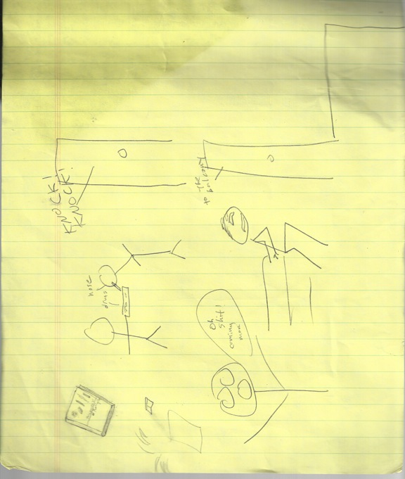

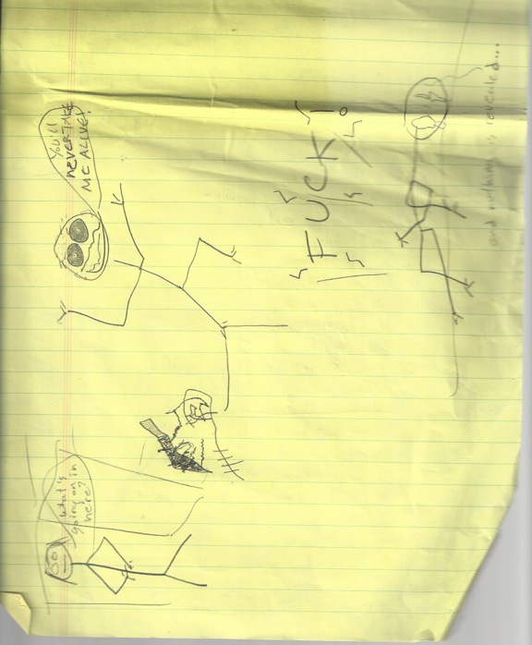

*

poppy snakes pound, like
Eastern drums,
cobra dance rhythm twine tight a
round his arms
and chest

poison blossom plume, in
laureled wreaths,
marking a feral crown above
his shallow
breast

and beneath it all,
a promise of rest.,
forever,
rest.

*

“old junkie”

Spiders crawl the length of his lazy veins and swarm like vision without breath, black dots back-dropping yellowed flesh. His height would be impressive if it wasn’t drawn in on itself, hunched and waiting to protect from unseen blows, guarding precious breath. His skin is shadowed, vacant, clinging to his face without ardor and falling down his body, parting and stretching around ribs before it settles in a stagnant pool around his feet. It’s grey beneath the glassy eyes of a doll, which swivel pointlessly from left to right and see little. A beak of a nose perches on petulant mouth, takes its shade from towering cheekbones. He distantly sucks on cheeks when his face is still, or puffs them out like pebbled grapefruit. They are hollows that eat the light when he talks, slowly, deliberately, words dripping from his lips like an untimed faucet. His speech is edgeless as it breeches the ear, soft and uncommanding like all the old, old junkies.
He takes his time because he knows there’s nowhere to go. Never has been. The track marks follow suit, marching ponderously up each arm, tracing the path of old scars that nestle in elbows, above wrists, along bicep that seems to be attached to the bone by nothing but heroin, marking guideposts over those covered by age spots or simply faded, like burning pinpricks in the night sky after the star’s imploded and the light’s traveled so far, twenty, thirty, forty years across vacuum to reach our eyes. They sleep in wasting stomach, brittle legs, everywhere on a body that shakes in the wind; they are nails in rotting timber.
His teeth are white-edged and defiant of his living death, the only bright spots in the world. They peak from his mouth, sometimes, when he talks about the past, thing’s he’s done or women he’s had. He talks a lot about places, old, old places. Ancient places that he reads about in his old, old books, all of it as ghostly and strange as him when he rocks back and forth slightly to whisper it. It’s hard to believe he’s ever done anything but shamble to the corner bar, or sit in his chair, collecting years while he quietly shoots up.

confused birds
fly
in
spirals
and blink their eyes.
(camera zooms)

one-eyed cyclops
eating sheep on a tiny
island in the Mediterranean.

rippled water falls between
an image of vision.
eyes dream:

when eye sleep eye
don’t forget the way
home forget the
way home

floats on smoke and ash-moths,
rain rears its dusty eyelid.

When eye looks back eye
gasps! in gashed glass and
lashed frozen lungs.

a cataract of tunneled eyes
screaming
back to the beginning.

[insert bottles at the moon]

(The stage is dark. Nothing can be seen but outlines of chaos, ugly red blotches of smoke and fire.)

Whisperers: (Many voices fading in and out, scattered with moans, howls, and laughter) The fire, the flame, the one who eats our toes on Tuesdays. Jesus? Do you hear us? Why am I eating flecks of wood? Ahhhhhh hell, ahhhhh hell, these walls, ceiling, this suffering underneath me, dark dark dark, shattered on the backdrop of a train in Mississippi. Ashes. Flashing past in pendril raggin’ mast of flames. Snow hell. Frozen. The finest silk made out of ashes. Here we trail to Laramie’s saddle. Where will it take us? Take us, take us, washing flips, spit cabs in Brooklyn. Burn burn, like Laramie’s tantrums. Laramie, tell us. Tell us, tell us... (Whispers fade into the background)

(The stage brightens to red glow. Amidst indiscernible terrain is a spot lit head, stuck in the rocky ground. Lava bubbles around it. Hands reach into the edge of the light at random intervals, trying to touch or rip or kill it. Its eyes are unfocused, and it converses with the air as though senseless. Its voice grows louder.)

Laramie: Hell’s not so bad. Mmmhmm, Mmmhmm, not so bad. Sure, toes, like gas logs, have seen better days, maybe when they were whole, great mountains, staring at the new blue world with a hip on her shoulder, tracing me. Why eyes? Why eyes? The mountains came crashing down, like Toonami, William Burroughs as a ginger doll. Hell extrapolates the freshness of Argentina, mmmmm, York Peppermint. I balk to metamother my intuition. Fuck it, fuck it. I have all the time in the world. Eternity. (Screaming, sobbing) ETERNITY!! (Returns to ranting volume) Maybe that’s why. Just sit there, just you sit there! Fucking toadstools, drooling opium. Wish me prosperity, will you? Samadhi within inches of his own face. What am I?! (Mad laughter for thirty seconds) I’m a pill, a pill, that’s it. I sit on tips of tongues and wait for magic, Satan, triads to push me down into the darkness, the sweetness of the tunnels of a person. On Friday nights I wait inside the pockets of Osama, terrorist drug money, tumbling London into DJs on the bridge. That’s where I wait, for little goat children to clip-clop over the top in high-heeled skirts and galoshes, sucking on mushrooms, farting shadows, soft tunnels where my echo sings me lullabies. I wait, I wait, no sudden movements, sending tendrils to little sister’s thirds, seeing if her mother’s home or in her hat or watching Oprah in the window. Then I eat spiders and slink back to wait. (Finally addresses the audience, attacking them.) I am a murderer of truffles, young children! I choke and chance murders with glee. There’s no one left to save misfortune, she’s helpless in the land of Hanalei.

Whisperers: (sing-song) Meta-butter makes better batter. Don’t make meta-batter, toenails will eat your eyelids. Laramie, Laramie, Sarcophagus will laugh at you. We stand in darkness beneath your feet, watch shadows play like blinking light bulbs, brownouts on glass ground. We shatter habits, crackle, mad rabbits. You’re so late you might as well not even go! You’re mad, you’re mad, heaven requires prompt madmen. Follow us, follow us!

(There is a great flash of fire, Laramie’s hair is on fire, his flesh pinkened. He twitches, but is used to this.)

Laramie: Ohhh, the fire burns it burns it burns but yes, but in it in it only in it I see the visions of the madmen I’ve become, in it only in it I see visions of the power of my throne, FIRE! Burns away the paper, flour, covers mother’s bread. This makes that all right. This makes that all right.

(Laramie stops talking, then oh-so-slowly looks to the audience. He is more composed)

Laramie: It’s the fire, you see? If you want to know what hell is, silly, silly person - but Lord knows I did - I can tell you tell you tell you. I can tell you all day. Show you, tell you, make you see. It’s all about the burn, my friend, all about the stream of thought. Here here, let me start over. When I was a young boy the fire made me happy, so I remembered it, kept it, saved it in a dark spot and hid it from my father. Hid it from my teachers, my sisters, brothers. Hid it down so deep I hid it from myself; it made me that happy. Wrapped myself around it like a beautiful butterfly cocoon, gossamer strands strangling all the drenched, milk-worm nothingness of crawling on my stomach, waiting for the birds to swoop down and pierce my swollen flesh and feed their sickly young Tyrannosaurs. No, no, not for me. A butterfly, that’s what I’d be, a beautiful, flaming red and painful eyed butterfly, so beautiful it hurt them to look at me. Hurt. HURT! Like fire, you see, like fire in the veins of madness, tearing apart their worthless, stenchy swollen flesh. (Cackles so wildly he can’t speak for several moments, then desperate breath breaks through the tide) No no no, wait wait, just my little joke, just my little joke. You still want to see? Yes? Of course, of course... just one.... just let me collect my thoughts.... (Attempts to stifle giggling, but is overtaken by it. The laughter is ravenous, and draws his head up towards the sky. The whisperers break into an unintelligible cacophony. The volume shrinks with the lights, and all is replaced with deathly loud static and jarring white noise.)

*

“r”

your skin beneath me, fire ! !
pounding coal trains moving down the line,
boneless hobos throwing bodies on the tracks, to the
churning wheels of

gearbox gleam,
robot motion
fevered armtree,
grown round and round commotion,
tangled sheets of sweaty leaves
sheen of
rocking locomotion

i'm burning, Lauren, burning, i am
reeling in the heat wave, i am
three faces, or a million, or a spider's eye of
strewn calculations,

i am the pebbled flesh between us,
streambed.
sheets
of driving, blinding rain.
dripping facets,
dry-bone faucet.

i'm burning Lauren, burning,
curling black into
th i n a i

*

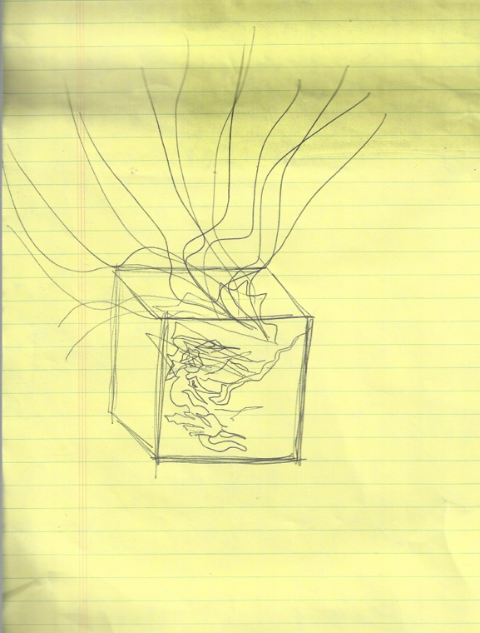

vi.

the lonely planet, sky veiled
with rings--

....andtheyalldiedinaterriblefireTHEEND

ii.

she sighs and lights a cigarette.

iii.

Jesse rages ripe blossoms at the sight of the elf whose clogs are two sizes too large.

Liquid carbon leaks from the bum's stigmata.

You owe me twenty dollars.

iv.

clogs donuts delay morning stomach
wart windshields meld dye drying
smother thermostat frogs and
mustard billow gas fevered dust moon
shutter mammoth despair drain
ghost haunting corpse bills rutting
Costa Rica flame subterranean onion
councilman asbestos dawn beans.

v.

*

how about a little less bullshit, Lewis?
how about two cheers for fruit loop ears.

waiters scurry like servants.

1. no space inside the iron mind
2. a slave to degenerate junkies
3. funky pogo sticks sever the west wing and Wobblies
4. generic wrestlers wear autistic shoes.
5. a black label combined shampoo and anti-freeze.
6. waiting for the one with a breakfast tie.
7. to come undone and spill his digits on detention fingers.

(Jen and Jesse sit in a nearly deserted coffee shop. Rain slashes against the window.)

Jen: This is ridiculous, Jesse. Fucking crazy. Have you said anything to your family? (Jesse stares out the window.) What will your mother do, for christ’s sake?

Jesse: She’ll do what she always does.

Jen: (Haughty exhalation.) She’ll worry.

Jesse: She’s already worried.

Jen: Look at me. This is crazy.

Jesse: I’m crazy.

Jen: You’re not crazy!

Jesse: Then you are.

Jen: Going there. (Her hands are flat on the table. Loose strands of hair make a halo around her white face. She whispers.) Jesse. (Takes a deep breath.) You don’t have to go. It’s fucked up, all right? Things are fucked up, but that’s not the place to fix it. (Looks at the rain.) Please, stay here, at least for a week or two. Tell your family. Tell people, let them know what’s going on. Just try. (Stares at his face. Near shouting.) Just fucking try, all right?

Jesse: Shhhhhh. I tried, Jen. I can’t stand it anymore.

(The waitress is staring at them from the counter. Jenny glances her way and lowers her voice before looking back.)

Jen: (Desperate whisper.) Here. This is the only place to get fixed.

Jesse: In a coffee shop? (Jen starts to speak, but he cuts her off.) I’m not going to get fixed. I’m going to get lost. Do you understand? Lost.

(Jen starts to speak and stops. She does this twice, then stares at him for a long time. She stands up slowly, but gains momentum as she moves. She’s walking very fast by the time she gets through the door.)

*

you claim to have rearranged your petals
into an octagon of tangled blue: but when
i follow you back to the base of the eyeball
i see miles of trembling air, and my fingers
around the razor. and then you blink:
everything is startled apart in a scrim of bats.

twitterpated.

tatterpated.

i'm in pain tonight.

*

we wait, in the silence of words
on scribbled bits of napkin
in sanctity, trust
in empty hands clasped together
in twisted fingers
and lust

i've really fucked up my writing ability.

what a fool i am.

i can't keep living this fool's life, but i have no idea how to change.

happy authoritis.

there's nothing left to write about but fear.

need hope eat eyes find magic stuff.
nettle loose stomach muscle,
jumping jack flash made the cash cash cash.

some people spend their time watching sitcoms and consuming canned laughter. soap operas. video games. anything to kill the time. some people inundate their days with chemicals. the haze is blameworthy. they can forget what's wrong for awhile, pretend there's no noise inside their head but brain cells popping.

*

something's coming coming. something's coming coming. little black earwigs crawl around in my eyes.

too too quiet.

God?

i haven't... i dunno. i haven't been living my life right. i've fucked up and i'm sliding down the edges. and i'll try, i'll really try to stand back up. but i just keep falling.

i'm tired, and scared, and desperate.

please help me find my way back.

*

little fingers locked through the belt loops
lost in the forest between worlds--
acorns crunch and i hurry
from the screams--
predator mouth or animal shriek--

limpingly and lame--
i call Your name--

