viii. Greyhound Lines
late 2001–March 2002


[princess power photo]

"train-hopping"

When I was adolescence it was
nicotine and upper trains, tracked on
chug-chug fuel emotion.
I hoboed in midnight stimulants
till destination was a single thought,
a furnace room philosophy which I
would have surely died for.
Much blood in a mile

Now, in Denver,
(it’s a faraway from starting place)
it’s been
three lifetimes-
four Halley’s teeth,
and each time a cavity dropped I
carved an ivory comet

I am
less sure of more than
I think I need to keep on hopping.

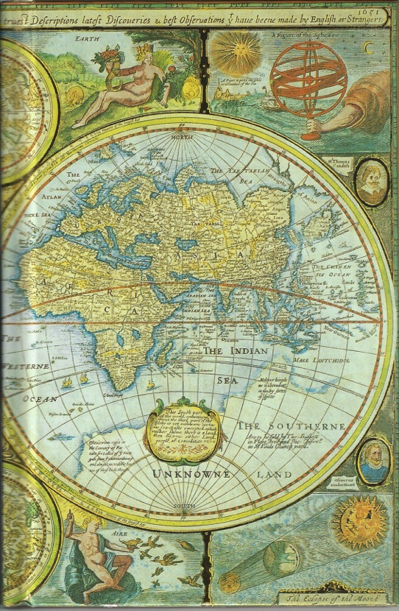

Louisiana. Lauren's kitchen. Silver ashtray on the stove where her mother and I perpetually stub out butts. With the fan on low, smoke washes out in beautiful waves. Hundreds of tiny, deadly waterfalls. 2am. First one up this morning, last one awake tonight. Smoking in the kitchen and blowing rings into the abyss.

Always the last one up--I've put it down to genes. Uncle Bob was some hotshot--one of Nixon's physicians. Mom says he never took more than four hours of sleep in his adult life.

Of course, he also swallowed a bottle of valium on the anniversary of his divorce, then blew his brains out.

So here I am. Smoking. Waiting for the dogs to bark or Lauren's lamp to click on. I bend down, face low and close to the counter, trying to get all the smoke into the suction of the fan. I count three butts in the ashtray. Paula must dump the ashtray every couple of hours--I see her smoking all the time, but there are never more than a few butts.

All the ashes and dirt and filters are squished on the left side of the tray, the side nearest the fan. They look like metal flakes. Magnetized.

I stub my butt out on the right side of the tray. Stand up.

I fill the empty spots until sleep.

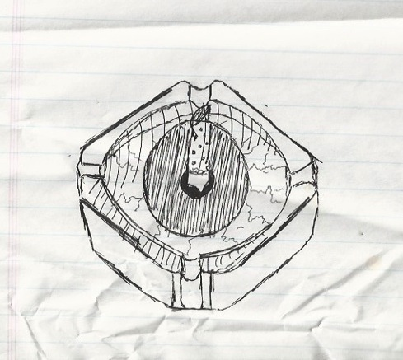

**

things in which i believe:

1) the big fucking hammer
2) the body is a fair shade of invincible on morphine. one not only can, but is strangely compelled, to push through the limits that would normally cause pain, hunger, or exhaustion.
3) never reread

Have faith in me, whose lips and lines
speak tempered silence.

These walls will hold
when the mountain wakes.

Have faith in me.

*

Procrastination will destroy me, in the end. All the dusty butterflies betraying and sighing while I pause to masturbate. Linger on, pale blue eyes.

one might be, maybe, saved
and stave the leaking memory
with words on which to meditate:

we celebrate life
by destroying

*
David Hume:

The best expedient to prevent this confusion is to be modest in our pretensions and even to discover the difficulty ourselves before it is objected to us. By this means we may make a kind of merit of our very ignorance.

*

sheets of cardboard brain
shivering skin
and Van Gogh mascara cheeks:

the mad painter weeps.

12/26/01 -- somewhere between Louisville and Montgomery

Scribbled down while a stranger reads. He offered me his terrible teenage poetry with no shame.

too many things from the past have been paraded in front of me in the last two days. too many things i'd thought had faded. but i still know my poems by heart. there are still finger-runnels on the edges of my book. my reading level is up. my compassion level is down.

i feel like the only thing i've actually lost is progress. i gave up "immutable forward motion."

Socrates spoke of death as simply an unknown. Showing cowardice or immorality to escape it is one of the greatest causes of human evil--they do a certain evil to escape a possible good.

that's how i've lived--clinging to the familiarity of a stagnant mediocrity that i know--choosing the certain purgatory over stepping out into unknown air.

So. what to do? push off, i guess, take my chances in unknown waters. i think i started pandering to people's opinions too much. let their critiques warp my great big brain, bend it in every direction at once--arriving at mushy writing.

who could have guessed?

a solemn vow--or as close to solemn as i can get with this great big, cluttered, catastrophic computer for a brain. i will stop and record the words when they come. i will pull over to write, i will drive home so i can have the necessary quiet, i will pull out my book in the most embarrassing of situations and scribble in it.

i want the Quiet now. the calm that comes in a bus full of strangers (or anyone, i guess). early dawn or late night when the lights are out, when birds peek our from our brain and make nests there--and for a little bit, we feel like majestic, noble, silent creatures.

beautiful. i can still write in the dark. darkness brings the communion of hand and page, like the deepest, coolest pools of shadow hanging from your eyelashes. darkness lying in wait to devour the heavy-footed, the incautious.

but no danger to me--my peace.

12/27/01

Mobile Alabama

My work as a missionary for Mother Church will take me to the heart of the untamed lands--where infidels wait.

if i could make the world
as pure and strange as what i see
i'd put you in the mirror
i hold in front of me.

linger on, your pale blue eyes

-Lou Reed

something stripped and naked and melancholy about the cowboy junkies and the velvet.

he said baby there're some things we all cling to, for all our lives.
it's time to let them go and become my wife.

*

decimating, this addiction.

if only i had the words...

12/31/01

He might not want it to be, or even know it. But right now, it's far more important to him to be friendly and loved and desired, to have a shadow, more important than being steadfast. fidelity. one face. one desire, no matter how deep the desire runs.

give him a couple of years.

*

ground to flesh beneath its fingers...

in these ways we keep dreams alive :

by fucking screaming crying weeping
dragging feet against pavement
rapping knuckles on granite
biting gnashing tearing eyelids
fucking ten times in the forest
punching earlobes on the carpet
pleading in the windowpane
praying to the bird's nest
leaving scars on the chalkboard
stretching the limbs to snapping
goading with a milk pail
saying please to the face in the painting
floating trembling
staying still to keep from breathing
peeing pants in supermarket
sleeping long enough to have a nightmare
gladly bearing embarrassment
with pliers wrenches hammers
measuring tapes and screwdrivers
antibiotics and cameras,
painkillers and hammers,
w/ the velvet stocking on your dresser
w/ a straining heart (which you would
gladly burst to beat a moment stronger)
w/ skin-tight smile, w/ needle thru the china

but still they die.

Chuck Berry is one of the greatest black lyricists to have walked the earth. No--scratch that: Chuck berry is one of the greatest lyricists to have walked the earth, right up there with Lennon-McCartney.

All along, there's only been one option. No chance to slow the decay or self-damage--only to squeeze every ounce of forward motion from it. spend every ounce of the lingering death to add my piece to the pattern. i know it's in me, i just can't afford to turn away, no matter how painful or lost or broken... or even content and smug, indulgently self-satisfied--no matter how complacent i become. these words are my life, my life these words. not my life in these words--my soul, the twisted architecture of the sentences themselves; and all the secret tombs beneath--the rats in the catacombs--all the life of my making, my existence.

at all costs.

at life's end, i will not be content unless i've forged myself--or have been forged--into the best goddam writer it's possible for me to be.

i will have this.

*

To L from the bus:

you are the most beautiful girl on the planet.

i am the most exhausted boy on the planet.

did i write about the dark? deep shadows hanging from fingernails and lashes? it's you, our faces close together, your eyes blinking against mine. so dark i can't see the night.

there are ghosts on this bus ride--in the pacing phantom smoke that rises up behind me. the recently dead and lingering whisper of your skin beneath my fingers. your eyes are too big, in the images that haunt me.

haunt me... scared to act in life, regretful of death, but desire you in both. for reasons muddled, beyond my language.

Matt.
some Other World.

*

Destiny, like a tiny chance. i'll never be able to be comfortable, because in becoming comfortable i destroy the source of my comfort--it comes out of agony, the resurrection after death. a catch 22: to be comfortable, i need pain, and so can't have true comfort, but only the absence of the more horrible pain that comes from the lack of comfort.

someday i will write some populist work, and know that it's full of shit. and that's a best-case scenario--that's with luck in the struggle. someday, i'll make something beautiful, and i won't be able to hear the voices clamoring in praise or censure--my ears will buzz too loudly with joy--if i am godlike and blessed in the struggle, if i am holy in the struggle and it becomes my religion and my secret name.

through the transparent skin
of the cigarette, i take a long drag
of cerulean sky.

i smooth the creases from my
paper face--
redraw w/ colored pencils--

on the scaffolding, i paint landscapes
of the girl that's laughing
underneath me: hers eyes like
daubs of insulin
in space.

*

the greyhound gets closer to home. anxiety builds--all the petty arguments rush back in, the complacency, the failures. i wonder... if i'll hang on to the seeming peace of mind, the sense of destination i found in Louisiana. Mostly, i miss Lauren, and am afraid to send her the letter i wrote because it's too uncovered, too naked. i want a fix to the issue, but i don't have one. nothing in the letter addressing the difficulty of finding a fix.

proceed w/ plan A--send the letter, pray she sees what i mean.

i'm haunted by desire, and she haunts me in the darkness. an emptiness--even the thought of her burrows down to the stomach. she deserves better. i... need the nakedness of the letter, and she deserves some rationale. send it now, uncover it partially, when the consequences are 1000 miles and a time zone away. opening it up now will make it difficult to hide from it later. forward thinking of me, i reason.

i am the cathedral
not the flickering thousands within it

in all things, in writing most of all: honesty. build the walls that funnel the voices, the echo chamber to shoot the bullet of song up and shatter the spheres of heaven. have courage--and above all stubborn persistence. pray to the god your heart knows, not the one they feed you.

love unashamedly. give freely. hide nothing. practice discretion in boldness.

be nice to your mother.

the hardest part: never, ever reread. the words become idols, little statues of truth that destroy the living Word. emblems, mementos, debris--this is not the life of words. setting them down on paper is only the outward act--the more vital act is their inscription on the soul, carving and carving and crafting a living word there, a spring of water that won't dry up. carve the poem in body and mind--violently, if necessary. this above all things. don't be deceived by the lie of artifacts. poems just the crumbling cities and petrified curiosities--the Logos once walked here, the Poem has passed this way.

*

i.

--Saturday, my cat scratched my arm.

--No way!

--Way. Then it took my ice cream.

--Blinking madness, my friend.

--Oh yes. It freaks out my mountain.

(pause)

--How about those elephant poachers?

--Completely uncool--fuck them. Fuck them and their eyeballs.

(pause)

--I dig.

--A flower?

--Yes, I dig.

--A flower?

--Yes.

(pause)

--Have you ever murdered a llama bean?

--A llama bean?

--A llama bean. You know, like a purple salmon.

(pause)

--Shut up.

--No, I'm serious. Green emu beans.

--A second ago it was llama beans!

--Bullshit.

--Serious.

--Bullshit.

--Serious.

(pause)

--You are fucking tragic.

--Eat tuna beans. Be free.

ii.

What a mangy assortment of miscreants, fuckups, derelicts, and addicts.

The bursts of inspiration are still too short, too timid. They lurk on the surface.

iii.

dearly beloved, gathered here today,

relatives,
friends,
et ceteras,
caboose.

*

rose dust, the ghost of the hombre
with a tilted hat, dark cowboy eyes
above millennia of sun-
and wind-etched creases:

his years precede him.

*

1/25/02

1. Her fingers walk the keys with precision. She pauses to tune her voice to F, then settles her glasses lower on the nose and begins the piece again.

2. His foot taps as he rings the bell a third time, then checks the address on the pizza box. He glances at his watch and jogs back to the car.

3. She is tired. Dead tired of shouting, screaming, yelling, and swearing. She sighs and pushes her head deeper into the pillow, would gladly follow it down forever until her body was swallowed by warm silence.

4. John kicks the ball. He watches it roll, then laughs. John kicks the ball again.

5. He coughs and coughs and coughs. His worn bathrobe shakes like a doll as he hacks and seizes. The cough subsides, leaving his torn voice to croak for the nurse to bring water.

6. He smiles so that his oily teeth show from corner to corner. His slicked-back hair glistens as he leans forward to drown the nervous clerk in his handshake.

7. She brings her knees together, draws them apart, then twitches them back together. She bites her lip, and fiercely wishes that she could stop fidgeting.

8. His shoulders fill the doorframe, poling out like tree stumps from the sleeves of a worn t-shirt. He crushes a hat between his fingers, and calls out "ma'am" before lumbering back to the trailer park across the block.

9. His drone fills the classroom like nuclear snow or white noise, battering wakeful minds to sleep. He too is a victim of his voice. He walks in a trance from blackboard to window, window to blackboard.

i'm losing everything. i'm lying.

Layer-by-layer, what seems to be is worn away--
beneath Thought: thought.
billions of elephants
stand in space.

*

Much later, when angelic heads take long, slow breaths--one restless mind lies, listening. sleep torn to shreds by amphetamines.
hard-to-grab ghosts of sleep. eyes burn and veins protrude from the back of his hands. there had been magic in those fingers. there's magic in beginnings. in first dawn. in the curve of prodigal neck.
the fingers grasp weakly for forgotten sorcery. But like everything today hangs on the world. Like doom. Frustrated, the boy body rises, paces room to shake off whispers. Blind and mute in the dark, wraps fingers around a pen, raises it to his face.
they stare at each other for an eternity in the darkness. thunder shakes the world outside. a little breeze runs through disheveled hair. Words come:

sometimes i lose my way
and shadow fills the world
with images, and though
the memory stays
the forms lose shape and i'm left
with blurry visions.

i am dizzy
from the years spinning by
so quickly--

when the colors bleed tomorrow gray,

i butcher life to eat today.

*

Deep down in my middle
where goose bumps pimple
and everyone fades away
and everything that's all the same and
all that's left is the music,
and all that's left is the drumbeat,
hi-fi eyes at ends of needles,
until nothing's left but the fingers
of the girl i left behind.

The one that
pushed off
from the water,
left my timing off,
made my rhythm falter.

It's where what's missing has gone,
when i'm too tired of the habits and
the static and the pop,
too tired of pushing voices away,
too tired of the rhythm in my bones
receding slow with
aching
fading
tones.

Just tired.
Sleeping.
waiting in the music,
in the Beatles, Reed, or Berry,
even in Buckcherry,
or any band that's soured with opinion.
Guns n' Roses.
The voice of Moses.

In the silence there while God reposes
in the speakers of my headphones.

*

remember when we kissed on the beach
in the valley, tied together by toes--
then dinner--you in the green dress,
and underneath naked and cold?

*

My head is made of ammonia.

Hullo, my love. Is your asparagus plump?

you used to be my wide-eyed, do-it-because-it's-the-dark-side girl. don't get me wrong--i never mistook you for one of the fey. No broken-limbed crawler like me. you did it because it was shiny. something new to win at--but you can't, you know.

but then again--maybe you are, and my arrogance deceives me. you always close your eyes at just the right times. most of all, you understand my broken center, the reason i limp, or stare at the clock for hours.

i love you, dear, like eyes love tears.

