xvii. footnotes to Heaven

(poem), 12/15/03

Carla (correspondence), 12/27/03

Carla,

you're amazing, dear. i have your picture on my printer, and i'm afraid it's consuming too much time. i keep talking to it and, (tell no one) smiling at it.
this room must get clean! but... i don't know if it will. i don't know what the future holds except books, and you.

-break - shower:

carla, thank you for being a friend. thank you for giving me the space to trust you, and for trusting me. you know, in a way, you have accepted me, and helped me get closer to self-acceptance. i hope our friendship continues to grow.

i was thinking about something i said on the phone, when you were talking about stealing, when you first told me, and i said something to the effect of "i won't be with a convict" or a felon, or something like that, something to that effect. i want you to know that i don't feel like that, and i don't feel it was right for me to say that or put conditions on who you are or who i'm okay with you being. i would, of course, like to hold you accountable for your struggles (triumphs and failures), as i would like you to hold me accountable, but... it's not right for me to put conditions on you.

i will finish tristessa tonight, and you may read it. i really had forgotten what a powerful intelligence jack kerouac is. i feel like i'm rediscovering the Beat generation - i had pushed them aside for awhile, because they are tied in inextricably with drug culture, but that does nothing to take away from the power of their message or their raw talent in writing. i was in the poetry section and i picked up a book of charles bukowski poems ( a Beat) and related to every one i read. he only got one poem, in the Norton anthology. "the only thing that matters / is how you walk / through the fire."

there are calluses forming on the ends of my fingers, which means i can't feel it when i'm picking my nose.

record that; i want it on my tombstone.

the neighbors are back over, which means it's time to unfold presents.

i will see you in digital fingers on the cellphone tonight.

yours in love,

(journal entry), 12/27/03

the last thing i want to do right now is write. so i will. journaling is maybe... second to last, on the list. the thing that seems like it would be the most difficult, right now, is something creative. trying to dredge a poem up. working on dreaded skits. so... maybe these are the things i should be doing. i will journal, first, and see what it brings up, see what is underneath, and ask for guidance in what to do next. a tenth step? what have i done right and wrong today?

i woke feeling extra guilty about carla, seeped into everything, feeling dismal. one thing i did right was read the book on relationships, and write a positive letter, talking about some things i've been meaning to for a long time and, in general, letting her know that i love her, clearing up for myself, as well, my feelings. i really care about her too much to let ambivalence and fear destroy it: important to be firm and clear about my feelings: i love her, she is the girl i love more than any other, she is my friend, probably my best friend.

one thing i did right was going to mcdonald's - much better than sitting in my misery is trying to do something about it. better, even, than calling a sponsor or going to a meeting is going out and actually living this way of life, i.e. clearing up the wreckage of the past. one thing i did wrong was not go in to the store. no, she probably was not there. yes, i did ask an employee. however, that employee didn't know, so i left being unsure if i had ever actually planned on going in and doing it. it would have been best to go inside, just so i knew for myself what i planned on doing. try again tomorrow.

one thing i did wrong, or let myself feel, not being consciously aware of, was hypersensitivity to mom about the vacuum cleaner. it would have been best to pick up the coins. i was also hypersensitive with kairen, and i made a smart comment, but i did the right thing when i went back in and shared how i was feeling and tried to make it right.

good meeting.

good work.

how about now? writing here is a good thing. a good way to experience growth. i saw a vision of charles bukowski hovering over his desk, scratching his life, his self, his very being into sheaf and sheaf which flew away on eternity wind in fractals of Existence which knew he Was.

what works for rilke, in writing, may not work for me. it's important for me to remember that, no matter how many books i read on the subject, i must always find my own way through to the Eternal Heart. no one can come with me. it is a lonely journey, lugubrious, sad gloom cloaked. alone in the darkness. end journal i'm tired of writing for the sake of words scrawling, heart or none, life or nothing, the blood in the veins dripping, seeping into the pavement and staining everything, forever, there for the bones of the earth and countless passersby to see and know that they have seen the Real Red life. or nothing. sad sediment, murky, turbid - this is worse than nothing, then, at least the silence is a testament to sorrowful things.

**

of tristessa, i wish he had left the second half out. i believe what he built in the first half was innocence, removal from world, depth - depth in innocence, depth in isolation, withdrawn, deep dark golden thoughts with the rustle of life far above on the surface. spiritual experience, vivid, full of colors. i feel his coming back robbed some of the innocence, showed us the Real Man and the Real Disorder. i preferred the illusion and the deep dark golden thoughts.

Dearest Carla, (correspondence), 1/1/04

Dearest Carla,

and you are my dearest. i am at work, trying not to watch tv, but i discovered long ago that tv always wins, when it comes to attention contests. destructive, it makes my brain feel like it's melting. the worst part is the feeling, the desire to rip away from it and do something else, and the inability to do so. i met frank today; he is nice. we have all kinds of snacks for the party tonight.

that was pretty good at anna's, last night. i often feel uncomfortable at anna's, i become very judgmental.

i was listening to nick's conversation with his girlfriend last night; i could hear her voice, when he told her he was in an apartment with three girls. i had the strange thought, that, in some perverted way, jealousy may be a way of expressing concern, care, and love. or need, at least, and then i thought, if i just let carla know how much i care for her, in my actions, on a consistent basis, there will be no need to resort to jealousy. but... i really don't know if that's a true thought or not. it was an interesting thought, and i'm sure the latter part (the advice to self) can't hurt.

it felt good to inventory some things last night; in a lot of ways, it's become something i do naturally (after some pain), or in my head, but it was good to write it out and see. there is always more to see, when it is written and in front of me. there are still some things, though, that i just can't quite put my finger on, and i have no idea how to inventory. they escape me. i have hope that, as much as my awareness of self opened up in the first year, it will open that much more in the second year (as long as i walk through the fire).

this is the ticking part, when the gears are turning, and it's my instinct to shut off, to stop writing, probably because something is rolling around inside, a real letter is about to start.

am i too involved in your recovery? i feel like, basically, i keep my hands out, but i am responding to something anna said, which i often find myself on the defensive about. i dunno. there are so many things that have gone on in my mind. for example, i was having a really minor disagreement with my mom today. it was really a small thing, and i took care of my part, basically, before i even acted on my part. which is a good switch. and i was turning my thoughts toward relationships, you (where they often go) and there was this feeling that i would never be able to function, in a marriage, this feeling that there could be no harmony, like rich was talking about, and i realized that it was because that's what i learned. in my home, watching my parents, i learned that minor disagreements can't be worked out, and that they will, in the end, rip and tear. i learned that these things are a big deal, and so i perceive them in that way. maybe. maybe it's a natural part of my perception that would have been there whether i learned it, or not. but it's coming to my attention that this is not true for everyone, nor does it have to be true for me. i am typing fast now. i was at the mt. zion center the other day, working on a commercial with josiah. we were in rich and tammy's office, and there was a small question that came up about an end tag, and how it should be. and they disagreed, and they clashed. i could feel tension, but later i realized that the tension was only in my mind, and not in reality. right in the midst of the tension, when i, in my mind, would have been turning to hopelessness, rich made a joke. tammy was right. he said, "tammy, you're so smart" a little sarcastically, sweetly sarcastic. and the tension broke, and i realized that the only place it had been was in my mind, because i have not had an example of how a healthy marriage can work. but i look to people like rich for hope, and his life is, in a way, hope. not even so much his words, but his life is hope, like ours. that's an apostolic ministry, where the ministry is simply the miracle god has done in a person's life, the ministry is their life.

i guess i'll wrap down. it seems like, the more i write, the more i have to write about. there really is, in this letter so far, pages and pages of things that need clarification, that need exploration. funny it should work that way, that the more we talk about, the more there is to talk about. so the only limit seems to be this page and how long i am willing to write for, and how deep i am willing to dig to get material to talk about, and how open i am willing to be, and how many of my thoughts and feelings i want to give. i encounter this same thing when writing creatively: the only limit is me, and my character, and my qualities. i was at work today, and i realized that i am lazy. i avoid physical work like the plague, and i'm sure this effects me in many negative ways, most clearly how i perceive myself, as being somehow exempt from working like the rest of us, and i realized that, if i want what god has for me, i'm going to have to be willing to work for it, but that He can and will take me the whole way, and that something as small as willingness to work, to do the whole job, to not shirk, to be willing to do physical labor, can carry through into all aspects of life. and quality of life.

i am willing to work for our relationship, and it strikes me sometimes that a relationship is not just pleasure (although there's just enough of that) and emotion, but also a big commitment which takes dedication and work.

-break-

12:10am. somewhere the start of a new year.

dearest, i see all these people making out, and i know i am missing your kiss. i don't like to miss out on memories. i was thinking about romance, in the hallway, while smoking, and the thought came to me that... romantic love will not hold a relationship together, but it is a part of a relationship. do you really want to go to new york? i am seriously planning on going on a trip; save your pennies. we will go, one way or another, if we put our minds to it. if we drive, i would like to check out cornell - it's in ithaca, NY. i looked at it on a map; it's basically en route.

i did, in the end, put the computer game in, but i haven't had an opportunity to play it much. almost all that's left for tonight is a little cleaning up, a few dishes, wipe down the counters. take the trash out to the dumpster in the morning. -- just got a text message from you -- everyone says happy new years -- From: Carla -- text messages build up awfully quickly.

i will keep this to a succinct two pages.

g'night love.

in my thoughts, prayers, dreams, etc..

Dear Carla, (correspondence), 2/4/04

Dear Carla,

it's very late, and i should be wrapping up the endless studying or sleeping, and i will, but i feel the need to write you. carla, i have to pour out my heart - i love you. it gets hard to go on, i catch in my throat. you've shown me something beautiful, and we have something beautiful together, and it's better than i thought was possible. god surprises me with the gifts he gives - they're never what i think, they're always beyond my expectations (and i have high ones, but they're often distant, stuffy dreams of prestige, which dull when set next to the things He puts in my life).
i love the ability we have to talk, to work things out, to share what's going on. i have that with you, i'm able to share.

this is short, because it's time for bed.

it means so much to wake up next to you.

yours,
M

February 4, 2004, 12:53 AM

**

carla (correspondence), 2/13/04

carla,

i wanna get to the roots, the good roots that are under all the walls that my finicky conscious self puts up around me. the fears et cetera that keep me from you, from my self of you and write it here for your record, for your self of you, and me.

carla, i never knew what it was to love and then i met you and then i still didn't know what it was to love, but you made me want to know - and i still do. i want to ... love you. treat your right. give you good things. do better for you, do better for me for you, (and me.) so... what i'm saying is, and i really have to keep typing here even if i want to stop, even if i don't know what comes next and i'm afraid of it, because that's the only way i've learned to get honest sometimes. carla, i love, i want to spend my life with you. i'm learning new things that go along with love, new desires:

i want you to be independent - i don't want you to be dependent on me, i want you to be confident in yourself and your abilities. i guess that's the nature of this new thing i'm learning, this new love - i want you to be fully yourself, i don't want you to need me so badly that you are dependent, nor would i want to be in that situation, even if it kept us together. does that make sense? you've shown me, i've discovered, god's shown, something more important than just being together, than just surviving.

we are separate people, and we should be. what is it about that, about being full and complete in and of ourselves that makes love... that makes our coming together... more worthwhile? we can take the time to grow, to find ourselves because our being together is an act of the will, a choice, each day.

maybe that's the new thing: choice.

i choo-choo choose you.

et cetera.

the poem didn't come, but this letter-thing did.

love you,

February 13, 2004, 4:54 PM

**

give the Poem a chance /
to rear
its despicable brain
and it
will always return
to haunt you.

**

thick book, you shut
around me like a mouth.

*

he holds a globe in his hand, TV screen
static in the aftermath where he's shaken:
it's taken time-dark, and redwood rings,
perpetual snowstorms in the Russian winter,
epochs, empires thrashing in
gargantuan Seizure, the froth of
letters in its teeth, whole alphabets
strewn across the concrete,
(in history's stretching procession
of Chinese dead - the greatest
Wall, the greatest -)

thin ticking her impenetrable skin.

On the American continent, tucked up
in an alcove of hidden history Indian
burials, mass graves, between Walden Pond
and concrete, between city and sky,
/
an afterthought.

perched on Radio Mountain
scraper needle, Shaman-like,
broadcasting the genetic fractals of a thousand
compounded generations, (Messianic beard, Messianic hair,)
into the ears of a dead receptacle,
(America, oh america,)

snowstorm globe in glass hands dark
with ink fingers,
stained by ashes,
the lives of a single flicker calm,
coax - burn - scrape -
scream
into being -

**

Andy, (correspondence), 5/5/04

Andy,

This life shifts around under our feet, gives me vertigo; the last clank of the tracks before the coaster drops and the whole stomach lurches free from the body. I have an interesting defense against this: obsessive future-planning, scribbling disembodied equations determining drop vector in the corkscrew's inner loop. Plans are comfort objects more than something I take seriously and, despite the number of times destroyed, broken, or realigned, I am instant in coming up with new ones.

I don't know where you're at on the ride, right now, but I feel I have to write you quickly before you're gone to another.

The bottom is the place where we stop digging; that's to say that the where of the bottom is our choice, and it's a new beginning. A cornerstone. When I get caught, when the structure gets stale -- there's the bottom, the place I started at, with nothing left to lose (we're talking internally here, not existentially). The greatest gift is not to be chained up. Then we can live.

Miss you brother; my prayers are always with you.

Matt

May 5, 2004, 4:43 PM

(poem), 5/30/04

i plug your ears
to the silence; i jam them
full of socks. you hear the ocean
in the darkness, in the darkness
full of oceans.

**

I shade your eyes from the silence;
taping the windows
to the blinds I plug
your ears with socks
and shadows.

I wait
for the cloud's crunch against the frost of the sun;
the tremor of lashes
under skin.
I know you're speaking underneath.

You speak with your eyes, laugh
but it's true; I remember every silent car trip,
the moon
like a bug in the window,
states passing,
nerves aching;
for the sound of words
you wouldn't give.

carla (lyrical essay), 6/2/04

Firstly, I'd like to say that the girl is soft, and I'd choose her over goose-down each and any day. Secondly, allow me to commend the girl on her charm and sense of humor - a degree of sophistication which marks the barest occasion (particularly when, like an untrained intellectual, she wears her glasses and her Aspen scarf, red and wrapped around the neck like a fashion noose).

I love the girl because she's a mother, a hard-worker, a friend - my companion. I love the girl because I don't need to say anything important or grand (I still do); my jokes can be as dumb as anything and she doesn't mind. I don't think she wants anything particularly from me, or for me to be anything particularly (except me), for which I'm grateful. she shows me and I show her and we show each other how to be just human beings, not too much more or less.

Carla, no one's written a song for me, or cared to maybe. Of all the things, this is the one that I understand the most: making something for you, you making something for me. There's something incredibly special in that which means more to me than... than anything else. This started with a poem, and it couldn't have without it. I could trust your poem. This is the thing, Carla - that's the way I love; by making; by saying there what words won't can’t say.

Look at how far we've come from the uncertain and terrified beginning, how much we've grown as individuals and as a couple. The poem was a possibility which I accepted and continue to accept. I have never taken a more rewarding risk than believing that poem at face value.

When I draw close to you, there's nothing that can tear me away.

The power of our love shines blinding; small men turn away; nations revolt; the earth spins wildly. The future is perched on our love. Whole generations of racket and clamor wait in the wings for our outcome. Entire races hang uncertain.

There is hope in love, and our love only.

But, if not, it's at least very important to me.

Carla, no one's ever meant more to me than you. There's too little time to talk about fear. I love you. Please, live your life for me; be alive; be happy. Too little time to talk about fear.

prof carla (correspondence), 6/6/04

Dear Carla,

Forgive my lack of punctuation.

as to the drama - i feel like i'm sending a toddler into the world to get a job. it needs about 3 rewrites to be decent, 5 to be good. however - production is july 23rd. on the positive, this is one of few things that i've brought to a state that might be mistaken (by the careless observer) as completion.

this poem is what i'm really struggling with. i feel lost with it. is there anything there? am i trying too hard, grasping at straws? it's just a mess and i don't know how to proceed. again, on the positive, it's come ten million miles from its dilapidated beginnings, so maybe there's hope for ten million more. i've included a copy of it because: a) i thought you'd be pleased with its progress, and b) i need your insight.

it's sort of a mess. i really won't go into too much explanation about the small roman numerals, because they're ineffective and need to change. i wrote a little blurb just to say who's speaking or who the POV is attached to in part I, just to see if it makes any difference in your reading.

more than enough about my work. how is your family, your brother?
how severe is the brain injury? does he have a family that depends on him?
I think it would probably actually be better just for me to leave that open for you to tell me whatever you feel comfortable with.

best of wishes,
your student and friend,

Matt

open talk notes, 8/23/04

working with others:

the first thing a person who is using will tell you is that, they're alright. in fact, they're doing good. sure, they use once in a while, but it's not as much as i used to use before, or it's not as much as my friend so-and-so. they're so used to hearing from themselves and others "you need to quit that stuff " or "what's wrong with you?" that they've stopped telling the truth, because they don't know how to tell others that they can't quit. they don't know how to quit, they've tried to quit and they've been unable, they've tried to do something better, to do something different and they've failed.

if you're there for that person, if you're motivation is to love them, to share your hope and faith with them, to feed them, they may see something in you that they long for - that's hope. that's courage. that's love. they may even open up to you.

when people open up to that vulnerable place, where they're willing to say, "you know what, I got this outside person, but inside i'm kinda broken," and i'm able to open up to that vulnerable place and say, "you know what? you're okay, you're alright, and god loves you.", when i see that hurt little kid in another, and i'm able to tell them they're alright, then the hurt little kid inside me hears "you're alright". when i see another person make it, then i see me make it, and that's why seeing others make it is so valuable. some of the most precious moments of my life have been very simple, quiet, and otherwise forgettable moments, but i was able to tell someone else, "you're okay.".

Correspondence with L--selected fragments (experimental prose), 10/10/04

author-centered, letter bits. i got totally lost in this project; it's very long; i've been meaning to do something with these letters for a long, long time; i couldn't bear to put much of it down unhacked; the sentences are pulled because i liked them; they are edited; conscious retrospective construction of self; pulled from letters between, roughly, july 2001 and somewhere 2002; oulipo to come.

**

before the
whale comes
you are too small your
harpoon will rust

experiment--lineation of a reference book (poem), 11/7/04

Chief Justice William
Howard
Taft
liked to think of the Constitution as the "
Ark of
the Covenant," and

the judiciary as a priestly class
guarding its

sacred principles.

When Taft became chairman
of the Supreme Court Building Commission cre-
ated by Congress in
19
28, he selected his
friend Cass Gilbert
to design
a suitably impressive edifice
for the Court's
first permanent home. A leading

exponent of neoclassicism in American
architecture, he
had been greatly influenced in
his early career
by the famous "White City"
exhibit at the

Chicago World's Fair of
18

93.

The buildings
on display
there had been imposing white
structures, whose
classical facades
and ornamentation created a make-believe world of antiseptic
beauty.
With its evocation of past imperial grandeur,
the Beaux-Arts version of class-
icism soon captured the imagination

of an expansionist
America
and became the official style
of federal buildings

for the next half century.

automatic writing (prose), 11/9/04

i will, in these invaluable minutes, spend in doing invaluable things in spirits which in same way you have written you in which have this thing done and written. therefore, then. somehow it doesn't strike me as surprising that there were letters there, and you inside them, and that the you inside them there had been written well and grown, well, or changed. i in fact expected letters there and had a premonition; before expecting them i had a premonition, there, and then expected. before this move into expression then i think i thought i think, i then and in in cognitive in thinking then in then an move in then an move from dilation from a switch a little button from a pressing, a switch a move from such a from a cranial such a cognitive such a thought i think i thought i what i thought i such a thinking thought i thought i made a switch am making then will make am attempting trying building motion then to make a switch a swerve a slightly different groove a then and then away a cognitive a skull a shiny brain a maze. which brings me to emotion.

steven,

i am sorry i said you look like shit. you did look worn, but i wasn't trying to economize on that. i'm sorry you are having a hard time. i remember looking like strung-out and not knowing others knew. i approached it quite in the wrong way, but my motivation was you.

i don't know. i am good i am great but most of my days are just okay, and some are terrible but then they're fine. i am wondering is how are you? i do think of you, and pray for you sometimes (but now of course consistently because you've been remembered to me). there is a spot in my heart for you, because you were important to me and there's a certain softness which still remains to those i knew in then. not that a then is too much different from a now, i often draw a dividing line which does not exist but which i draw. what i am saying is, what the perceived line is, is that then i simply went, and my motivations were love (getting it) and giving it of course when it suited me, and camaraderie of course, and a certain softness., and all of these were in you and others. and so, a then not being so much different from a now, there is of course camaraderie and a certain softness there in you, and others. just a perception of you, a way i have of angelizing faces which i mean to, or which i want to, or which serve another purpose. if you've ever read on the road, you'd know, because kerouac angelizes cassidy, "Old Dean Moriarty the father we never found,". because you were open. old dean, neal, he came to kerouac's house and read the book and never spoke to him again. but kerouac told it, told the story of him coming there and reading it and leaving for ever or ever and ever. in a certain way, in saying something. old cold empty jack, died young young and young and bleary maybe yellow, fat, pure whiskey. looked for the body, pure Americana, physical pure word punch, pure word from the gut, and that's how he wrote it, "...my beloved Mississippi River, dry in the summer haze, low water, with its big rank smell that smells like the raw body of America itself because it washes it up".

don't speak to me, i'm angry. don't speak to me, i'm cold i'm hard i'm empty, i've a red pale white veneer fingernail lacquer heart i heart.

we are cold and
old together,
and all dead
memories are dying.

*

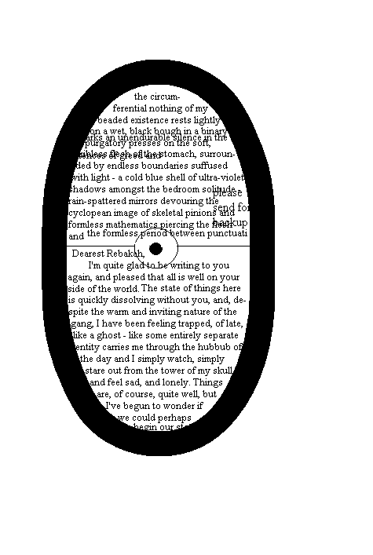

*

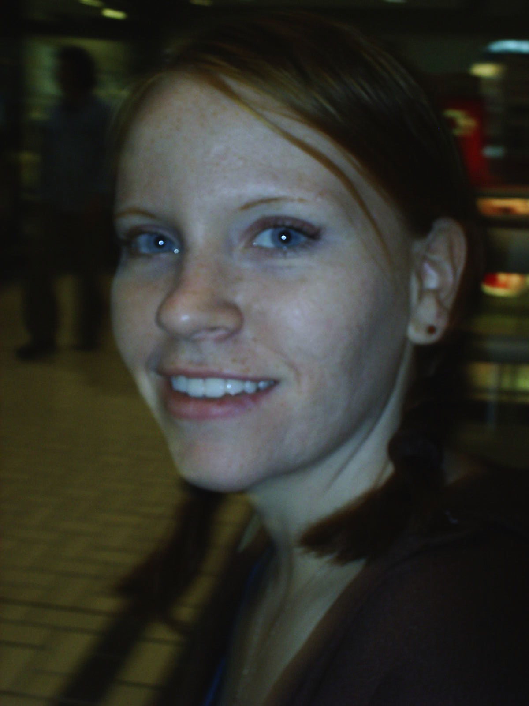my dear

from notebooks (poems), 5/25/05

the crumpled cellophane
of the heart.

**

and that says something
about the clientele
of heaven

**

the cruel cage of words

**

i hate the way
the human body is made:

awkward,
clumpy,
enraged

**

sappho 55--for the living (translation), 5/29/05

For the Living

Sappho 55

When all your stirrings,
of blood and breath still,
and you pass through the outermost silence,
where neither remembrance of you
nor the heat of desire may puncture
once

that final hanging veil,

then (for you take no communion
with roses,
where Music was born
with the Muses)
you will dart,
invisible in the domicile
of Baal, above the bodies,
to and fro,

that melt like shadow beneath you.

Departed from us.

(prose poem), 6/30/05

III 6 i.

In ancient culture,

There are three concepts that will prove helpful to the reader in organizing the emotional sequencing of the poem:

miasma
pharmakon
divine violence

wasteland as an "objective-correlative", an arcade, in the early 20th century French sense of the word (as in Walter Benjamin’s famous analyses) of strategically arranged emotional / environmental object markers. Many of you have been trained to read from left to right, top to bottom, unless your origins nest in an Arabic or Near-Eastern culture (note on hieroglyphs and the difference invoked between phonetic and logographic writing systems. Ezra Pound‘s interest in the Eastern glyph or logograph as a ) which scrolls (quite stubbornly, I might add) antithetically bottom-top, left-right; both methods are positively wrong (the notion of positive wrongness has been analyzed in great detail by the theorist-mathematician Charles Sandburne, who may be more familiar to the reader for his work in logarithmic system theories and Pythagorean numbness (from which violets spring in mid-December (I remember a winter day from the murky grayness of the past; on the ice, I slipped into the depths of the forest, and as the trunks of trees rose up around me and their arms draped lower in a ghastly dangle - suddenly the darkness parted. There, in the middle of winter, a clearing, pure white, with a hillock in its center, from the side of which grew violets. Bright red in the depths of the frozen winter (I recalled words that my pastor spoke some time ago and which have been a constant companion to me in the darkest hours of the night: "Bless the Lord O my soul, Bless the Lord O my soul, and all that is within me. Bless His holy name. Bless the Lord O my soul; Bless the Lord O my soul, and all that is within me. You are the Mighty One, You are the King above all kings. Bless the Lord O my soul, and all that is within me.)))

I had slipped away from my mother as she carried the groceries in the house (we lived on top of a hill and it was winter, the cold blue black of winter and a thin sheen of ice on everything on the top of the crusted snow that was crystal traced and crackled beneath our breath which rose out to meet it and cover everything in a pure white and blinding fire of frost and ice and numbness) and I slipped off around the back of the house - away, on an adventure I thought and crept stealthily into the cover of the underbrush that was the soft line of skin between blouse and skirt, the liminal threshold between this, my known world of childhood proportions, and the moon of ancient and savage grandeur - all this to say that,

6 poems, 7/6/05

a soft wind blows
across the bleach-white
specters of the silent trees
that weep,
and shore their tears
against the sun

**

wings spread against
my back and lift me into
bed and sing me
a lullaby that everything
will be alright
in the end

**

(hidden in the hidden heart
of the violet mound,
that sweetness,
that sweetness singing Holy! Holy! Holy!

the body is spirit,
the spirit is flesh,
the word is an empty funeral mound -
sing Holy! Holy! Holy!

**

From the heart of the violet mound
in the silence of the winter clearing,

from the womb of the dark black earth
sings Holy! Holy! Holy!

Holy is the Lord of hosts!
Holy His children!
Holy His handkerchief, the earth!

**

O my soul,
don't leave me here all alone
in the cold dank hotel room
of the musty neon mind
where a metal vacant sign
bangs haphazardly against the glass
and spreads
its echo out
like a ripple that the desert swallows
as it blinks and lifts,
ever so slightly,
its reptilian head and runs its pink
protruding tongue across the cartilage
of my bleach-white skull
and hisses at me whispers;

and off in some lost corner
of that forsaken world a wooden
door bangs open and shut
and out comes the howling whir
of a tattoo needle piercing
the blue-white flowers of eternal
beauty repeatedly inscribing*1
the pale-pink flesh of the innocent
soul with its emblem:

“twenty-three and thirty.
There are four threads of life;
one unravels from the badger’s mouth;
one whips in the wind of the hawk’s blind flight;
but yours, however--
you hang in the balance;”

*1 Volta Prißnikof calls technological inscription the physical manifestation and extension of the intangible inner processes of perception itself. Perception itself he objectifies as an inscription tool of the metaphysical substance of the individual. We are, of course, familiar with the long-standing division, in Western thought, of physical and metaphysical, and that such philosophers as Husserl have, within the last century, resituated the relation between metaphysical essence and corporeal substance as one of lodging: the animate, willful soul inhabits the passive body like a feudal lord his castle: it is mere stone; at his beck and command. More recently, Schlenner employs the dual functionality of the metaphor in his rendering of the relationship between perception and metaphysical essence (perception as both inscriptional tool and inhabitation) and, thereby, through a complex reversal and extension of metaphor, relates technological inscription as both extension and tool of metaphysical essence, and also its manifest inhabitation.
See Schlenner's artful analysis is Technological Bodies: Remediating Metaphysical Essence in the Networked World.

**

You are the Worthy One,
and Mighty;
You are the Might of the angels, Lord,
You are the fire of their flashing teeth;
You are the gleaming-eyed, our Savior,
the standard-bearer
arrayed in glory;
You are the Mighty One, radiant and holy;

You are the Sword of Truth and Fire, Lord,
the One who reigns on high;
Your wrath is terrible to look upon;
You are the awe and terror of the living armies, Lord,
the living immortal armies of Your host;
You are the Lord our God,
the Mighty One, the Mighty One.

my friend doug, 8/6/05

Doug was ridiculously innocent, in his way. It's too bad he got locked away for five years on assault and battery charges, stuck in jail with his brother because he tagged along and carried a mammoth wrench when Kevin broke into the apartment of some guy who had robbed him.

**
when i have something then you make it nothing,

i'm at a loss for words in you.
i
you've made me something and i'm empty with your debt, which is nothing..
my nothing is your something.
i give you nothing because you asked for nothing.
you ask for me; i give you nothing.

**

your face
is a diagonal shape i stretch to see,
i see not everything but something,
i resent not seeing something.

when you've left i
remember nothing,
i remember
remembering something
that you left there,
some deep something which is nothing to me but
turns my somethings into nothings.

four parts (poems), 9/27/05

some head rush of a promise that never quite comes to, some tinkling sound at the back of the ears that refuses to realize. It happened; it's over; it never began.

a cage of books in hooks of words,
the coldest hooks of words.

i bend to the bottom of the page,
i shut my eyes: i’m sorry
for what i’m about
to do.

the bursting page contains my multitudes
which are wisps.

i.
i wait for the sun to
mount the horizon and
leave its wake of blood-
red blood to
come shuddering up the
crest of the final
mountain, God, which is the cross
of the sky the
-(s(o)n)- is
crucified on to light
up the stupid
morning.

ii.
the sun drags its shivering body up the
glass-stained pavement pooled in
oil and empty
bottles and heaves
itself with afinal
weeping
less=than=a=cry and
hangs there,
stunted,
ape-like,
made of a thousand
punctured
yellows (orange fire
red helium helio-
trope the crimson
holocausttheweepingcon
flagrationdevourngel-
emntangl-xplsnfirfre fr r ) spin-
ning hung-
up on a milk-
y cata-
ract.

Dawn
in
the
de
se
r
t
.

iii.
holy milk the holy
blood the holier
bells the holier
carillons ringing
the soft white milk of the end
of the world the moon
is black inthe sky the sky
is broken flecks
of ash fall through.

