05-430

Section B

Name: Andrew Lee

Andrew ID: siheonl

Computer mouse

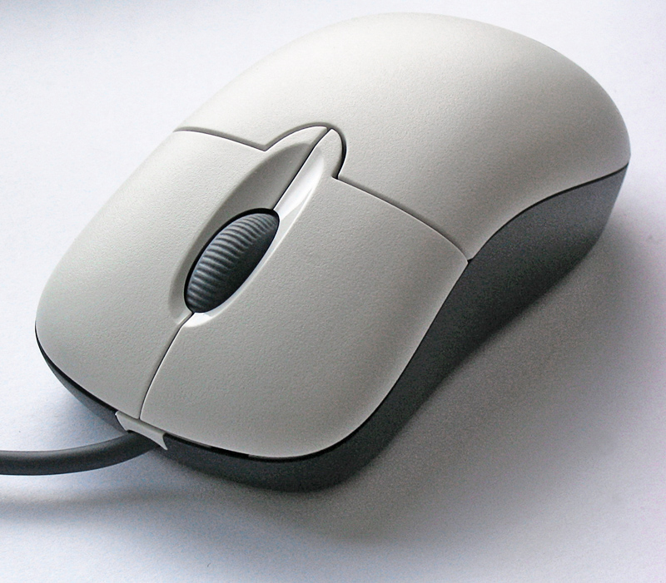

Nowadays, it is quite obvious to have a mouse to use a desktop. Surprisingly, a computer mouse did not exist when the computer had been invented. To communicate with a computer, users have to type commands that correspond to the actions what they want. Enough, those commands were all different by each operation and users have to memorize or at least write down those commands to use a computer properly. However, the invention of computer mouse just made the use of the machine more accessible than ever by only clicking the mouse buttons to any actions that users want to conduct.

There are some distinctively user-centered aspects of a computer mouse. First, the hardware is designed from a human's right hand. 90 percent of computer users are right-handed (even left-handed people use a right side when clicking a mouse button), and they use their index fingers primarily in daily lives. Based on this physical trait, a mouse has been designed for users to use a right-index finger to click something on the interface. Moreover, the mouse click has followed people's heuristics: pointing to a something with a clear direction. The mouse click is always indicating the upper right path and resembles an arrow to show something clearly, as people use fingers to point to something.