**Compiler HW2 Java Syntax Highlighter**

21000494 이성경

21400351 배드로

1. **Abstract**

This Java Syntax Highlighter Program uses “flex” and Lexical structure is based on “The Java Language Specification” (<https://docs.oracle.com/javase/specs/jls/se7/jls7.pdf>) chapter 3. Installation guide and run guide follow including attachment “README.md” file.

1. **Code**
2. **Definitions part**

In this program, Java syntax identifiers/tokens are analyzed as follow(using regex)

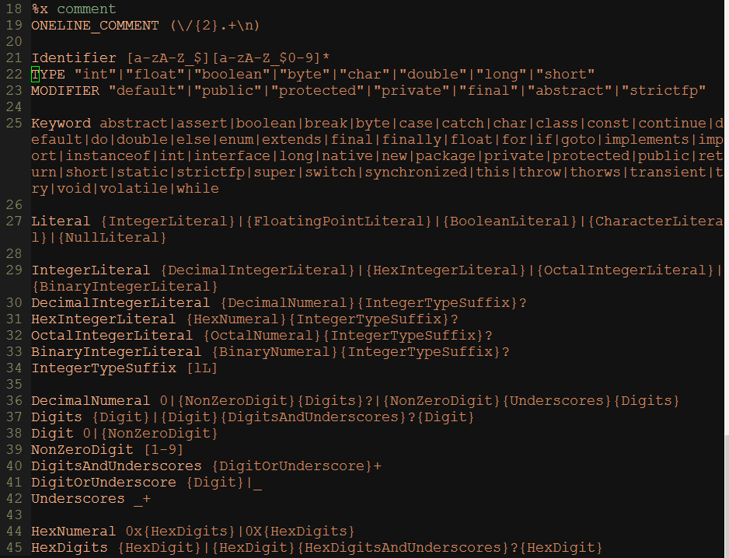

*<Definition Part code>*

1. **Rules part**

Except Comment and Bold comment, all attributes are highlighted through pre-definition, as like :

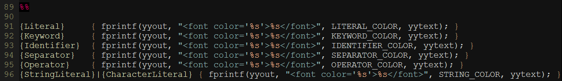

*<Rule part>*

SOMETHING_COLOR is color of each attributes predefined above (#define LITERAL_COLOR #008c00). When each attribute is matched through regex, using fprintf, it adds html code infront and behind the java code to highlight them.

In case of comment, it uses states to differentiate each type of comment.

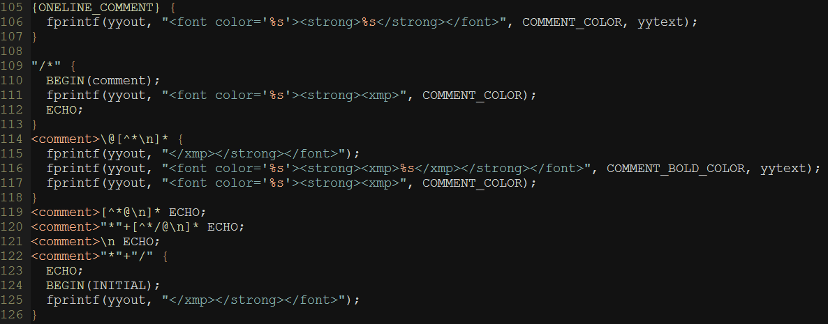

*<Rule comment part>*

1. **Highlighting scheme design**

For highlighting scheme Literal, Keyword, Identifier, Separator, Operator, StringLiteral, CharacterLiteral, Comment are highlighted.

Background color is in black(#000000) and default letter color is gray(#d1d1d1).

Identifier is in gray(#d1d1d1).

Keyword is in red(#e66170).

String is in skyblue(#00c4c4).

Literal is in green(#008c00).

Separator is in pink(#b060b0).

Operator is in yellowish green(#d2cd86).

Comment is in bluish gray(#9999a9).

Bold comment is in darkblue(#8695b8). (Comment using @)

1. **User Code**

In main program, it applies default setting of html file such as background color of html file. Until end of file, *yylex()* is executed to tokenize the java code.

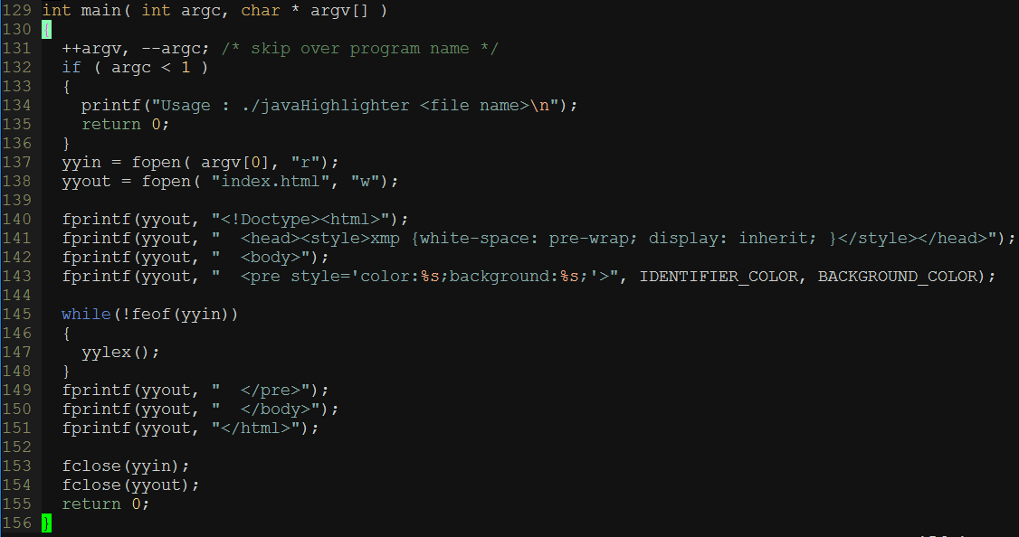

*<User code part>*

1. **Demonstration**

This is demonstration of the program : demo code comes from

https://www.cs.utexas.edu/~scottm/cs307/javacode/codeSamples/EightQueens.java

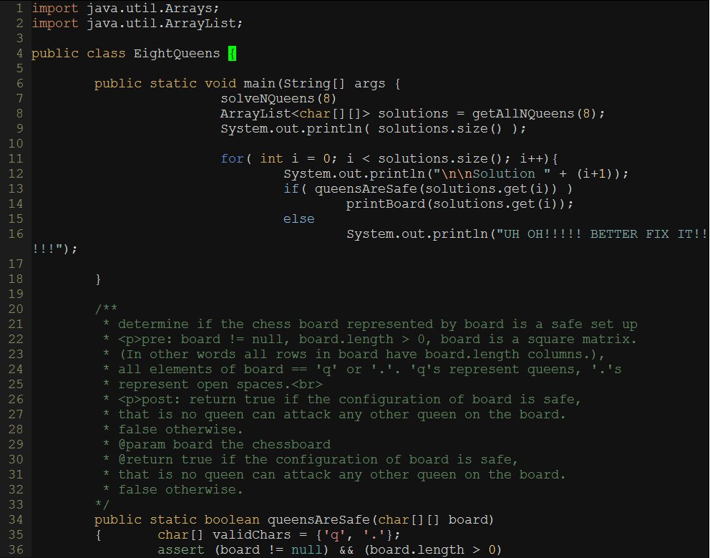

*<Example code>*

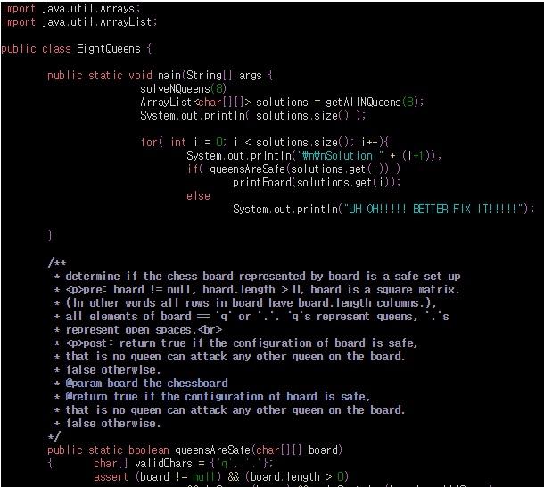

*<Result html on Chrome browser>*

1. **Discussion on design and implementation**

As you can see above, it was successful to highlight the attributes. However, it was difficult to catch syntax error through regex. As an example, we tried to catch variable or method starting with non-alphabet (ex. Int 23num), but knowing correct syntax doesn’t mean knowing wrong syntax, thus it produced wrong highlighting in many other code.

Follow code is what we try syntax error check and demonstration. If there is syntax error than program underline with red color.



*<Definition part>*

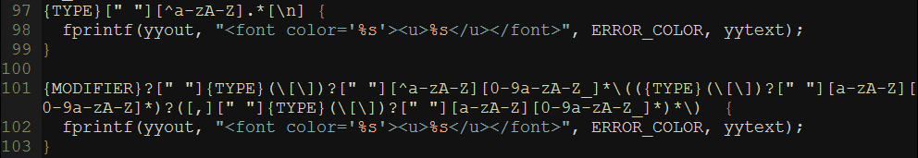

*<Rule part>*

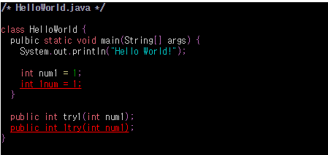

*<Demonstration Error checking>*